controlPump v1.01

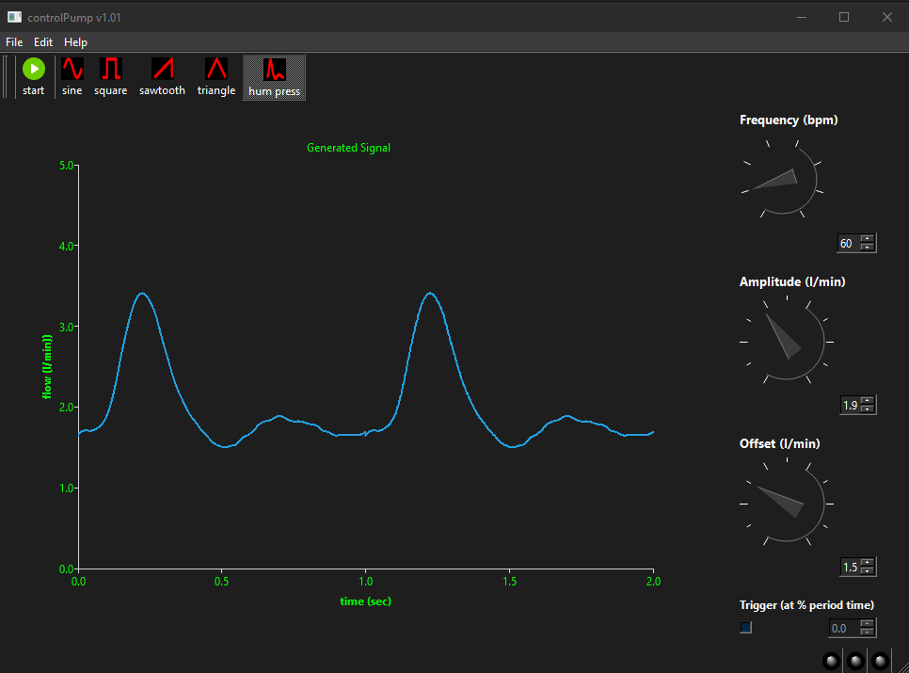

software to control the lifetec gear pump

date | version | comments
22-jan-2026 | v1.01 | initial version

Table of Contents
1 Introduction 3
2 Usage 4
3 Signals 5
4 Ini-file 6

Introduction

controlPump controls the lifetec gear pump of the Music-department. It replaces the application “Vasculaire Opstelling”. Vasculaire Opstelling was written in LabView. The yearly cost of LabView is high, so a new application is developed using the Qt framework in C++.

With “Vasculaire Opstelling, it was also possible to acquire analog signals (for instance flow or pressure). This is not possible in the new application. Therefore a derivate of PhysioMon should be used.

The new application has also some advantages. All signals that are used to control the pump(sine, sawtooth, human pressure) are now user defined. These signals can be generated using a Matlab script. (see chapter signals). Also the temporal resolution of these user generated signals is increased. Also the application has a Windows standard layout

Usage

Due to the standard interface the usage is very simple.

- Start he application. In most cases the configuration is done and the same layout is shown as in the cover-page of the manual
- If the pump is connected, the message “pump ready” appears in the statusbar. If the pump is not connected and error message is seen.
- Now the desired signal can be selected. This can be done within the “edit” menu or clicking the appropriate icon in the toolbar. In the edit menu, a mark signal is placed to indicate which signal is selected.
- If the signal is selected you can adjust the offset of the signal with the offset knob or with the edit field on the right side of the offset knob. The arrows key on the keyboard can be used to set the value. Changes appear in the statusbar.
- The same can be done with the amplitude of the signal or the frequency. Note the frequency is given in beats per minute (bpm) instead of Hz.
- The changes to the signal appears directly on the main screen

- If the signal is set to the one you want, you can start the pump. This can be done by clicking “start” in the file menu or by clicking on the start icon in the toolbar. If the pump is started, the toolbar icon changes form a start icon to a stop icon and also the text in the file menu is changed from “start” to “stop”
- With the stop icon in the toolbar or clicking “stop” in the file-menu you can stop the pump.

- If you want to quit the program press “quit” in the file menu or the windows cross in the upper-right side of the window. A confirmation is asked and selecting “yes” quits the program. If the pump was running it is also stopped.

In the current release of the software, there are no shortcut keys defined for some actions and so the mouse should be used. These shortcuts will be implemented in a next release.

Signals

Advantage of the new application is that all signals are user configurable. This can be done using a tool in Matlab that should be used to generate signals. This tool is pumpSignal. To use this tool, the following should be done.

Generate a signal in Matlab with exactly 1000 datapoints for one period. So you have a vector of 1000 points that represents the signal. The amplitude of the signal should be between 0 and 1. Check the signal with the Matlab plot command.

If you are satisfied, you can generate the data-file and the icon-file that are used by the controlPump application with the following command

pumpSignal(name,data)

with <name> the name of the data-file and the icon-file that can be used by the contorlPump application.

Below an example is given to generate a sine-signal in Matlab

>> x = 1:1000;
>> data = sin(2 * pi * x / 1000) + 0.5;
>> pumpSignal(“sine”,data)

This generates a <sine.ico> and <sine.bin> file that can be used. The data is stored in a binary file that is not readable by a human.

Ini-file

When the application is started, some settings are read from an *INI file. An example of such an *.INI file is given below and each setting is explained below the example

[algemeen]
default = 2
updatetime = 10

[hardware]
address = USB0
device = epos2motor
conversionFactor = 1250

[signal 1]
name = sine
data = sine.bin
icon = sine.ico

[signal 2]
name = square
data = square.bin
icon = square.ico

[signal 3]
name = sawtooth
data = sawtooth.bin
icon = sawtooth.ico

[signal 4]
name = triangle
data = triangle.bin
icon = triangle.ico

[signal 5]
name = hum press
data = humanpressure.bin
icon = humanpressure.ico

Algemeen

default

This is the standard signal that is used when the application is started. It should be between 1 and 5 and referenced to the signal x section of the *.INI file.

updateTime

This is the time (in ms) a new value is written to the pump. In the “vasculair application” this was 10 ms and was not changeable by the user. In controlPump, the best setting is also 10 ms. On fast computers or to get a higher accuracy a smaller value can be chosen, on slow computer or for less accuracy, higher values can be set

hardware

address

used to know which port is used to control the pump. For the lifetec gear pump this should be “USB0” or “USB1”

device

Which pump is used. Currently only the lifetec gear pump is supported. This is a pump that internally use the EPOS 2 control and therefore, this setting should be always “epos2motor”

Conversionfactor

The pump is controlled by the number of rotations per minute (rpm). However, the user wants to set the flow in liters per minute. There is a linear relationship between the flow and the number of rotations. A value of 1250 (which is a standard value for the lifetec gear pump) means a flow of 1 ltr/min is 1250 rpm

signal-x

In the signal sections the properties of the signals can be set.

name

The name of the signal as it appears in the edit menu and in the toolbar. Can be anything but best is to use a name that describes the signal

Data

The name of the data-file that contains the signal (see chapter signals). Best practice is to place the data-file in the same folder as the application. If not, the full path should be given.

Icon

The name of the icon-file that is used. Generating a signal with the matlab application (see chapter signals) generates also an icon file. This icon is visible in the toolbar. As for the data file, the best practice is to store the icon file in the same location as the application, else the full path should be used

