**Jan Mikicki**

**Solution**

Because the task asked to “train a model for erosion detection” I decided that the best idea was to try to produce a semantic segmentation for the eroded land.

In other words, given some aerial image try to output a mask with shapes outlining eroded patches.

Unfortunately I didn’t manage to achieve any good results - my predictions never contained any eroded patches.

Nevertheless I will describe my solution and try to propose potential improvements.

My idea was to make a binary raster mask from the shapefile (0 - no erosion, 1 - erosion)

and then cut this mask, together with the original raster image, into smaller tiles which then will be used for training a semantic segmentation model.

**1.** Following the [link](https://medium.datadriveninvestor.com/preparing-aerial-imagery-for-crop-classification-ce05d3601c68) you provided I filtered the shapefile to only contain only shapes present in the raster which reduced the number of masks from around 900 to 400. I assume the other shapes are taken from some neighboring satellite tile.

**2.** Next I constructed a binary mask from the remaining shapes which looked something like this:

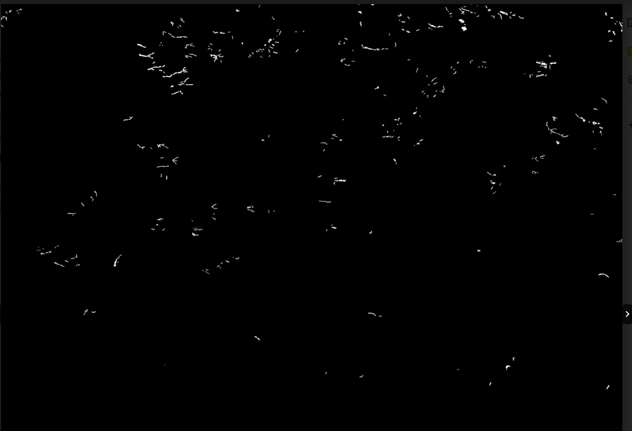

**3.** Then I cut the mask together with the raster into 512x512 tiles like this:

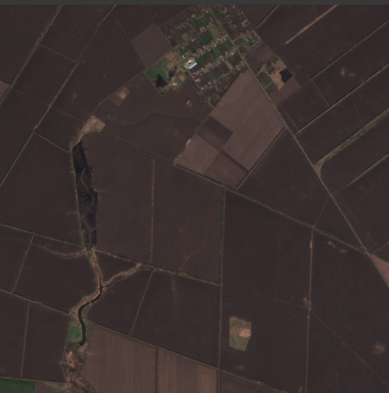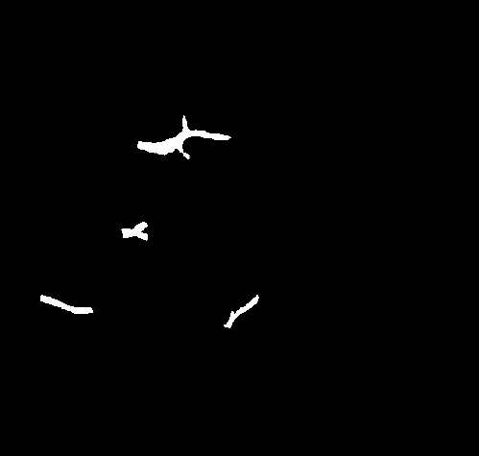

**4.** To build a model I mainly followed [this](https://keras.io/examples/vision/oxford_pets_image_segmentation/#what-does-one-input-image-and-corresponding-segmentation-mask-look-like) example which uses a U-Net-like architecture.

The inputs to the net were RGB images and the outputs/targets were binary masks.

**5.** I trained the model for 15 epochs with 50 validation samples and *sparse_categorical_crossentropy* loss.

**6.** Even though the loss seemed to be very small, all the predictions contained only “black”/uneroded class. I tried to change several parameters but with no luck. Below I listed some possible reasons as to why it turned out like that.

**Why it didn’t work?**

* bad model and/or parameters: it is likely that I picked some bad parameters during training. With more time it would be useful to try different tile sizes, batch sizes, learning rates, etc.
* Imbalanced Data Sets: I suspect one of the obstacles is the fact that there is a lot more uneroded land in all the examples. In fact, most tiles contain exclusively uneroded land. Because of this the model might just learn to achieve a good score by always predicting uneroded class. Some solutions are suggested here: <https://iopscience.iop.org/article/10.1088/1742-6596/1213/2/022003/pdf>
* small dataset: could try getting more data or augmenting current data
* detecting erosion is just hard: maybe it’s just a hard problem and requires more “tricks” to get working well.
* all of the above

**Proposals**

It seems to me that it's quite hard to detect soil erosion from the RGB image alone. When looking at the images, there is often very little visible indication of erosion.

Based on what I read, many erosion detecting methods utilize also other types of data, most commonly elevation/slope information:

* <https://www.researchgate.net/publication/257840453_Estimating_soil_erosion_using_MODIS_and_TM_images_based_on_support_vector_machine_and_a_trous_wavelet>
* <https://www.researchgate.net/publication/331485798_A_Remote_Sensing_Based_Method_to_Detect_Soil_Erosion_in_Forests>
* <https://www.mdpi.com/2072-4292/12/24/4047/htm>
* <https://citeseerx.ist.psu.edu/viewdoc/download?doi=10.1.1.924.5272&rep=rep1&type=pdf>

Apparently high erosion often appears where there is a steep slope/change in elevation.

Many of them also use vegetation data (high vegetation often correlates with low erosion) and different band combinations. For example one study suggest that Red/Green ratio is useful for detecting soil degradation:



I tried to use this myself but the R/G band didn’t seem to help in this particular example.

I think it would also be interesting to see if other wavelengths (infrared, SAR radar) help detecting eroded soil but I don’t know if data like this is available.

Perhaps you are also familiar with **ESA SNAP** software which is used to analyze satellite imagery. I used it a little bit during my college studies. It can be useful for doing band math, visual inspection or for making and editing shapefiles:

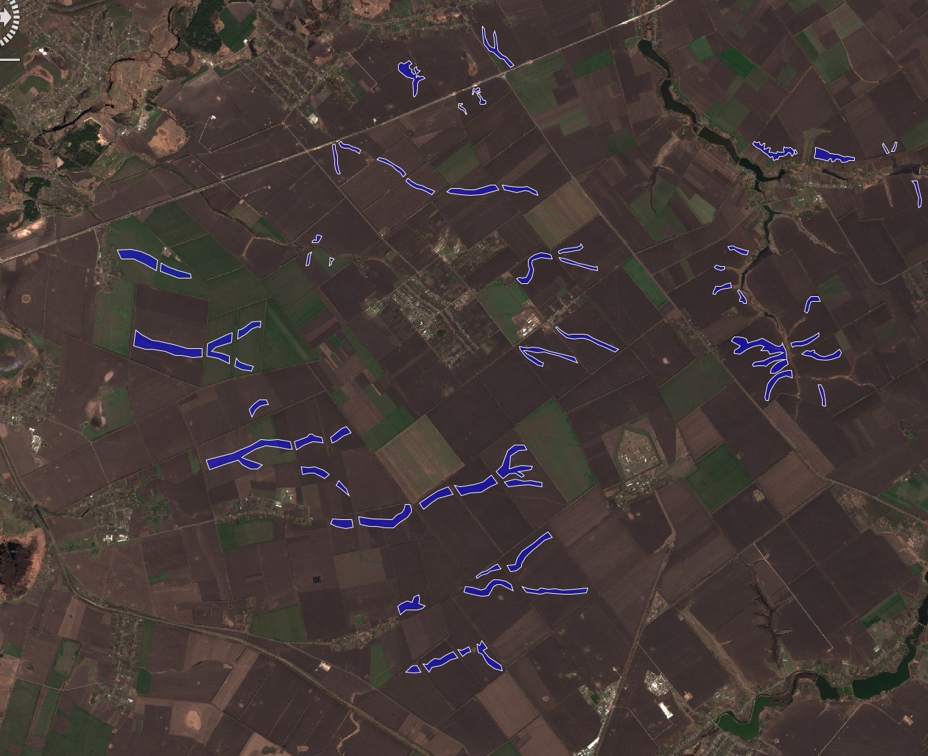

That’s all the proposals I could think of at this time.

Thank you