Business

- low foil thickness, delicate cells 🡪 avoid mechanical damage (danger in ultrasonic welding) by using contactless laser welding

- pack must be very high quality to avoid explosion, laser beam welding causes less mechanical stress on the copper foil connectors

- 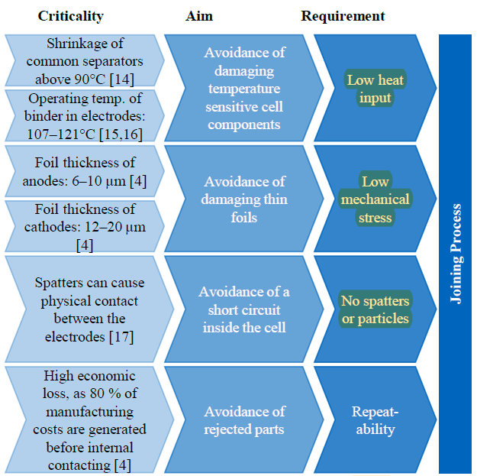

- laser beam welding: highly focused and dynamic energy deposition 🡪 inline quality check required

- In lithium-ion cell-based battery storages, up to several thousand electrical contacts have to be manufactured (Brand et al., 2015). As a feasible joining process, LBW is characterized by a high degree of automation, a low cycle time, and a precise local energy input (Das et al., 2018)

- Joining highly reflective metals and dissimilar materials such as copper and aluminum – often encountered in battery electrical vehicles – is viewed as a challenging task.