# Finals-Handout: Mood4Food

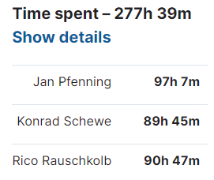

Jan Pfenning: [jan.pfenning@gmail.com](mailto:jan.pfenning@gmail.com)   
(Android Backend, Scrum Master, Project & Deployment Manager)

Rico Rauschkolb: [r.rauschkolb@web.de](mailto:r.rauschkolb@web.de)  
(Android Backend, Test-Manager, System Analyst)

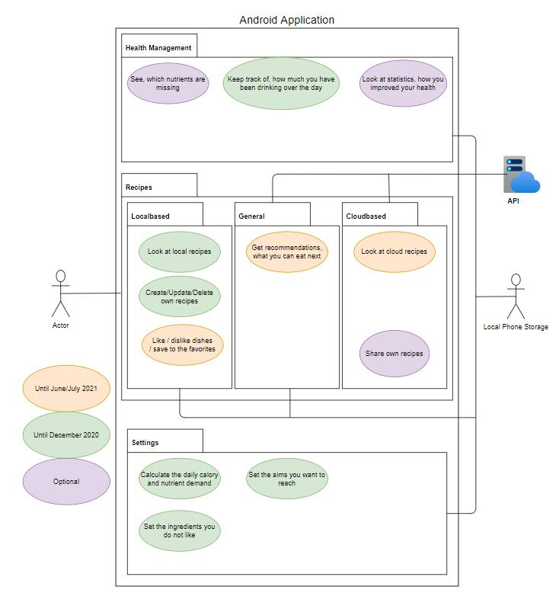  
Konrad Schewe: [konrad.schewe@outlook.de](mailto:konrad.schewe@outlook.de)  
(Android Frontend, Backend-API, Configuration Manager, Software Architect)

