Use of the Arduino platform in the teaching
of programming

Milan Novák, Jana Kalová, Jiří Pech
Faculty of Science
University of South Bohemia
Branišovská 1760
370 05 České Budějovice
Czech Republic

Abstract The paper deals with the use of the Arduino platform in the teaching of programming. This issue is part
of PRIM project (Podpora rozvíjení informatického myšlení, Support of the development of information thinking). The output of the project will be a set of teaching and methodical materials that will serve as a pedagogical guide.
Keywords Arduino; development of information thinking; programming teaching

Introduction
The industry has transformed itself into the present form during the four revolutions. Nowadays, it has been in a big revolution for several years, which is called Industry 4.0, and is based on complexity, use of information technology (IT) and integration [1]. The basic trigger for this revolution is the booming of smart technologies, the mass expansion of the Internet and its extension to other areas. In Industry 4.0, IoT (Internet of Things) or Industry Internet of Things (IoT) is represented. However, the onset of this revolution and the full use of its aspects in practice is limited by an insufficient number of experts. Now there is a shortage of experts in the Czech Republic. In response to this request, the PRIM project (Podpora rozvíjení informatického myšlení, Support of the development of information thinking) was prepared. The project can be considered as supporting the development of information thinking. The PRIM project aims to support a change in the orientation of the IT subject from a user level towards the basics of IT as a discipline.
Fig. 1 Benefits of Arduino platform

As a result of the ongoing Industry 4.0 revolution, there is a rapid increase in the need for IT professionals as well as the general education of the IT population. The PRIM project responds to similar activities in a number of advanced countries where computational thinking comes to the forefront of the attention of schools and national curriculum makers. The PRIM project focuses on the issues of informatics at all levels of schools, ranging from kindergartens to high schools.
The PRIM project develops textbooks and a set of methodical materials for teachers with a focus on programming. The resulting material should reflect the revised framework curriculum for programming. The material produced should reflect the revised framework curriculum of informatics and fulfill some of the competencies included in it. Based on these requirements, the Arduino platform was chosen, which not only fulfills the condition of the curriculum in the area of algorithmization and programming but also distributes it to 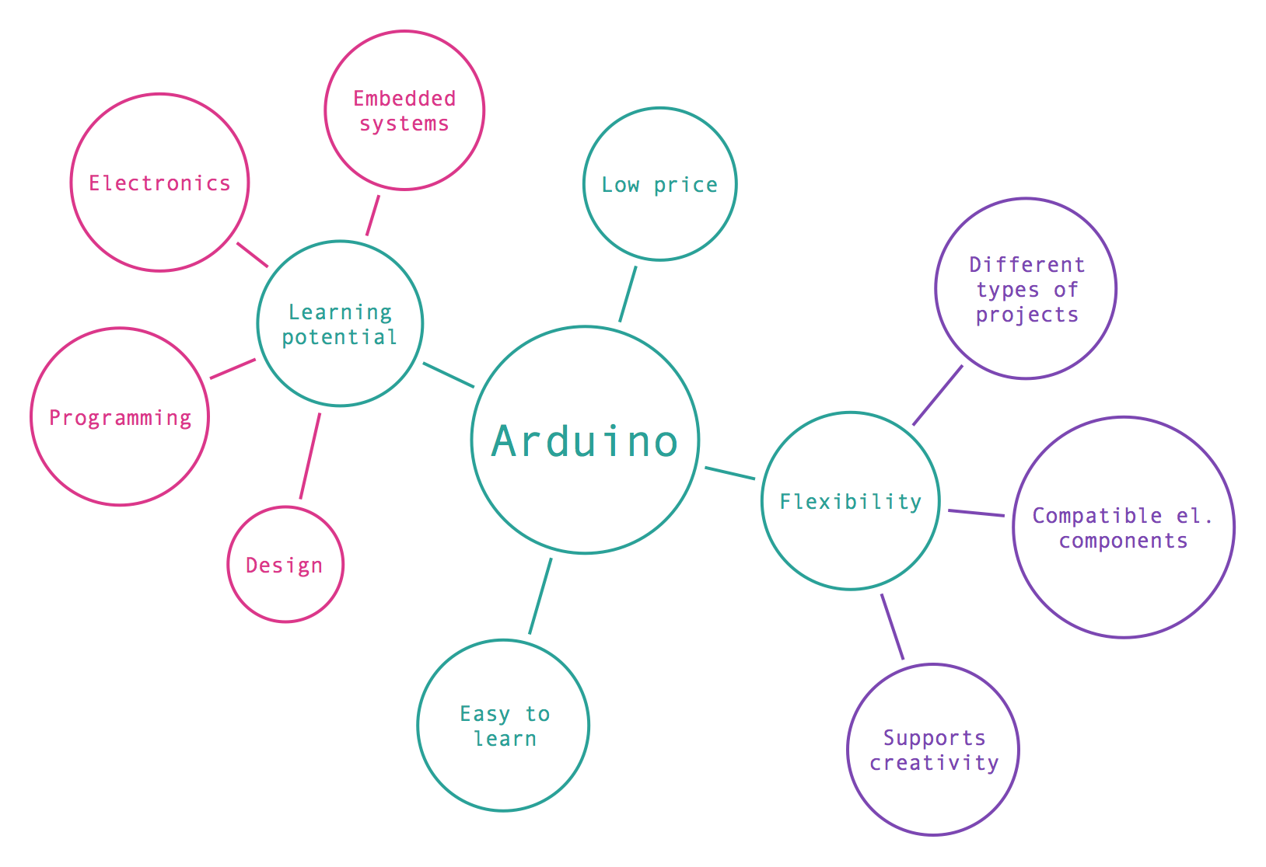other disciplines. Arduino has a wide range of benefits (Fig. 1) [2].
The term "Arduino" includes both hardware and software. Arduino is a prototype and open platform based on easy-to-use hardware and software. The Arduino programmable boards process inputs and output the output code using the program code. Several other hardware components can be added to the Arduino board. Using open source libraries available on the Web, Arduino can be used for a wide range of projects from extremely simple to highly complex. This makes this platform very flexible. Programmers create robots, remote-controlled vehicles, home automation devices, etc. Arduino gained popularity for its simplicity and affordability. For a beginner, including a child, it is relatively easy to start programming with the Arduino platform. The educational potential can be seen in several areas such as design, electronics, embedded systems, and last but not least, programming. These areas complement one another. The educational materials were based on the established ADDIE model. This model is part of the ISD - Instructional System Design and provides a general framework for system design of courses or learning processes [3]. Its five core components helped us to clarify and choose a strategy for creating learning materials (Fig. 2).

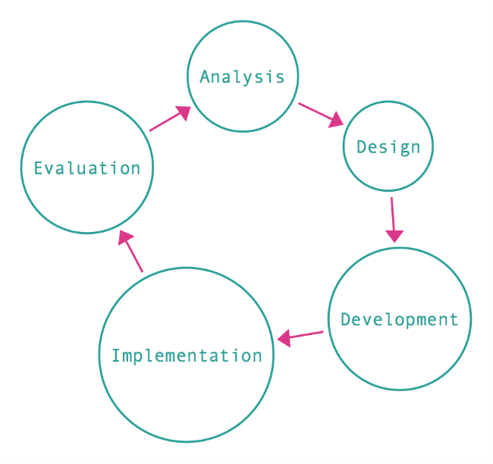
Fig. 2 Model ADDIE

ISSUE ANALYSIS
The basic problem was how to operate the Arduino platform. This platform in the context of information thinking with regard to the field of informatics requires different skills. This is especially the ability to complete electronic circuits. Although it is not necessary to fully understand them, it is not possible to create the relevant program code only, and then run it. In that case, we would have to work with Arduino platform for example on a robotic basis.
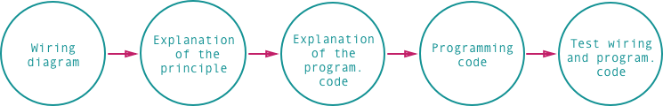
There was a choice. Either to use the Arduino platform at all or to use e.g. some of the virtual simulators in the computer. However, own experience gained in Arduino or some research [4] suggests that real objects programming is more beneficial for students. The ability to interact with real-world objects is more motivating for students and simultaneously leads to the development of information thinking in terms of algorithmization, not only of the program code but also in the creation of electronic connections. In the analysis, a survey of publications focused on Arduino programming was conducted. We analyzed mainly foreign literature. Generally, all books use a uniform model (Fig. 3).
Fig. 3 Basic model
Fig. 4 Extended model

This model focuses in particular on the description of one electronic scheme, explaining the principles of the components used. Following are descriptions and explanations of the used program structures and commands. Then the entire program code that controls the circuit is given. According to the model, the student passively accepts and tests the solution.
Although the model was chosen as the default, modifications had to be made to make it possible to meet the information thinking condition and the student (the user) was forced to think about the connections or the program code.
The analysis also identified possible tasks suitable for inclusion in teaching materials. This step was also important for defining the procurement criteria for the purchase of Arduino kits, which would include the necessary components while allowing for dynamic expansion of other topics for new tasks.

DRAFT STRUCTURE OF LEARNING MATERIALS
The initial design of the structure of the educational materials is based on the analysis. To take teachers and students into account primary, the basic model was modified. Furthermore, the emphasis is placed on the fulfillment of the didactic principles of the learning process such as sequence, continuity, persistence, clarity, or a combination of theory and practice. The basic structure of educational materials is divided into three basic elements (Fig. 4).
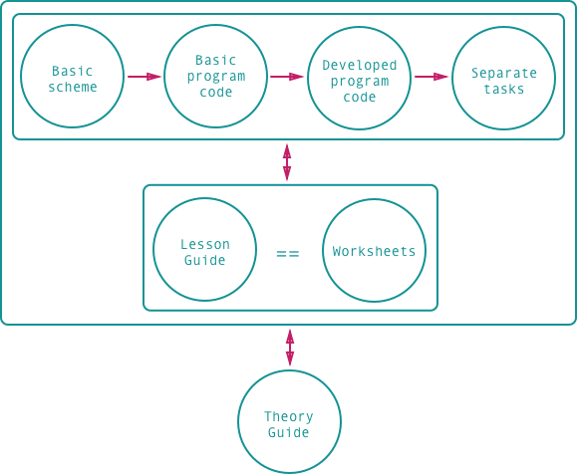

Lesson guide
A lesson guide material is a methodological sheet intended for teachers. It contains a time schedule of the lesson with recommendations in the form of tasks the teacher can perform. These are questions, tasks, and basic explanations of the topic being discussed (circuit diagram, components, program structures). In the lesson guide, questions are addressed to students and require immediate answers. The guide provides cautionary notes that should allow the cantor to react quickly student incentives or problems associated with solving individual asks. For each subject, the teacher is provided with a presentation that can be used in parallel with the worksheets and which copies the structure of the class guide. It is intended for the frontal interpretation of some phenomena and basic programming structures.

Worksheets
The worksheet focuses primarily on students. It copies the lesson guide. There are questions related to the topic that should explain some phenomena to students. As stated before, the same questions are available to the teacher in the lesson guide, but the answers in student's worksheet are not given. The structure of the worksheet depends on the topic being processed. In general, its basic form is illustrated in Fig. 5.

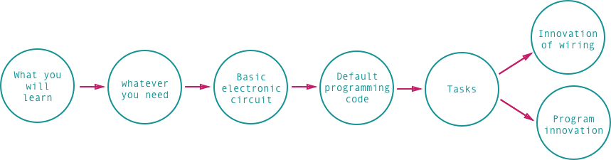
Fig. 5 Worksheet structure
Students are informed about what they will learn the lesson. The following is a list of components needed to create
a circuit. When making a basic circuit, if necessary, it explains possible unclarities. Each lesson focuses on a particular programming structure or command. This is taken into account in the default program code. This introductory part is complemented by questions that should help the student himself find the functionality of the circuit or the logic of the program code. The last part of the worksheets is separate tasks, which relate to the innovation of the circuit construction and to the innovation of the program code. The innovation of the program code is crucial and we used the general taxonomy of learning tasks to formulate separate assignments [5]. We focused mainly on the category of tasks requiring creative thinking. Most tasks do not require complicated editing of basic connections, but rather focus on the progressive development of program code from simple to more complex.

Theory guide
The theory guide contains detailed program codes and all electronic diagrams. It explains the principles of used electronic components and some physical phenomena. The program code of most examples is described in detail. It serves in particular as a detailed guide to the issue for teachers and as a self-study material for students. Part of the theory guide is the final project, which is at least symbolically aimed at interconnecting the learned with practice. In these simply designed projects, students build a mechanical structure, according to the enclosed instruction and pictorial procedure. For example, after discussing a substance related to the programming of servomotors, temperature sensors, displays, and a DC motor, students can combine these parts in one project called Automatic Greenhouse Control. The enclosed template and implementation instructions will build a greenhouse model that is automatically controlled by programming the behavior of the components.

- CREATION OF LEARNING RESOURCES

Based on the design and the established concept, basic topics were selected and included into lessons. The course of each lesson can be influenced by several individual factors given by students knowledge and skills, the time range of lessons or the type of school. Therefore, each lesson is divided into several basic time units of 45 minutes. These units can be combined depending on the factors mentioned. An example of the arrangement of lessons is shown in Fig. 6.
Fig. 6 shows only part of the lessons that use some of the electronic components and discussing basic programming structures.
Other lessons use, for example, a DC motor and its control, a display for displaying values from a thermo-resistor, a temperature sensor, and a hygrometer, buttons for controlling traffic lights, a motor with a robotic hand, etc.

- CONCLUSIONS

In this paper, we have tried to outline the possible design of educational materials for teaching programming at high schools using the Arduino platform. According to previous experience in initial testing, students of the Arduino platform praise, especially at grammar schools. At vocational schools, the situation is a little different. Students already have better knowledge in the field of electrical engineering, so the problem of circuits, at least in introductory lessons, is simple for them. We have expected this fact. Lessons are created so that what the students of the grammar school can handle for two teaching units, the vocational school students will be able to handle on one repeating unit. Materials of each lesson for teacher - lesson guides, and for students - worksheets, are also conceived according to this experience. The difficulty of individual lessons is also graduated from simple to complex examples.
We assume that students of grammar school will not pass through all the lessons, but they will study the basic areas only, while the students of vocational schools will turn to more complicated examples and the introductory lesson will be a repetition for them.
The issue, depending on the type of school, is a little more complicated. Creating of circuits will take less time for high school students than for grammar school students, but in programming, the situation is a little bit different. In comparison with other high school students, grammar schools students are better at solving more complex logical programming tasks. Similarly, the basics of programming knowledge are different. This interesting observation for the moment is no more verified. Deeper conclusions will be interpreted only after pilot testing most of the educational material.
The chosen concept of creating of educational materials for Arduino platforms is starting to provide a uniform framework. We consider it important because at the beginning of the PRIM project we did not know how to grasp the issue in this area (a connection of HW and SW). Even though we already have a substantial part of the material prepared, we have a problem with the concept of inclusion in teaching. It practically does not currently exist, and according to experience, the teacher solves this issue in different ways. Testing takes place, for example, in professional subjects or optional seminars, but not in standard school lessons.

First
program
Final project: SPEAKING ROBOT
Introduction to Arduino and basics of el.
LED, buzzer,
breadboards, Arduino

Rezistor
Digital Input and Output. Useing function for LED and buzzer programming. Getting to know the Wiring programming language and the Arduino IDE.
Control multiple LEDs
Final project: LIGHT ANIMATION
Extended LED work. Functions, For, Fields.
LED,
breadboard, Arduino, resistor
Students will consolidate their knowledge in compiling el. circuit. They learn to streamline program code using program structures such as functions, loop and field.
Control
servo
Final prpject: SUNFLOWER
Using the conditional if statement.
Servomotor, photoresistor, potentiometer, breadboard, Arduino board
Resistor
When using actuators, students will learn how to use the el. components - a photo resistor and a potentiometer. They will learn how to use the condition if.
RGB diode
Final project: MAGIC LAMP
Programming RGB diode and control using PWM.
RGB diode,
breadboard,
Arduino, resistor
The RGB diode is a very attractive component that shows how PWM can be used. This lesson uses and leads to the consolidation of all the prog. structures.
Fig. 6 Sample of lessons arrangement

References

- U. Sendler, Industrie 4.0: Beherrschung der industriellen Komplexität mit SysLM. Berlín: Springer Vieweg, 2013. ISBN 978-3-642-36916-2
- Using Robotics with the Arduino Uno for Education. University of Puerto Rico at Arecibo [online]. University of Puerto Rico at Arecibo: Computer Science Department, 2014 [cit. 2018-03-06]. http://cahsi.cs.utep.edu/
- ADDIE Model: Instructional Design. IJET [online]. 2017, 2017(3), 1 [cit. 2018-03-06]. ISSN 2476-0730. https://educationaltechnology.net/ijet/
- S. Atmatzidou, S.Demetriadis, Advancing students’ computational thinking skills through educational robotics. Robotics and Autonomous Systems. ELSEVIER, 2015, 2015(75), 10. ISSN 0921-8890.
- D. Tollingerová, A. Malach, Metody programování. Hradec Králové: Pedagogická fakulta, 1973. Učební texty vysokých škol.

