Website Performance Analytics Report
StudyCalc – Smart Academic Student Platform
Course:Web Data Analysis
Instructor:Dr. Salwa Al-Thubaiti
Prepared By (Project Members):
Student ID: | Name:
446017177 | Jana Abdul Rauf Saati
446002883 | Nouf Saleh bin Taleb
446004806 | Yumna Yasser Binafif
446000160 | Asmaa Khalid Alakbari

Section: 9
University:Umm Al-Qura University
Department:Data Science Department

Project Description:
StudyCalc is a smart academic web platform designed to help university students manage their academic life through integrated tools including a GPA calculator, budget planner, study schedule generator, intelligent dashboard with a gamification points system, and a Student Quiz for personalized study-type insights.

1.Business Goals
•Help students calculate their GPA accurately and quickly.
•Help students manage their monthly budget and expenses.
•Help students organize study schedules and improve time management.
•Increase student engagement through account creation and gamified tools.
•Collect and analyze web traffic data to improve platform performance.

2.Key Performance Indicators (KPIs)
- KPI #1: Total Active Users
- KPI #2: Sessions
- KPI #3: User Engagement (Avg. Engagement Time)
Why are these KPIs relevant?
These KPIs help measure website reach, user interaction, and the effectiveness of academic services. Total Users shows platform adoption, Sessions measures how often users return, and Engagement Time reflects how useful users find the content.

3.Ask four simple macro questions to guide analysis.

Q1. How many visitors are coming?
A custom report was created showing the number of active users, new users, sessions, and average engagement time for the period April 27 – May 24, 2026.

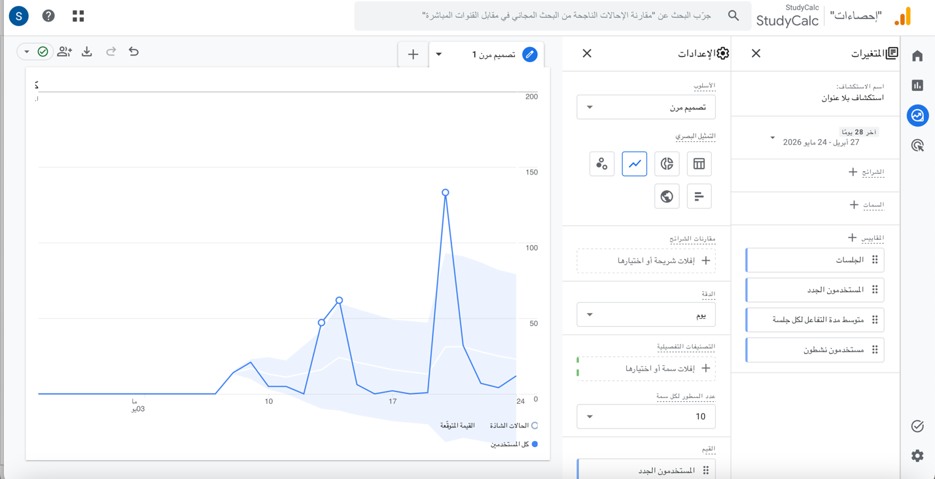

Analysis and Interpretation:
The traffic source analysis shows that Direct traffic was the dominant source with 460 sessions, confirming that the majority of visitors accessed StudyCalc through shared links via WhatsApp and direct URL sharing among university students.
Referral traffic contributed 41 sessions, representing visitors who arrived through external websites that linked to StudyCalc, such as scanned.page and t.co.
Organic Social accounted for 37 sessions, reflecting traffic from social media platforms including Instagram, Twitter, and Snapchat where the platform link was shared.
Unassigned traffic recorded 18 sessions, which likely represents visits where the traffic source could not be properly identified due to tracking limitations.
The traffic spike visible around May 19–20 in the chart aligns with the period when StudyCalc was actively shared among university students, confirming that peer-to-peer sharing campaigns are the most effective acquisition strategy for this platform at its current stage.

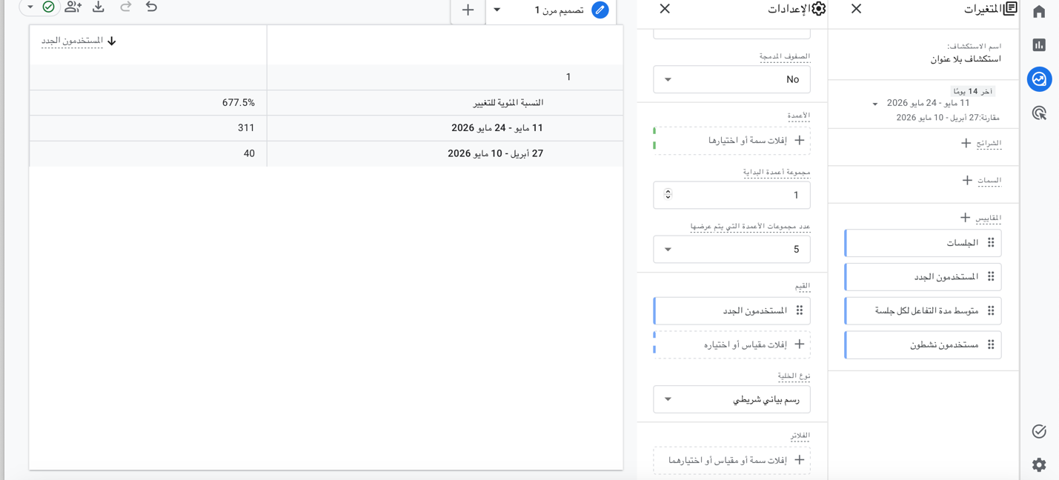
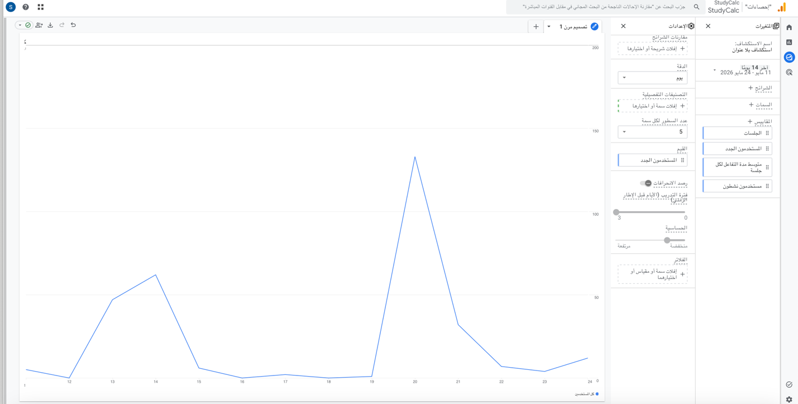

Analysis and Interpretation:
A comparison between the two periods reveals a significant increase in new users. The period from May 11–24, 2026 recorded 311 new users, compared to only 40 new users during the previous period (April 27–May 10, 2026), representing a 677.5% increase.
This dramatic growth is directly linked to the platform being shared among university students via WhatsApp and social media during the second period, which coincides with the academic project data collection phase. The spike confirms that peer-to-peer sharing campaigns are highly effective in driving new user acquisition for StudyCalc.

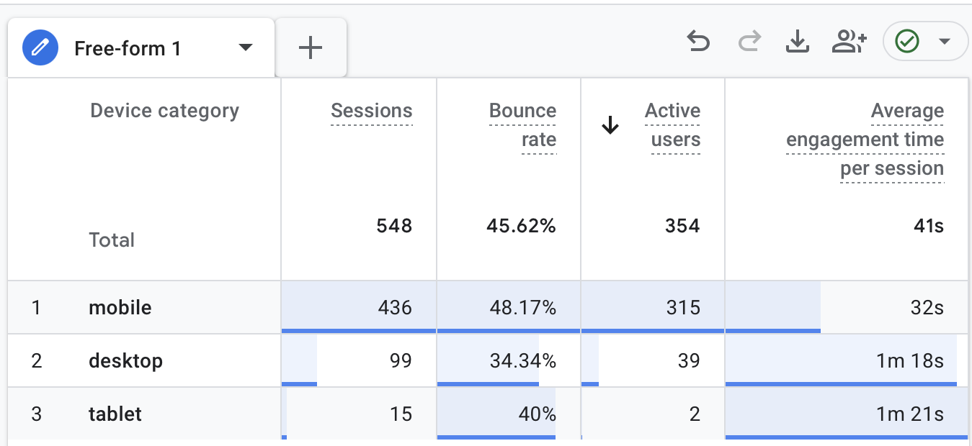

Analysis and Interpretation:
The device analysis shows that mobile dominated with 436 sessions (315 active users) and a bounce rate of 48.17%, confirming that most students access StudyCalc via smartphones.
Desktop users recorded 99 sessions with a lower bounce rate of 34.34% and higher engagement time of 1m 18s, indicating deeper interaction when using larger screens.
These findings highlight the importance of optimizing StudyCalc's mobile experience to improve engagement and reduce bounce rate.

Q2. Where are visitors coming from?
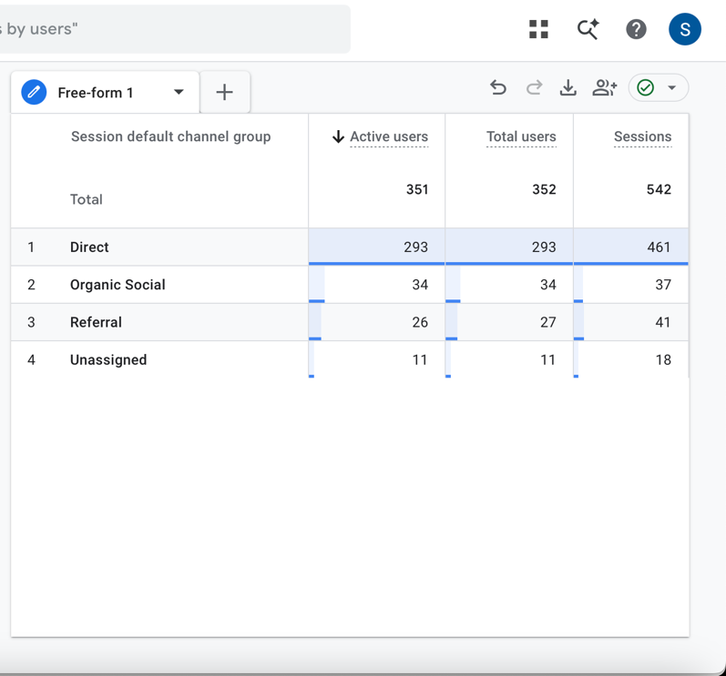

Analysis and Interpretation:
The data shows that Direct traffic was the dominant source with 461 sessions and 293 active users, confirming that most visitors accessed StudyCalc through shared links via WhatsApp and direct URL sharing.
Organic Social ranked second with 37 sessions and 34 active users, representing traffic from social media platforms where the website link was shared among students.
Referral traffic contributed 41 sessions and 26 active users, coming from external websites linking to StudyCalc.
The high direct traffic percentage is expected for a newly launched academic platform primarily promoted through peer-to-peer sharing among university students.
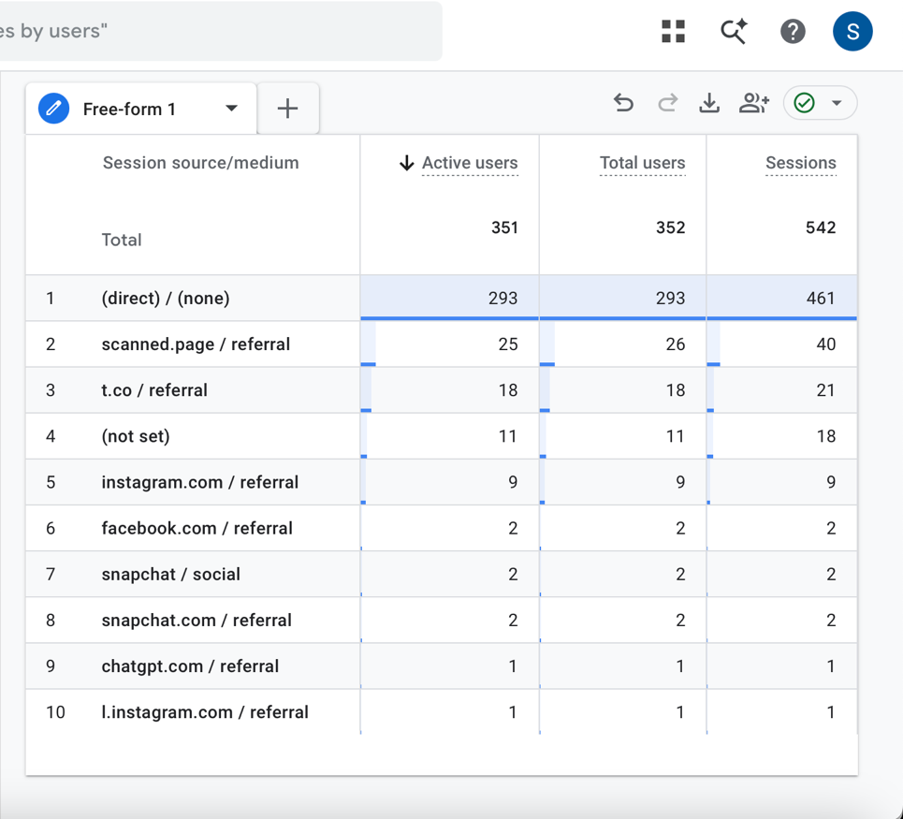
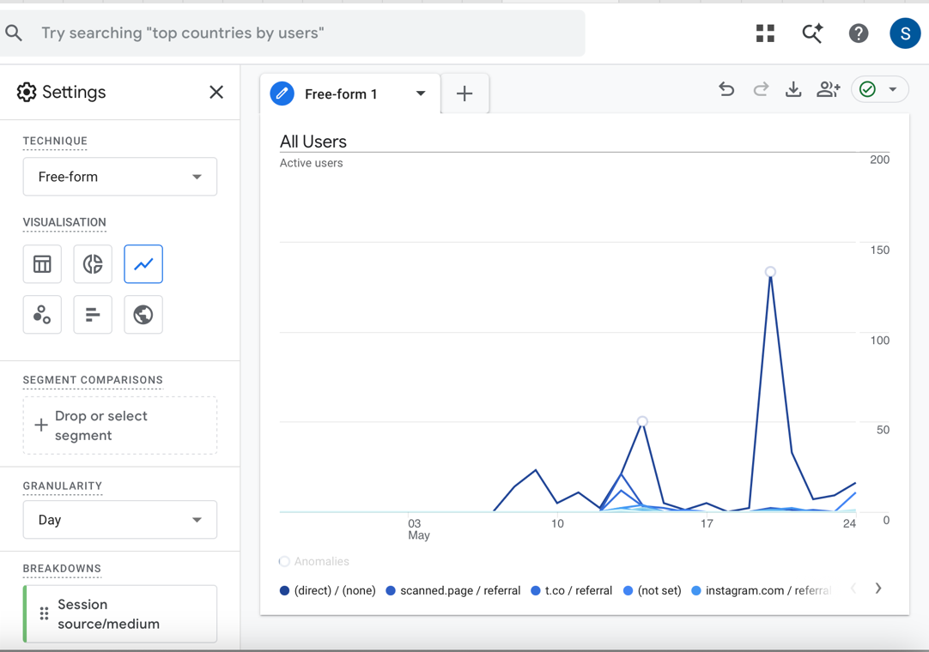

Analysis and Interpretation:
A deeper analysis of traffic sources by session source/medium reveals that (direct)/(none) was the dominant source with 461 sessions and 293 active users, confirming that most visitors accessed StudyCalc through direct link sharing via WhatsApp and other messaging platforms.
scanned.page/referral ranked second with 40 sessions, suggesting that some users accessed the platform through QR code scanning, which indicates physical or digital promotional materials were used.
t.co/referral came third with 21 sessions, representing traffic from Twitter/X, where the platform link was shared among students.
instagram.com/referral contributed 9 sessions, confirming that Instagram was also used as a channel to promote the platform.

Q3. What do we want visitors to do?
Goal:
Visit the Home Page → Create an Account → Use Academic Tools (GPA Calculator / Budget Calculator) → Explore the Dashboard → Complete the Student Quiz

Q4. What are visitors actually doing?

Page Title Report (What Page People View)

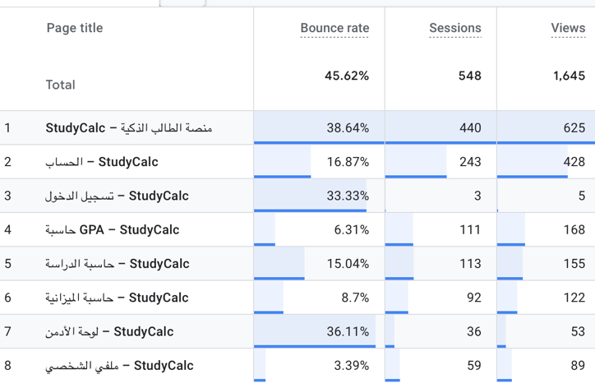
Analysis and Interpretation:
The Page Title Report reveals how visitors actually interact with StudyCalc's pages.
The Home Page received the highest views (625) with 440 sessions and a bounce rate of 38.64%, confirming it is the main entry point and that most visitors continue exploring after landing.
The Account Page ranked second with (428 views) and the lowest bounce rate of 16.87%, indicating strong interest in account creation and registration, which aligns with our goal of increasing user engagement.
The GPA Calculator recorded (168 views) with an exceptionally low bounce rate of 6.31%, confirming it is the most engaging academic tool on the platform.
The Study Schedule and Budget Calculator followed with (155) and (122 views) respectively, showing solid engagement with the platform's core academic tools.
The Profile Page had a very low bounce rate of 3.39%, suggesting that registered users who visit their profile are highly engaged and spend meaningful time reviewing their data.
The Admin Dashboard recorded (53 views) with a 36.11% bounce rate, which is expected as it is primarily used for data review.
Overall, the data confirms that visitors are following the intended user journey: entering through the Home Page, registering an account, and actively using the academic tools."

Landing Page Report (Where user enter the website)
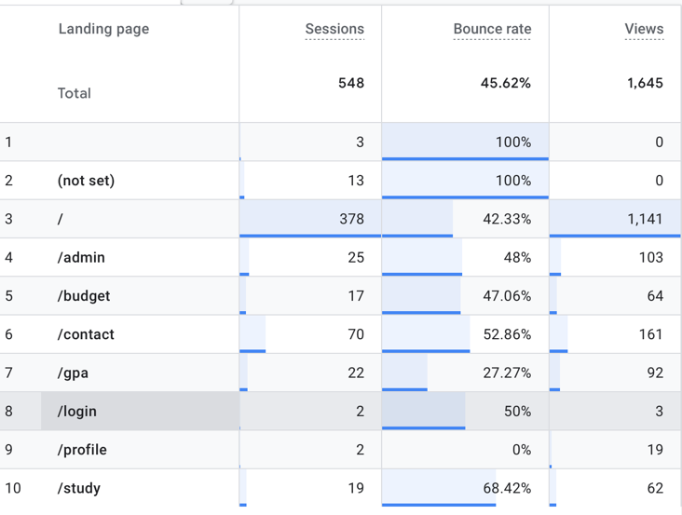
Analysis and Interpretation:
The homepage drives most traffic (378 sessions), while the /gpa page leads in engagement with the lowest bounce rate at 27.27%. The /study and /contact pages show the highest bounce rates (68% and 53%), suggesting user experience optimization is recommended. Login and profile pages have minimal traffic, indicating a possible onboarding gap.

Overall:
improve /study and /contact page user experience, and review the user login flow.

Mobile vs. Web Performance — /study & /contact
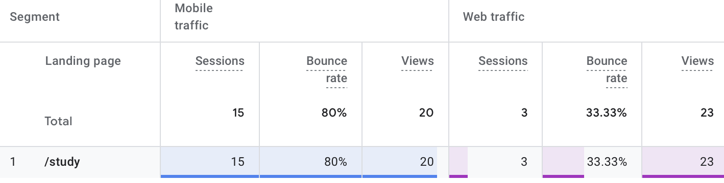
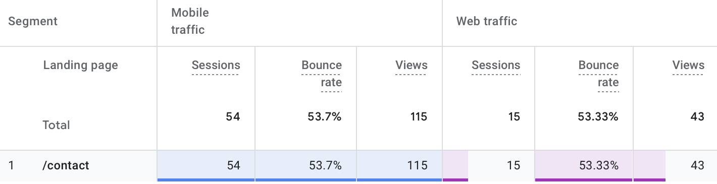

Analysis and Interpretation:
The /study page struggles significantly on mobile, with an 80% bounce rate across 15 sessions, compared to just 33.33% on web (3 sessions). This suggests the page is not mobile-friendly — layout, load speed, or content presentation likely needs improvement for smaller screens.
The /contact page shows consistently high bounce rates on both mobile (53.7%, 54 sessions) and web (53.33%, 15 sessions), meaning the issue is not device-specific. The content or form on this page may not be meeting visitor expectations regardless of how they access it.
Key takeaway: /study needs a mobile experience fix; /contact needs a content or UX overhaul across all devices.

Outcomes by Traffic Source

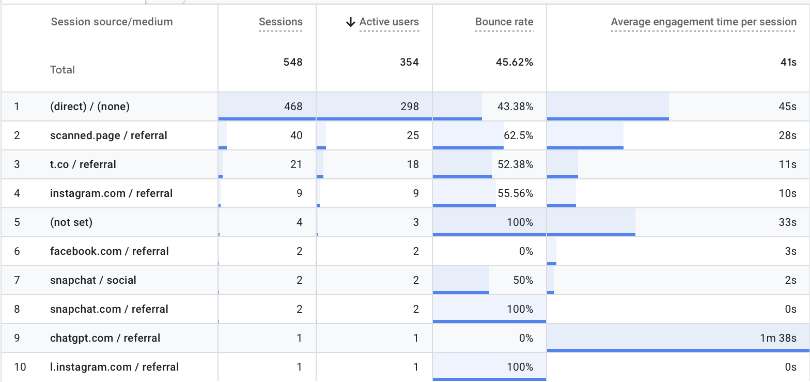

Analysis and Interpretation:
Top-performing channels:
- Direct traffic is the strongest channel, bringing 468 sessions with 298 active users and a 45s average engagement time, indicating a loyal and returning user base.
- scanned.page / referral ranks second with 40 sessions, suggesting that physical QR code sharing — likely on campus — is an active discovery method for StudyCalc.
- Twitter/X (t.co / referral) brought 21 sessions with 18 active users, making it the most effective social channel in driving actual visits to the site.
Low-performing channels:
- These channels bring either few visitors, low engagement, or both.
- Instagram and Facebook referrals show bounce rates above 55% and engagement times under 10 seconds, indicating that social content is not effectively converting curiosity into real usage.
- Snapchat referrals (both social and direct) contributed only 4 sessions combined with 0s engagement, making it the weakest social channel.
- (not set) sources show a 100% bounce rate, representing untracked or broken referral links that should be investigated and fixed.

Final Insights
- The platform attracted 351 active users and 542 sessions in its first 28 days, demonstrating strong initial adoption for a newly launched academic tool.
- Mobile users represent 88.43% of all visitors, confirming that mobile-first design is essential for this platform's target audience.
- Direct traffic (85.06%) was the dominant acquisition channel, driven by peer-to-peer sharing among university students via WhatsApp and social media.
- The GPA Calculator and Study Schedule tools attracted the most users among the academic tools, validating these as the platform's core value propositions.
- The spike in traffic around May 19–21 demonstrates that direct outreach campaigns to university students are highly effective for driving platform visits.

Suggested Next Actions

Step 1: Improve Mobile Experience
Since 88.43% of users access via mobile, prioritize mobile UI optimization. Address any mobile-specific layout issues and ensure all interactive tools function smoothly on small screens.

Step 2: Encourage Repeat Visits and Account Creation
With 351new users but relatively low login page views, focus on converting one-time visitors into registered users who return regularly. Implement email reminders, push notifications, or streak-based incentives through the Dashboard gamification system.

Step 3: Expand Organic Discovery Channels
The current low organic search traffic suggests an opportunity to improve SEO. Add relevant meta tags, descriptive page titles, and structured content to help students discover StudyCalc through Google searches for GPA calculators and study tools.

StudyCalc – Smart Academic Platform | Data Science Department, Umm Al-Qura University

