**To Supply Leftover Food to Poor**

**College Name: Kumaraguru College of Liberal Arts and Science**

**College code: BRUAX**

**Team ID:** NM2025TMID25577

**Team Size:** 4

**Team Leader:** JANA SRI G

Email ID: janasri.23bds@kclas.ac.in

**Team member:** JANANI J M

Email ID: jananijoghee@gmail.com

**Team member:** AGSHATHA A

Email ID: agshatha.23bds@kclas.ac.in

**Team member:** RATHISH S

Email ID: rathish.23bds@kclas.ac.in

**Introduction:**

Every day, large amounts of edible food go to waste while many poor people struggle with hunger. This project focuses on collecting surplus food from events, restaurants, and households. The aim is to supply this leftover food to the needy, reducing waste and feeding the hungry.

Salesforce developer account creation:

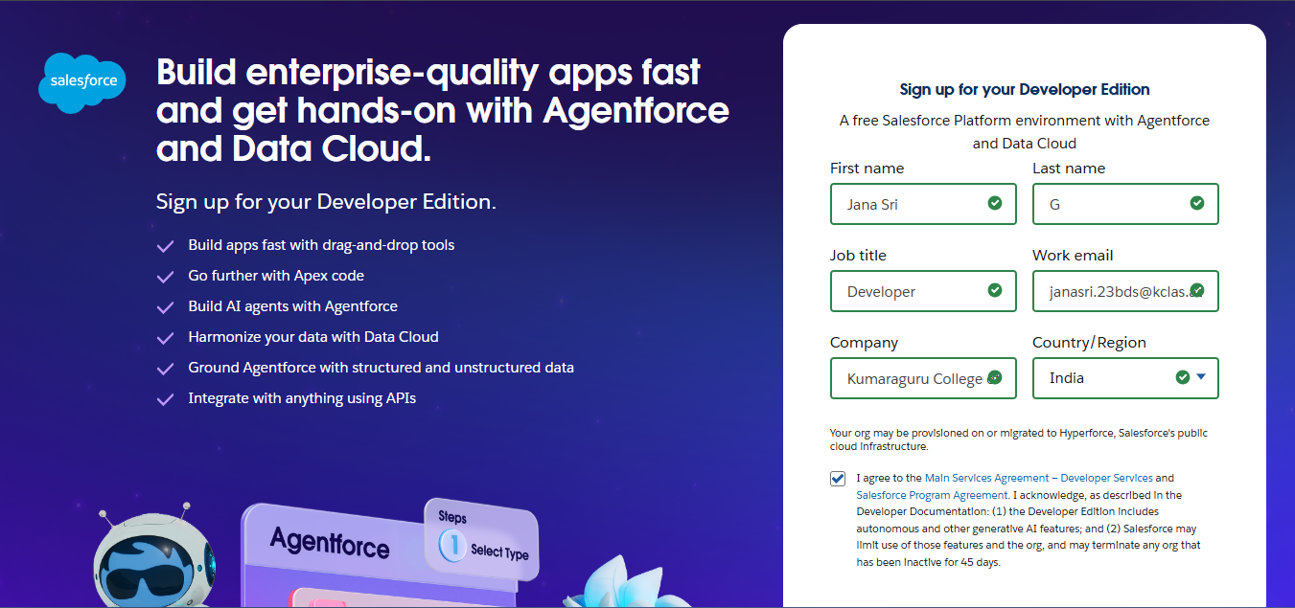

Object:

* Drop-off point:

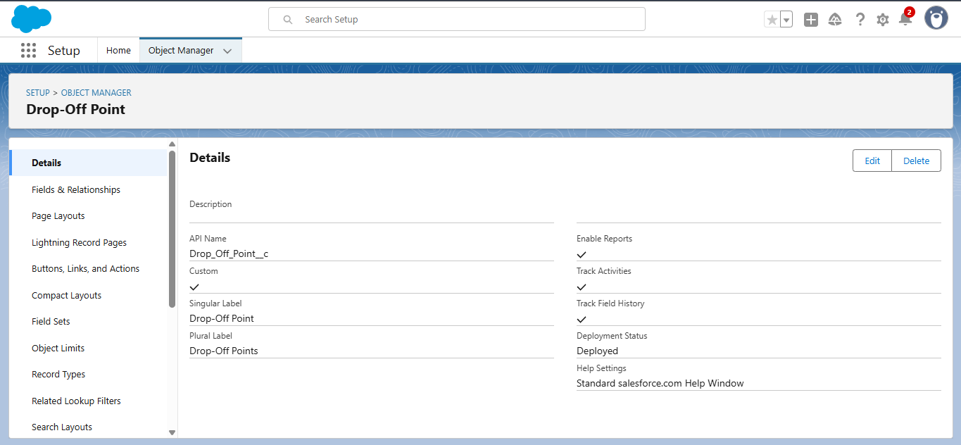

* Execution details:

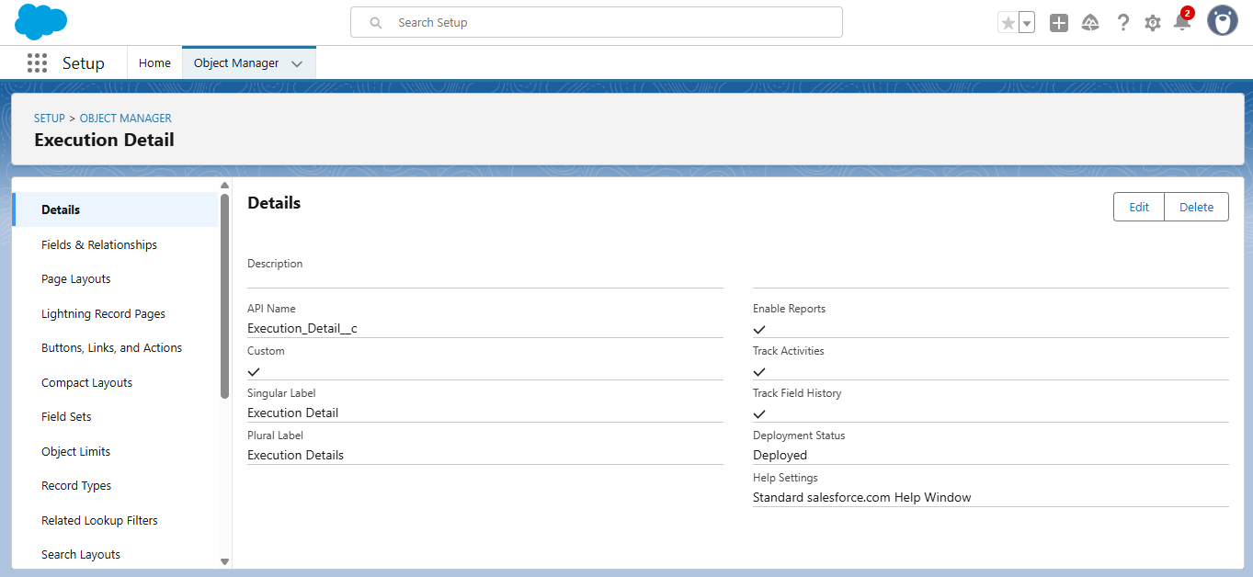

* Task:

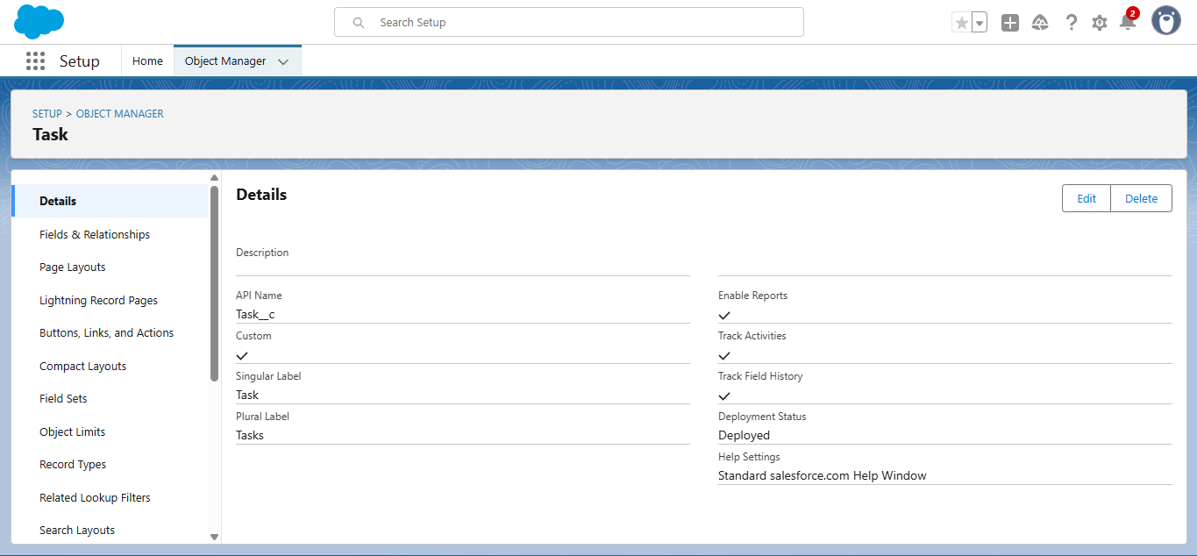

* Venue:

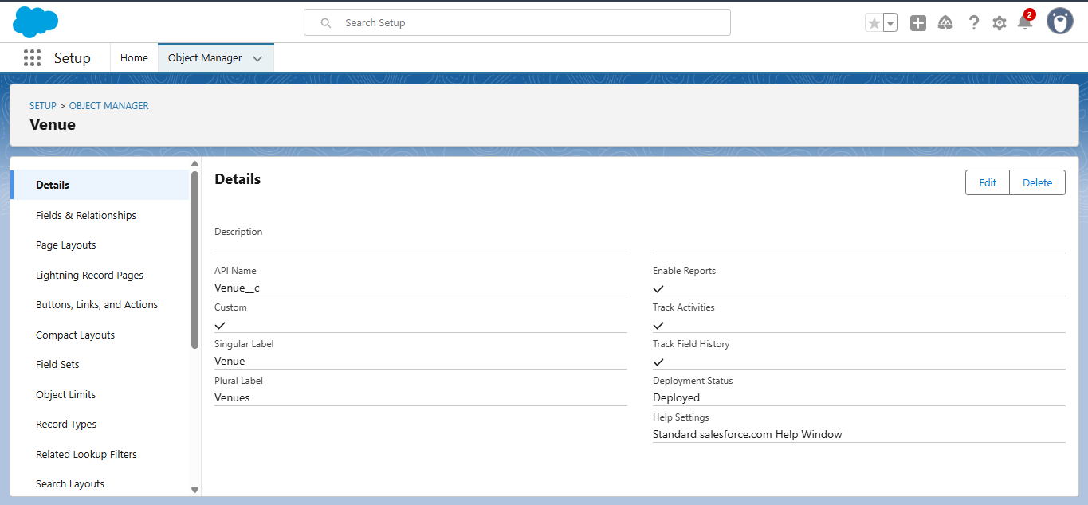

* Volunteer:

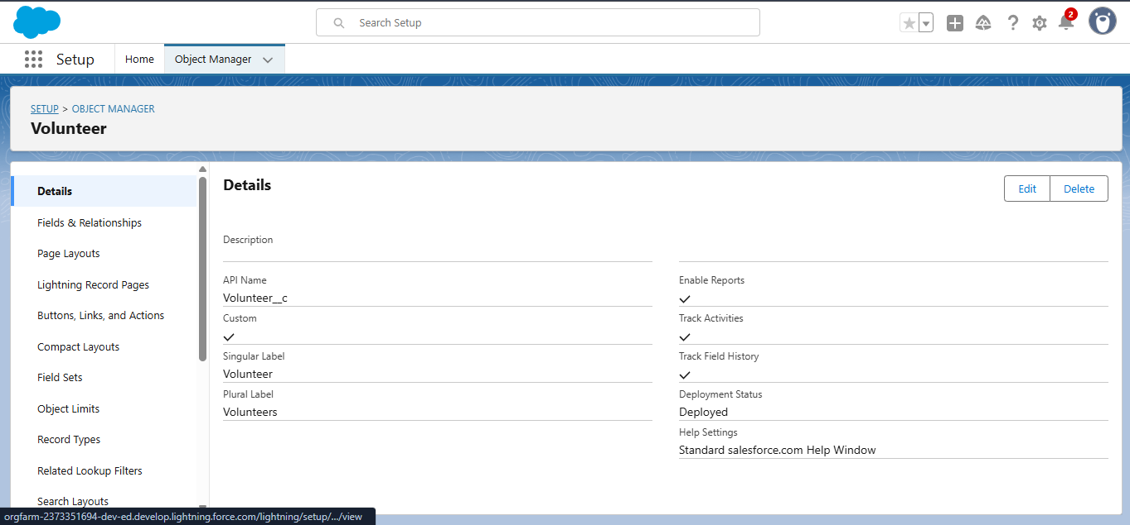

Tabs:

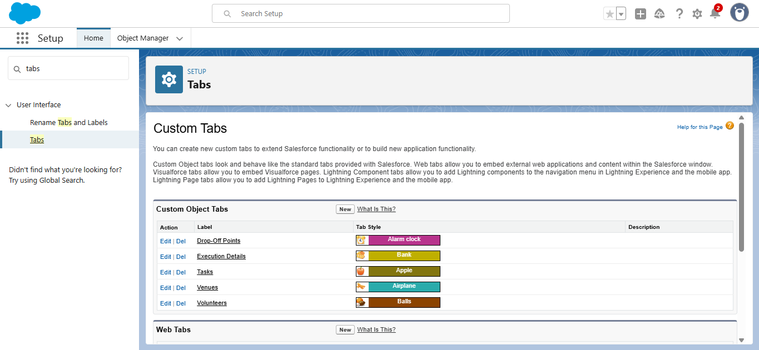

Fields:

* Drop-off point:

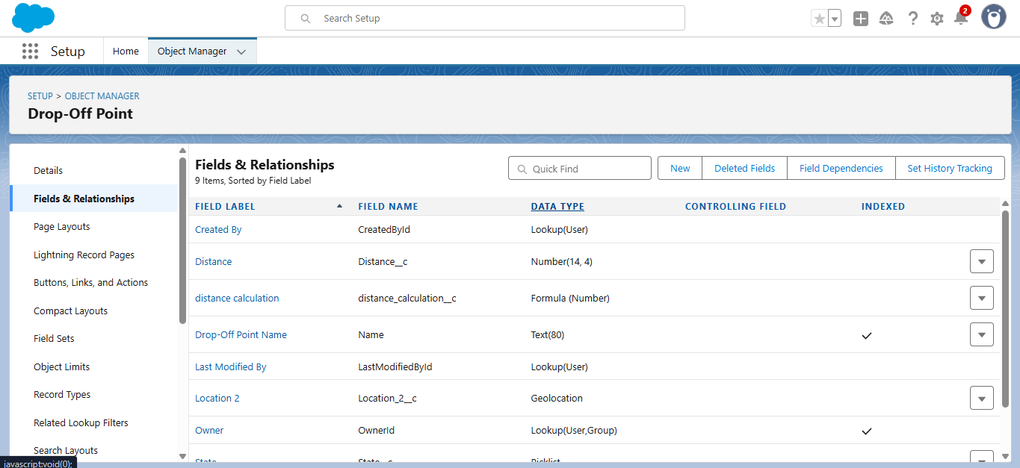

* Execution details:

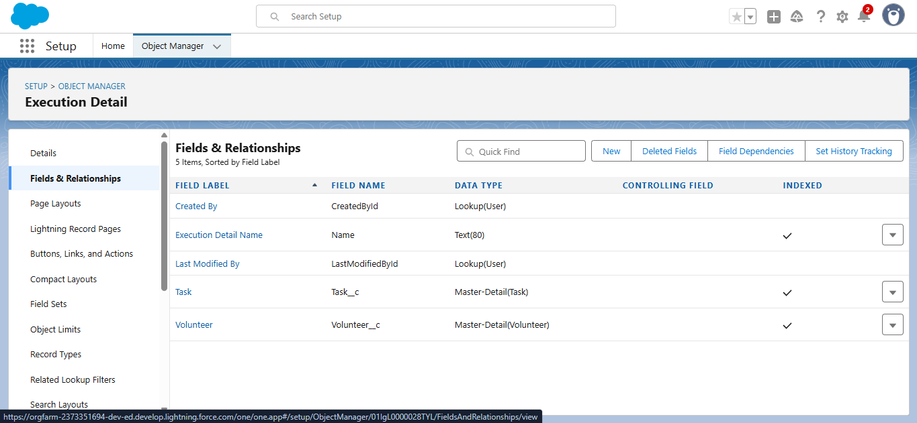

* Task:

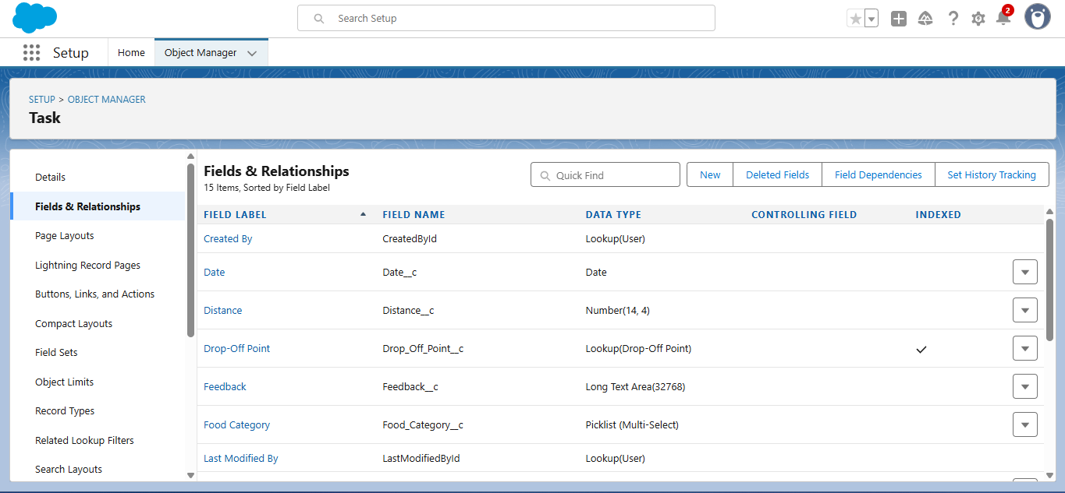

* Venue:

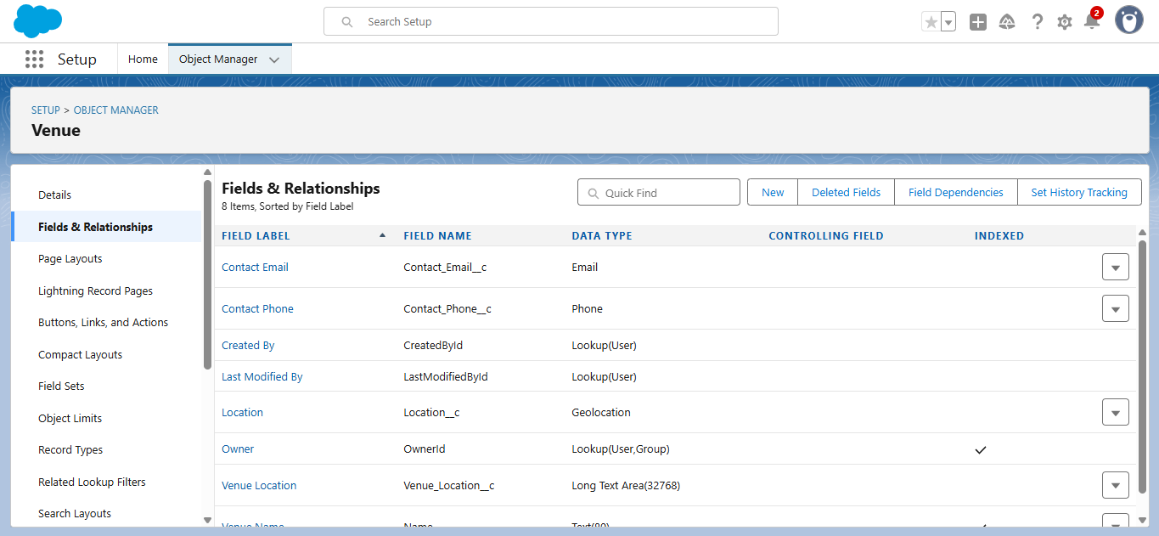

* Volunteer:

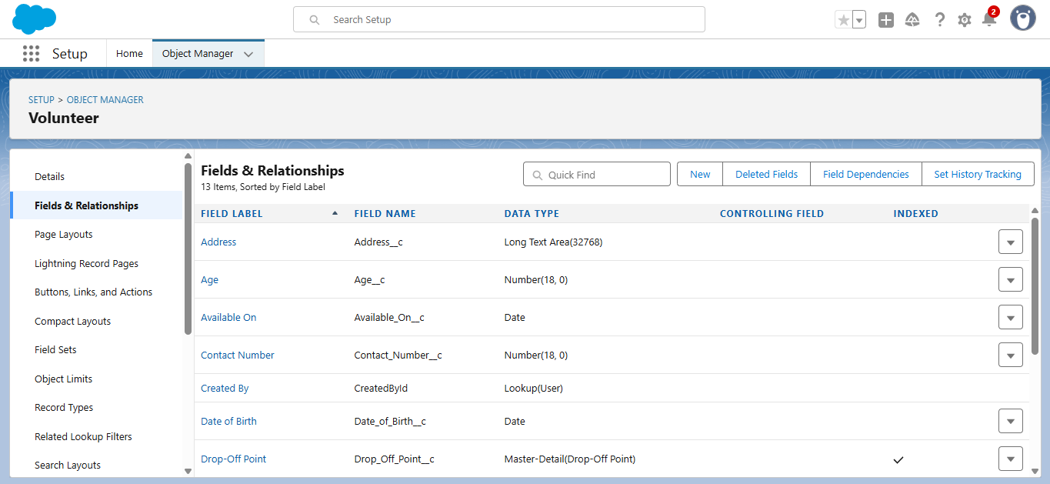

Flows:

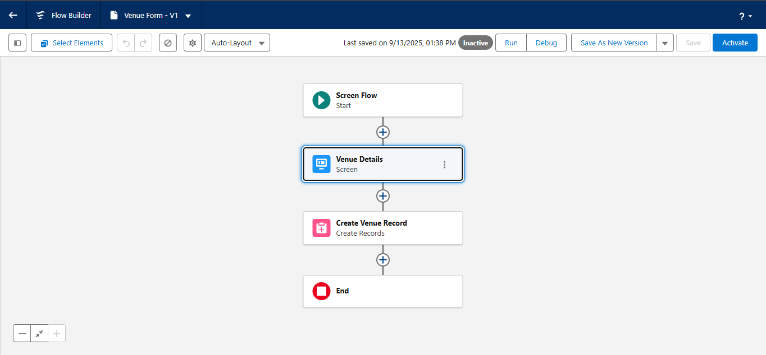

Creation of users:

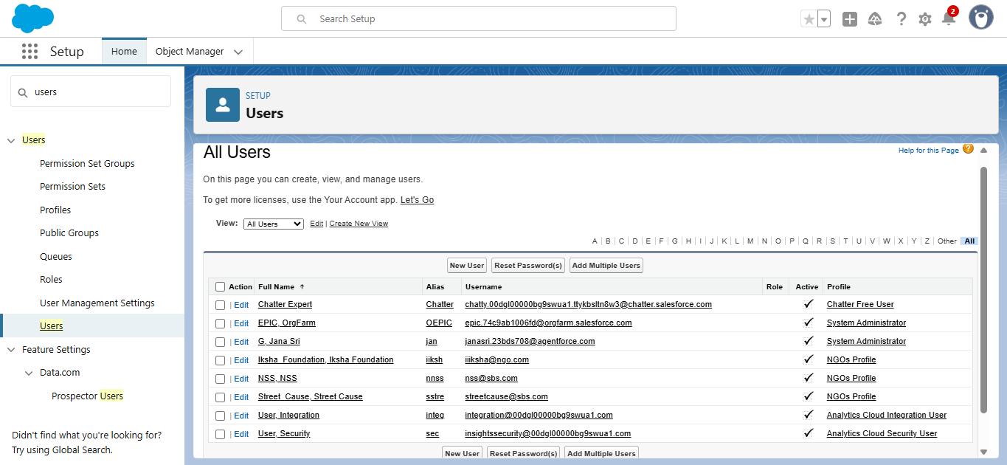

Public Groups:

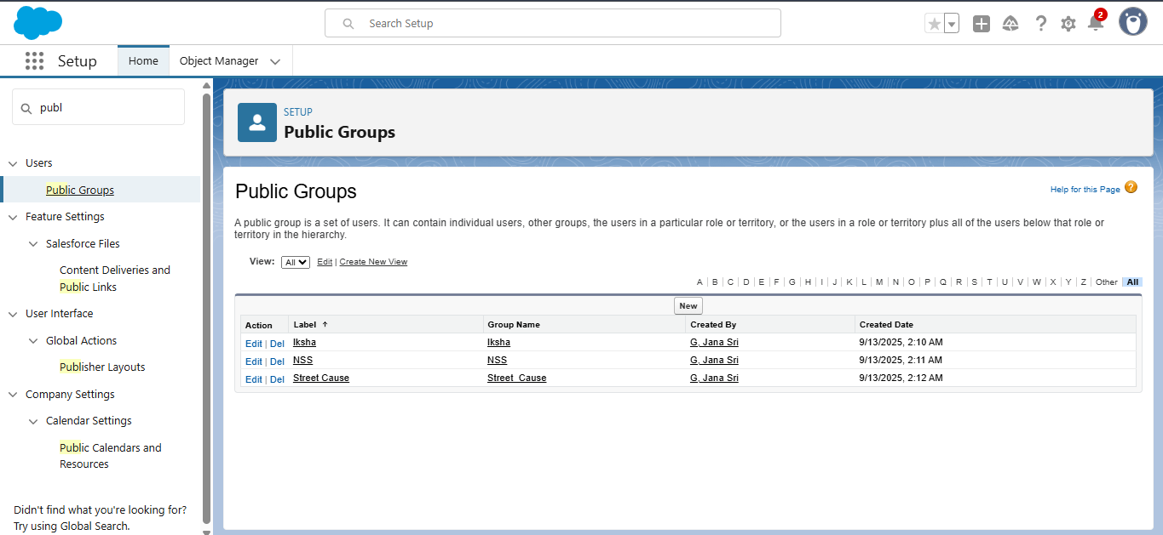

Reports:

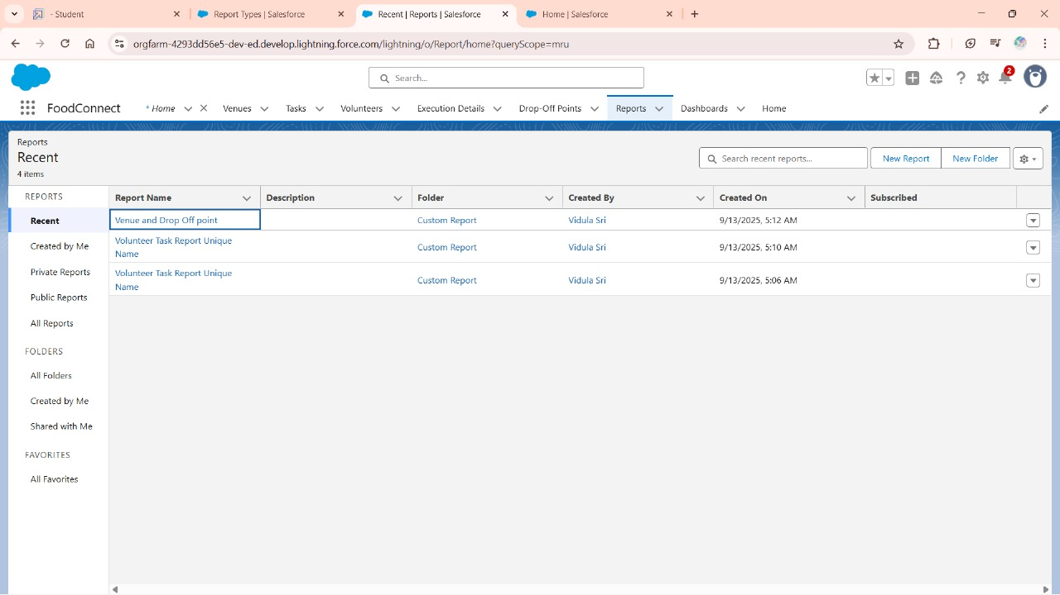

Report Types:

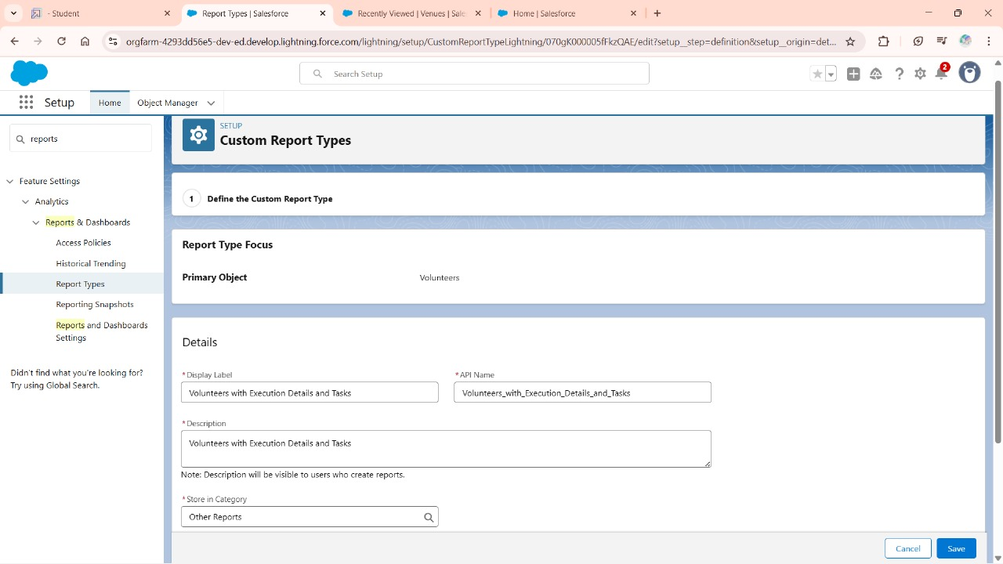

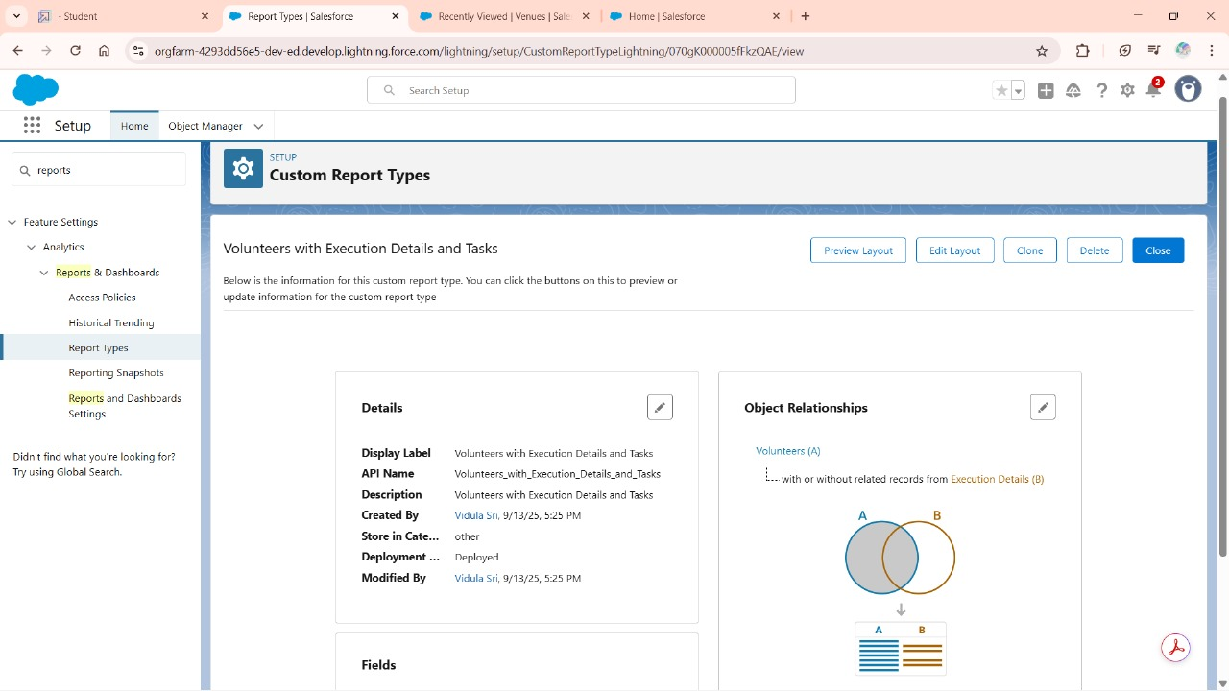

Dash boards:

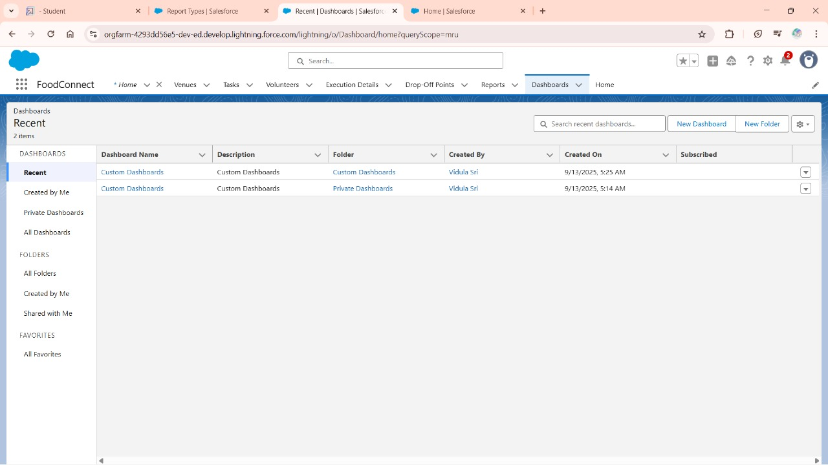

Home page:

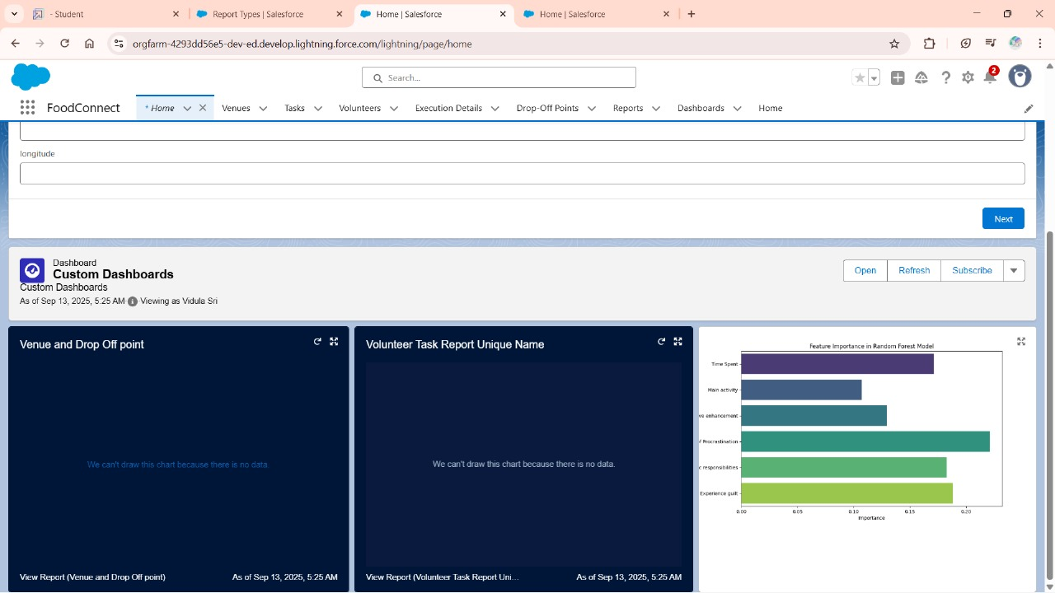

**Conclusion:**

This project helps reduce the gap between food wastage and hunger by redirecting surplus food to the needy. It ensures that edible leftovers from various sources are collected and distributed efficiently.

By minimizing waste, it contributes to both social welfare and environmental sustainability. The initiative builds a culture of sharing, compassion, and responsibility in society.

Ultimately, it creates a positive impact by feeding the poor and promoting a hunger-free community.