Laptop Request Process
Project Documentation
Date: June 18, 2026
Platform: ServiceNow

MILESTONE 1: Project Overview & Scoped Application
Project Overview
The Laptop Request Process is a ServiceNow-based application that enables employees to request laptops for official use through a structured, automated workflow. The system manages the full lifecycle of a laptop request — from submission to approval, assignment, and notification — ensuring transparency and efficiency.

Objective
- Allow employees to raise laptop requests through a Service Catalog item.
- Route requests through a structured approval workflow.
- Notify relevant stakeholders at every stage.
- Maintain records of all requests and assignments.

Scope
This project covers the following ServiceNow components:
- Custom Tables for storing request, approval, assignment, and catalog data.
- Role-based Access Control (ACL) for data security.
- Service Catalog Item with variables for user input.
- Flow Designer for automated approval and notification.
- Business Rules for backend logic.
- UI Policies and UI Policy Actions for dynamic form behavior.
- Email Notifications at each stage of the process.
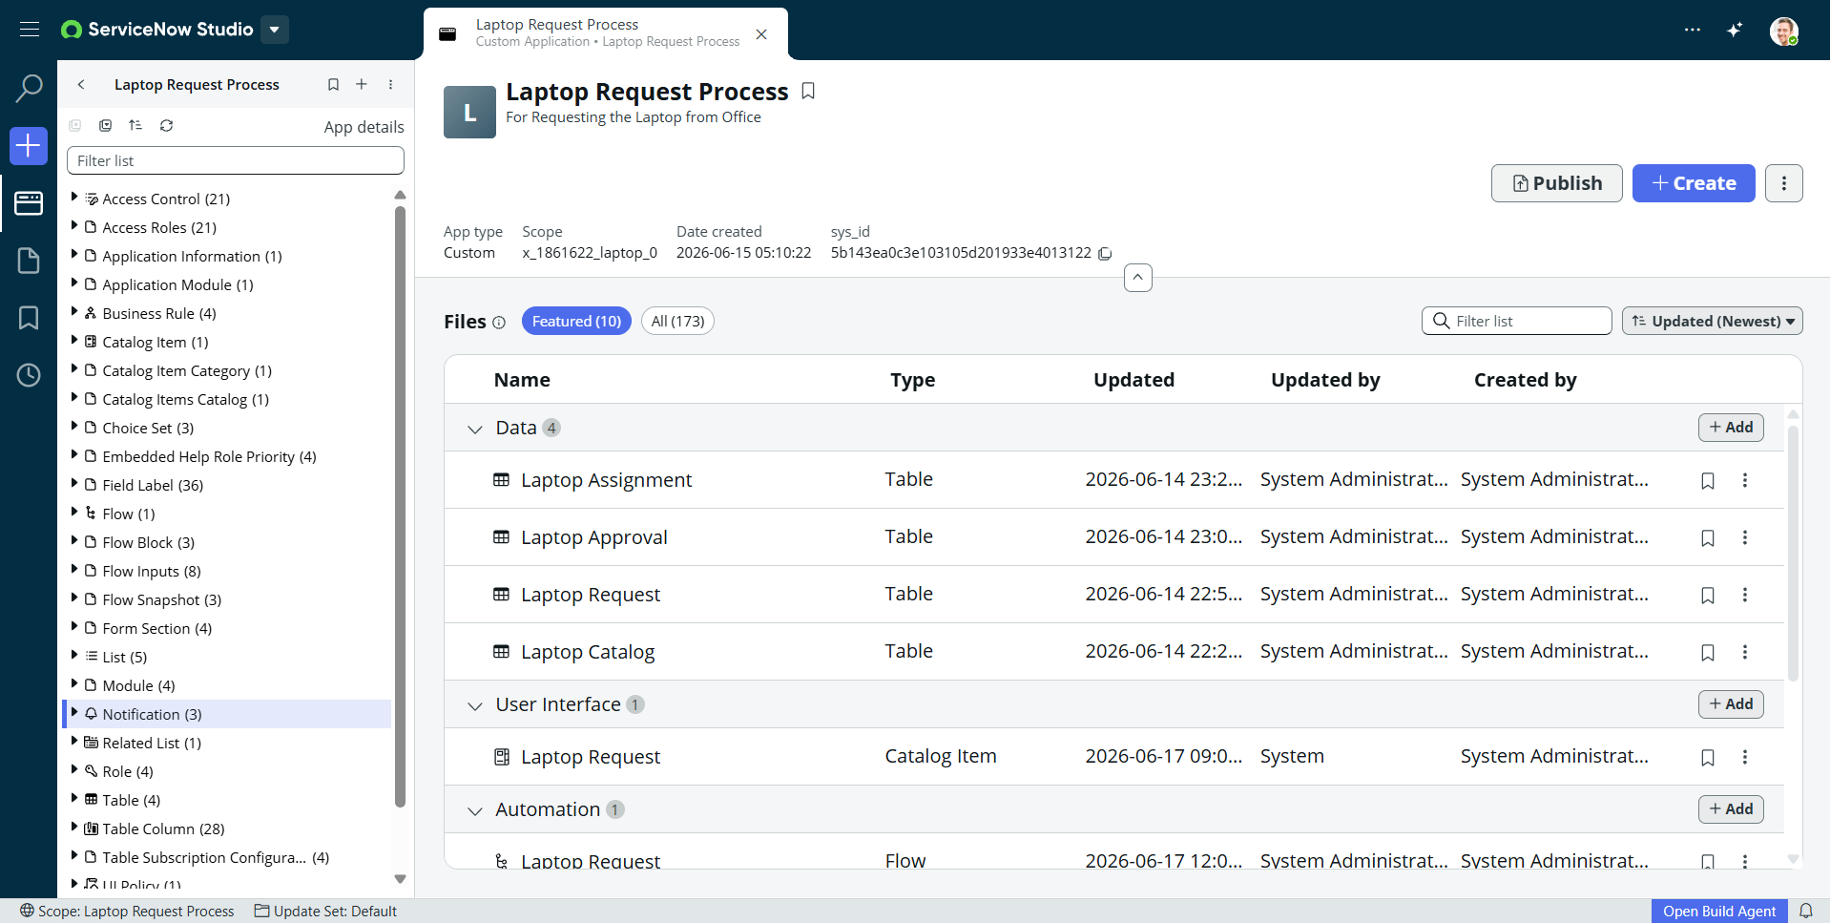

MILESTONE 2: Tables , Roles & Access

Tables Created
Four custom tables were created for this application:
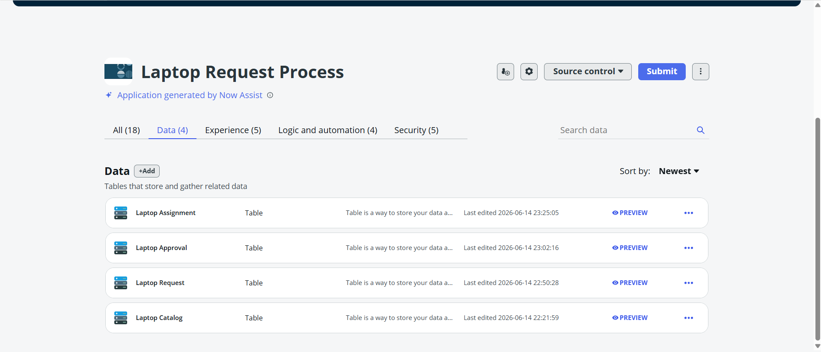

Roles & Access
Four custom roles were created to manage access control:
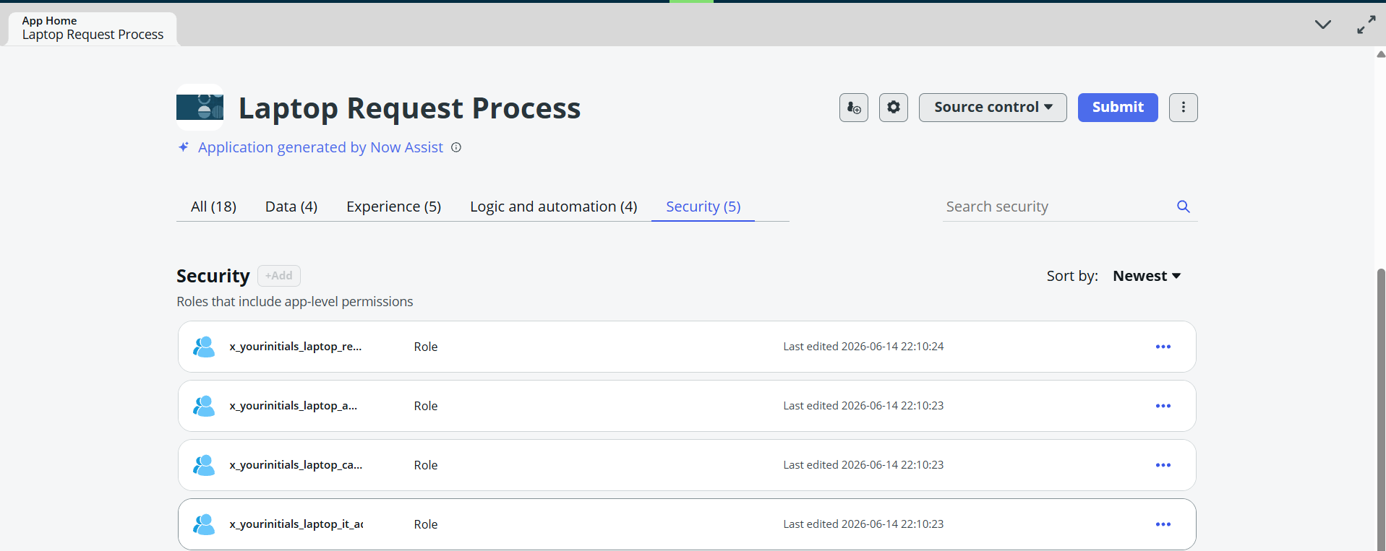

MILESTONE 3: Access Control List (ACL) & Catalog

Access Control List (ACL)
ACLs were configured to ensure each role can only access the data relevant to their function. This maintains data security and prevents unauthorized access.
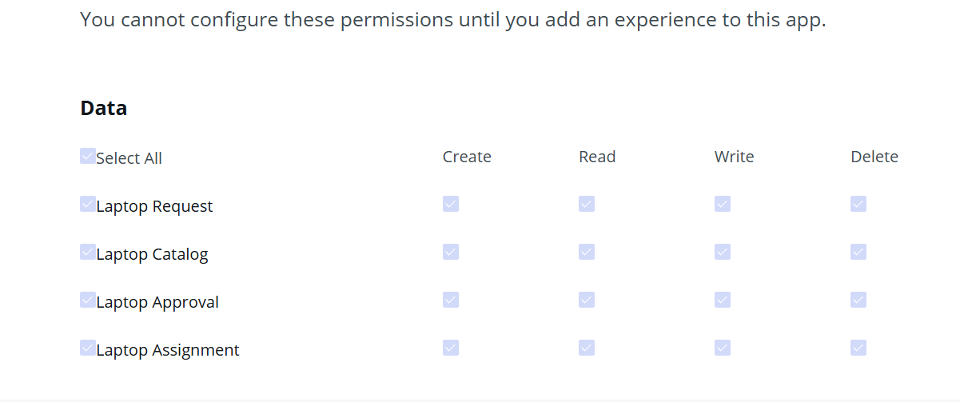
Service Catalog Item
A Catalog Item named "Laptop Request" was created under the Service Catalog. Employees can access this item from the Service Portal to submit their requests.

Catalog Item Details
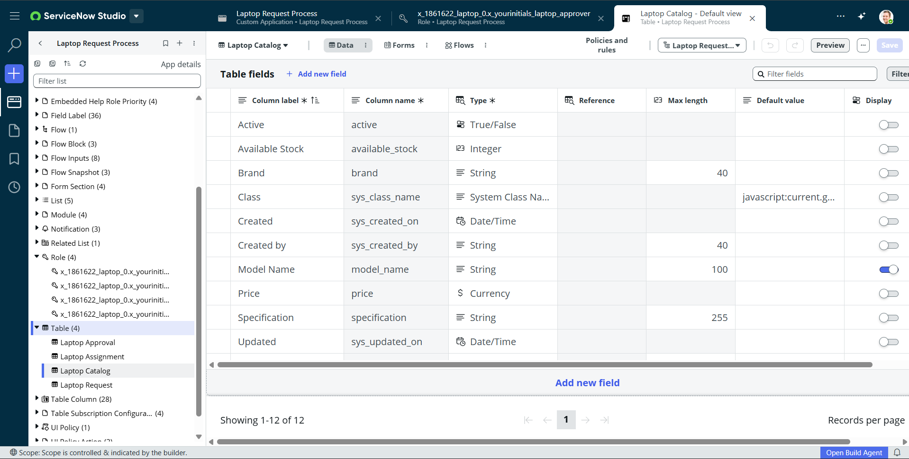

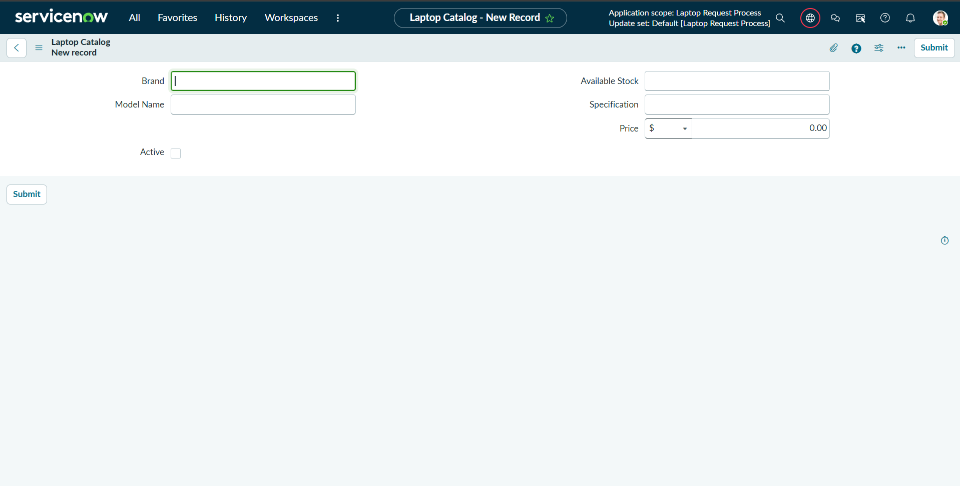

MILESTONE 4: Flow Designer & Business Rules

Flow Designer (Approval Workflow)
A Flow Designer flow was created to automate the laptop request approval process. The flow is triggered when a catalog item is submitted and handles approvals and notifications automatically.

Flow Structure
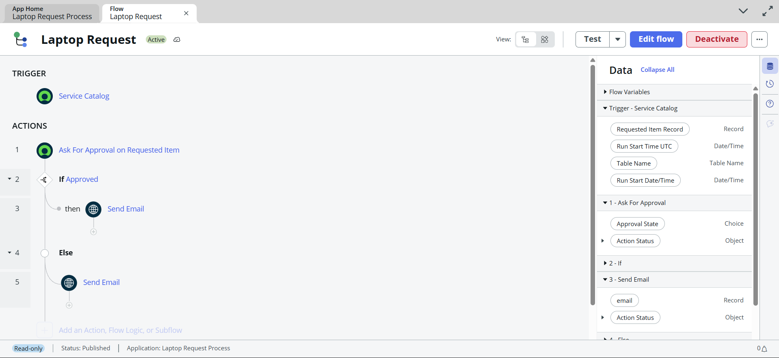

Flow Diagram
Employee submits Catalog Request → Approval email sent to Manager → Manager Approves or Rejects → Approval/Rejection email sent to Employee

Business Rules
Business rules were implemented to handle backend automation and data validation. And I Add four Business rule
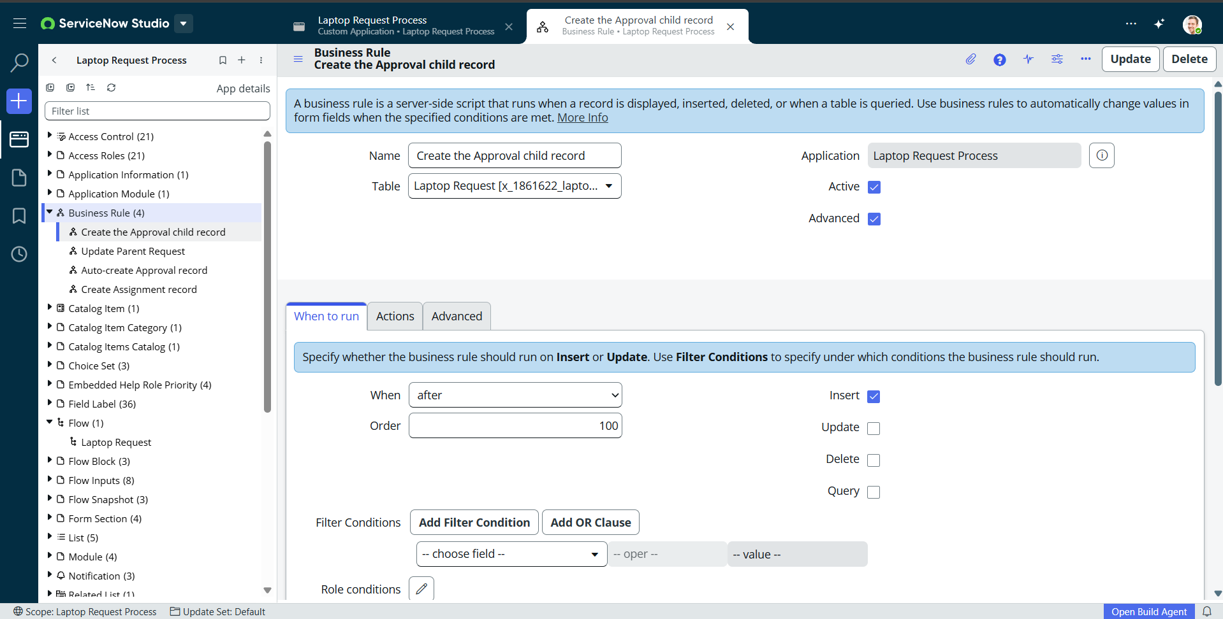

MILESTONE 5: Notification & UI Policies & Action

Notifications
Email notifications were configured to keep all stakeholders informed at every stage. These are the three notifications
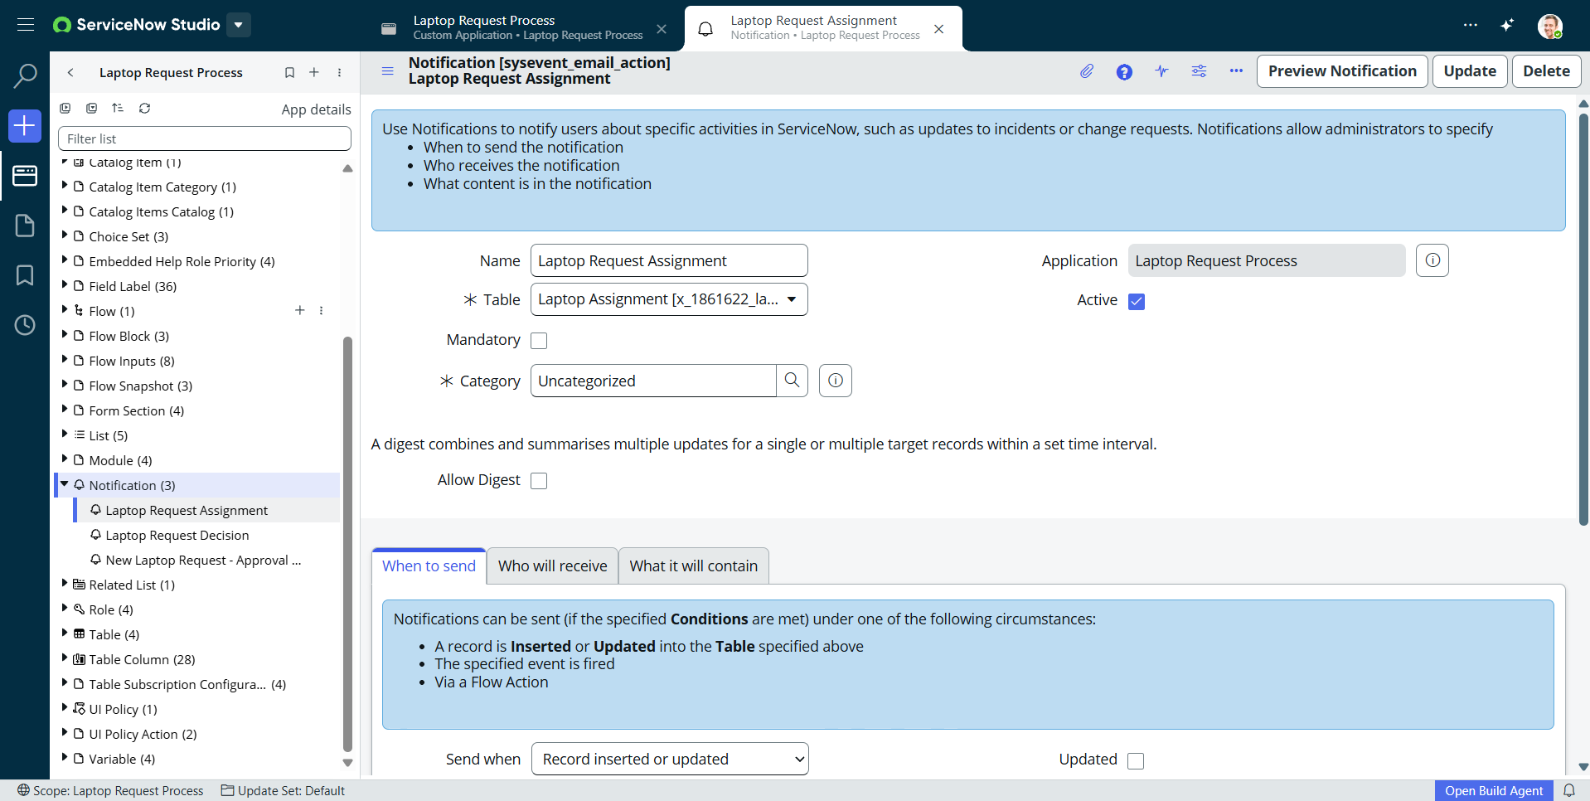

UI Policies & UI Policy Actions
UI Policies were added to control the dynamic behavior of forms based on user input or role.
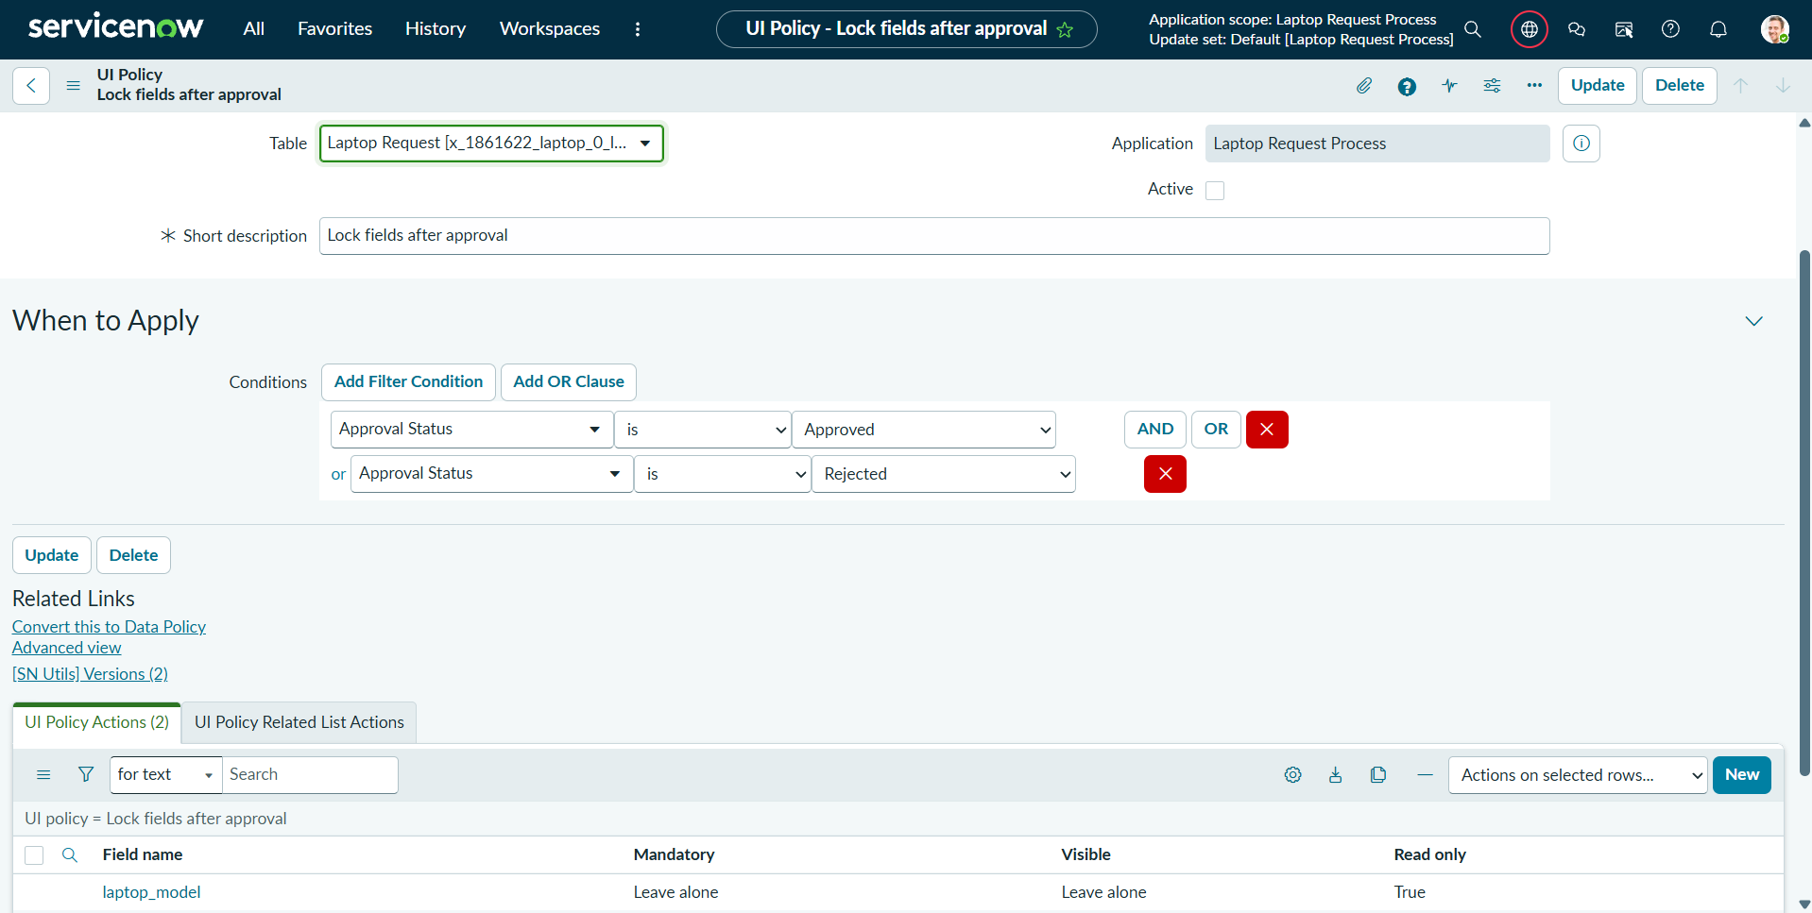

Testing
The following testing steps were performed to validate the application:
STEP 1: Change the required Impersonation
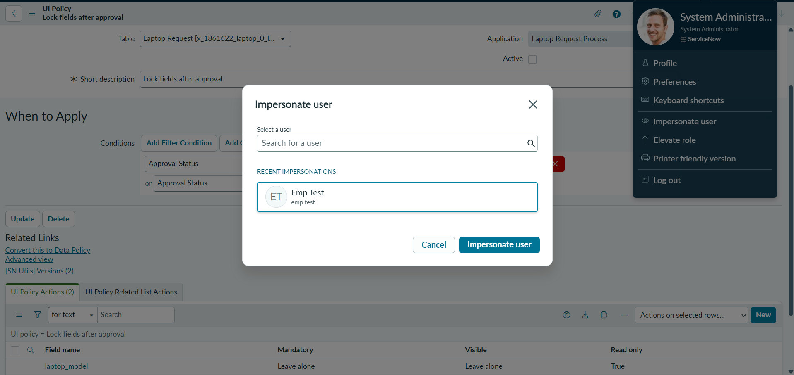
STEP 2: Navigate > All > Laptop Request Process > My Request
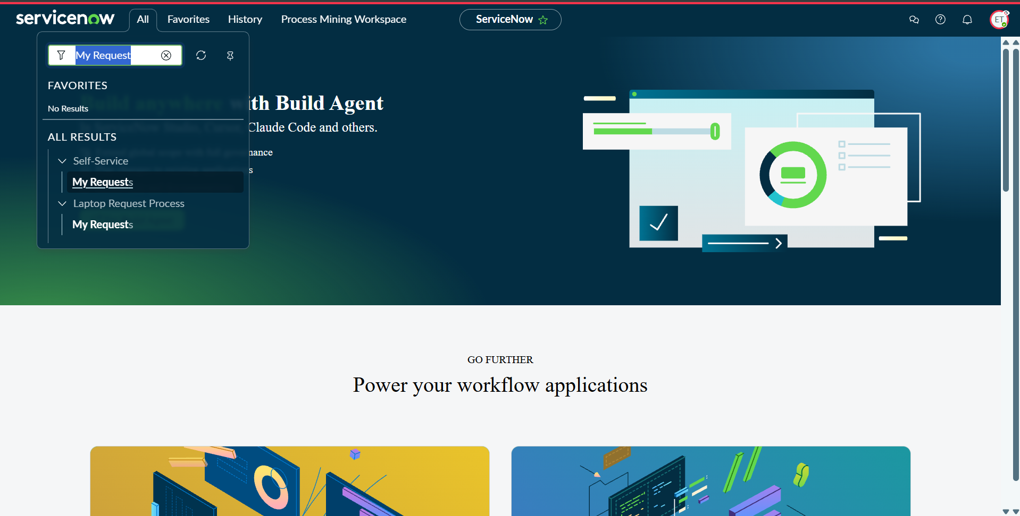

STEP 2: Click > New
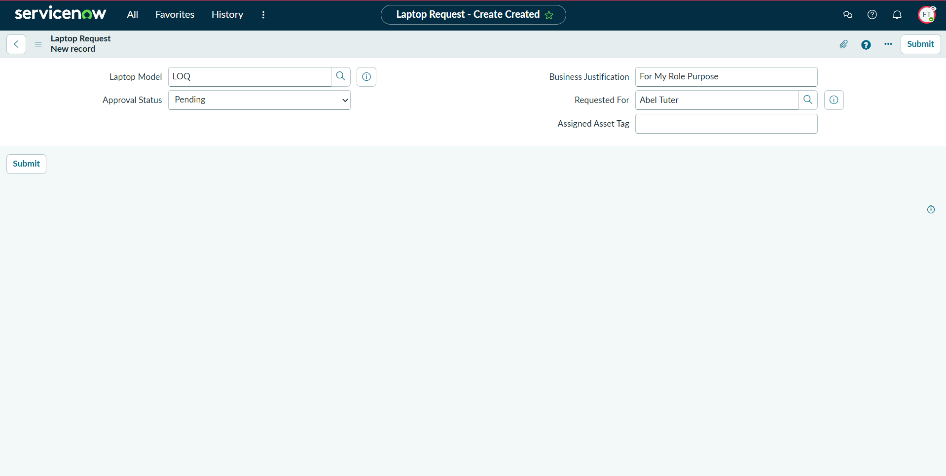
Click – Submit
Another way to make request:
step 1 :
Navigate > all > Self service > Service Catalog > laptop request
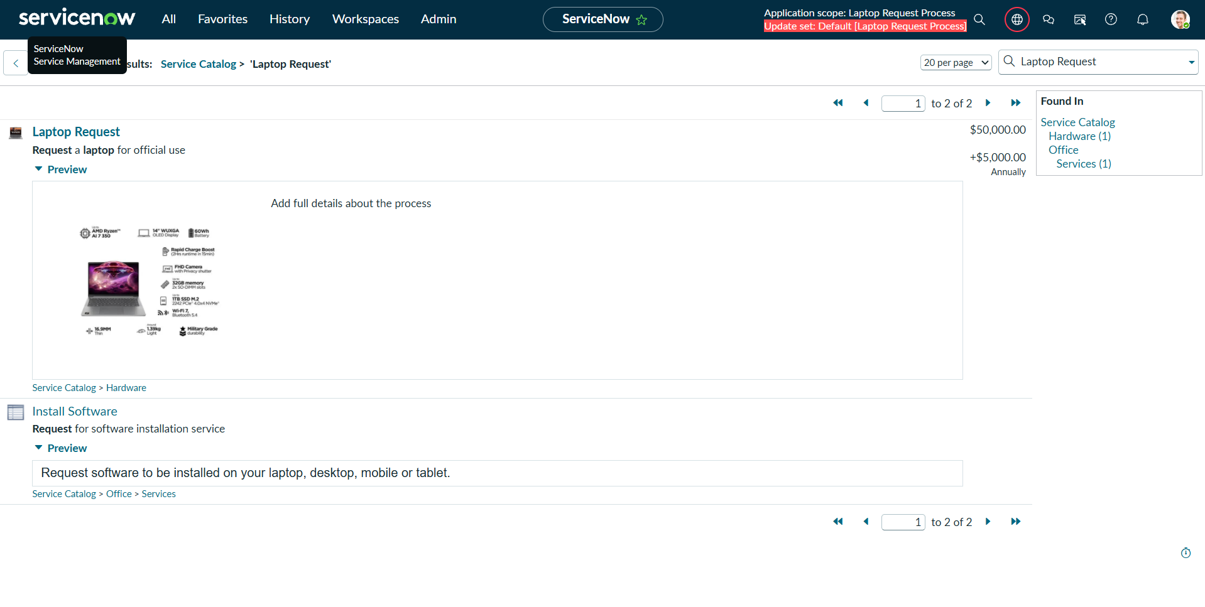

Step 2:
Fill the detail then you can order the laptop
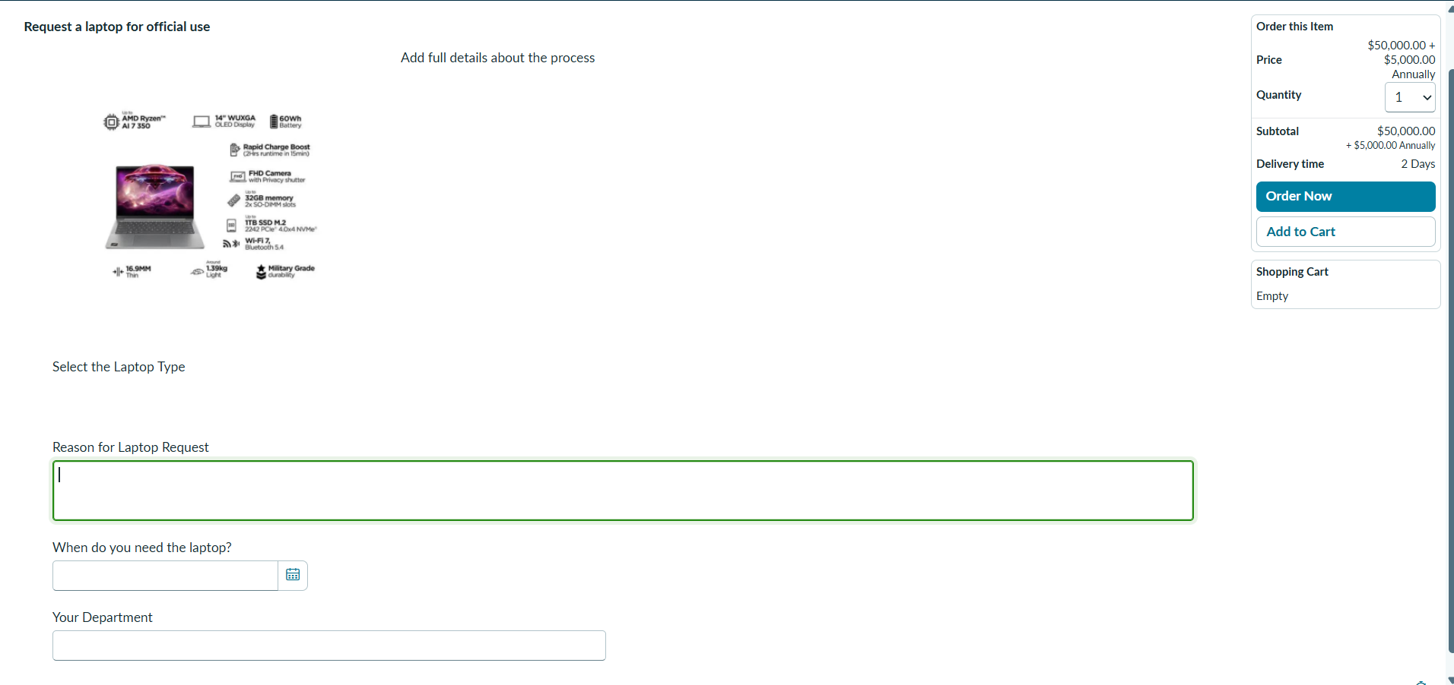

Future Enhancements
The following features can be added to improve the application further:
- Multi-Level Approval: Add Manager → IT Head → Finance approval chain.
- SLA Management: Define and track SLAs for each approval stage.
- Asset & CMDB Integration: Auto-create asset records after approval.
- Eligibility Check: Validate if employee already has an assigned laptop.
- Dashboard & Reports: IT Admin dashboard with request analytics.
- Return & Replacement Flow: Handle laptop return or replacement requests.

Conclusion
The Laptop Request Process application was successfully developed on the ServiceNow platform. It provides a structured and automated way for employees to request laptops, with proper role-based access control, approval workflows, and email notifications. The application is ready for testing and deployment, with a clear roadmap for future enhancements.

