**Data Model Diagram:**

Problem Statement:

Based on some surfing on Interphase website, I tried to imagine the backend part of the platform where we track the progress of MSMES along the journey.

We have a group of MSMES and a group of consultants.

One MSME can be helped by one or more consultant.

One consultant can help one or more MSME.

One MSME has a list of products (empty if it’s a service based business)

Every MSME will have a list of monthly records where we can track progress.

Before beginning any consulting process, we keep record of the expected coaching hours required to meet the company's objectives, starting from the beginning stage.

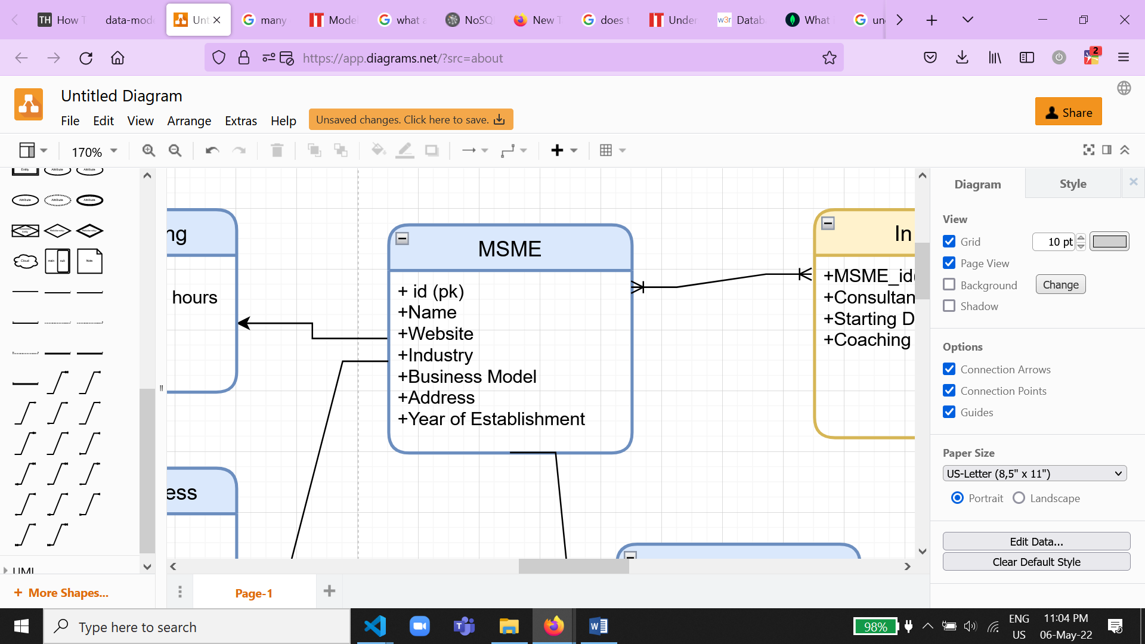The Entities:

1. MSME:
2. Monthly Progress:

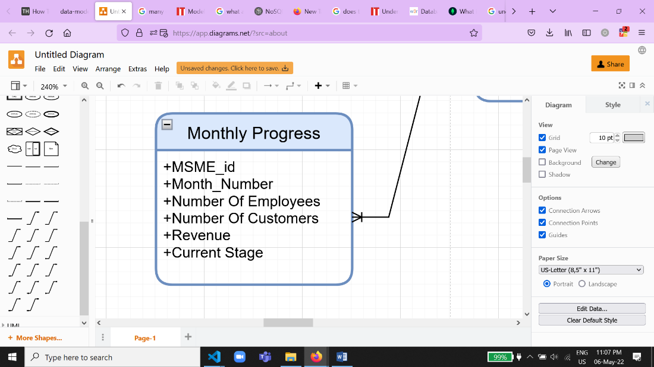

1. 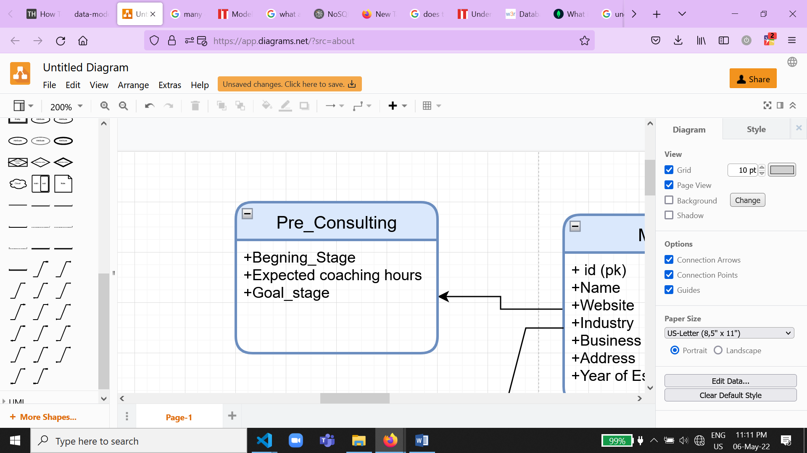Pre_Consulting:
2. 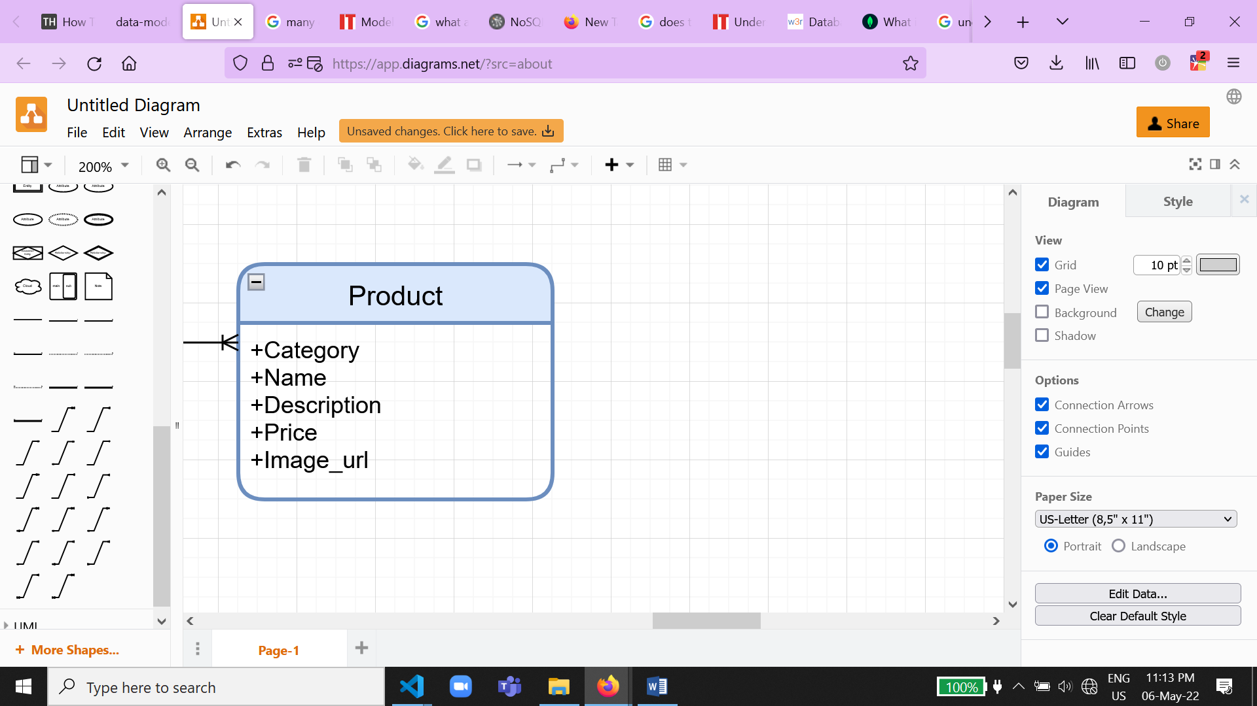Product:
3. 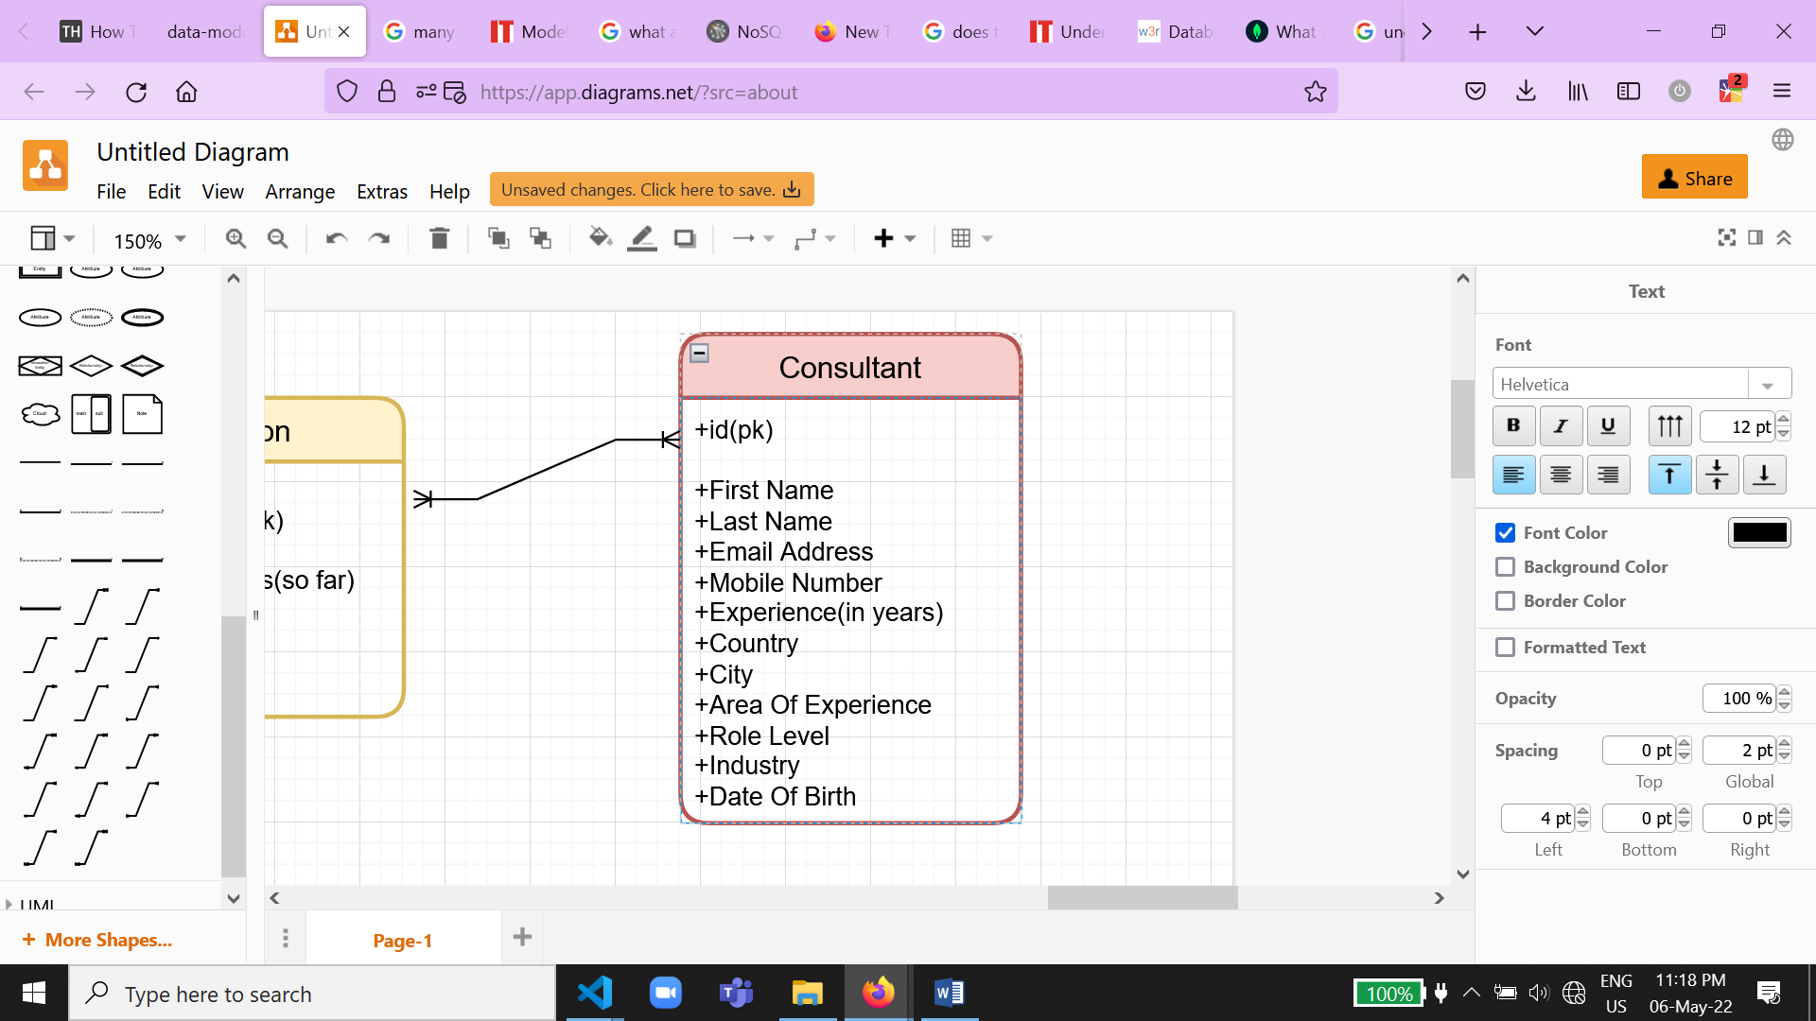Consultant:
4. In Action :

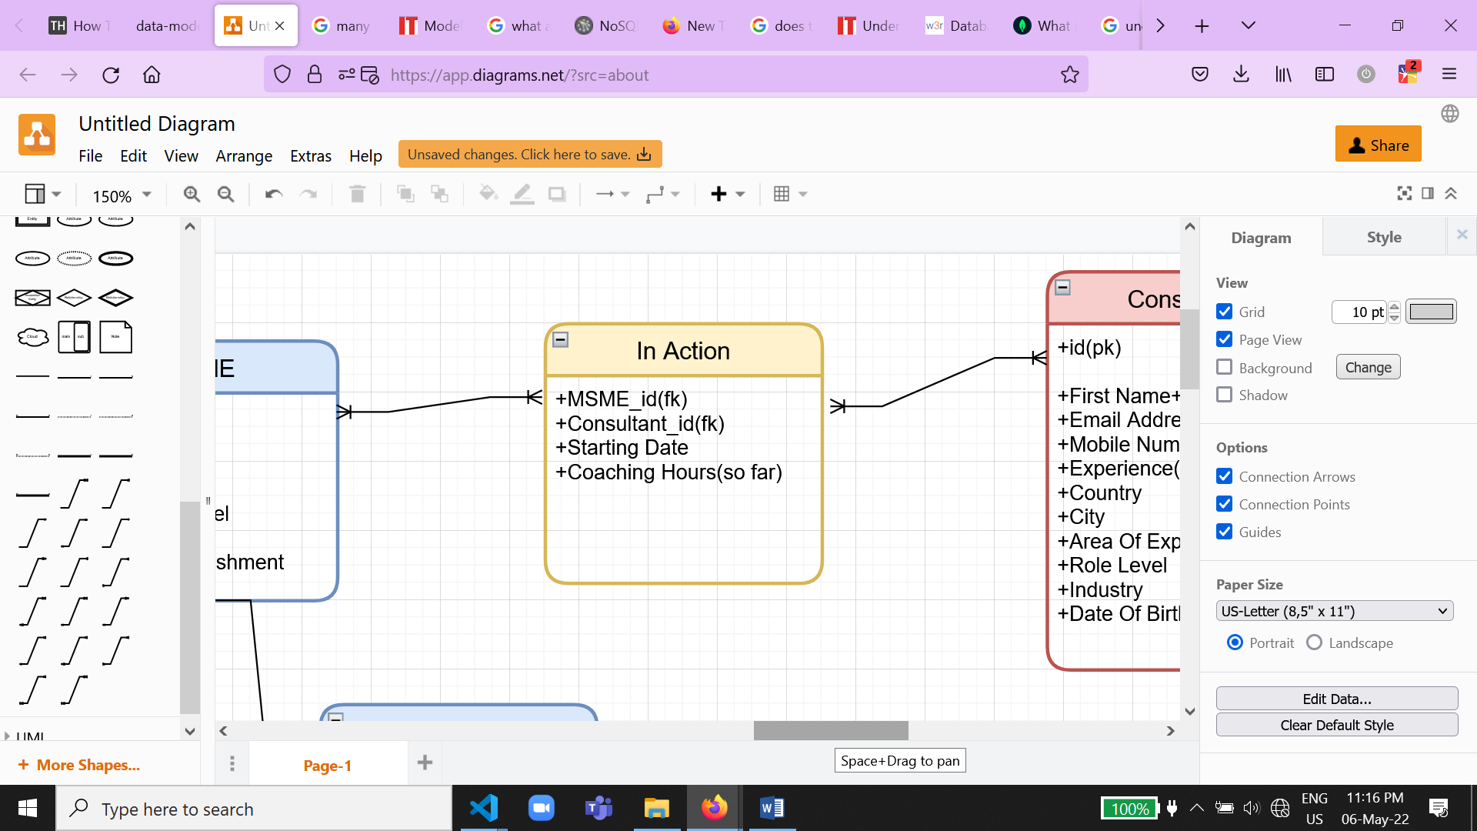

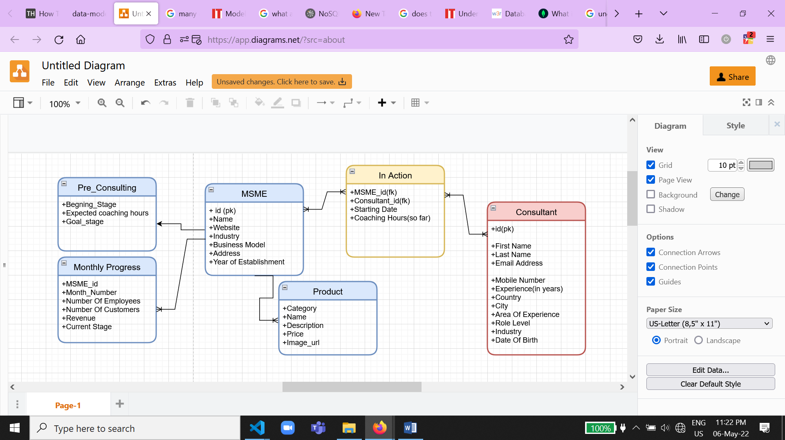Diagram:

Relationships:

MSME and Consultant: Many to Many

MSME and Pre_Consulting: One to One

MSME AND Product: One to Many

MSME and Monthly Progress: One to Many

Some possible queries:

1. Writing Data: adding a new MSME, adding a consultant for existing MSME, adding new product, changing business model…
2. Reading Data: being able to know how much we’ve reached our goal based on monthly progress, knowing what type of businesses is every consultant good at (based on reached goals), find out how closely our coaching hours expectations matched reality…..