# CONTROL STRUCTURES

## SET SERVEROUTPUT ON;

BEGIN

EXECUTE IMMEDIATE 'DROP TABLE loans'; EXECUTE IMMEDIATE 'DROP TABLE customers'; EXCEPTION

## WHEN OTHERS THEN NULL; END;

CREATE TABLE customers (

customer_id NUMBER PRIMARY KEY, name VARCHAR2(100),

age NUMBER,

balance NUMBER(10,2), loan_interest_rate NUMBER(5,2), IsVIP VARCHAR2(5)

);

CREATE TABLE loans (

loan_id NUMBER PRIMARY KEY,

customer_id NUMBER, due_date DATE,

FOREIGN KEY (customer_id) REFERENCES customers(customer_id)

);

INSERT INTO customers VALUES (101, 'John', 65, 15000, 7.5, 'FALSE');

INSERT INTO customers VALUES (102, 'Alice', 45, 8000, 8.0, 'FALSE');

INSERT INTO customers VALUES (103, 'Bob', 70, 11000, 6.5, 'FALSE');

INSERT INTO customers VALUES (104, 'Priya', 30, 5000, 9.0, 'FALSE');

INSERT INTO loans VALUES (201, 101, SYSDATE + 10); -- due in 10 days

INSERT INTO loans VALUES (202, 102, SYSDATE + 40); -- outside range INSERT INTO loans VALUES (203, 103, SYSDATE + 5); -- due soon

INSERT INTO loans VALUES (204, 104, SYSDATE + 29); -- near limit

## COMMIT;

BEGIN

-- Scenario 1: Apply 1% discount to loan interest rate for customers above 60 FOR rec1 IN (

SELECT customer_id, age, loan_interest_rate FROM customers

WHERE age > 60

## ) LOOP

UPDATE customers

SET loan_interest_rate = loan_interest_rate - 1 WHERE customer_id = rec1.customer_id;

DBMS_OUTPUT.PUT_LINE('Discount applied: Customer ID ' || rec1.customer_id || ', Age: ' || rec1.age ||

', New Interest Rate: ' || (rec1.loan_interest_rate - 1));

## END LOOP;

-- Scenario 2: Promote customers to VIP based on balance FOR rec2 IN (

SELECT customer_id, balance FROM customers

WHERE balance > 10000

## ) LOOP

UPDATE customers SET IsVIP = 'TRUE'

WHERE customer_id = rec2.customer_id;

DBMS_OUTPUT.PUT_LINE('VIP promoted: Customer ID ' || rec2.customer_id || ', Balance: ' || rec2.balance);

## END LOOP;

-- Scenario 3: Print loan due reminders within next 30 days FOR rec3 IN (

SELECT c.customer_id, c.name, l.loan_id, l.due_date FROM customers c

JOIN loans l ON c.customer_id = l.customer_id

WHERE l.due_date BETWEEN SYSDATE AND SYSDATE + 30

## ) LOOP

DBMS_OUTPUT.PUT_LINE('Reminder: Loan ID ' || rec3.loan_id || ' for Customer ' || rec3.name ||

' is due on ' || TO_CHAR(rec3.due_date, 'DD-MON-YYYY'));

## END LOOP;

COMMIT; END;

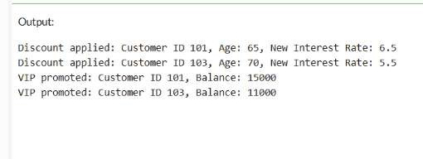

1. ***STORED PROCEDURES*** SET SERVEROUTPUT ON; BEGIN

EXECUTE IMMEDIATE 'DROP TABLE accounts'; EXECUTE IMMEDIATE 'DROP TABLE employees'; EXCEPTION

## WHEN OTHERS THEN NULL; END;

CREATE TABLE accounts (

account_id NUMBER PRIMARY KEY, account_type VARCHAR2(20), balance NUMBER(10,2)

);

CREATE TABLE employees (

employee_id NUMBER PRIMARY KEY, department_id NUMBER,

salary NUMBER(10,2)

);

INSERT INTO accounts VALUES (1001, 'SAVINGS', 10000); INSERT INTO accounts VALUES (1002, 'SAVINGS', 15000); INSERT INTO accounts VALUES (1003, 'CURRENT', 8000); INSERT INTO accounts VALUES (1004, 'SAVINGS', 5000);

INSERT INTO employees VALUES (201, 101, 30000);

INSERT INTO employees VALUES (202, 101, 28000);

INSERT INTO employees VALUES (203, 102, 35000);

## COMMIT;

-- Scenario 1: Process Monthly Interest

CREATE OR REPLACE PROCEDURE ProcessMonthlyInterest AS BEGIN

FOR acc IN (SELECT account_id, balance FROM accounts WHERE account_type = 'SAVINGS') LOOP UPDATE accounts

SET balance = balance + (acc.balance * 0.01) WHERE account_id = acc.account_id;

DBMS_OUTPUT.PUT_LINE('Interest applied to Account ID: ' || acc.account_id); END LOOP;

## COMMIT; END;

-- Scenario 2: Update Employee Bonus

CREATE OR REPLACE PROCEDURE UpdateEmployeeBonus ( p_dept_id IN NUMBER,

p_bonus_percent IN NUMBER

## ) AS BEGIN

FOR emp IN (SELECT employee_id, salary FROM employees WHERE department_id = p_dept_id) LOOP

UPDATE employees

SET salary = salary + (emp.salary * p_bonus_percent / 100) WHERE employee_id = emp.employee_id;

DBMS_OUTPUT.PUT_LINE('Bonus applied to Employee ID: ' || emp.employee_id); END LOOP;

## COMMIT; END;

-- Scenario 3: Transfer Funds Between Accounts CREATE OR REPLACE PROCEDURE TransferFunds (

p_from_acc IN NUMBER, p_to_acc IN NUMBER, p_amount IN NUMBER

## ) AS

v_balance NUMBER; BEGIN

-- Lock and check source balance SELECT balance INTO v_balance FROM accounts

WHERE account_id = p_from_acc FOR UPDATE;

IF v_balance < p_amount THEN

RAISE_APPLICATION_ERROR(-20001, 'Insufficient funds in source account.'); END IF;

-- Deduct from source UPDATE accounts

SET balance = balance - p_amount WHERE account_id = p_from_acc;

-- Add to destination UPDATE accounts

SET balance = balance + p_amount WHERE account_id = p_to_acc;

DBMS_OUTPUT.PUT_LINE('Transferred ₹' || p_amount || ' from Account ' || p_from_acc ||

' to Account ' || p_to_acc);

## COMMIT; END;

-- Procedure Calls & Output BEGIN

DBMS_OUTPUT.PUT_LINE('--- Running ProcessMonthlyInterest ---'); ProcessMonthlyInterest;

DBMS_OUTPUT.PUT_LINE('--- Running UpdateEmployeeBonus (Dept 101, 10%) ---'); UpdateEmployeeBonus(101, 10);

DBMS_OUTPUT.PUT_LINE('--- Running TransferFunds (₹2000 from 1002 to 1004) ---'); TransferFunds(1002, 1004, 2000);

END;

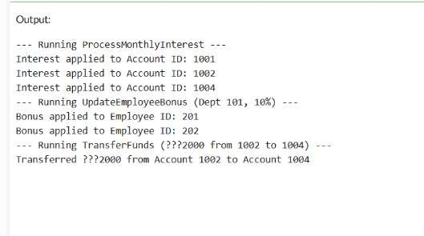

# SETTING UP JUNIT

class Calculator {

public int add(int a, int b) { return a + b;

}

}

public class Main {

public static void testAdd() {

Calculator calc = new Calculator();

if (calc.add(5, 3) != 8) {

System.out.println(" Test 1 Failed: 5 + 3 != 8");

} else {

System.out.println(" Test 1 Passed: 5 + 3 = 8");

}

if (calc.add(-2, 2) != 0) {

System.out.println(" Test 2 Failed: -2 + 2 != 0");

} else {

System.out.println(" Test 2 Passed: -2 + 2 = 0");

}

if (calc.add(0, 0) != 0) {

System.out.println(" Test 3 Failed: 0 + 0 != 0");

} else {

System.out.println(" Test 3 Passed: 0 + 0 = 0");

}

}

public static void main(String[] args) { System.out.println("Running Calculator Tests...\n"); testAdd();

}

}

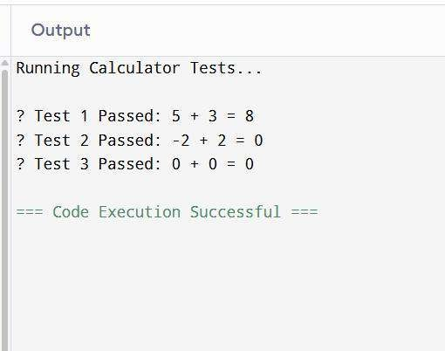

# ASSERTIONS IN JUNIT

public class Main {

public static void main(String[] args) {

System.out.println("Running simulated JUnit assertions...\n"); if (2 + 3 == 5) {

System.out.println(" assertEquals passed: 2 + 3 == 5");

} else {

System.out.println(" assertEquals failed: 2 + 3 != 5");

}

if (5 > 3) {

System.out.println(" assertTrue passed: 5 > 3");

} else {

System.out.println(" assertTrue failed: 5 is not greater than 3");

}

if (!(5 < 3)) {

System.out.println(" assertFalse passed: 5 < 3 is false");

} else {

System.out.println(" assertFalse failed: 5 < 3 is true");

}

Object obj1 = null; if (obj1 == null) {

System.out.println(" assertNull passed: object is null");

} else {

System.out.println(" assertNull failed: object is not null");

}

Object obj2 = new Object(); if (obj2 != null) {

System.out.println(" assertNotNull passed: object is not null");

} else {

System.out.println(" assertNotNull failed: object is null");

}

System.out.println("\n All simulated tests completed!");

}

}

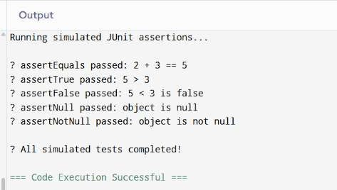

# AAA PATTERN

public class Main {

static class Calculator {

public int add(int a, int b) { return a + b;

}

public int subtract(int a, int b) { return a - b;

}

}

private Calculator calculator;

public void setUp() {

System.out.println(" Setup: Creating Calculator instance"); calculator = new Calculator();

}

public void tearDown() {

System.out.println(" Teardown: Clearing Calculator instance\n"); calculator = null;

}

public void testAddition() { setUp();

int a = 10; int b = 5;

int result = calculator.add(a, b);

if (result == 15) {

System.out.println(" testAddition passed");

} else {

System.out.println(" testAddition failed: Expected 15, Got " + result);

}

tearDown(); }

public void testSubtraction() { setUp();

int a = 20; int b = 8;

int result = calculator.subtract(a, b);

if (result == 12) {

System.out.println(" testSubtraction passed");

} else {

System.out.println(" testSubtraction failed: Expected 12, Got " + result);

}

tearDown();

}

public static void main(String[] args) { Main testRunner = new Main();

System.out.println(" Running tests with AAA pattern and setup/teardown:\n"); testRunner.testAddition();

testRunner.testSubtraction(); System.out.println(" All tests finished");

}

}

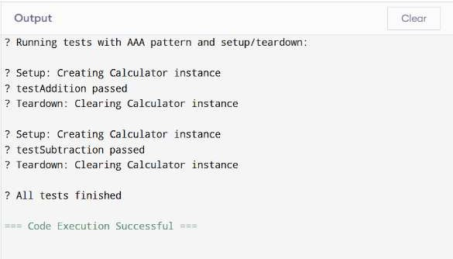

# MOCKING AND STUBBING

public class Main { interface ExternalApi {

String getData();

}

static class MyService { private ExternalApi api;

public MyService(ExternalApi api) { this.api = api;

}

public String fetchData() { return api.getData();

}

}

public static void main(String[] args) {

System.out.println(" Simulating mocking and stubbing...\n");

ExternalApi mockApi = new ExternalApi() { @Override

public String getData() {

return "Mock Data"; }

};

MyService service = new MyService(mockApi);

String result = service.fetchData();

if ("Mock Data".equals(result)) {

System.out.println(" Test Passed: fetchData() returned: " + result);

} else {

System.out.println(" Test Failed: Expected 'Mock Data', but got: " + result);

}

}

}

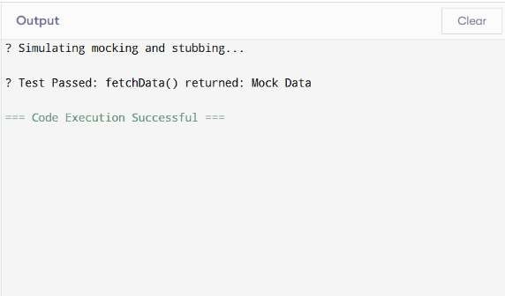

# VERIFYING INSTRUCTIONS

public class Main { interface ExternalApi {

String getData(String input);

}

static class MyService { private ExternalApi api;

public MyService(ExternalApi api) {

this.api = api;

}

public String fetchData() { return api.getData("hello");

}

}

static class MockExternalApi implements ExternalApi { private boolean wasCalled = false;

private String receivedArgument = null;

@Override

public String getData(String input) { wasCalled = true;

receivedArgument = input; return "Mocked Result";

}

public boolean wasGetDataCalled() { return wasCalled;

}

public String getReceivedArgument() { return receivedArgument;

}

}

public static void main(String[] args) {

System.out.println(" Verifying method interaction with specific argument...\n"); MockExternalApi mockApi = new MockExternalApi();

MyService service = new MyService(mockApi);

String result = service.fetchData(); if (mockApi.wasGetDataCalled()) {

System.out.println(" getData() was called on ExternalApi");

} else {

System.out.println(" getData() was NOT called");

}

if ("hello".equals(mockApi.getReceivedArgument())) {

System.out.println(" Correct argument passed: " + mockApi.getReceivedArgument());

} else {

System.out.println(" Wrong argument passed: " + mockApi.getReceivedArgument());

}

System.out.println("\n Service returned: " + result);

}

}

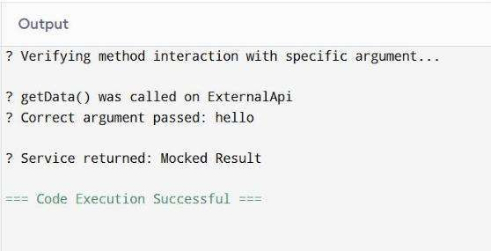

# LOGGING ERROR MESSAGES AND WARNING LEVELS

import java.time.LocalDateTime;

import java.time.format.DateTimeFormatter;

public class Main {

public static void log(String level, String message) {

String timestamp = LocalDateTime.now().format(DateTimeFormatter.ofPattern("yyyy-MM-dd HH:mm:ss"));

System.out.println(timestamp + " [" + level + "] " + message);

}

public static void main(String[] args) { System.out.println(" Simulated Logging Output:\n"); log("ERROR", "This is an error message");

log("WARN", "This is a warning message"); log("INFO", "This is just an info message");

}

}

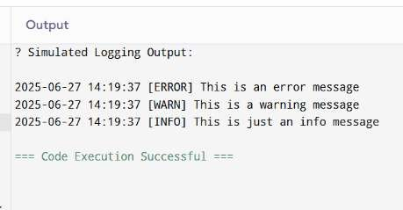

**THANKYOU**