**Week – 5**

**Microservices with Spring Boot 3 and Spring Cloud**

**2. Microservices with API gateway  
Creating Microservices for account and loan**

**Account Service - Spring Boot Microservice Setup**

**AccountServiceApplication.java**

package com.example.account_service;

import org.springframework.boot.SpringApplication;

import org.springframework.boot.autoconfigure.SpringBootApplication;

@SpringBootApplication(scanBasePackages = "com.example.account")

public class AccountServiceApplication {

public static void main(String[] args) {

SpringApplication.run(AccountServiceApplication.class, args);

}

}  
  
**application.properties**  
server.port=8085

spring.application.name=account-service

**pom.xml**

<project xmlns="http://maven.apache.org/POM/4.0.0"

xmlns:xsi="http://www.w3.org/2001/XMLSchema-instance"

xsi:schemaLocation="http://maven.apache.org/POM/4.0.0

https://maven.apache.org/xsd/maven-4.0.0.xsd">

<modelVersion>4.0.0</modelVersion>

<parent>

<groupId>org.springframework.boot</groupId>

<artifactId>spring-boot-starter-parent</artifactId>

<version>3.5.3</version>

<relativePath/>

</parent>

<groupId>com.example</groupId>

<artifactId>account-service</artifactId>

<version>0.0.1-SNAPSHOT</version>

<name>account-service</name>

<description>Microservice for Account</description>

<properties>

<java.version>21</java.version>

</properties>

<dependencies>

<dependency>

<groupId>org.springframework.boot</groupId>

<artifactId>spring-boot-starter-web</artifactId>

</dependency>

<dependency>

<groupId>org.springframework.boot</groupId>

<artifactId>spring-boot-starter-actuator</artifactId>

</dependency>

<dependency>

<groupId>org.springframework.boot</groupId>

<artifactId>spring-boot-devtools</artifactId>

<scope>runtime</scope>

<optional>true</optional>

</dependency>

<dependency>

<groupId>org.springframework.boot</groupId>

<artifactId>spring-boot-starter-test</artifactId>

<scope>test</scope>

</dependency>

</dependencies>

<build>

<plugins>

<plugin>

<groupId>org.springframework.boot</groupId>

<artifactId>spring-boot-maven-plugin</artifactId>

</plugin>

</plugins>

</build>

</project>

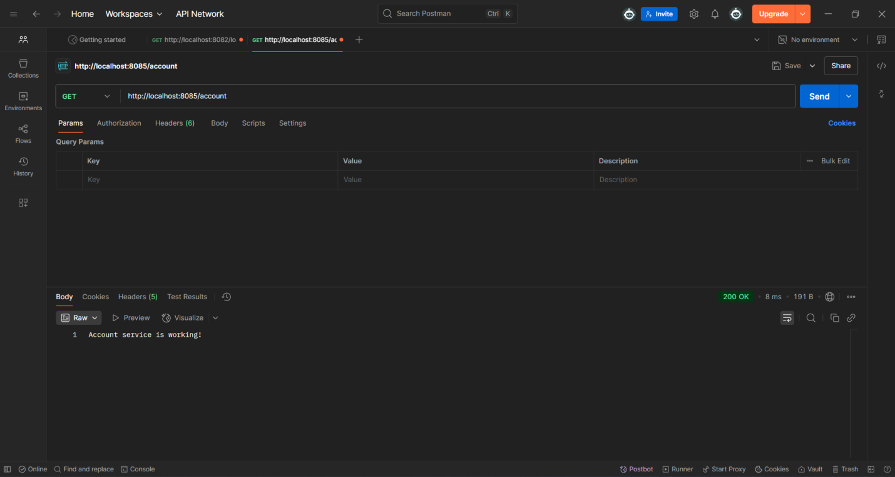

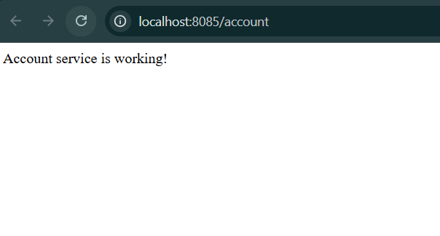

. ____ _ __ _ _

/\\ / ___'_ __ _ _(_)_ __ __ _ \ \ \ \

( ( )\___ | '_ | '_| | '_ \/ _` | \ \ \ \

\\/ ___)| |_)| | | | | || (_| | ) ) ) )

' |____| .__|_| |_|_| |_\__, | / / / /

=========|_|==============|___/=/_/_/_/

[32m :: Spring Boot :: [39m [2m (v3.5.3)[0;39m

[2m2025-07-20T19:53:02.190+05:30[0;39m [32m INFO[0;39m [35m7072[0;39m [2m--- [account-service] [ restartedMain] [0;39m[36mc.e.a.AccountServiceApplication [0;39m [2m:[0;39m Starting AccountServiceApplication using Java 21.0.7 with PID 7072 (D:\CTS12345\microservices\account-service\target\classes started by Admin in D:\CTS12345\microservices\account-service)

[2m2025-07-20T19:53:02.197+05:30[0;39m [32m INFO[0;39m [35m7072[0;39m [2m--- [account-service] [ restartedMain] [0;39m[36mc.e.a.AccountServiceApplication [0;39m [2m:[0;39m No active profile set, falling back to 1 default profile: "default"

[2m2025-07-20T19:53:02.247+05:30[0;39m [32m INFO[0;39m [35m7072[0;39m [2m--- [account-service] [ restartedMain] [0;39m[36m.e.DevToolsPropertyDefaultsPostProcessor[0;39m [2m:[0;39m Devtools property defaults active! Set 'spring.devtools.add-properties' to 'false' to disable

[2m2025-07-20T19:53:02.247+05:30[0;39m [32m INFO[0;39m [35m7072[0;39m [2m--- [account-service] [ restartedMain] [0;39m[36m.e.DevToolsPropertyDefaultsPostProcessor[0;39m [2m:[0;39m For additional web related logging consider setting the 'logging.level.web' property to 'DEBUG'

[2m2025-07-20T19:53:03.358+05:30[0;39m [32m INFO[0;39m [35m7072[0;39m [2m--- [account-service] [ restartedMain] [0;39m[36mo.s.b.w.embedded.tomcat.TomcatWebServer [0;39m [2m:[0;39m Tomcat initialized with port 8085 (http)

[2m2025-07-20T19:53:03.373+05:30[0;39m [32m INFO[0;39m [35m7072[0;39m [2m--- [account-service] [ restartedMain] [0;39m[36mo.apache.catalina.core.StandardService [0;39m [2m:[0;39m Starting service [Tomcat]

[2m2025-07-20T19:53:03.374+05:30[0;39m [32m INFO[0;39m [35m7072[0;39m [2m--- [account-service] [ restartedMain] [0;39m[36mo.apache.catalina.core.StandardEngine [0;39m [2m:[0;39m Starting Servlet engine: [Apache Tomcat/10.1.42]

[2m2025-07-20T19:53:03.417+05:30[0;39m [32m INFO[0;39m [35m7072[0;39m [2m--- [account-service] [ restartedMain] [0;39m[36mo.a.c.c.C.[Tomcat].[localhost].[/] [0;39m [2m:[0;39m Initializing Spring embedded WebApplicationContext

[2m2025-07-20T19:53:03.417+05:30[0;39m [32m INFO[0;39m [35m7072[0;39m [2m--- [account-service] [ restartedMain] [0;39m[36mw.s.c.ServletWebServerApplicationContext[0;39m [2m:[0;39m Root WebApplicationContext: initialization completed in 1169 ms

[2m2025-07-20T19:53:03.982+05:30[0;39m [32m INFO[0;39m [35m7072[0;39m [2m--- [account-service] [ restartedMain] [0;39m[36mo.s.b.d.a.OptionalLiveReloadServer [0;39m [2m:[0;39m LiveReload server is running on port 35729

[2m2025-07-20T19:53:03.992+05:30[0;39m [32m INFO[0;39m [35m7072[0;39m [2m--- [account-service] [ restartedMain] [0;39m[36mo.s.b.a.e.web.EndpointLinksResolver [0;39m [2m:[0;39m Exposing 1 endpoint beneath base path '/actuator'

[2m2025-07-20T19:53:04.061+05:30[0;39m [32m INFO[0;39m [35m7072[0;39m [2m--- [account-service] [ restartedMain] [0;39m[36mo.s.b.w.embedded.tomcat.TomcatWebServer [0;39m [2m:[0;39m Tomcat started on port 8085 (http) with context path '/'

[2m2025-07-20T19:53:04.073+05:30[0;39m [32m INFO[0;39m [35m7072[0;39m [2m--- [account-service] [ restartedMain] [0;39m[36mc.e.a.AccountServiceApplication [0;39m [2m:[0;39m Started AccountServiceApplication in 2.374 seconds (process running for 3.197)

[2m2025-07-20T19:53:04.746+05:30[0;39m [32m INFO[0;39m [35m7072[0;39m [2m--- [account-service] [on(4)-127.0.0.1] [0;39m[36mo.a.c.c.C.[Tomcat].[localhost].[/] [0;39m [2m:[0;39m Initializing Spring DispatcherServlet 'dispatcherServlet'

[2m2025-07-20T19:53:04.746+05:30[0;39m [32m INFO[0;39m [35m7072[0;39m [2m--- [account-service] [on(4)-127.0.0.1] [0;39m[36mo.s.web.servlet.DispatcherServlet [0;39m [2m:[0;39m Initializing Servlet 'dispatcherServlet'

[2m2025-07-20T19:53:04.747+05:30[0;39m [32m INFO[0;39m [35m7072[0;39m [2m--- [account-service] [on(4)-127.0.0.1] [0;39m[36mo.s.web.servlet.DispatcherServlet [0;39m [2m:[0;39m Completed initialization in 1 ms

**Loan Service - Spring Boot Microservice Setup**

**LoanServiceAccountApplication.java**

package com.example.loan;

import org.springframework.boot.SpringApplication;

import org.springframework.boot.autoconfigure.SpringBootApplication;

@SpringBootApplication

public class LoanServiceAccountApplication {

public static void main(String[] args) {

SpringApplication.run(LoanServiceAccountApplication.class, args);

}

}

**application.properties**

server.port=8082

spring.application.name=loan-service

**pom.xml**

<project xmlns="http://maven.apache.org/POM/4.0.0"

xmlns:xsi="http://www.w3.org/2001/XMLSchema-instance"

xsi:schemaLocation="http://maven.apache.org/POM/4.0.0

https://maven.apache.org/xsd/maven-4.0.0.xsd">

<modelVersion>4.0.0</modelVersion>

<parent>

<groupId>org.springframework.boot</groupId>

<artifactId>spring-boot-starter-parent</artifactId>

<version>3.5.3</version>

<relativePath/>

</parent>

<groupId>com.example</groupId>

<artifactId>loan-service</artifactId>

<version>0.0.1-SNAPSHOT</version>

<name>loan-service</name>

<description>Microservice for Loan</description>

<properties>

<java.version>21</java.version>

</properties>

<dependencies>

<dependency>

<groupId>org.springframework.boot</groupId>

<artifactId>spring-boot-starter-web</artifactId>

</dependency>

<dependency>

<groupId>org.springframework.boot</groupId>

<artifactId>spring-boot-starter-actuator</artifactId>

</dependency>

<dependency>

<groupId>org.springframework.boot</groupId>

<artifactId>spring-boot-devtools</artifactId>

<scope>runtime</scope>

<optional>true</optional>

</dependency>

<dependency>

<groupId>org.springframework.boot</groupId>

<artifactId>spring-boot-starter-test</artifactId>

<scope>test</scope>

</dependency>

</dependencies>

<build>

<plugins>

<plugin>

<groupId>org.springframework.boot</groupId>

<artifactId>spring-boot-maven-plugin</artifactId>

</plugin>

</plugins>

</build>

</project>

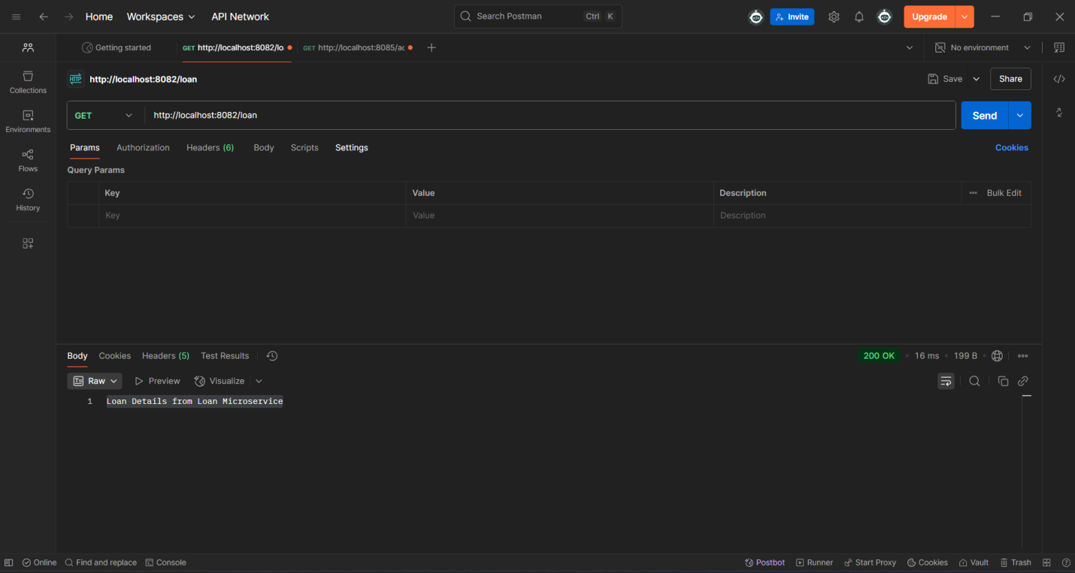

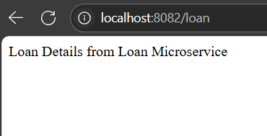

**Api –Gateway**

**Application.properties**server:

port: 8091

spring:

application:

name: api-gateway

cloud:

gateway:

server:

webflux:

routes:

- id: account-service

uri: http://localhost:8080

predicates:

- Path=/account/**

- id: loan-service

uri: http://localhost:8082

predicates:

- Path=/loan/**

<http://localhost:8091/account/details>  
<http://localhost:8091/loan/details>

worked!!!

**Thank you**