**ReactJS Hands-On – Setup and First App**

**npx create-react-app** myfirstreact

**cd** myfirstreact

**code .**

src/App.js

import React from 'react';

function App() {

return (

<div>

<h1>Welcome to the first session of React</h1>

</div>

);

}

export default App;

**npm start**

<http://localhost:3000/>

**o/p:** Welcome to the first session of React

**sc:**

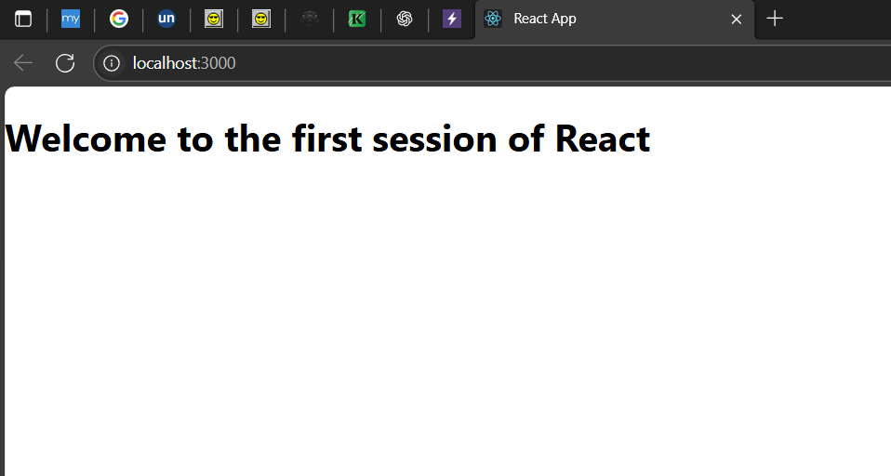

**ReactJS Hands-On** – **Creating and Rendering Multiple Components**

**npx create-react-app** studentapp

**cd** studentapp

**code .**

src/Components

Home.js

import React from 'react';

function Home() {

return (

<div>

<h2>Welcome to the Home page of Student Management Portal</h2>

</div>

);

}

export default Home;

About.js

import React from 'react';

function About() {

return (

<div>

<h2>Welcome to the About page of the Student Management Portal</h2>

</div>

);

}

export default About;

Contact.js

import React from 'react';

function Contact() {

return (

<div>

<h2>Welcome to the Contact page of the Student Management Portal</h2>

</div>

);

}

export default Contact;

App.js

import React from 'react';

import Home from './Components/Home';

import About from './Components/About';

import Contact from './Components/Contact';

function App() {

return (

<div>

<Home />

<About />

<Contact />

</div>

);

}

export default App;

**npm start**

<http://localhost:3000>

**o/p:** Welcome to the Home page of Student Management Portal

Welcome to the About page of the Student Management Portal

Welcome to the Contact page of the Student Management Portal

**Sc:**

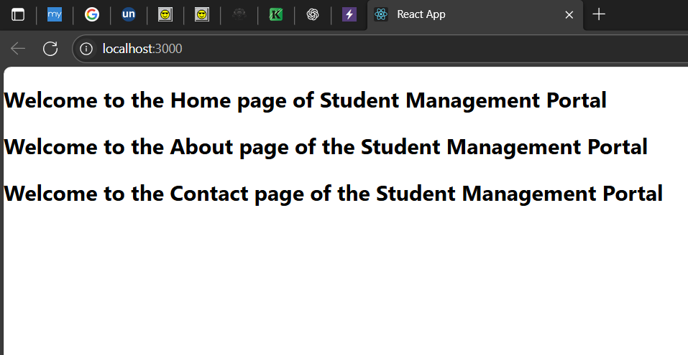

**ReactJS Hands-On** – Creating Function Component with Props and Styling

**npx create-react-app** scorecalculatorapp

**cd** scorecalculatorapp

**code .**

src/Components CalculateScore.js

import React from 'react';

import '../Stylesheets/mystyle.css';

function CalculateScore(props) {

const average = props.total / props.goal;

return (

<div className="scoreBox">

<h2>Student Score Calculator</h2>

<p><strong>Name:</strong> {props.name}</p>

<p><strong>School:</strong> {props.school}</p>

<p><strong>Total Marks:</strong> {props.total}</p>

<p><strong>Goal Subjects:</strong> {props.goal}</p>

<p><strong>Average:</strong> {average.toFixed(2)}</p>

</div>

);

}

export default CalculateScore;

src/Stylesheets mystyle.css

.scoreBox {

width: 350px;

margin: 20px auto;

padding: 20px;

border: 2px solid black;

border-radius: 10px;

background-color: #f2f2f2;

font-family: Arial, sans-serif;

}

src/App.js

import React from 'react';

import CalculateScore from './Components/CalculateScore';

function App() {

return (

<div>

<CalculateScore

name="Janarthanan"

school="K.Ramakrishnan College of Engineering"

total={460}

goal={5}

/>

</div>

);

}

export default App;

**npm start**

<http://localhost:3000/>

o/p:

Student Score Calculator

Name: Janarthanan

School: K.Ramakrishnan College of Engineering

Total Marks: 460

Goal Subjects: 5

Average: 92.00

**Sc:**

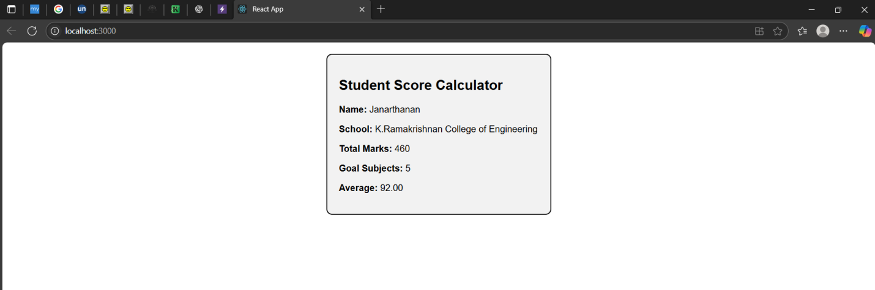

**ReactJS Hands-On** – **Lifecycle Methods (componentDidMount, componentDidCatch)**

**npx create-react-app** blogapp

**cd** blogapp

**code .**

src/Post.js

import React from 'react';

function Post(props) {

return (

<div style={{ border: "1px solid black", margin: "10px", padding: "10px" }}>

<h3>{props.title}</h3>

<p>{props.body}</p>

</div>

);

}

export default Post;

Posts.js

import React, { Component } from 'react';

import Post from './Post';

class Posts extends Component {

constructor(props) {

super(props);

this.state = {

posts: [],

hasError: false

};

}

componentDidMount() {

this.loadPosts();

}

loadPosts() {

fetch('https://jsonplaceholder.typicode.com/posts')

.then(response => response.json())

.then(data => this.setState({ posts: data.slice(0, 5) }))

.catch(error => console.error("Error fetching posts:", error));

}

componentDidCatch(error, info) {

alert("An error occurred while rendering the component.");

this.setState({ hasError: true });

}

render() {

if (this.state.hasError) {

return <h2>Something went wrong.</h2>;

}

return (

<div>

<h2>Blog Posts</h2>

{this.state.posts.map(post => (

<Post key={post.id} title={post.title} body={post.body} />

))}

</div>

);

}

}

export default Posts;

App.js

import React from 'react';

import Posts from './Posts';

function App() {

return (

<div>

<Posts />

</div>

);

}

export default App;

**npm start**

<http://localhost:3000/>

**o/p:** Blog Posts

**sc:**   
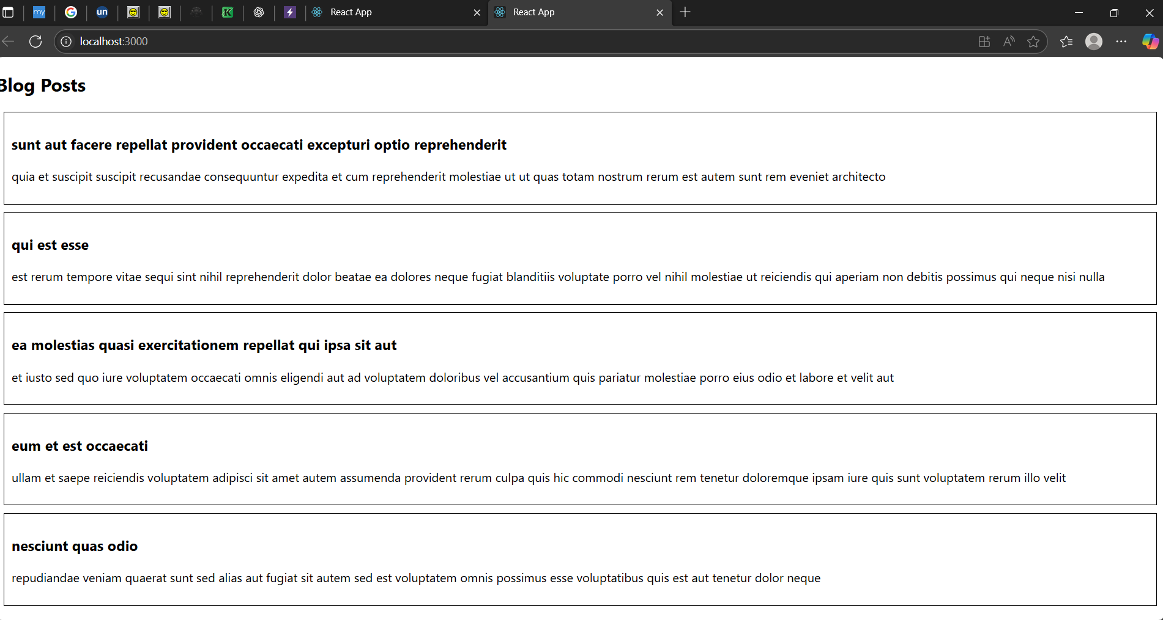

**ReactJS Hands-On** – Styling React Components with CSS Modules and Conditional Inline Styles

**npx create-react-app** cohortdashboard

**cd** cohortdashboard

**code .**

src/ CohortDetails.module.css

.box {

width: 300px;

display: inline-block;

margin: 10px;

padding: 10px 20px;

border: 1px solid black;

border-radius: 10px;

}

dt {

font-weight: 500;

}

CohortDetails.js

import React from 'react';

import styles from './CohortDetails.module.css';

function CohortDetails({ cohort }) {

const statusColor = cohort.status === "Ongoing" ? "green" : "blue";

return (

<div className={styles.box}>

<h3 style={{ color: statusColor }}>{cohort.name}</h3>

<dl>

<dt>Started On</dt>

<dd>{cohort.startDate}</dd>

<dt>Current Status</dt>

<dd>{cohort.status}</dd>

<dt>Coach</dt>

<dd>{cohort.coach}</dd>

<dt>Trainer</dt>

<dd>{cohort.trainer}</dd>

</dl>

</div>

);

}

export default CohortDetails;

App.js

import React from 'react';

import CohortDetails from './CohortDetails';

function App() {

const cohortList = [

{

name: "INTADMDF10 - .NET FSD",

startDate: "22-Feb-2022",

status: "Scheduled",

coach: "Aathma",

trainer: "Jojo Jose"

},

{

name: "ADM21JF014 - Java FSD",

startDate: "10-Sep-2021",

status: "Ongoing",

coach: "Apoorv",

trainer: "Elisa Smith"

},

{

name: "**CD**BJF21025 - Java FSD",

startDate: "24-Dec-2021",

status: "Ongoing",

coach: "Aathma",

trainer: "John Doe"

}

];

return (

<div>

<h2>Cohorts Details</h2>

{cohortList.map((c, index) => (

<CohortDetails key={index} cohort={c} />

))}

</div>

);

}

export default App;

**npm start**

**o/p:** Multiple cohort boxes are shown with: <h3> in green for "Ongoing" and blue for other statuses

**sc:**

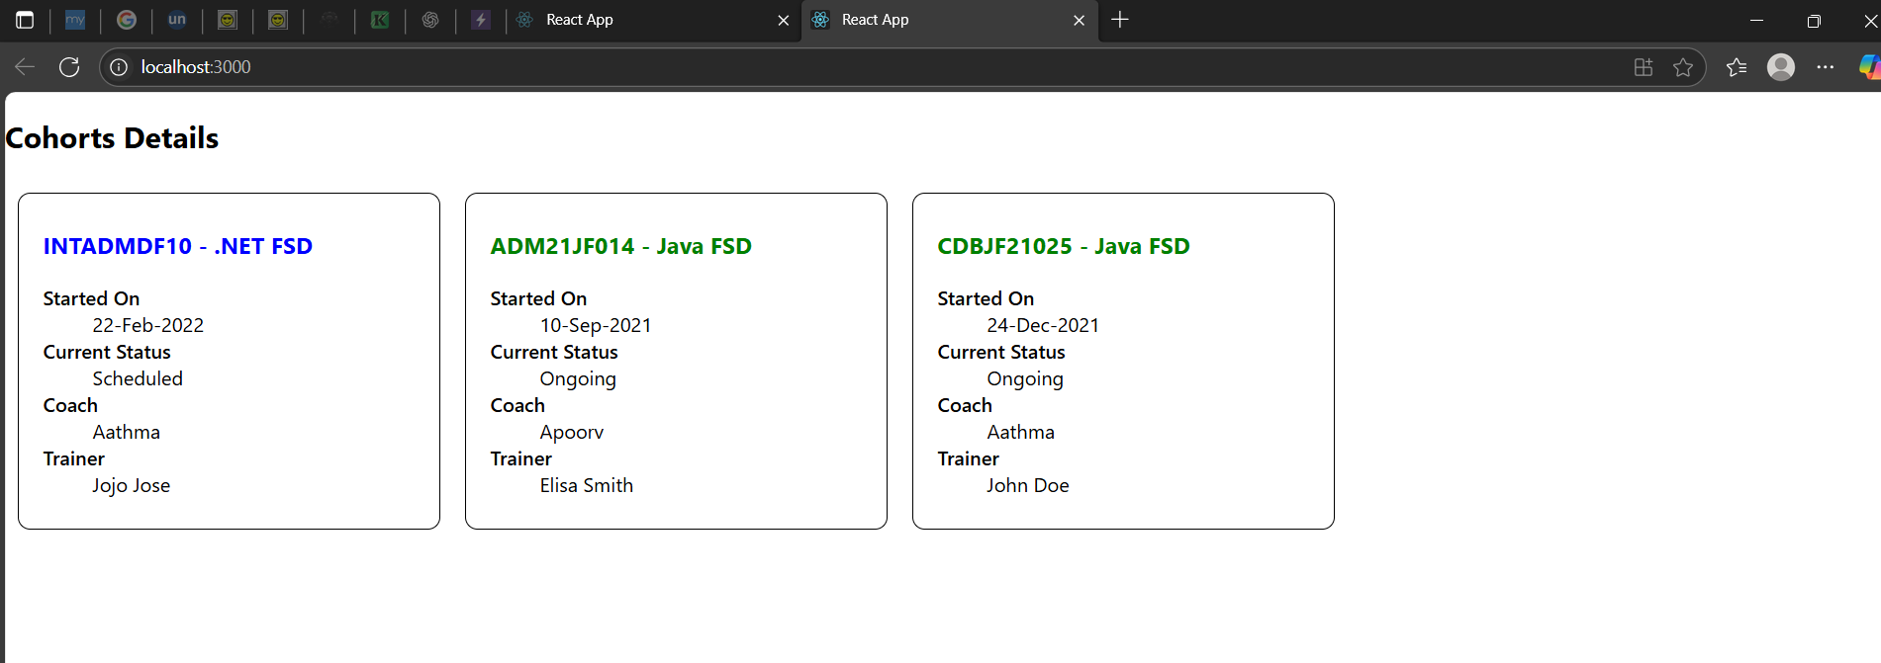

THANK YOU