**ReactJS-HOL 9: ReactJS Hands-On – ES6 Features in React (cricketapp)**

npx create-react-app cricketapp

cd cricketapp

code .

**Components/ListOfPlayers.js**

import React from 'react';

function ListOfPlayers() {

const players = [

{ name: "Virat", score: 95 },

{ name: "Rohit", score: 89 },

{ name: "Gill", score: 60 },

{ name: "Rahul", score: 55 },

{ name: "Hardik", score: 71 },

{ name: "Pant", score: 66 },

{ name: "Jadeja", score: 75 },

{ name: "Ashwin", score: 45 },

{ name: "Bumrah", score: 78 },

{ name: "Shami", score: 58 },

{ name: "Kuldeep", score: 50 }

];

const filtered = players.filter(p => p.score >= 70);

return (

<div>

<h3>Players with score ≥ 70</h3>

<ul>

{filtered.map((p, i) => (

<li key={i}>{p.name} - {p.score}</li>

))}

</ul>

</div>

);

}

export default ListOfPlayers;

**IndianPlayers.js**

import React from 'react';

function IndianPlayers() {

const t20 = ["Virat", "Rohit", "Gill"];

const ranji = ["Jaiswal", "Sarfaraz", "Iyer"];

const merged = [...t20, ...ranji];

const [odd, even] = [

merged.filter((_, i) => i % 2 !== 0),

merged.filter((_, i) => i % 2 === 0)

];

return (

<div>

<h3>Odd Team Players</h3>

<ul>{odd.map((p, i) => <li key={i}>{p}</li>)}</ul>

<h3>Even Team Players</h3>

<ul>{even.map((p, i) => <li key={i}>{p}</li>)}</ul>

</div>

);

}

export default IndianPlayers;

**App.js**

import React from 'react';

import ListOfPlayers from './Components/ListOfPlayers';

import IndianPlayers from './Components/IndianPlayers';

function App() {

const flag = true; // toggle true/false to test

return (

<div>

<h2>Cricket App</h2>

{flag ? <ListOfPlayers /> : <IndianPlayers />}

</div>

);

}

export default App;

**npm start**

**o/p:**

displays list of players with score ≥ 70

**Sc**:

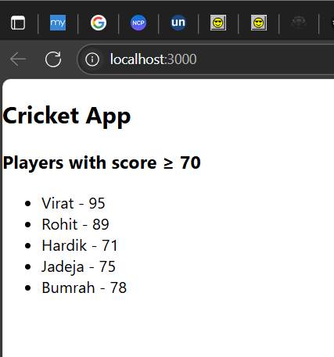

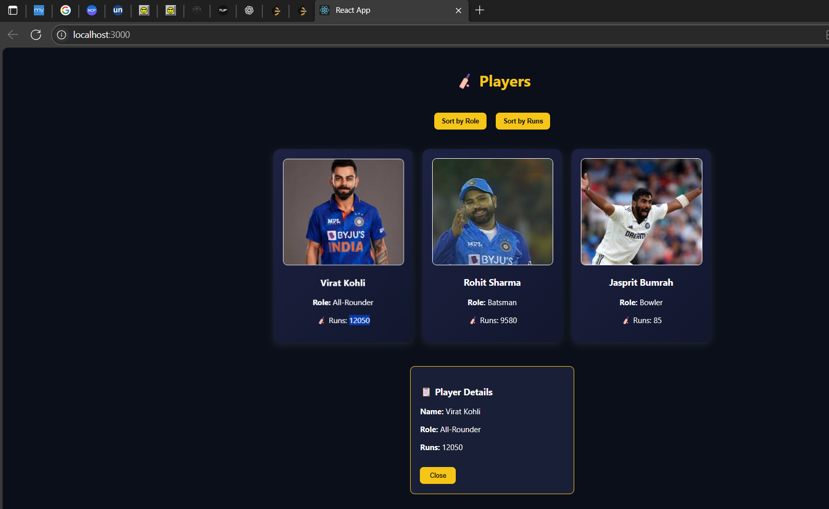

**ReactJS-HOL 10: ReactJS Hands-On – Using JSX, Objects, and Conditional Inline CSS (officespacerentalapp)**

npx create-react-app officespacerentalapp

cd officespacerentalapp

code .

**OfficeSpaceList.js**

import React from 'react';

function OfficeSpaceList() {

const offices = [

{ name: "Alpha Co-Working", rent: 45000, address: "Chennai" },

{ name: "Beta Hub", rent: 70000, address: "Bangalore" },

{ name: "Gamma Workspace", rent: 30000, address: "Hyderabad" },

{ name: "Delta Space", rent: 85000, address: "Mumbai" }

];

return (

<div>

<h2>Office Space Listings</h2>

{offices.map((office, index) => (

<div key={index} style={{

border: '1px solid gray',

margin: '10px',

padding: '10px',

backgroundColor: '#f9f9f9'

}}>

<img

src="https://via.placeholder.com/300x150"

alt="Office"

width="300"

height="150"

/>

<h3>{office.name}</h3>

<p><strong>Address:</strong> {office.address}</p>

<p style={{ color: office.rent < 60000 ? 'red' : 'green' }}>

<strong>Rent:</strong> ₹{office.rent}

</p>

</div>

))}

</div>

);

}

export default OfficeSpaceList;

**App.js**

import React from 'react';

import OfficeSpaceList from './OfficeSpaceList';

function App() {

return (

<div>

<h1>Office Space Rental App</h1>

<OfficeSpaceList />

</div>

);

}

export default App;

**npm start**

**o/p:**

1. **Red** if < ₹60000
2. **Green** if ≥ ₹60000

**Sc:**

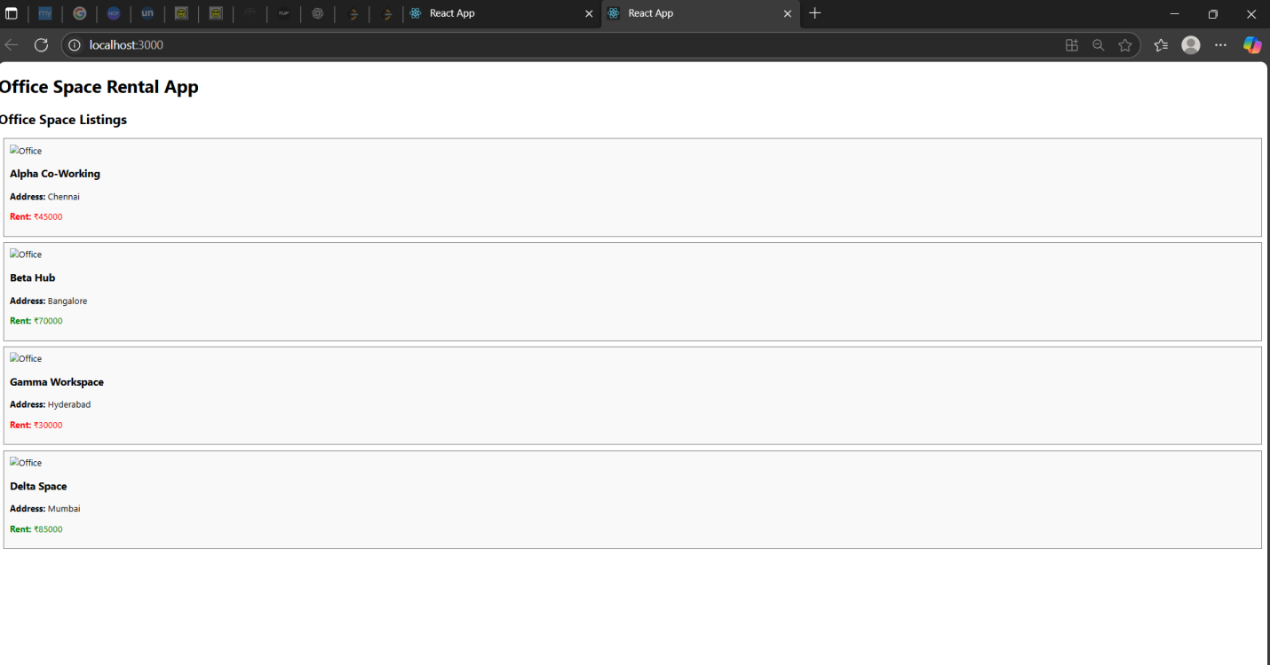

**ReactJS-HOL 11: ReactJS Hands-On – Handling Events and Synthetic Events (eventexamplesapp)**

npx create-react-app eventexamplesapp

cd eventexamplesapp

code .

**src/Components**

**Counter.js**

import React, { Component } from 'react';

class Counter extends Component {

constructor() {

super();

this.state = { count: 0 };

}

increment = () => {

this.setState({ count: this.state.count + 1 });

this.sayHello();

}

decrement = () => {

this.setState({ count: this.state.count - 1 });

}

sayHello() {

console.log("Hello from React Events!");

}

render() {

return (

<div>

<h3>Count: {this.state.count}</h3>

<button onClick={this.increment}>Increment</button>

<button onClick={this.decrement}>Decrement</button>

</div>

);

}

}

export default Counter;

**SayWelcome.js**

import React from 'react';

function SayWelcome() {

const greet = (message) => {

alert(message);

};

return (

<button onClick={() => greet("Welcome Janarthanan!")}>

Say Welcome

</button>

);

}

export default SayWelcome;

**SyntheticEventDemo.js**

import React from 'react';

function SyntheticEventDemo() {

const handleClick = (e) => {

e.preventDefault();

alert("I was clicked");

};

return (

<button onClick={handleClick}>Synthetic Event</button>

);

}

export default SyntheticEventDemo;

**CurrencyConvertor.js**

import React, { useState } from 'react';

function CurrencyConvertor() {

const [rupees, setRupees] = useState("");

const [euro, setEuro] = useState("");

const handleSubmit = () => {

const result = (parseFloat(rupees) / 90).toFixed(2);

setEuro(result);

};

return (

<div>

<h3>Currency Converter</h3>

<input

type="number"

placeholder="Enter INR"

value={rupees}

onChange={(e) => setRupees(e.target.value)}

/>

<button onClick={handleSubmit}>Convert</button>

<p>{euro && `€${euro}`}</p>

</div>

);

}

export default CurrencyConvertor;

**App.js**

import React from 'react';

import Counter from './Components/Counter';

import SayWelcome from './Components/SayWelcome';

import SyntheticEventDemo from './Components/SyntheticEventDemo';

import CurrencyConvertor from './Components/CurrencyConvertor';

function App() {

return (

<div>

<h2>Event Examples App</h2>

<Counter />

<br />

<SayWelcome />

<br />

<SyntheticEventDemo />

<br />

<CurrencyConvertor />

</div>

);

}

export default App;

**npm start**

**o/p:**

1. To increment and decrement values
2. **Say Welcome** alert message on click
3. **Synthetic event** alert: “I was clicked”
4. **Currency Converter** that converts INR to Euro on button click

**Sc:**

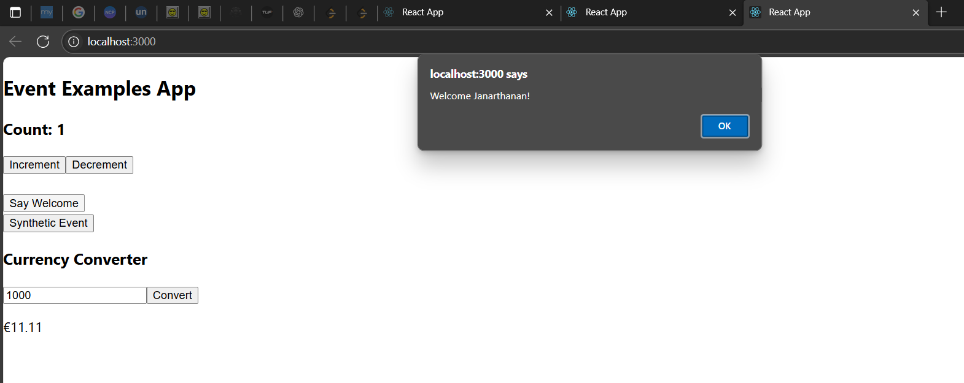

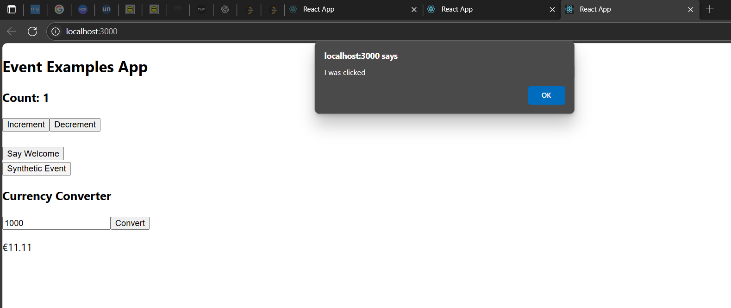

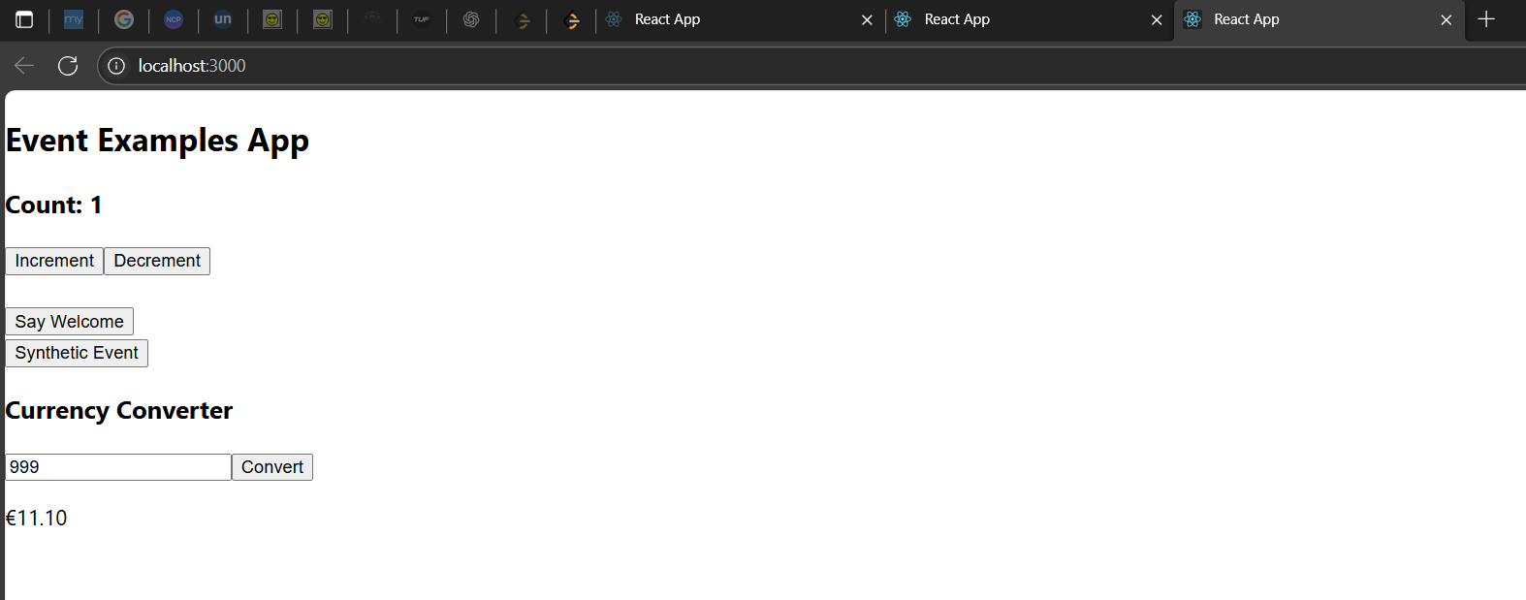

**ReactJS-HOL 12: ReactJS Hands-On – Conditional Rendering (Login/Guest Views) (ticketbookingapp)**

npx create-react-app ticketbookingapp

cd ticketbookingapp

code .

**src/Components/**

**Guest.js**

import React from 'react';

function Guest(props) {

return (

<div>

<h3>Welcome Guest! Please log in to book your tickets.</h3>

<button onClick={props.login}>Login</button>

</div>

);

}

export default Guest;

**User.js**

import React from 'react';

function User(props) {

return (

<div>

<h3>Welcome User! You can now book your flight tickets.</h3>

<button onClick={props.logout}>Logout</button>

</div>

);

}

export default User;

**App.js**

import React, { Component } from 'react';

import Guest from './Components/Guest';

import User from './Components/User';

class App extends Component {

constructor() {

super();

this.state = {

isLoggedIn: false

};

}

login = () => {

this.setState({ isLoggedIn: true });

}

logout = () => {

this.setState({ isLoggedIn: false });

}

render() {

return (

<div>

<h2>Ticket Booking App</h2>

{this.state.isLoggedIn ?

<User logout={this.logout} /> :

<Guest login={this.login} />

}

</div>

);

}

}

export default App;

**npm start**

**o/p:**

Welcome Guest! Please log in to book your tickets.  
[Login]

After login,  
Welcome User! You can now book your flight tickets.  
[Logout]

**Sc:**

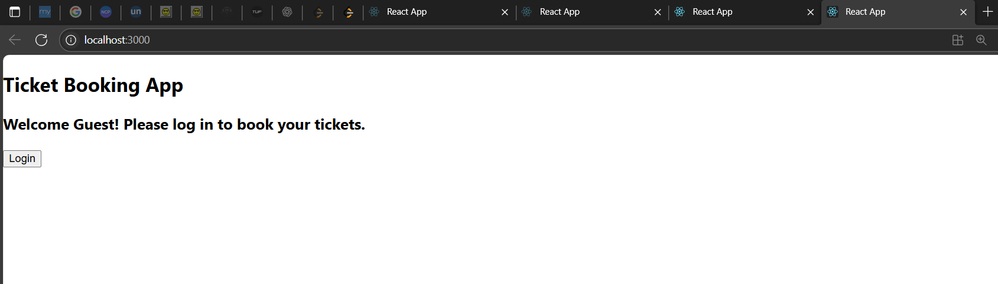

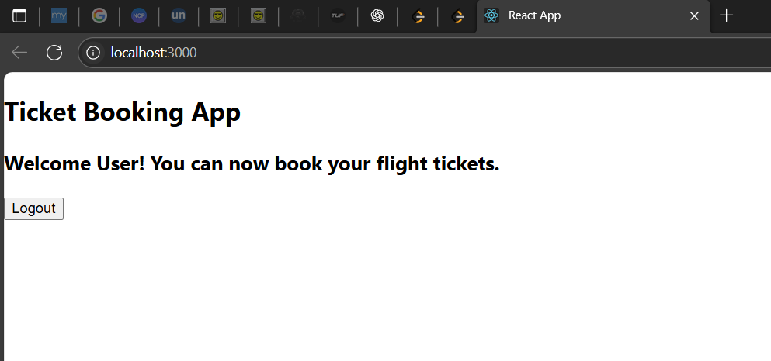

**ReactJS-HOL 13: ReactJS Hands-On – Conditional Rendering & Lists with Keys (bloggerapp)**

npx create-react-app bloggerapp

cd bloggerapp

code .

**src/Components**

**BookDetails.js**

import React from 'react';

function BookDetails() {

const books = ["Clean Code", "Eloquent JavaScript", "React Explained"];

return (

<div>

<h3>📚 Book List</h3>

<ul>

{books.map((book, index) => <li key={index}>{book}</li>)}

</ul>

</div>

);

}

export default BookDetails;

**BlogDetails.js**

import React from 'react';

function BlogDetails() {

const blogs = ["How to Learn React", "Why ES6 Matters", "Understanding Props vs State"];

return (

<div>

<h3>📝 Blog Articles</h3>

<ul>

{blogs.map((blog, index) => <li key={index}>{blog}</li>)}

</ul>

</div>

);

}

export default BlogDetails;

**CourseDetails.js**

import React from 'react';

function CourseDetails() {

const courses = [

{ id: 1, name: "React Bootcamp" },

{ id: 2, name: "Full Stack Web Dev" },

{ id: 3, name: "JavaScript Mastery" }

];

return (

<div>

<h3>🎓 Course List</h3>

<ul>

{courses.map(course => <li key={course.id}>{course.name}</li>)}

</ul>

</div>

);

}

export default CourseDetails;

**App.js**

import React, { useState } from 'react';

import BookDetails from './Components/BookDetails';

import BlogDetails from './Components/BlogDetails';

import CourseDetails from './Components/CourseDetails';

function App() {

const [showBooks, setShowBooks] = useState(true);

const [showBlogs, setShowBlogs] = useState(true);

const [showCourses, setShowCourses] = useState(false);

return (

<div>

<h2>Blogger App Dashboard</h2>

{/* if-else logic */}

{showBooks ? <BookDetails /> : <p>No books to show.</p>}

{/* ternary operator */}

{showBlogs ? <BlogDetails /> : <p>No blogs avaiReactJS-HOLle.</p>}

{/* logical AND rendering */}

{showCourses && <CourseDetails />}

</div>

);

}

export default App;

**npm start**

**o/p:**

A list of **books**, **blogs**, and optionally **courses**

Each item is rendered using .map() with proper keys

Conditional rendering techniques: if-else, ternary, logical AND

**Sc:**

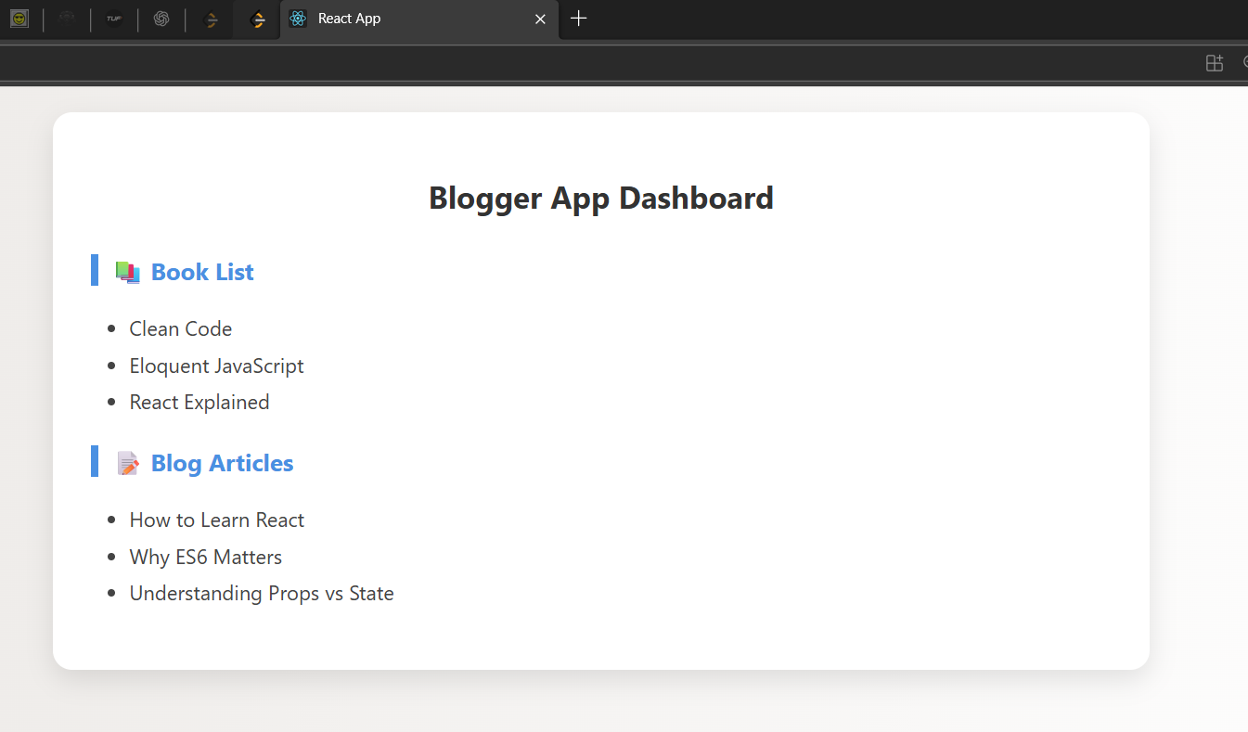

**Thank You**