E-COMMERCE DATA PROJECT

Project Documentation
Prepared by Jana • Graduation Project — Data Creation, Analysis & Visualization

1. The Problem
Online stores generate large volumes of transactional data — customers, products, orders, payments, and reviews — but this data is often scattered across spreadsheets and hard to act on.
Without a structured database and clear reporting, it is difficult to answer basic business questions: which products sell best, who the most valuable customers are, and where revenue is being lost to cancelled or unfulfilled orders.
This project builds a complete data solution — from database design through SQL analysis, Python analysis, Excel reporting, and an interactive Power BI dashboard — to turn raw e-commerce data into clear, actionable insights that could support real business decisions.

2. Database Design
The database (EcommerceDB) is built around six related tables, normalized so that each table holds one type of entity and relationships are expressed through foreign keys rather than repeated data:
Table | Rows | Description
customers | 800 | Customer profile: name, email, phone, city, gender, join date
products | 149 | Products across 6 categories, with price, cost, and stock
orders | 2,757 | Each order's date, status, shipping city and total value
order_items | 8,181 | Line items linking each order to its products and quantities
payments | 2,067 | Payment method, amount and date for each order
reviews | 2,777 | Customer product ratings (1-5) and review dates

Every table has a Primary Key. Foreign Keys enforce the relationships: orders references customers; order_items references both orders and products; payments references orders; and reviews references both customers and products. order_items acts as a bridge table, since a single order can contain many products and a single product can appear in many orders (a many-to-many relationship expressed through two one-to-many relationships).
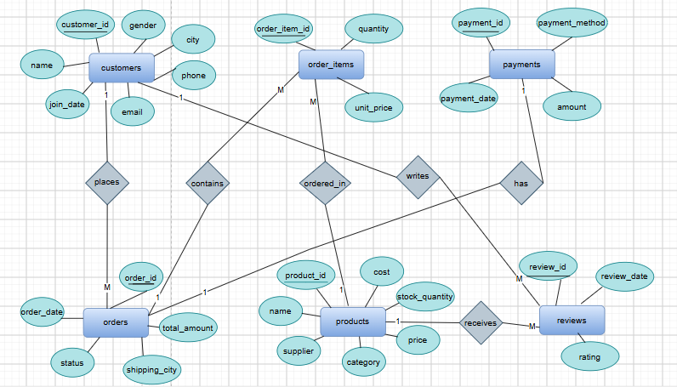
Figure 1 — Entity-Relationship Diagram of the six tables and their relationships

3. Main Insights from the Analysis
The dataset was generated with Python (Faker), deliberately introduced with realistic data-quality issues (missing values, duplicates, inconsistent formatting, invalid ratings), then cleaned with pandas before being loaded into SQL Server. The headline figures across the cleaned dataset:
Total sales value: 31.26M | Total orders placed: 2,757
Registered customers: 800 | Average order value: 11.34K
Products listed: 149 | Product categories: 6
Average product rating: 3.00 / 5 | Cities represented: 8

SQL Analysis
Ten business queries were written against the database, joining across tables to answer questions such as: the top 5 products and categories by revenue, the top 5 customers by spending, the monthly sales trend, order counts by status, average order value by city, low-stock products that still sell well, the most used payment methods, average product rating by category, and customers who have never placed an order.

Python Analysis
Using pandas, matplotlib and seaborn, the cleaned data was used to chart the monthly sales trend, the top 10 products by revenue, and the split of sales across categories. Customers were also segmented into High / Medium / Low value tiers based on total spending (using the 25th and 75th percentiles as cut-offs), which highlighted a small group of high-value customers responsible for a disproportionate share of revenue.

Excel Reporting
All six tables were imported into Excel via Power Query, and five Pivot Tables with matching charts were built to summarize: sales by order status, top selling products, orders by city, payment method usage, and average price by category — each highlighting the key figures at a glance.

Power BI Dashboard
A 3-page interactive Power BI dashboard (Overview, Sales Analysis, Customer Insights) was connected directly to the SQL Server database. It combines KPI cards, charts, a map of customers by city, and slicers (date, category, city) so the figures can be filtered and explored interactively rather than read as a static report.

Key Takeaways
- Sales are concentrated in a handful of top-selling products and categories, which should guide inventory and marketing priorities.
- A small group of high-value customers drives a disproportionate share of revenue — a strong target for loyalty programs.
- A meaningful share of orders is cancelled, representing lost revenue worth investigating further.
- The project delivers a full pipeline — from a normalized SQL database to a live, interactive Power BI dashboard — ready to support real business decisions.

