**CSCE 1101 Assignment 1 Report**

**Car Class:**

It went well, with no errors or issues. Making the class, car, was pretty easy and depended on the knowledge gained from the previous CSCE course. However, I tried making a default argument constructor and I couldn’t seem to get it to work, so I just did two separate constructors for the car class.

**Road Class:**

This was where I had more difficulties. Doing the constructors, setters and getters for the road class was easy enough, but the issues arose in the radar and allow functions. I couldn’t really understand how the functions were supposed to work at first, especially after seeing how the main function was supposed to work. I was very confused but I kept trying and changing the code until I understood the general idea of the assignment well.

**Efficiency:**

To calculate the efficiency of the roads, I assumed that all private vehicles and motorcycles went on road A and all trucks went on road C, and all the rest went on road B. This means that if a vehicle passed on road A or road C, it did not pass by road B as well. So the way I designed the efficiency part of my code was based on this assumption, so if there are 8 vehicles in total, and 4 vehicles are allowed on road A, and 3 vehicles are allowed on road C, then 1 vehicle will go on road B. In this case, road A’s efficiency will be 100%, road C’s efficiency will be 75% and road B’s efficiency will be 25%. To calculate the efficiency, I made a function in my main file and implemented the function in my main.

**Main:**

The main function took a lot of research to find out how to use a queue properly and functions I can use with queues. After I got the queue part down, it took effort to do the loop where I count the cars on each road and pass them on the radar and age functions. Lastly, I made a function to calculate the efficiency of each road and used it in the main function. Below is a screenshot of my output when I run the code with 4 trucks, 1 motorcycle, 1 private vehicle and 2 buses. First, the road the car is allowed on is displayed, then if it fined, its information will be printed below it. After that, the road efficiencies are displayed.

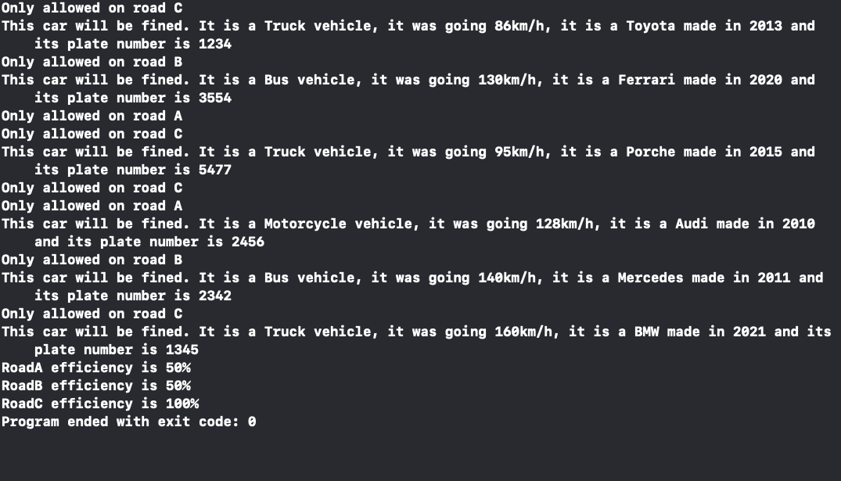

This is another screenshot of my output with 3 trucks, 2 motorcycles, 1 private vehicle, and 2 buses. First, the road the car is allowed on is displayed, then if it fined, its information will be printed below it. After that, the road efficiencies are displayed.

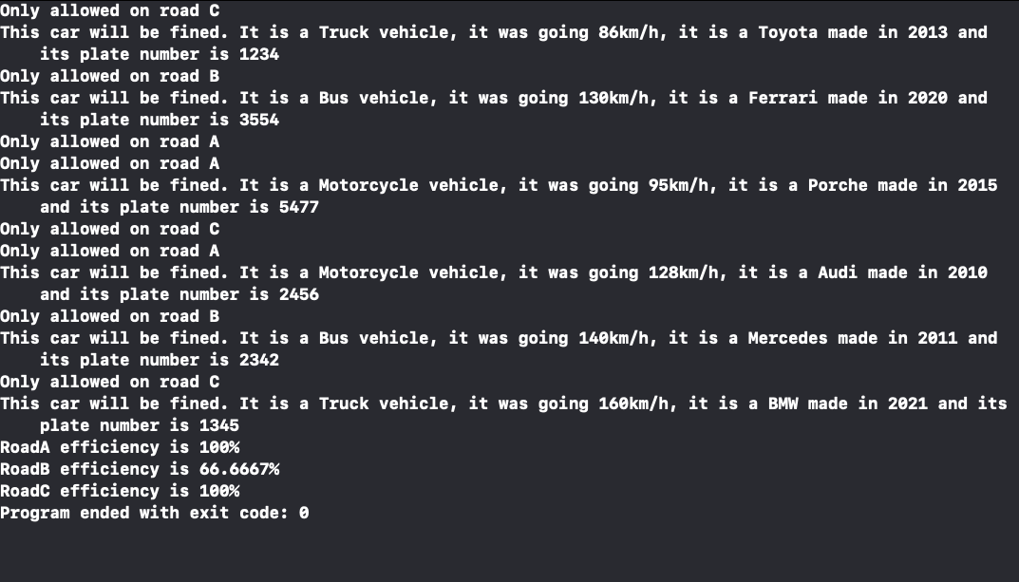

This is another screenshot of my output with 1 truck, 1 motorcycle, 1 private vehicle, and 5

buses. First, the road the car is allowed on is displayed, then if it fined, its information will be printed below it. After that, the road efficiencies are displayed.

