ARDUINO IDE INSTALLATION

1. **Search for “arduino software”. Install the Arduino 1.8.19 version from the website.**

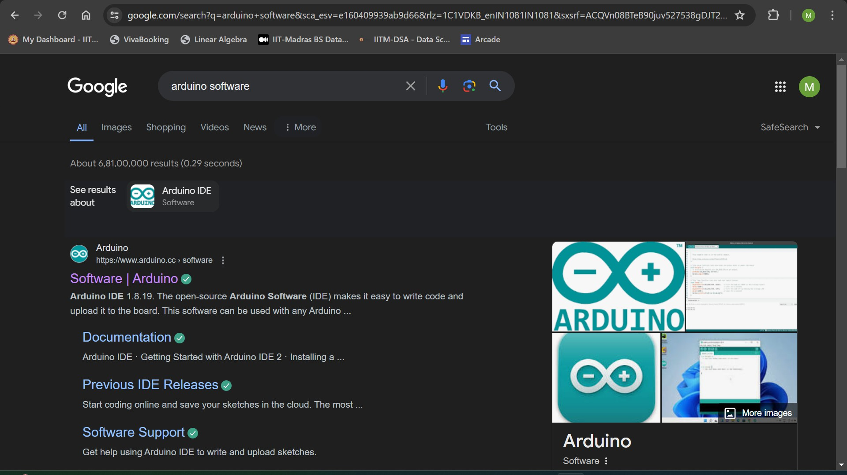

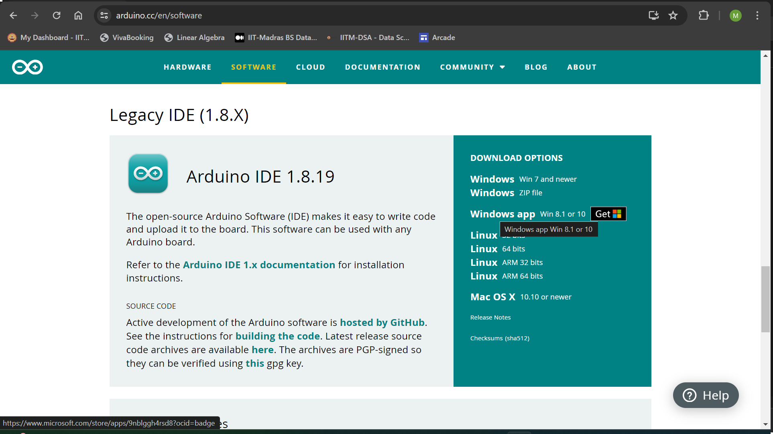

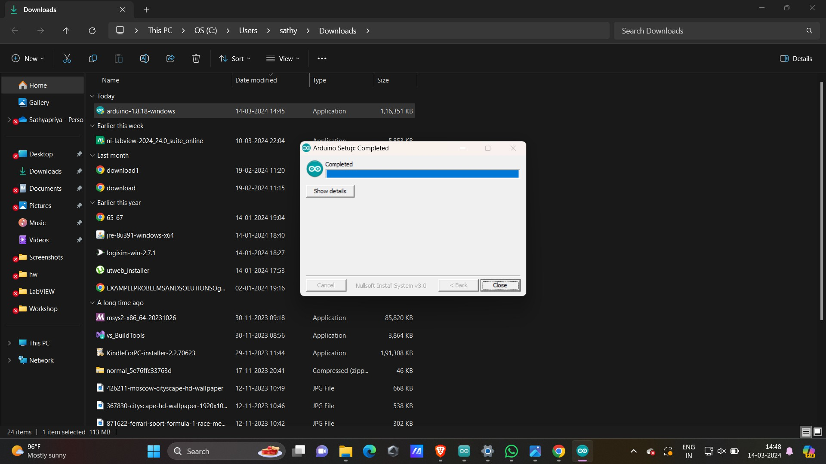

1. **Installation of ch340 driver (Optional)**

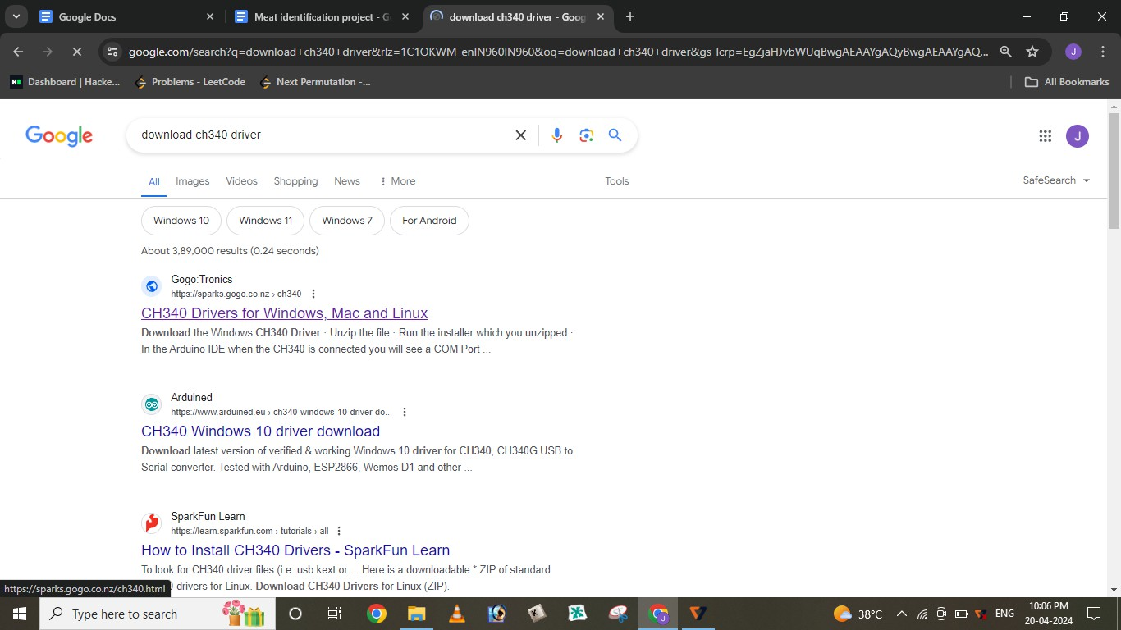

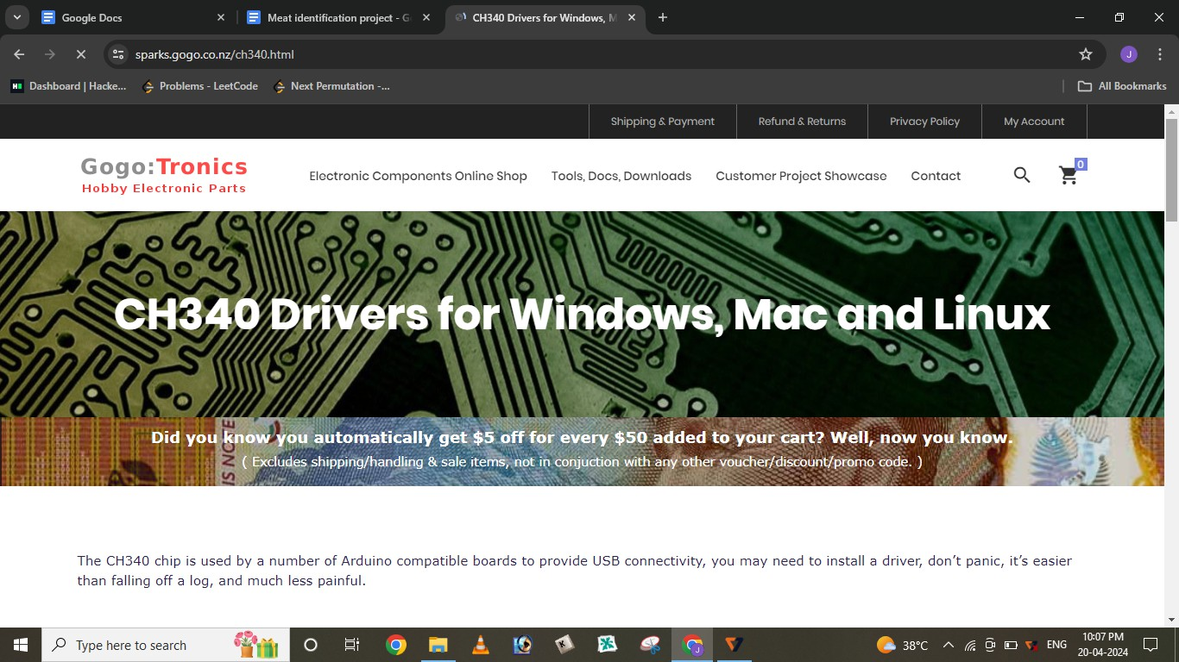

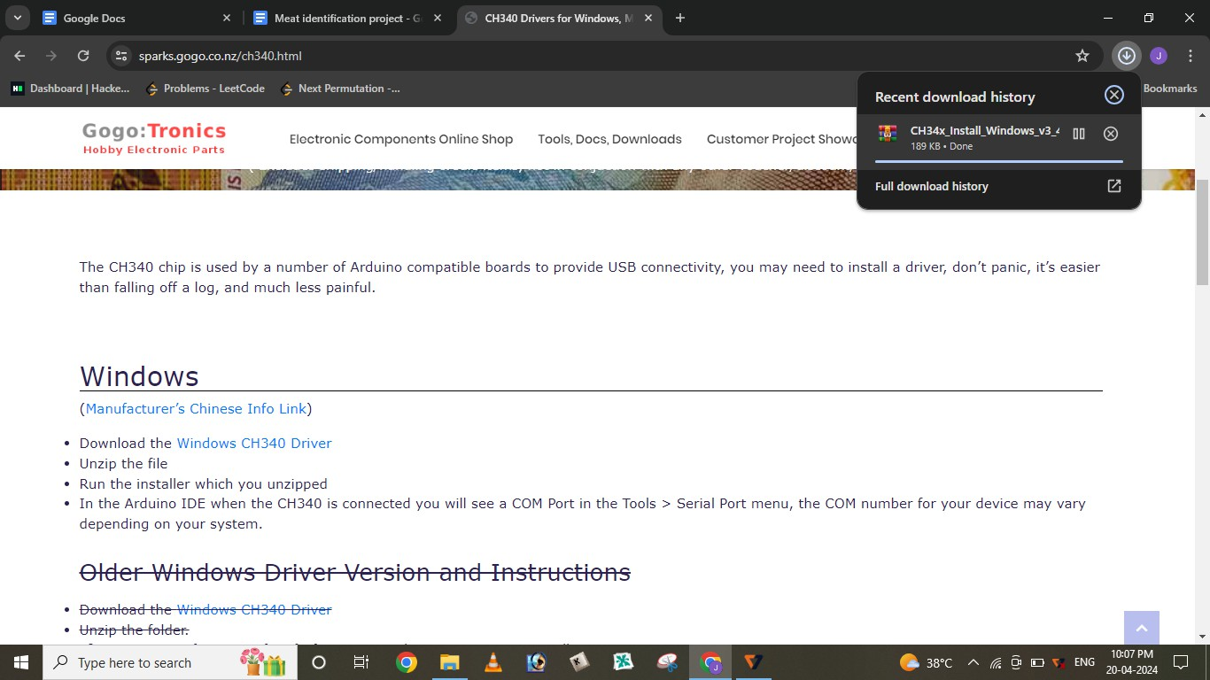

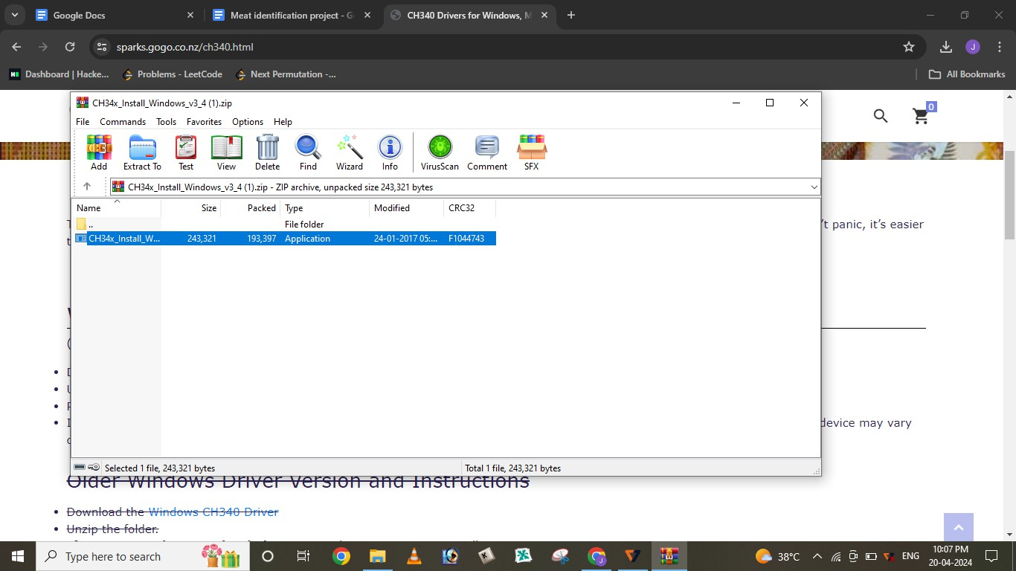

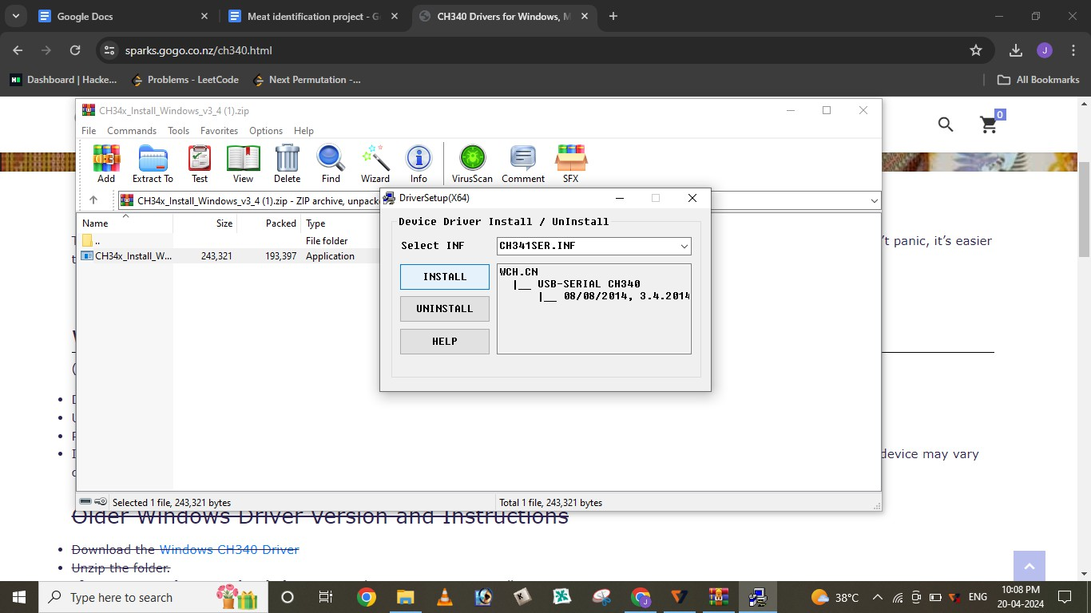

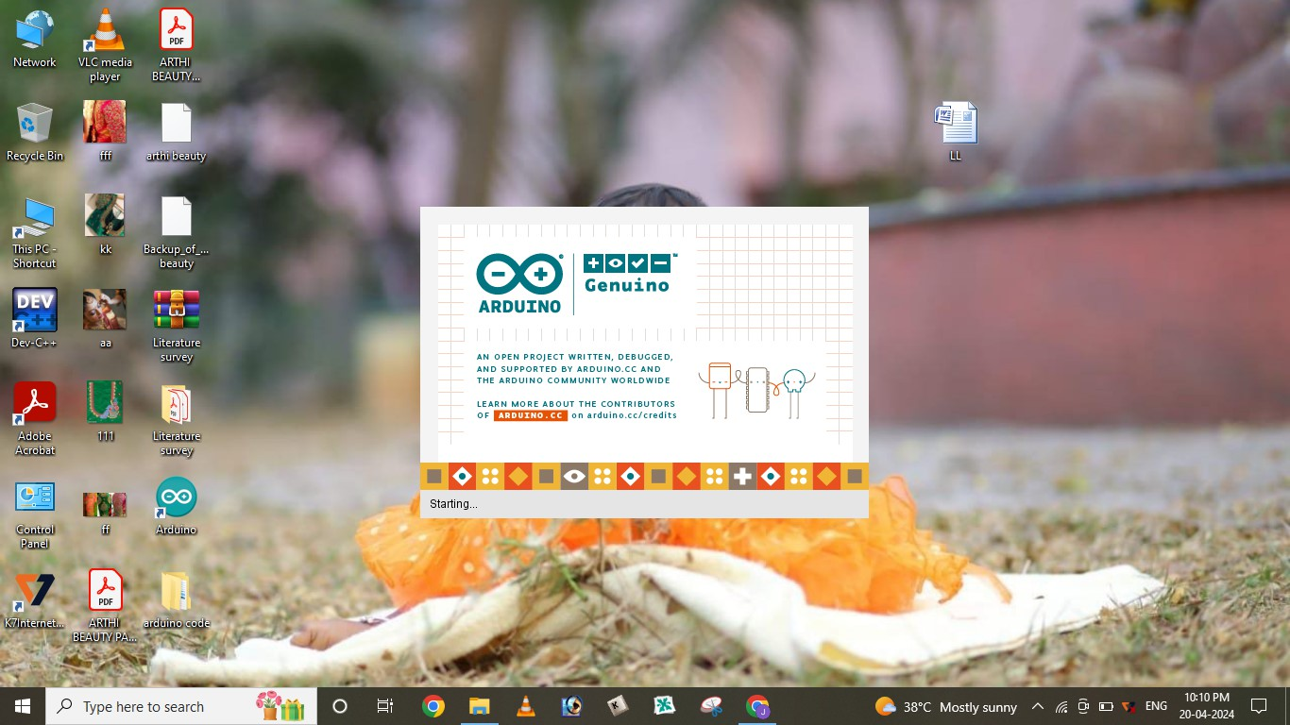

1. **Selection of board**

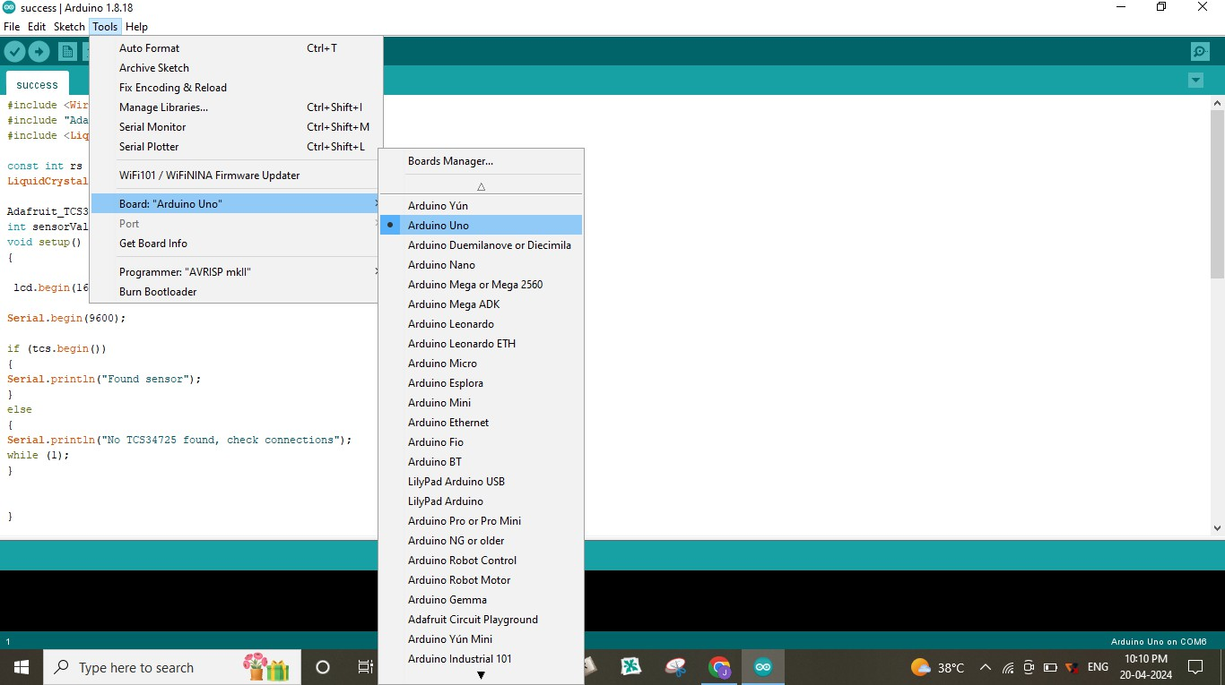

1. **Selection of port**

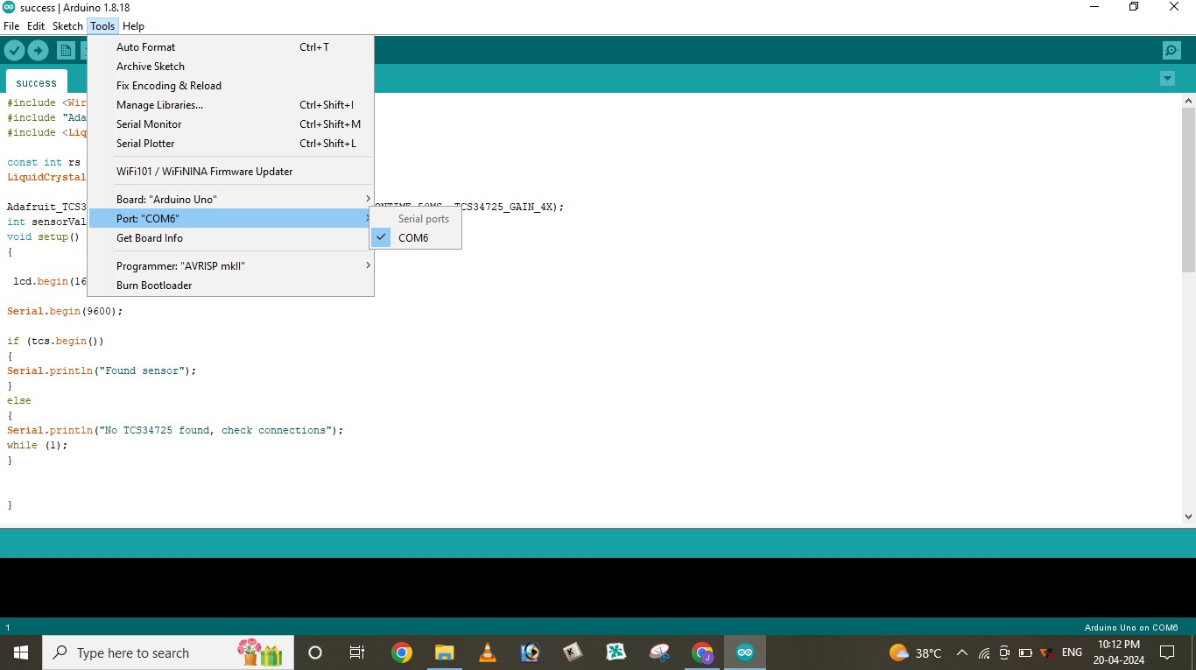

1. **Copy code to arduino**

#include <Wire.h>

#include "Adafruit_TCS34725.h" #include <LiquidCrystal.h>

const int rs = 10, en = 11, d4 = 4, d5= 5, d6 = 6, d7 = 7; LiquidCrystal lcd(rs, en, d4, d5, d6, d7);

Adafruit_TCS34725 tcs = Adafruit_TCS34725(TCS34725_INTEGRATIONTIME_50MS, TCS34725_GAIN_4X);

int sensorValue; void setup()

**{**

lcd.begin(16, 2); Serial.begin(9600); if (tcs.begin())

**{**

Serial.println("Found sensor");

**}**

else

**{**

Serial.println("No TCS34725 found, check connections"); while (1);

**}**

**}**

void loop()

**{**

uint16_t r, g, b, c, colorTemp, lux; tcs.getRawData(&r, &g, &b, &c);

colorTemp = tcs.calculateColorTemperature(r, g, b); lux = tcs.calculateLux(r, g, b);

Serial.print("R: "); Serial.print(r);

Serial.print(" G: "); Serial.print(g); Serial.print(" B: "); Serial.println(b); lcd.setCursor(0,0); lcd.print(" ");

lcd.clear();

if( (r>110 && r<160) && (g>110 && g<190) && (b>100 && b<170))

//if(r>110 && g>150 && b>120)

**{**

Serial.print("Meat is Fresh"); Serial.print(" "); lcd.setCursor(0, 0);

// print the number of seconds since reset: lcd.print("Fresh meat");

lcd.setCursor(0, 1);

// print the number of seconds since reset: lcd.print(":)");

**}**

sensorValue = analogRead(0); // read analog input pin 0 Serial.print("AirQua=");

Serial.print(sensorValue,DEC); // prints the value read Serial.println(" PPM");

delay(100); Serial.println(" "); delay(1000);

**}**

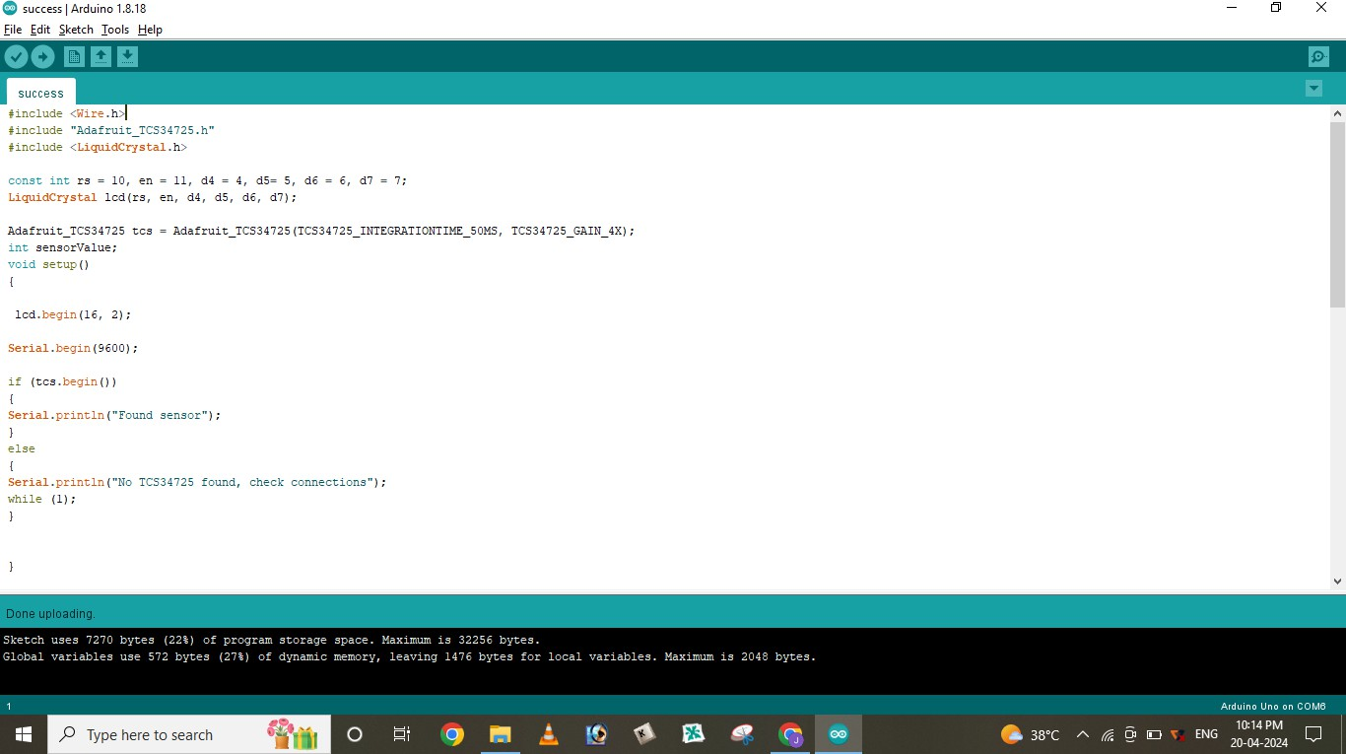

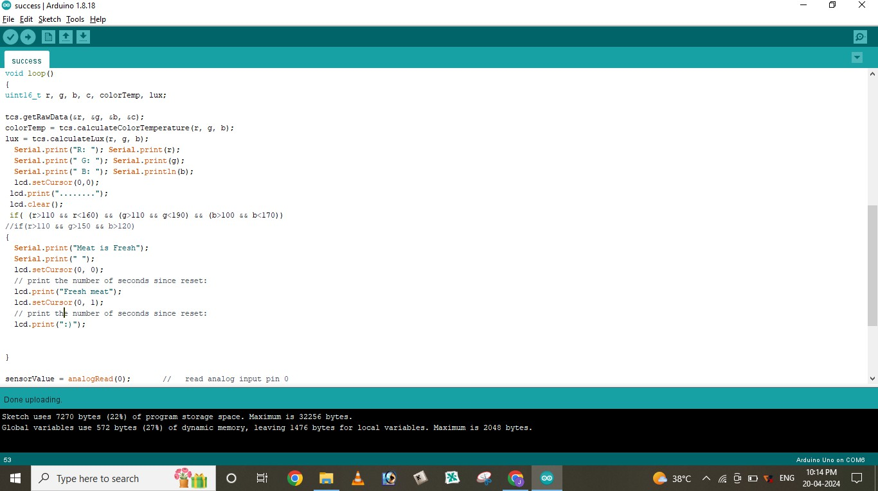

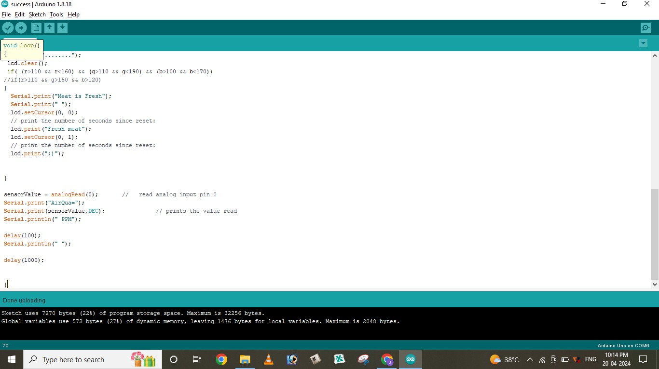

1. **Installation of color sensor**

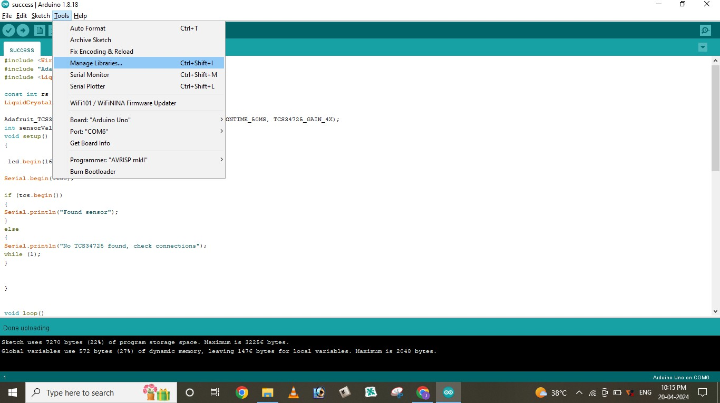

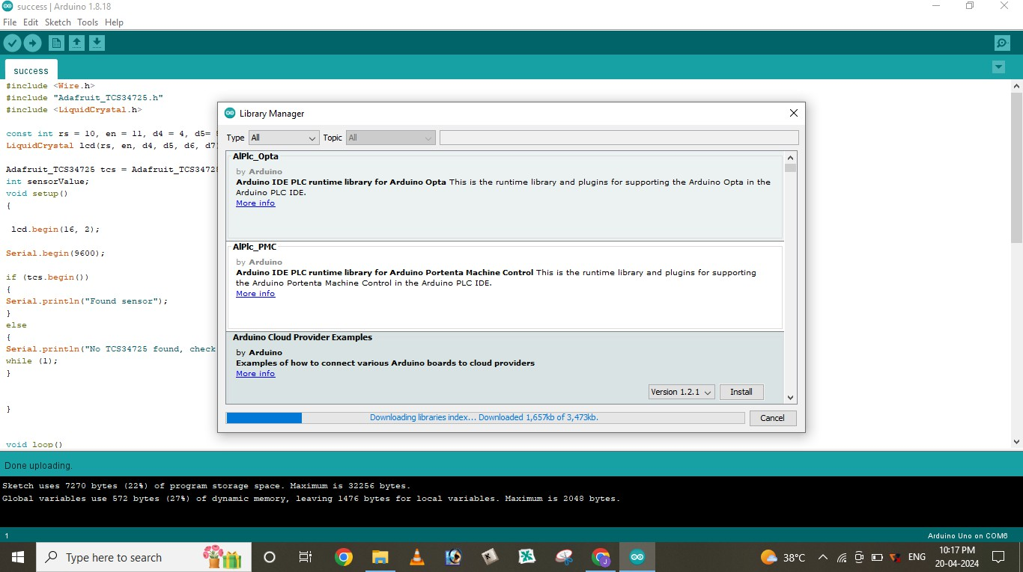

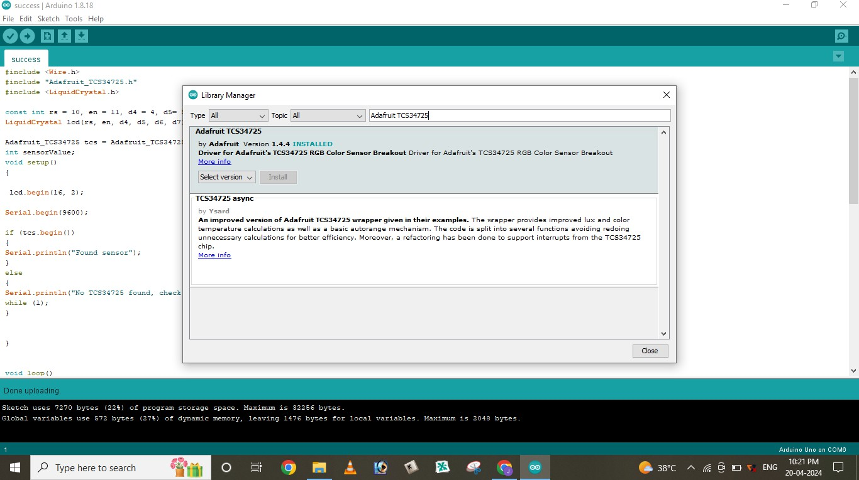

1. **Upload and compile**

