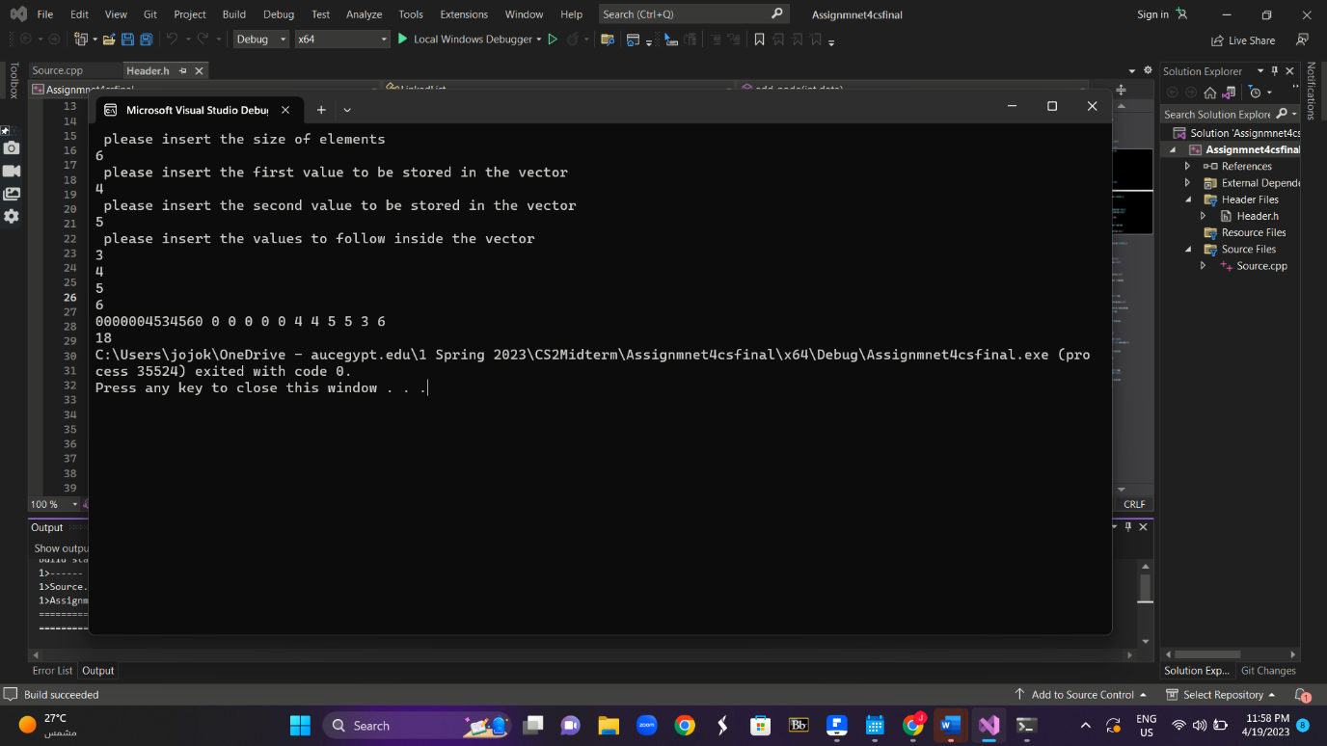

Link to linked list class:

<https://www.youtube.com/watch?v=w8CV57TaY9o>

<https://www.geeksforgeeks.org/program-to-implement-singly-linked-list-in-c-using-class/>