Report:

**Algorithm for During the Standard Run :**

1. Set maximum simulation Time(Tmax)=360 & delta time (DeltaT).=6 minutes
2. Calculated the probability of a plane's arrival (pa) based on DeltaT
3. Create variables to keep track of time (t), runway timer (Tr), total wait time (TotalwaitTime), and the number of planes landed (num_planes_landed).
4. Used the deque template class to store< airplanes> waiting to land (LandingQueue) & we created an instance of airport Runway (Runway)
5. Set the landing time(Tlanding) for the runway object (Runway).
6. Initialized a counter for the number of arrivals (n).
7. Started a while loop that runs as long as t < Tmax. Within the loop:

a. Generate a random R to check if a plane arrives (R<pa).

b. If an airplane arrives, check if the landing queue isFull() ; Else create a new (airplane) object and set its arrival Time ( t), wait time ( 0), and add it to the landing queue.

c. If (! landing queue.isempty()) && the runway timer (Tr) ==0,

retrieve the first airplane in the queue,

plane.setTwait(t - plane.getTarrival());,

pop it from the landing queue.

d. Set the runway to occupied, set the airplane object to the runway, and set Tr to the runway landing time. Increment the number of planes landed and output the arrival time, landing time, and wait time for the airplane.

f. because the runway is occupied, decrement the runway timer.

e. Increment the time counter (t) and arrival counter (n).

8. Calculate the average wait time by dividing the total wait time by the number of planes landed.

9. Output the number of planes landed, total wait time, and average wait time.

**Screenshots & comments :**

In the screenshots below, we were able to output a log of arrivals with their wait times for each airplane Then, we calculated the average wait time.

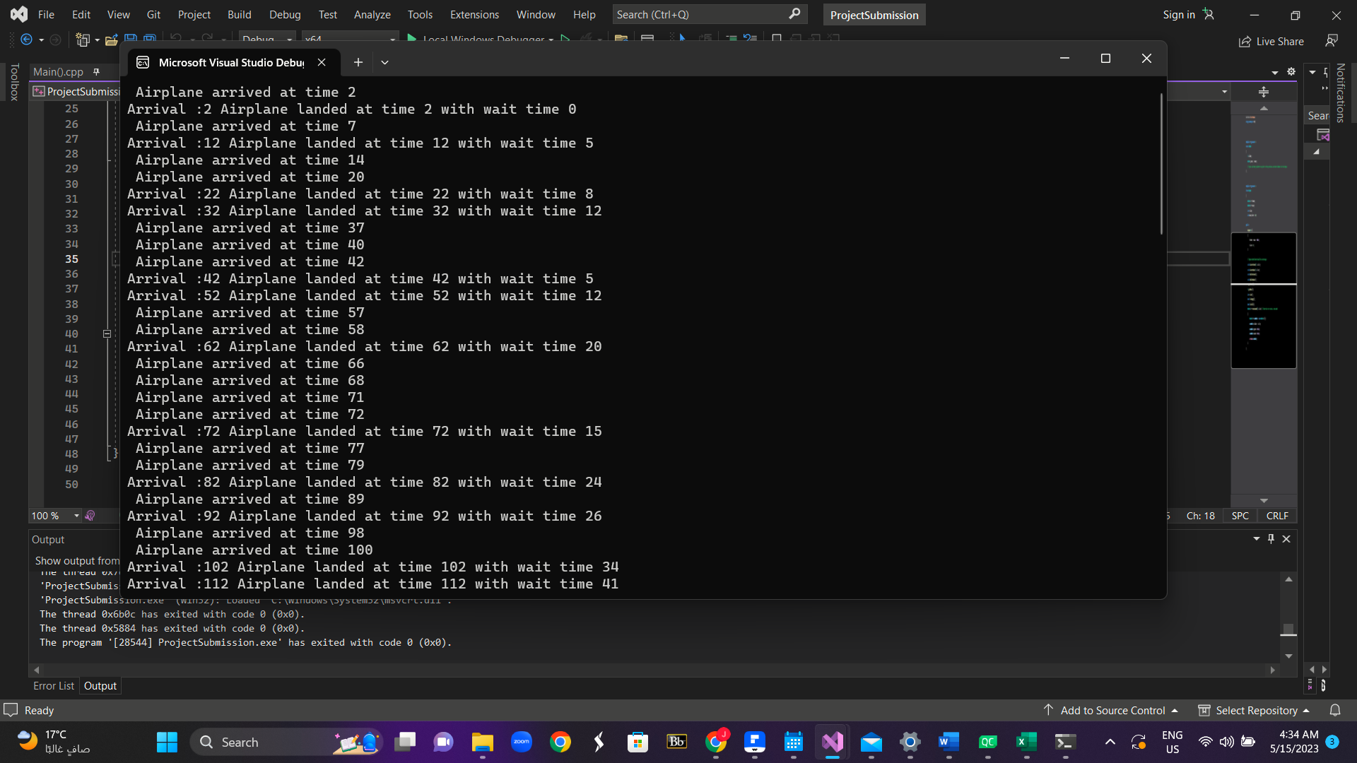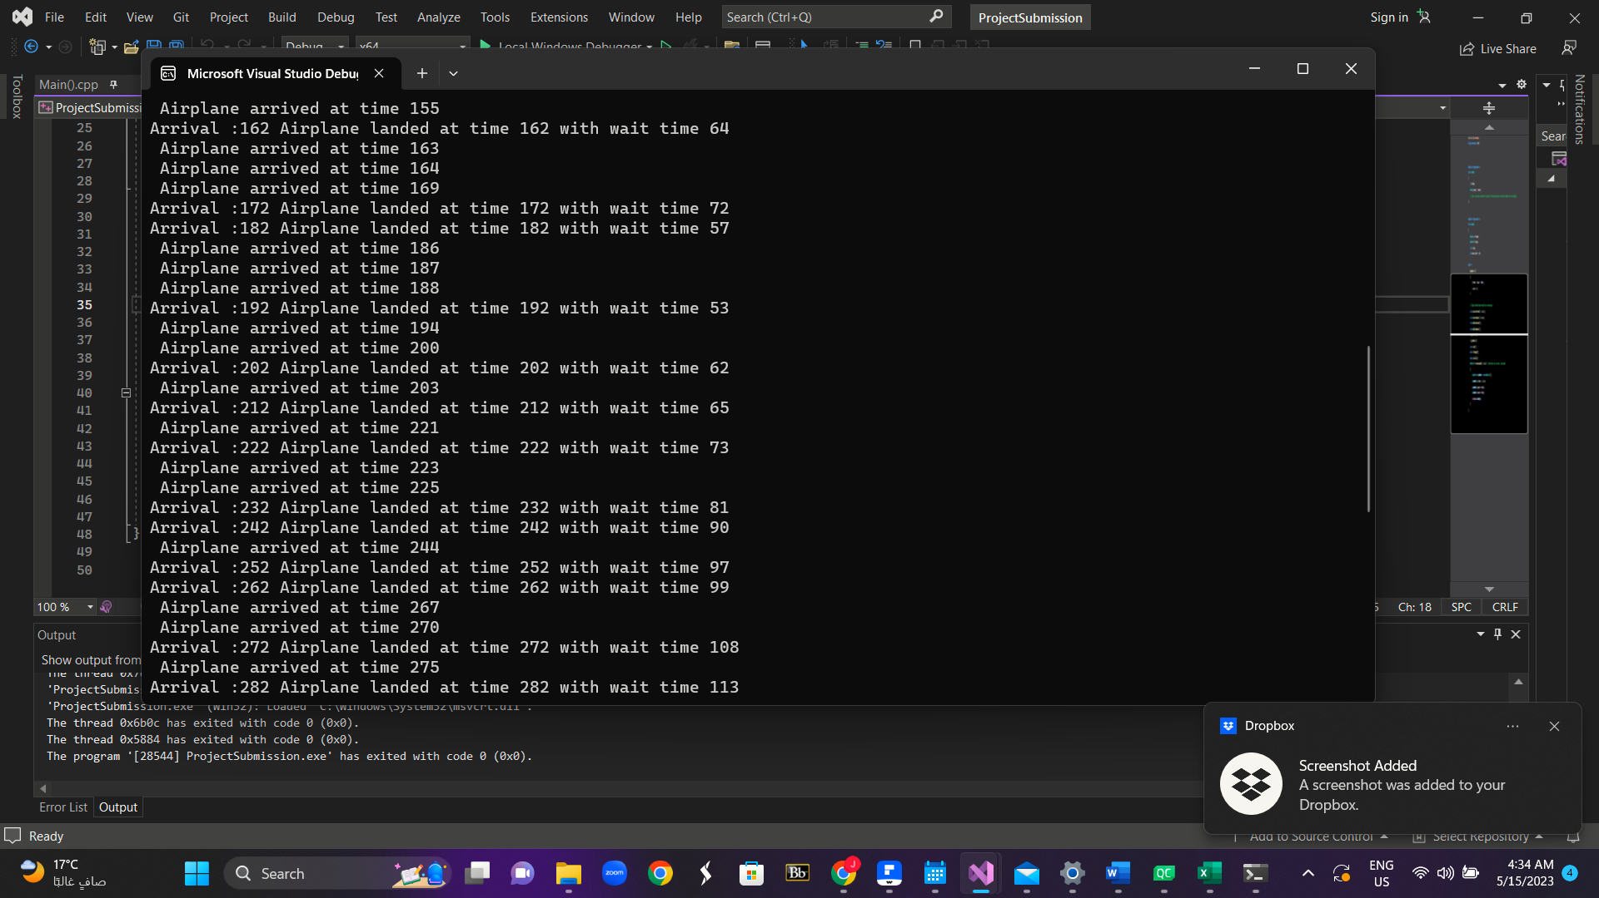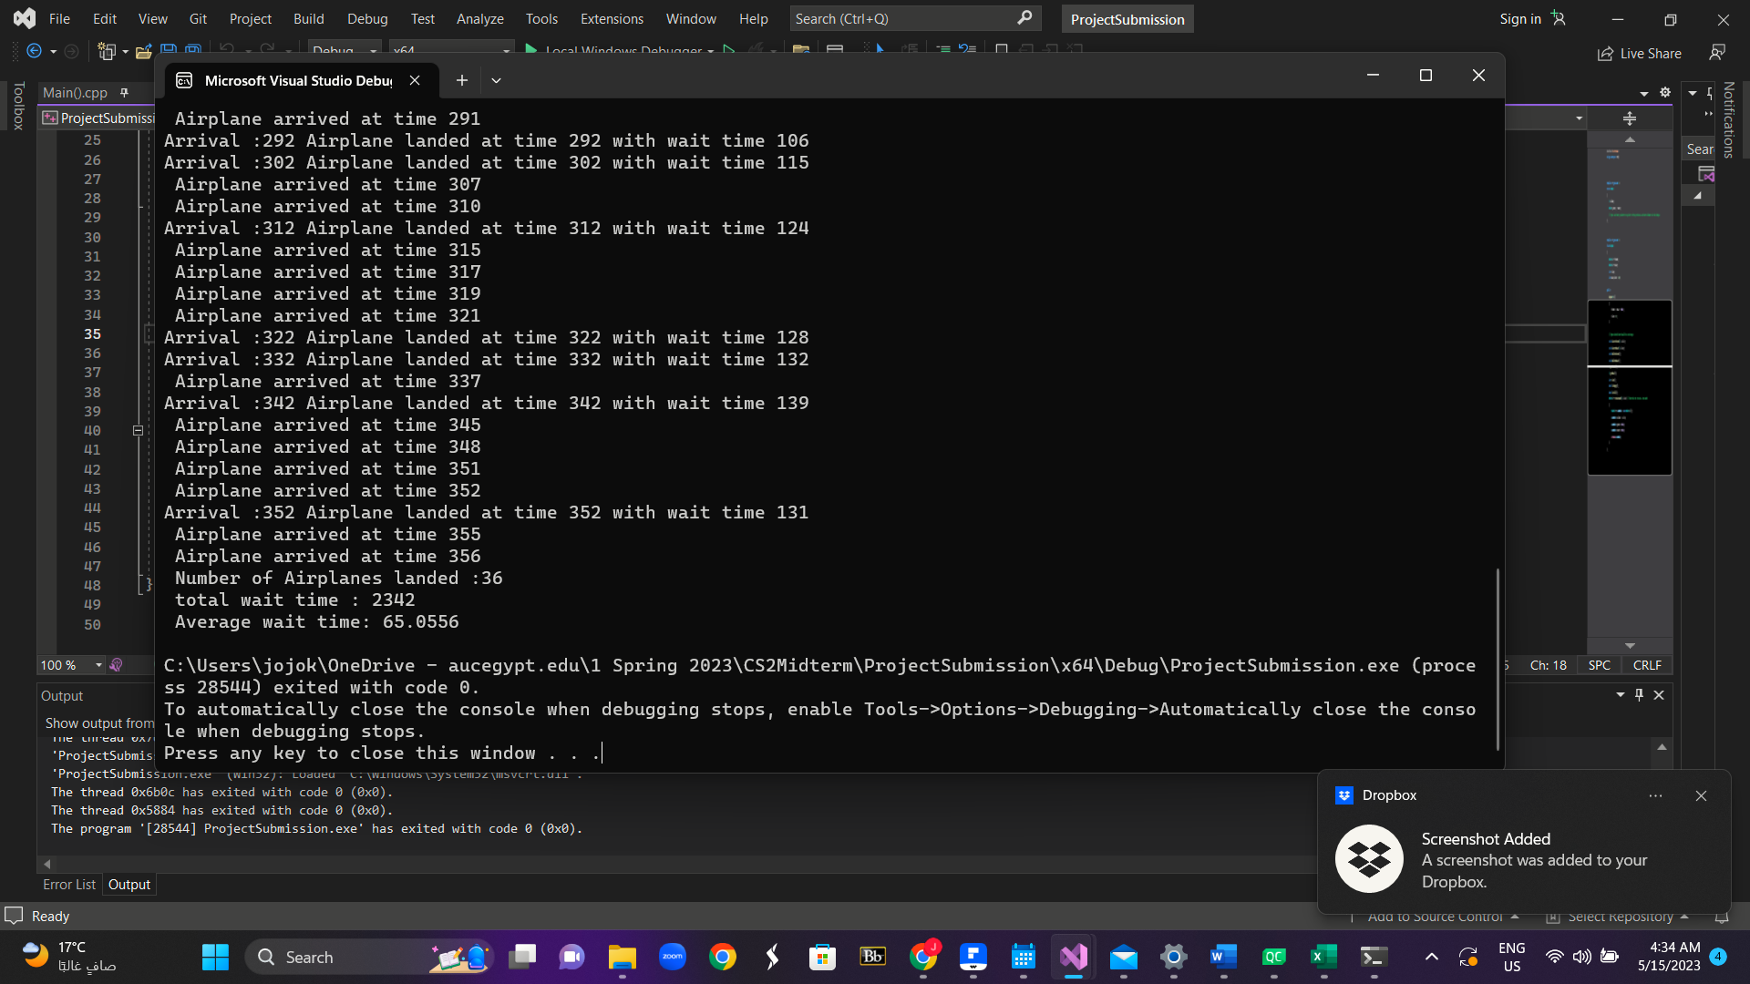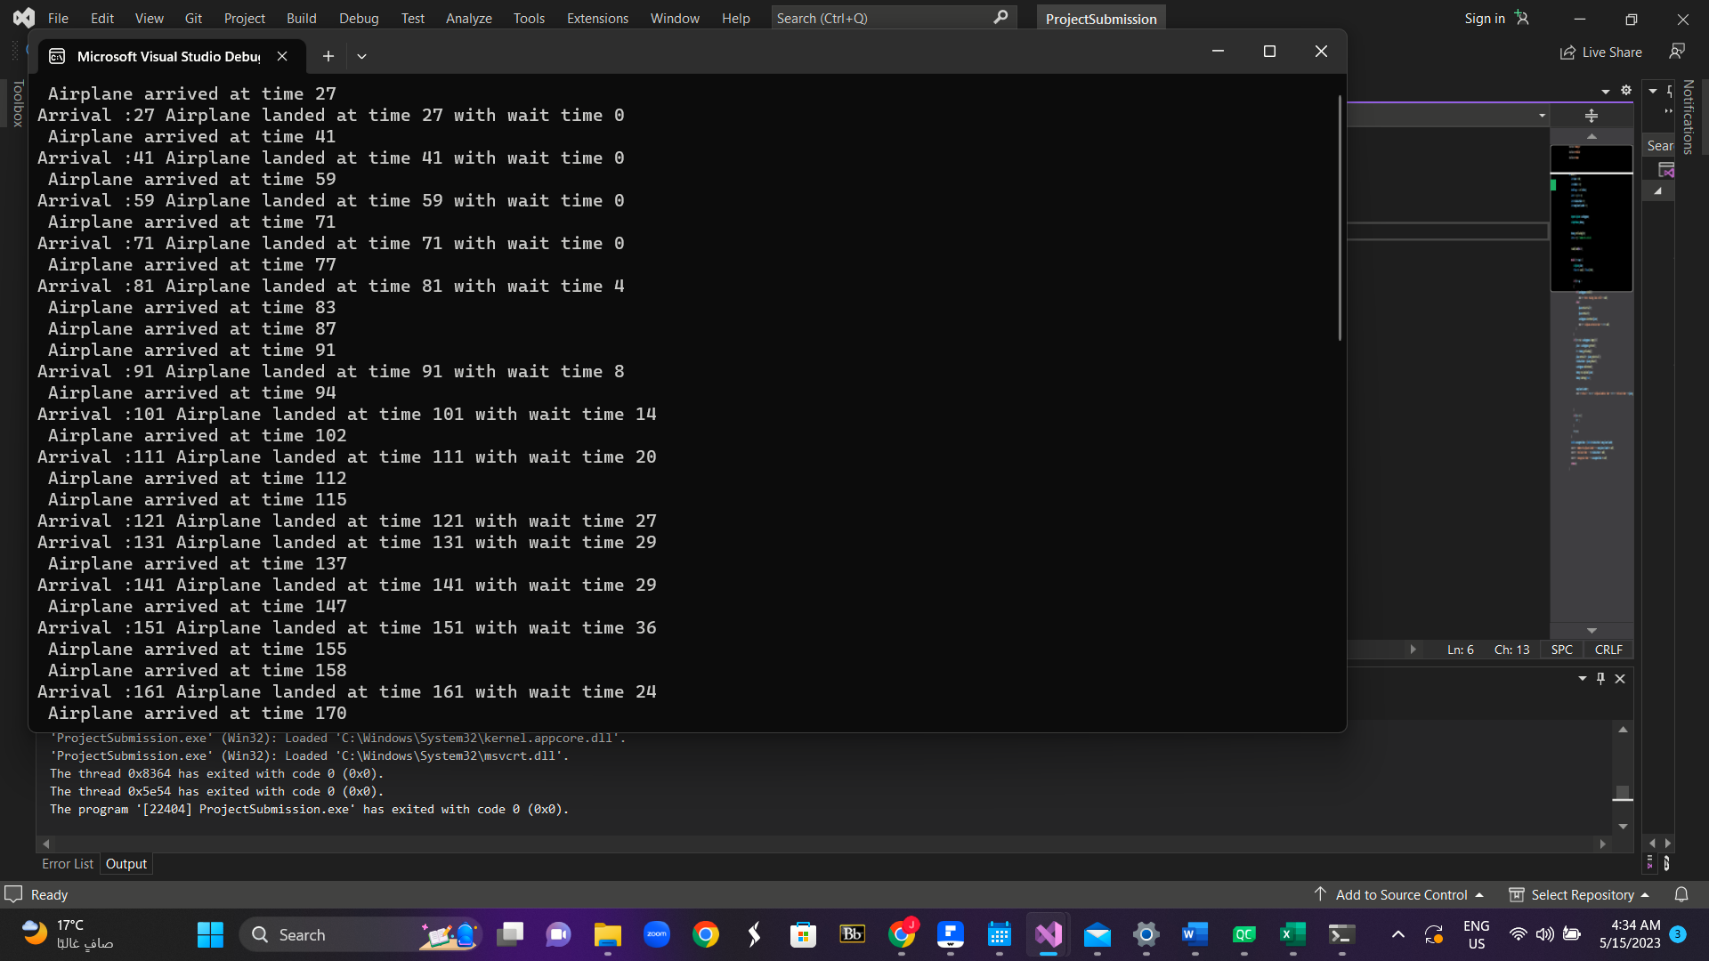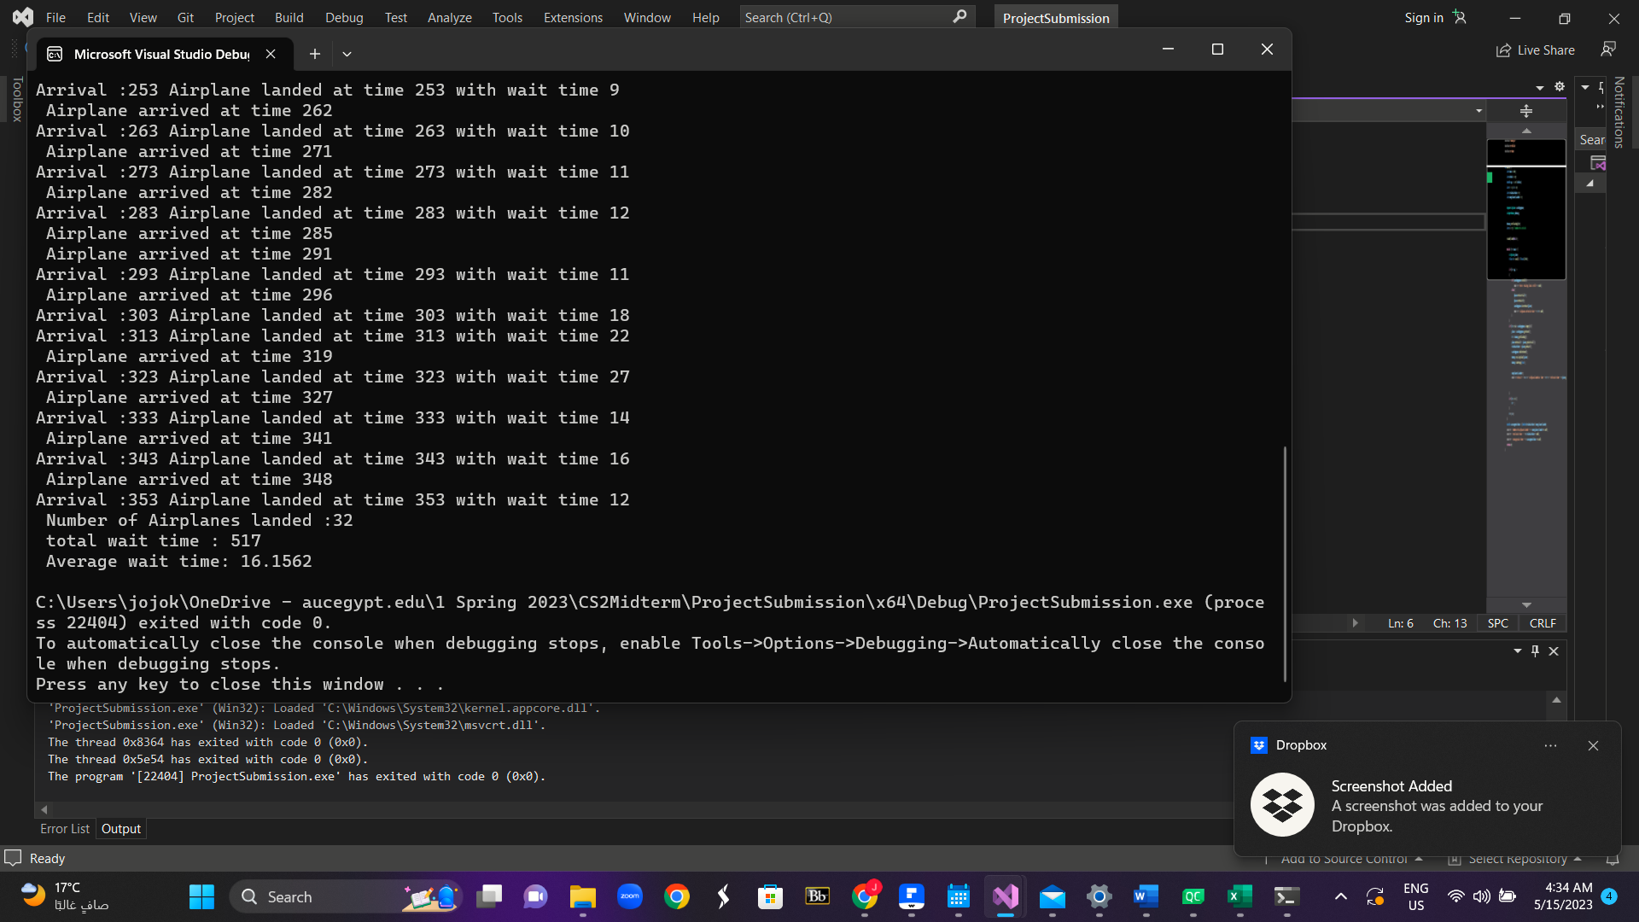

**Methodology :**

To explore the effect of DeltaTand Tlanding, we chose a range of values for each parameter. Then, We modified the code accordingly to incorporate the parameter variations. Before the main loop for the simulation, we inserted a for loop that iterates over the range of DeltaT values and another for loop in a different run to iterate over Tlanding values. Then we collected the data during each simulation run and output it to a text file

**Exploring the effect of DeltaT:**

**Observations:**

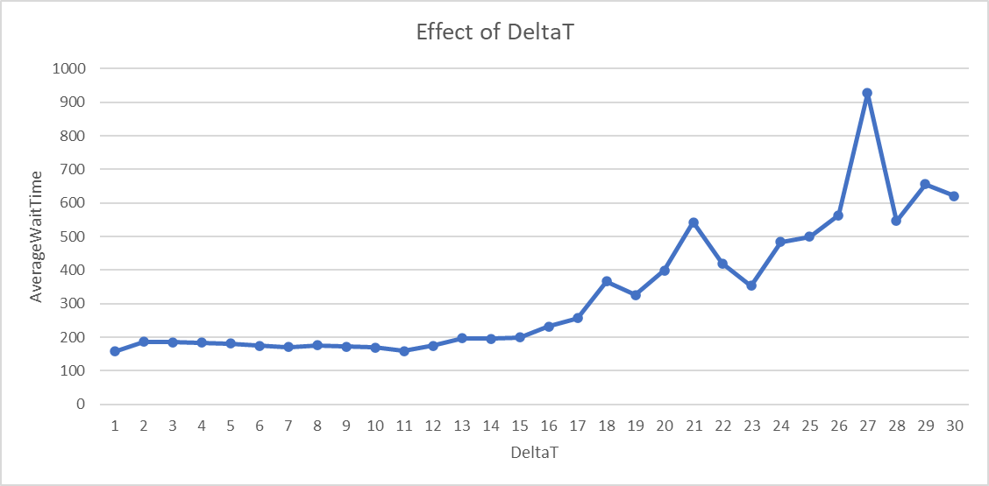

Based on the graph above, The average wait time normally increases progressively as DeltaT climbs from 1 to roughly 10. This implies that the wait times are larger when the time gap between airplane arrivals is smaller

Between DeltaT values 10 and 15, typical wait times vary but stay rather steady, with small increases. This suggests that there may be an ideal DeltaT range where average wait times are generally stable.

Average wait times begin to climb dramatically after DeltaT value 15. This implies that when the time delay between airline arrivals grows too long, wait times tend to increase significantly.

**Conclusion:**

The choice of DeltaT is crucial in properly controlling typical wait times. When DeltaT values are lower (between 1 and 10), it often results in shorter average wait times, suggesting a higher number of airplane arrivals and better runway utilization, making operations more efficient.

Surprisingly, there appears to be a DeltaT optimum range in which average wait times stabilize with few variations. The ideal range is about between DeltaT values of 10 and 15.

However, when DeltaT values surpass 15, typical wait times increase noticeably. This implies that larger gaps between airplane arrivals result in higher wait times and may affect runway efficiency.

Based on these findings, it is reasonable to conclude that striking the proper balance when determining the DeltaT value is critical for efficiently managing wait times and guaranteeing efficient runway operations. The best figure will be determined by a variety of criteria, including the runway's capacity and estimated traffic flow. Further research and testing can help us deepen our understanding of the link between DeltaT and average wait times, allowing us to optimize runway operations.

**Exploring the effect of Tlanding:**

**Observations:**

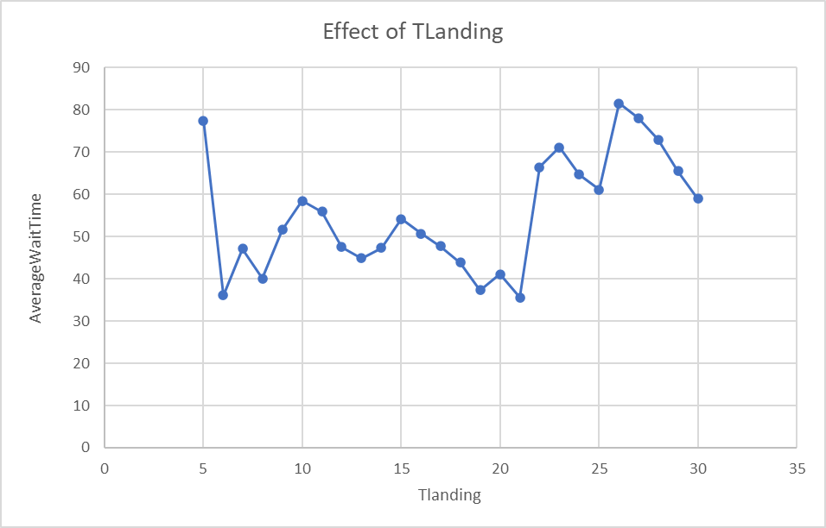

In an airport queue simulation, the data supplied allows us to investigate the link between Tlanding (time for airplane landing) and AveragewaitTime (average wait time in the queue). The following observations are possible:

As Tlanding changes, so does the average wait time.

Tlanding values of 5-15 often correspond to shorter AveragewaitTime, suggesting a greater pace of airplane arrivals and better runway utilization.

AveragewaitTime fluctuates minimally in a consistent range for Tlanding (about 15-20).

Tlanding values greater than 20 cause a rise in AveragewaitTime, implying longer intervals between airplane arrivals, resulting in longer wait times and perhaps poorer runway efficiency.