**CHAPTER 1**

**INTRODUCTION**

* 1. **ROBOTIC PROCESS AUTOMATION**

Robotic process automation (RPA) is the application of technology that allows employees in a company to configure computer software or a “robot” to capture and interpret existing applications for processing a transaction, manipulating data, triggering responses and communicating with other digital systems.

* 1. **PROBLEM DEFINITION**

Rejected trades file is received from the batch process and that is taken as input for the reconcillation process. Trades file is manually processed by the associate by sequentially reading through the file and validating against the security master.If the CUSIP is an equity,it has to be copied to an output file and mailed to the clients. This is highly manual and prone to error.Here we automate this process which will reduce manual time .

**1.3 AIM**

To implement a software robot that reduces human effort for performing various tasks .

**1.4 OBJECTIVES**

The main objective is to implement a software robot that performs the following tasks :

* High Volume – Tasks that need to be performed with large number of employees.
* Highly Repeatable – Tasks that are repeating and does not require much of human intervention.
* Least Complex- Tasks that are not very difficult and which doesn’t require much of human knowledge

**1.5 OVERVIEW**

In this software , the input files get stored in a specified location and the robot fetches those files and reads the records . It then extracts the cussip value from the input file and then populates it into the source application and generates the result set which contains only the equity record . And then writes those equity records into the output files automatically . By making these processes automatic , we can thus reduce a lot of time and human effort which can be used for other significant purposes.

**CHAPTER 2**

**LITERATURE SURVEY**

Robotic process automation (RPA) is the application of technology that allows employees in a company to configure computer software or a “robot” to capture and interpret existing applications for processing a transaction, manipulating data, triggering responses and communicating with other digital systems.

In the finance and accounting (F&A) domain, many manual processes are labor intensive and highly repetitive. The people performing these tasks are human, and may inadvertently introduce errors that require costly rework or even legal action. Automation can help speed up these processes and reduce errors. Some IT groups create integrations between business applications, but this customization is time-consuming, expensive, and often short-lived, as new releases of business applications may require new integration work. Today, RPA is helping automate repetitive tasks across multiple business applications without expensive custom integrations.

RPA simulates a “virtual person” and drives existing application software in the same way as a human user. It orchestrates business application software through existing applications’ user interfaces, so it doesn’t require custom integrations. RPA learns how to perform a task through a combination of screen captures (screen scrapping) and scripting. Today, RPA automates end-to-end manual processes, with a focus on repetitive rules-based transactional processing.

While RPA can reduce costs by replacing some full-time employees (FTEs) with automation, its benefits go beyond cost-cutting. By eliminating mind-numbing repetitive processes, organizations can free up resources to work on tasks that require a higher skill level, and provide greater value to an organization. This gives employees more challenging work to perform and better career opportunities. In addition, RPA provides faster throughput with greater accuracy and less rework. In F&A, automation helps reduce fraud, increases on-time payments, and minimizes discount losses.

An accounting process used to compare two sets of records to ensure the figures are in agreement and are accurate. **Reconciliation** is the key process used to determine whether the money leaving an account matches the amount spent, ensuring the two values are balanced at the end of the recording period.

In our project, the first step is to set up the configuration screen with the basic requirements such as screen bounds, width, input type, tag name, cusip coordinates. And then it goes to the parent URL automatically as specified in the screen. In the Second step, robot will automatically open the trade file which serves as the input file for them and it would read it like a human. Next, it would zone the cusip value in the input file and populate it in the source application.

Finally the result will be displayed in the screen, then the robot will zone the resultset based on the coordinates specified in the configuration screen and if the zoned area has equity ,then that record is automatically copied to the output file and mailed to the clients.

**2.1 EXISTING SYSTEM**

In the already existing system the rejected trade files are stored in a particular location. The employee opens the file manually, reads it and then he has to find the cusip id in the file and put in the security master search screen. The result set will be displayed on the screen and if that record is of type equity, then he should copy the same record in a new output text file. According to the Client’s the output files have to be sent to their corresponding mail id.This process is done manually for multiple records.(maybe a thousand records)

**2.1.1 DRAWBACKS OF EXISTING SYSTEM**

* The error rate is very high as the employee may miss some of the records from the input text file.
* Manually, the time taken for the reconciliation process is very high.
* The process does not give any work for the brain, i.e it is highly repetitive.

**2.2 PROPOSED SYSTEM**

In our system, we set the requirements in the configuration screen that we have built and it automatically goes to the URL path specified in the screen. The trade files stored in the specified location are the input files for the robot. The robot will automatically open the file and read it like a human. Then it will zone the cusip value in the input file and populate it in the source application. The result will be displayed on the screen.The robot will zone theresult set based on the coordinates specified in the configuration screen and if the zoned area has equity ,then that record is automatically copied to the output file and mailed to the clients.

**2.2.1 BEST FEATURES OF THE SYSTEM**

* It is 100% accurate. There is no chance of any records being missed.
* It works at very high speed.
* It is scalable.
* It can be scheduled to run every day as soon as the input file is received.

To view any transaction, the processing can be paused at any time.

**2.1 SYSTEM REQUIREMENT**

To be used efficiently all computer software needs certain hardware components or other software resources to be present on a computer. These requirements are known as (computer) system requirements. Most software defines two sets of system requirements: minimum and recommended. With increasing demand for higher processing power and resources in newer versions of software, system requirements tend to increase over time. Industry analysts suggest that this trend plays a bigger part in driving upgrades to existing computer systems than technological advancements.

**2.2 FUNCTIONAL AND NON FUNCTIONAL REQUIREMENTS**

**2.2.1 Functional Requirement**

Functional requirement as the product capabilities are things that a product must do for its users. Functional requirements define how software behaves to meet user needs. A functional requirement is a requirement that , when satisfied, will allow the user to perform some kind of function.

**2.2.2 Non Functional Requirement**

Non functional requirements as the quality attributes, design and implementation constraints, and external interfaces which a product must have. Quality attributes are often affectionately called the “ilities” because the names of many of them end in ility. Examples of quality attributes include availability, maintainability, performance, portability, reliability, robustness, security, scalability, testability, usability and others. Many non functional requirements are global in nature; they applied to an entire system.

**2.3 HARDWARE AND SOFTWARE SPECIFICATION**

**2.3.1 Hardware Requirements**

The most common set of requirements defined by any operating system or software application is the physical computer resources, also known as hardware. A hardware requirement list is often accompanied by a Hardware Compatibility List(HCL), especially in case of operating systems. An HCL lists tested, compatible and sometimes incompatible hardware devices for a particular operating system or application.

* SYSTEM : IBM-Compatible PC
* PROCESSOR : Pentium IV
* SPEED : 2.0 GHz
* MEMORY : 256 MB RAM
* HARD DISK DRIVE : 40 GB and above.

**2.3.2 Software Specification**

Softaware requirements deal with defining software resource requirements and requirements that need to be installed on a computer to provide optimal functioning of an application. These requirements are generally not included in the software installation package and need to be install separately before the software is installed.

* PLATFORM : Windows 7
* LANGUAGE USED : JAVA, HTML
* DATABASE USED : Oracle
* TOOLS USED : Eclipse Kepler

**CHAPTER 3**

**SYSTEM ANALYSIS AND DESIGN**

**3.1 SYSTEM ANALYSIS**

Systems are created to solve problems. One can think of the systems approach as an organized way of dealing with a problem. In this dynamic world, the subject system analysis and design, mainly deals with the software development activities. A collection of components that work together to realize some objectives forms a system. Basically there are three major components in every system, namely input, processing and output.

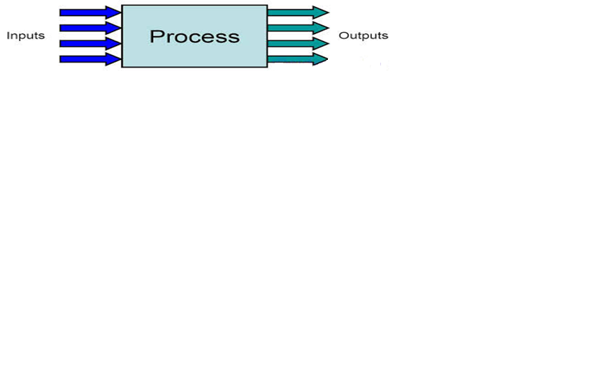

In a system the different components are connected with each other and they are interdependent. The objective of the system demands that some output is produced as a result of processing the suitable inputs. A well designed system also includes an additional element referred to as ‘control’ that provides a way feedback to achieve desired objectives of the system.

System analysis is a process of collecting factual data, understand the process involved, identifying problems and recommending feasible suggestions for improving the system functioning. This involves studying the business processes, gathering operational data, understand the information flow, finding out bottlenecks and evolving solutions for overcoming the weaknesses of the system so as to achieve the organizational goals. System analysis also includes subdividing of complex process involving the entire system, identification of data store and manual processes. The major objectives of system analysis are to find answers for each business process:

What is being done, How is it being done, Who is doing it, When is he doing it, Why is it being done and How can it be improved? It is more of a thinking process and involves the creative skills of the system analyst.

It attempts to give birth to a new efficient system that satisfies the current needs of the user and has scope for future growth within the organizational constraints. The result of this process is a logical system design. System analysis is an iterative process that continues until a preferred and acceptable solution emerges.

**3.1.1 SYSTEM LIFE CYCLE**

System life cycle is an organizational process of developing and maintaining systems. It helps in establishing a system project plan, because it gives overall list of processes and sub-processes required for developing a system. System development life cycle means combination of various activities. In other words we can say that various activities put together are referred as system development life cycle. In the system analysis and design terminology, the system development life cycle also means software development life cycle. The different phases of system development life cycle is shown in this diagram.

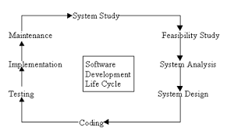

**3.2 SYSTEM STUDY**

For the development of **Robotic Process Automation** the following packages are used

**3.2.1 Apache Tomcat 7.0.53**

Apache Tomcat is an open source software implementation of the Java Servlet and Java Server Pages technologies. The Java Servlet and Java Server Pages specifications are developed under the [Java Community Process](http://jcp.org/en/introduction/overview).

It is developed in an open and participatory environment and released under the [Apache License version 2](http://www.apache.org/licenses). Apache Tomcat is intended to be a collaboration of the best-of-breed developers from around the world. Apache Tomcat powers numerous large-scale, mission-critical web applications across a diverse range of industries and organizations. It also provides by default a HTTP connector on port 8080, which helps it to work as a HTTP server.

Apache Tomcat, Tomcat, Apache, the Apache feather, and the Apache Tomcat project logo are trademarks of the Apache Software Foundation.

**3.2.2 JDK 1.7**

The Java Development Kit (JDK) is an implementation of either one of the [Java SE](http://en.wikipedia.org/wiki/Java_SE), [Java EE](http://en.wikipedia.org/wiki/Java_EE) or [Java ME](http://en.wikipedia.org/wiki/Java_ME) platforms[[1]](http://en.wikipedia.org/wiki/Java_Development_Kit#cite_note-1)released by [Oracle Corporation](http://en.wikipedia.org/wiki/Oracle_Corporation) in the form of a binary product aimed at [Java](http://en.wikipedia.org/wiki/Java_(programming_language)) developers on [Solaris](http://en.wikipedia.org/wiki/Solaris_(operating_system)), [Linux](http://en.wikipedia.org/wiki/Linux), [Mac OS X](http://en.wikipedia.org/wiki/Mac_OS_X) or [Windows](http://en.wikipedia.org/wiki/Windows).

The JDK includes a private JVM and a few other resources to finish the recipe to a Java Application. Since the introduction of the [Java](http://en.wikipedia.org/wiki/Java_(software_platform)) platform, it has been by far the most widely used Software Development Kit ([SDK](http://en.wikipedia.org/wiki/Software_development_kit)).On 17 November 2006, Sun announced that it would be released under the [GNU General Public License](http://en.wikipedia.org/wiki/GNU_General_Public_License) (GPL), thus making it [free software](http://en.wikipedia.org/wiki/Free_software).

**3.2.3 Eclipse Kepler**

In [computer programming](http://en.wikipedia.org/wiki/Computer_programming), Eclipse is an [integrated development environment](http://en.wikipedia.org/wiki/Integrated_development_environment) (IDE). It contains a base [workspace](http://en.wikipedia.org/wiki/Workspace) and an extensible [plug-in](http://en.wikipedia.org/wiki/Plug-in_(computing))system for customizing the environment. Written mostly in [Java](http://en.wikipedia.org/wiki/Java_(programming_language)), Eclipse can be used to develop applications. By means of various plug-ins, Eclipse may also be used to develop applications in other [programming languages](http://en.wikipedia.org/wiki/Programming_language): [Ada](http://en.wikipedia.org/wiki/Ada_(programming_language)), [ABAP](http://en.wikipedia.org/wiki/ABAP), [C](http://en.wikipedia.org/wiki/C_(programming_language)), [C++](http://en.wikipedia.org/wiki/C%2B%2B), [COBOL](http://en.wikipedia.org/wiki/COBOL), [Fortran](http://en.wikipedia.org/wiki/Fortran), [Haskell](http://en.wikipedia.org/wiki/Haskell_(programming_language)), [JavaScript](http://en.wikipedia.org/wiki/JavaScript), [Lasso](http://en.wikipedia.org/wiki/Lasso_(programming_language)), [Lua](http://en.wikipedia.org/wiki/Lua_(programming_language)), [Natural](http://en.wikipedia.org/wiki/NATURAL), [Perl](http://en.wikipedia.org/wiki/Perl), [PHP](http://en.wikipedia.org/wiki/PHP), [Prolog](http://en.wikipedia.org/wiki/Prolog), [Python](http://en.wikipedia.org/wiki/Python_(programming_language)), [R](http://en.wikipedia.org/wiki/R_(programming_language)), [Ruby](http://en.wikipedia.org/wiki/Ruby_(programming_language)) (including [Ruby on Rails](http://en.wikipedia.org/wiki/Ruby_on_Rails) framework), [Scala](http://en.wikipedia.org/wiki/Scala_(programming_language)), [Clojure](http://en.wikipedia.org/wiki/Clojure), [Groovy](http://en.wikipedia.org/wiki/Groovy_(programming_language)), [Scheme](http://en.wikipedia.org/wiki/Scheme_(programming_language)), and [Erlang](http://en.wikipedia.org/wiki/Erlang_(programming_language)). It can also be used to develop packages for the software [Mathematica](http://en.wikipedia.org/wiki/Mathematica). Development environments include the Eclipse Java development tools (JDT) for Java and Scala, Eclipse CDT for C/C++ and Eclipse PDT for PHP, among others.

The initial [codebase](http://en.wikipedia.org/wiki/Codebase) originated from [IBM VisualAge](http://en.wikipedia.org/wiki/IBM_VisualAge). The Eclipse [software development kit](http://en.wikipedia.org/wiki/Software_development_kit) (SDK), which includes the Java development tools, is meant for Java developers. Users can extend its abilities by installing plug-ins written for the Eclipse Platform, such as development toolkits for other programming languages, and can write and contribute their own plug-in modules.

Released under the terms of the [Eclipse Public License](http://en.wikipedia.org/wiki/Eclipse_Public_License), Eclipse [SDK](http://en.wikipedia.org/wiki/Software_development_kit) is [free and open source software](http://en.wikipedia.org/wiki/Free_and_open_source_software) (although it is incompatible with the [GNU General Public License](http://en.wikipedia.org/wiki/GNU_General_Public_License)). It was one of the first IDEs to run under [GNU Classpath](http://en.wikipedia.org/wiki/GNU_Classpath) and it runs without problems under [IcedTea](http://en.wikipedia.org/wiki/IcedTea).

**3.3 SYSTEM FEATURES**

**Java** is a general-purpose computer programming languagethat is concurrent, class-based, object-oriented, and specifically designed to have as few implementation dependencies as possible. It is intended to let application developers "write once, run anywhere” (WORA) meaning that compiledJava code can run on all platforms that support Java without the need for recompilation. Java applications are typically compiled to bytecodethat can run on any Java virtual machine(JVM) regardless of computer architecture. As of 2015, Java is one of the most popular programming languages in use, particularly for client-server web applications, with a reported 9 million developers. Java was originally developed by James Goslingat Sun Microsystems(which has since merged into Oracle Corporation) and released in 1995 as a core component of Sun Microsystems’ Java platform. The language derives much of its syntax from Cand C++, but it has fewer low-level facilities than either of them.

Five primary goals in the creation of Java language :

* Simple, object-oriented and familiar
* Robust and secure
* Architecture-neutral and portable
* High performance
* Interpreted, threaded, and dynamic

HyperText Markup Language, commonly referred to as HTML, is the standard markup language used to create web pages. It is written in the form of HTML elements consisting of tags enclosed in angle brackets (like <html>). HTML tags most commonly come in pairs like <h1> and </h1>, although some tags represent empty elements and so are unpaired, for example <img>. The first tag in a pair is the start tag, and the second tag is the end tag (they are also called opening tags and closing tags).

Web browsers can read HTML files and compose them into visible or audible web pages. Browsers do not display the HTML tags and scripts, but use them to interpret the content of the page. HTML describes the structure of a website semantically along with cues for presentation, making it a markup language, rather than a programming language.

HTML elements form the building blocks of all websites. HTML allows images and objects to be embedded and can be used to create interactive forms. It provides a means to create structured documents by denoting structural semantics for text such as headings, paragraphs, lists, links, quotes and other items. It can embed scripts written in languages such as JavaScript which affect the behavior of HTML web pages.

Web browsers can also refer to Cascading Style Sheets (CSS) to define the look and layout of text and other material. The World Wide Web Consortium (W3C), maintainer of both the HTML and the CSS standards, encourages the use of CSS over explicit presentational HTML.

In computer programming, Eclipse is an integrated development environment (IDE). It contains a base workspace and an extensible plug-in system for customizing the environment. Written mostly in Java, Eclipse can be used to develop applications. By means of various plug-ins, Eclipse may also be used to develop applications in other programming languages: Ada, ABAP, C, C++, COBOL, Fortran, Haskell, JavaScript, Lasso, Lua, Natural, Perl, PHP, Prolog, Python, R, Ruby (including Ruby on Rails framework), Scala, Clojure, Groovy, Scheme, and Erlang. It can also be used to develop packages for the software Mathematica. Development environments include the Eclipse Java development tools (JDT) for Java and Scala, Eclipse CDT for C/C++ and Eclipse PDT for PHP, among others.

The initial codebase originated from IBM VisualAge. The Eclipse software development kit (SDK), which includes the Java development tools, is meant for Java developers. Users can extend its abilities by installing plug-ins written for the Eclipse Platform, such as development toolkits for other programming languages, and can write and contribute their own plug-in modules.

Released under the terms of the Eclipse Public License, Eclipse SDK is free and open source software (although it is incompatible with the GNU General Public License). It was one of the first IDEs to run under GNU Classpath and it runs without problems under IcedTea.

**3.4 SYSTEM DESIGN**

Based on the user requirements and the detailed analysis of the existing system, the new system must be designed. This is the phase of system designing. It is the most crucial phase in the developments of a system. The logical system design arrived at as a result of systems analysis is converted into physical system design. Normally the design proceeds in two stages:

**3.4.1 Preliminary or General Design**

In the preliminary or general design, the features of the new system are specified. The costs of implementing these features and the benefits to be derived are estimated. If the project is still considered to be feasible, we move to the detailed design stage.

**3.4.2 Structured Or Detailed Design**

In the detailed designed stage, computer oriented work begins in earnest. At this stage, the design of the system becomes more structured. Structure design is a blue print of a computer system solution to a given problem having the same components and inter relationships among the same components as the original problem. Input, output, databases, forms, codification schemes and processing specifications are drawn up in detail.

In the design stage, the programming language and the hardware and software platform in which the new system will run are also decided. There are several tools and techniques used for describing the system design of the system. These tools and techniques are:

* Flowchart
* Data Flow Diagram (DFD)

**3.4 DATABASE**

A database is an organized collection of data. The data is typically organized to model relevant aspects of reality(for example, the availability of rooms in hotels), in a way that supports processes requiring this information(for example, finding a hotel with vacancies). A general purpose database management system(DBMS) is a software system design to allow the definition, creation, querying, update and administration of databases. Well known DBMSs include Oracle database. It consists of only one table in our system and that is

* Equity table

**Equity Table:**

Equity table is used to store the details of equity. It consists of the columns such as symbol, cusip, underlying symbol, underlying cusip, description, div.reinvest eligible, origin, intl id, identifier value, expiry date, strike price, asset type-asset class.

**TABLE - EQUITY**

|  |  |  |
| --- | --- | --- |
| SERIAL NO | COLUMN NAME | DATA |
| 1. | Symbol | Varchar(20) |
| 2. | Cusip | Varchar(20) |
| 3. | Underlying Symbol | Varchar(20) |
| 4. | Underlying Cusip | Varchar(20) |
| 5. | Description | Varchar(20) |
| 6. | Div.Reinvest Eligible | Varchar(20) |
| 7. | Origin | Varchar(20) |
| 8. | Intl ID | Varchar(20) |
| 9. | Identifier Value | Varchar(20) |
| 10. | Expiry Date | Varchar(20) |
| 11. | Strike Price | Varchar(20) |
| 12. | Asset type-Asset class | Varchar(20) |

**ER-Diagram**

**EQUITY**

FIG 3.4.1 ER DIAGRAM

**DATA FLOW DIAGRAM**

LOGOUT

LOGIN

**LEVEL 0 :**

FIG 3.4.2 DFD LEVEL 0

**LEVEL 1 :**

LOGOUT

LOGIN

FIG 3.4.3 DFD LEVEL 1

**LEVEL 2:**

ADMIN

LOGOUT

RPA PROCESSING

APPLICATION CONFIGURATION

FIG 3.4.4 DFD LEVEL 2

**CHAPTER 4**

**SYSTEM IMPLEMENTATION AND TESTING**

**4.1 SYSTEM IMPLEMENTATION**

After having the user acceptance of the new software developed , the implementation phase begins.Implementation is the stage of a project during which theory is turned into practice.The major steps involved in this phase are:

* Acquisition and Installation of Hardware and Software
* Conversion
* User Training
* Documentation

The Hardware and the relevant software required for running the system must be made fully operational before implementation .The conversion is also one of the most critical and expensive activities in the system development life cycle.The database needs to be setup with security and recovery procedures fully defined .

During the phase , all the programs of the system are loaded onto the user’s computer.After loading the system,training of the user starts.

Main topics of such type of training are :

* How to execute the package
* How to enter the data
* How to process the data(processing details)
* How to take out the reports

After the users are trained about the computerized system , working has to shift from manual to computerized working.The process is called “Changeover”.The following strategies are followed for changeover of the system :

**(1)Direct Changeover :**

This is the complete replacement of the old system by the new system. It is a risky approach and requires comprehensive system testing and training.

**(2)Parallel Run :**

In the parallel run both the systems, i.e. computerized and manual , are executed simultaneously for certain defined period. The same data is processed by both the systems. This strategy is less risky but more expensive because of the following :

* Manual results can be compared with the results of the computerized system.
* The operational work is doubled
* Failure of the computerized system at the early stages does not affect the working of the organization ,because the manual system continues to work, as it used to do .

**(3)Pilot Run :**

In this type of run ,the new system is run the with the data from one or more of the previous periods for the whole part of the system. The results are compared with the old system results. This strategy builds the confidence and the errors are traced easily affecting the operations. The documentation of the system is also one of the most important activity in the system development life cycle. This ensures the continuity of the system. There are generally two types of documentation prepared for any system.

These are :

* User or Operator Documentation
* System Documentation

The user documentation is a complete description of the system from the users point of view detailing how to use or operate the system. It also includes the major error messages likely to be encountered by the users. The system documentation contains the details of the system design , programs , their coding, system flow, data dictionary and process description ,etc..

**Maintenance:**

It is necessary to eliminate errors in the system during its working life and to tune the system to any variations in its working environments. It has been seen that there are always some errors found in the systems that must be noted and corrected. It also means the review of the system from time to time .The review of the system is done for :

* Knowing the full capabilities
* Knowing the required changes or the additional requirements
* Studying the performance

If a major change to a system is needed, a new project may have to be set up to carry out the change. The new Project will then proceed through all the above life cycle phases

**4.2 PROJECT DESCRIPTION**

An accounting process used to compare two sets of records to ensure the figures are in agreement and are accurate. **Reconciliation** is the key process used to determine whether the money leaving an account matches the amount spent, ensuring the two values are balanced at the end of the recording period.

In our project, the first step is to set up the configuration screen with the basic requirements such as screen bounds, width, input type, tag name, cusip coordinates. And then it goes to the parent URL automatically as specified in the screen. In the Second step, robot will automatically open the trade file which serves as the input file for them and it would read it like a human. Next, it would zone the cusip value in the input file and populate it in the source application.

Finally the result will be displayed in the screen, then the robot will zone the resultset based on the coordinates specified in the configuration screen and if the zoned area has equity ,then that record is automatically copied to the output file and mailed to the clients.

**4.3 TESTING** Software testing is the process of evaluating a software item to detect difference between given input and expected output. Also to assess the feature of a software item. Testing assesses the quality of the product .Software testing is a process that should be done during the development process. In other words , software testing is a verification and validation process.

**VERIFICATION :**

Verification is the process to make sure the product satisfies the conditions imposed at the start of the development phase. In other words ,to make sure the product behaves the way we want it to .

**VALIDATION :**

Validation is the process to make sure that the product satisfies the specified requirements at the end of the development phase. In other words ,to make sure the product is built as per customer requirements.

**4.3.1 TYPES OF TESTING :**

There are many types of testing like :

* Unit Testing
* Integration Testing
* Functional Testing
* System Testing
* Stress Testing
* Performance Testing
* Usability Testing
* Acceptance Testing
* Regression Testing
* Beta Testing
* Black Box Testing
* White Box Testing

**UNIT TESTING :**

Unit testing is the testing of an individual unit of group of related units. It falls under the class of white box testing .It is often done by the programmer to test that the unit he/she has implementation is producing the expected output against given input.

**INTEGRATION TESTING :**

Integration testing is the testing in which a group of components are combined to produce output. Also, the interaction between software and hardware is tested in integration testing if software and hardware components have any relation. It may fall under both white box and black box testing.

**FUNCTIONAL TESTING :**

Functional testing is the testing to ensure that the specified functionality required in the system requirements works. It falls under the class of blackbox testing.

**SYSTEM TESTING :**

System testing is the testing to ensure that by putting the software in different environment it still works. System testing is done with fullsystem implementation and environment. It falls under the class of black box testing.

**STRESS TESTING :**

Stress testing is the testing to evaluate how system behaves under unfavorable conditions. Testing is conducted at beyond limits of the specifications. It falls under the class of black box testing.

**PERFORMANCE TESTING :**

Performance testing is the testing to assess the speed and effectiveness of the system and to make sure it is generating result within a specified time as in the performance requirements. It falls under the class of black box testing .

**USABILITY TESTING :**

Usability testing is performed to the perspective of the client ,to evaluate how GUI is user-friendly? How easily can the client learn? After learning how to use, how proficiently can the client perform? How pleasing is it to use its design? This falls under the class of black box testing

**ACCEPTANCE TESTING :**

Acceptance testing is often done by the customer to ensure that the delivered product meets the requirement and works as the customer expected. It falls under the class of black box testing.

**REGRESSION TESTING :**

Regression testing is the testing after the modification of a system, component, or group of related units to ensure that the modification is working correctly and not damaging or imposing other modules to produce unexpected results. It falls under the class of black box testing.

**BETA TESTING:**

Beta testing is the testing which is done by end-users , a team outside development or publicly releasing full pre-versions of the product which is known as beta version. The aim of beta testing is to cover unexpected errors. It falls under the class of black box testing.

**BLACKBOX TESTING:**

Black box testing is a testing technique that ignores the internal mechanisms of the system and focuses on the input and the output generated against any input and execution of the system. It is also called as functional testing.

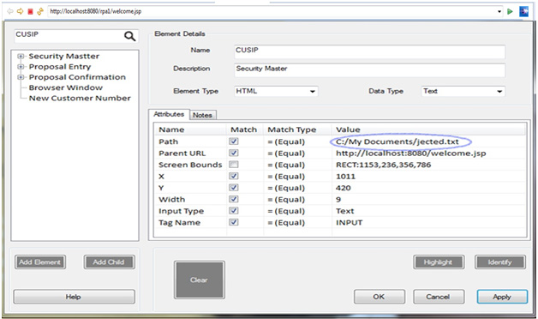

FIG 4.1 WRONG INPUT FILE

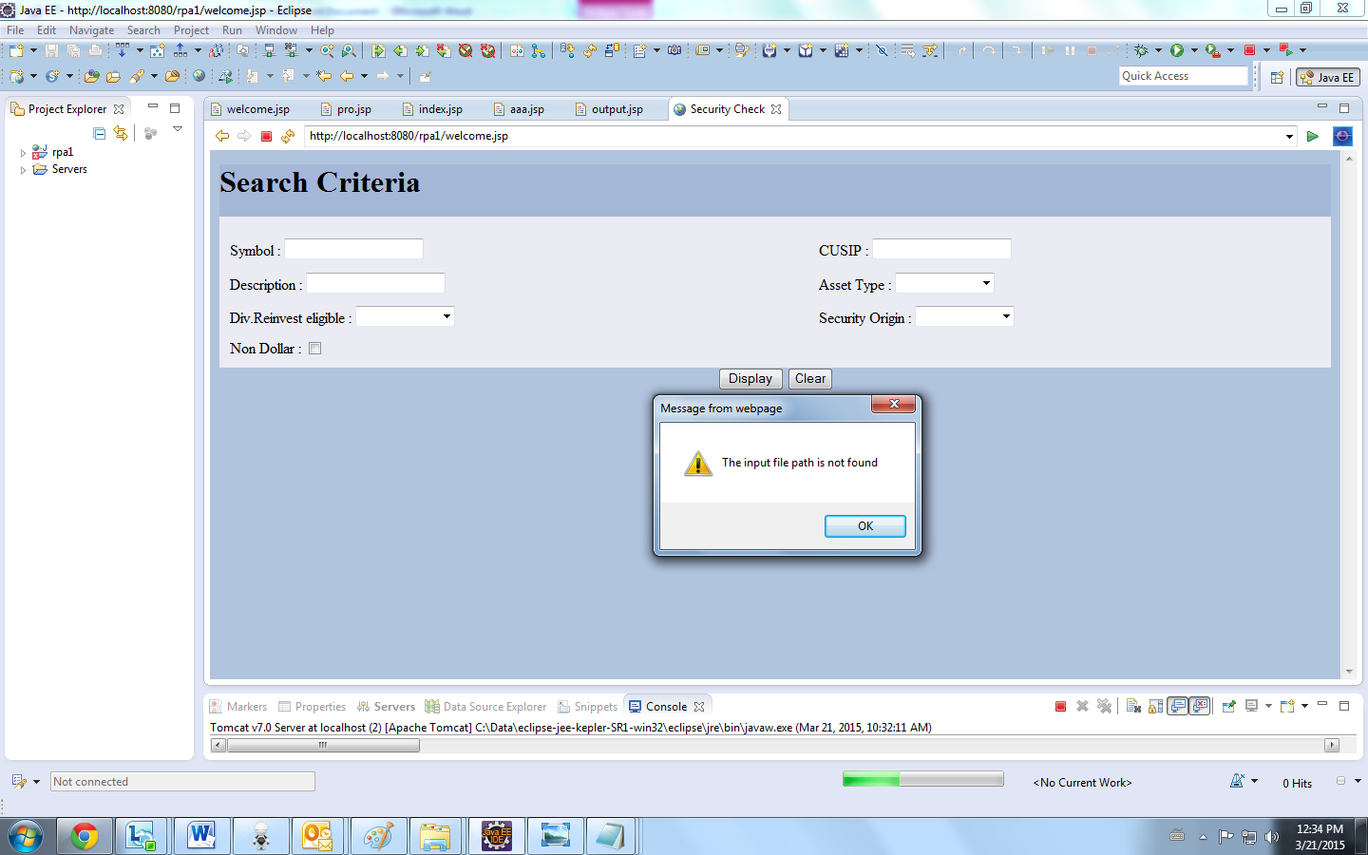

FIG 4.2 ERROR DUE TO WRONG INPUT FILE

**WHITEBOX TESTING :**

White box testing is a testing technique that takes into account the internal mechanisms of a system. It is also called as structural testing and glass box testing. Black box testing is often used for validation and white box testing is often used for verification.

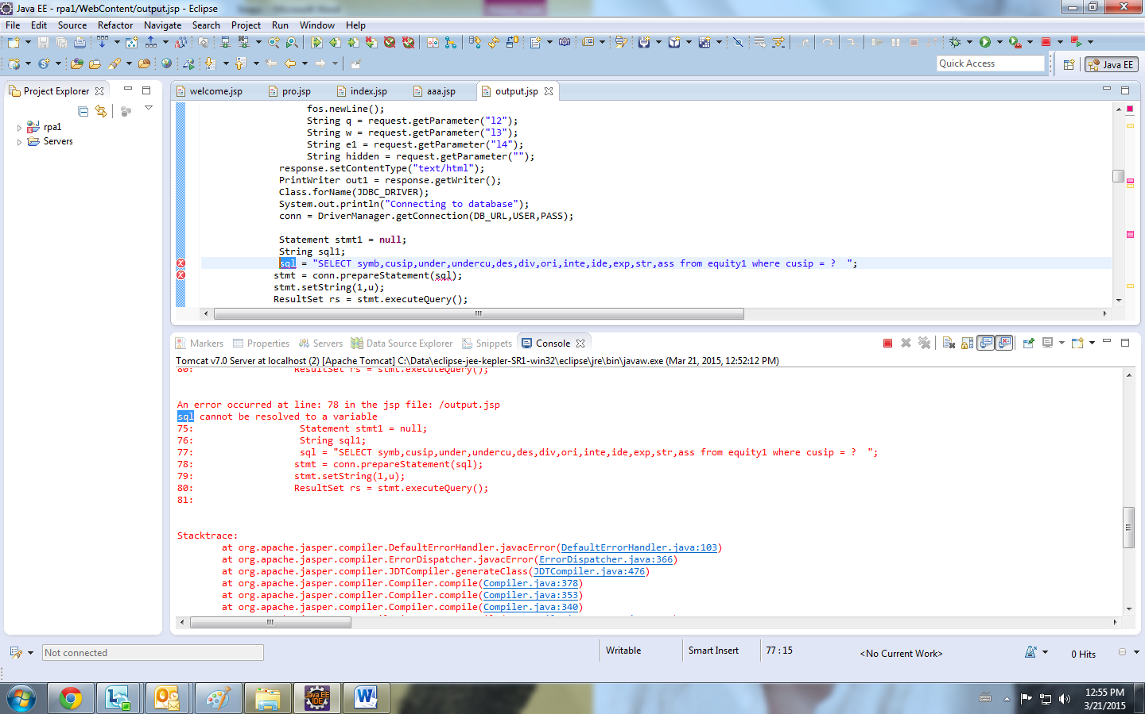

FIG 4.3 ERROR DUE TO UNDECLARED VARIABLE

**4.4 PROCESS FLOW DIAGRAM :**

CREATE REJECTED TR**A**DES REPORT

TRADE PROCESSING SYSTEM-SETTLEMENT

NO

CHECK REJECTED TRADE CUSIP IN THE SECURITY MASTER

YES NO

CHECK IF THE SECURITY IS EQUITY

YES

WRITE IN THE OUTPUT FILE

A

SEND THE REJECTED TRADES FOR THE CLIENT VIA EMAIL

IDENTIFY THE CLIENT MAIL ID

GROUP ALL EQUITIES BELONGING TO CLIENT

A

FIG 4.3.1 PROCESS FLOW DIAGRAM

**4.5 MODULES OF STUDY**

**Module 1**

The first module of the project deals with authentication process. Authentication involves with login form which includes user id and password.

Users are classified as Admin users and processors. If the user who logs in is an admin user, Configuration screen will be available for the user. If the user logging in is a processor then, Robot screen will be available.

**Module 2:**

In the second module, basic requirements of configuration screen is taken care of. Such as setting the path for the input file, values that are extracted from the input file, parent URL, input type, data type, element type which says about proposal confirmation.

**CHAPTER 5**

**SNAPSHOTS**

**Login Screen for Authentication**

The manager logins with the secure user id and password

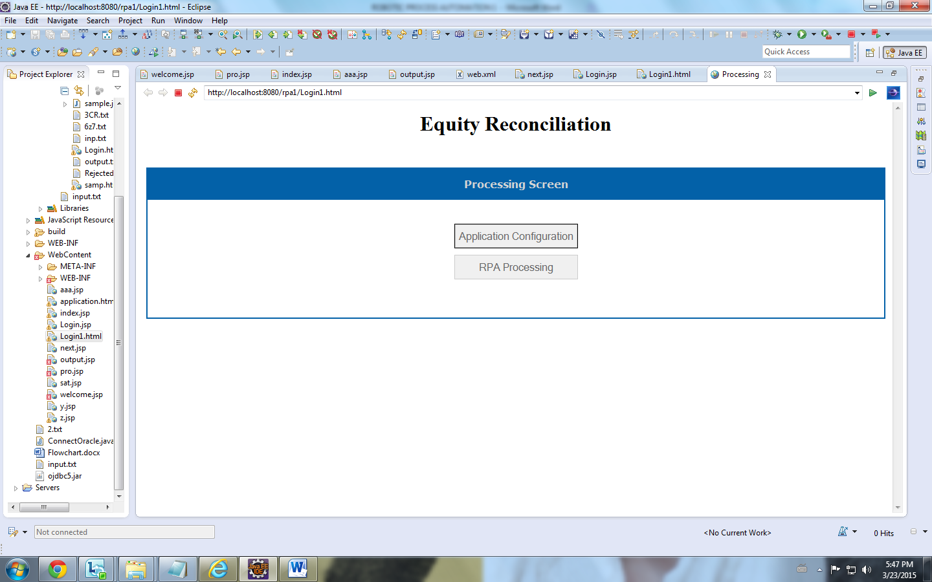

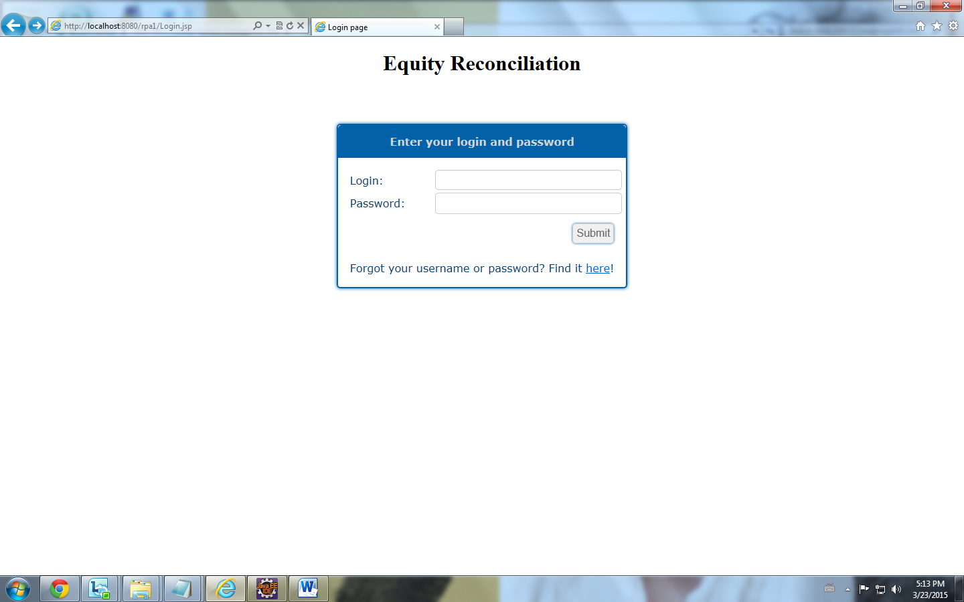

FIG 5.1 ADMIN LOGIN

**Processing Screen for RPA:**



FIG 5.2 PROCESSING SCREEN

**Configuration Screen :** Here we configure the input file , output file and the field to be extracted from the input file.

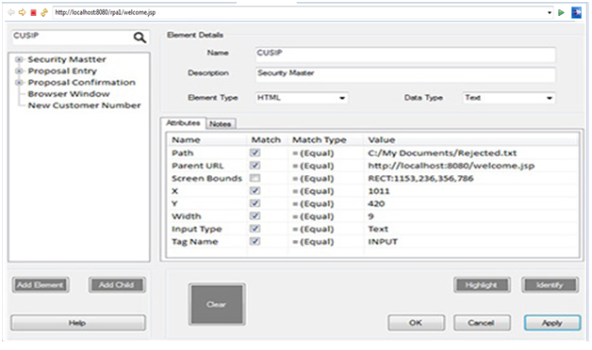

FIG 5.3 APPLICATION CONFIGURATION

**Input File :** This is the input file from which the cussip id is extracted.

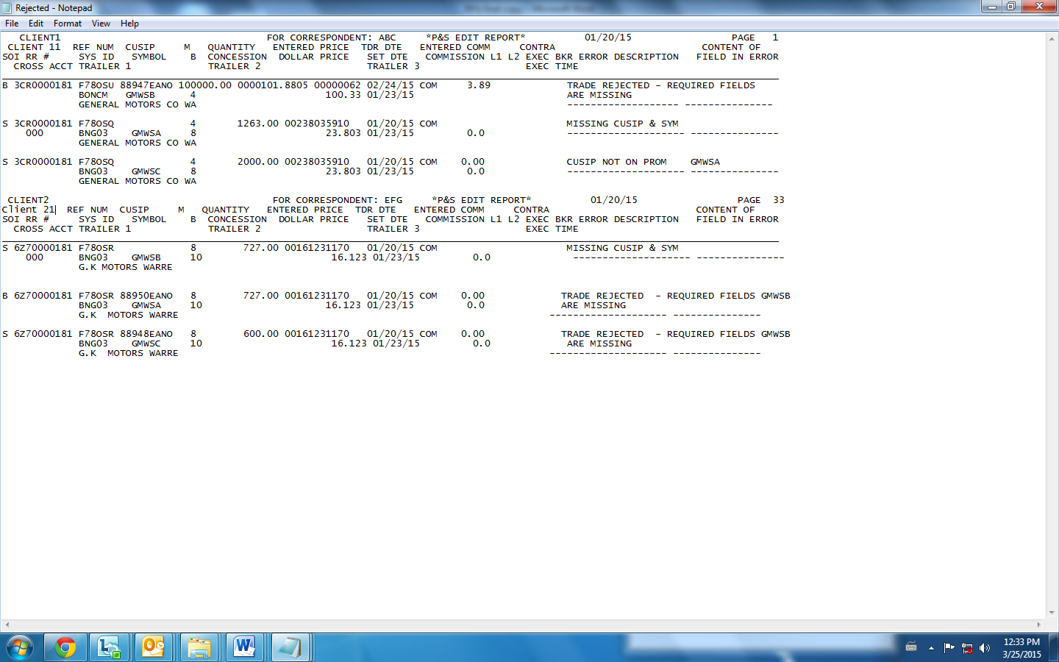

FIG 5.4 INPUT FILE

**Source Application (Search Screen) :** This is the search screen where software robot populates the cussip id and then processes.

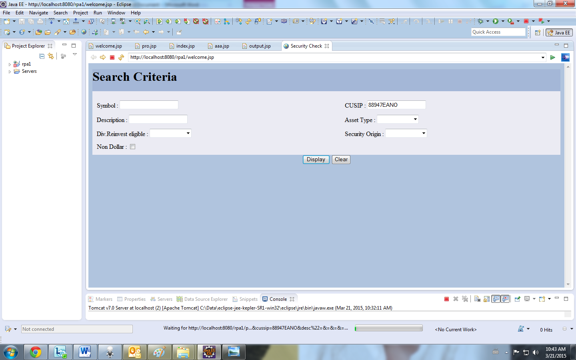

FIG 5.5 SOURCE APPLICATION SCREEN

**Search Screen with Result Sets:**

The below screen displays the result set with equity record.

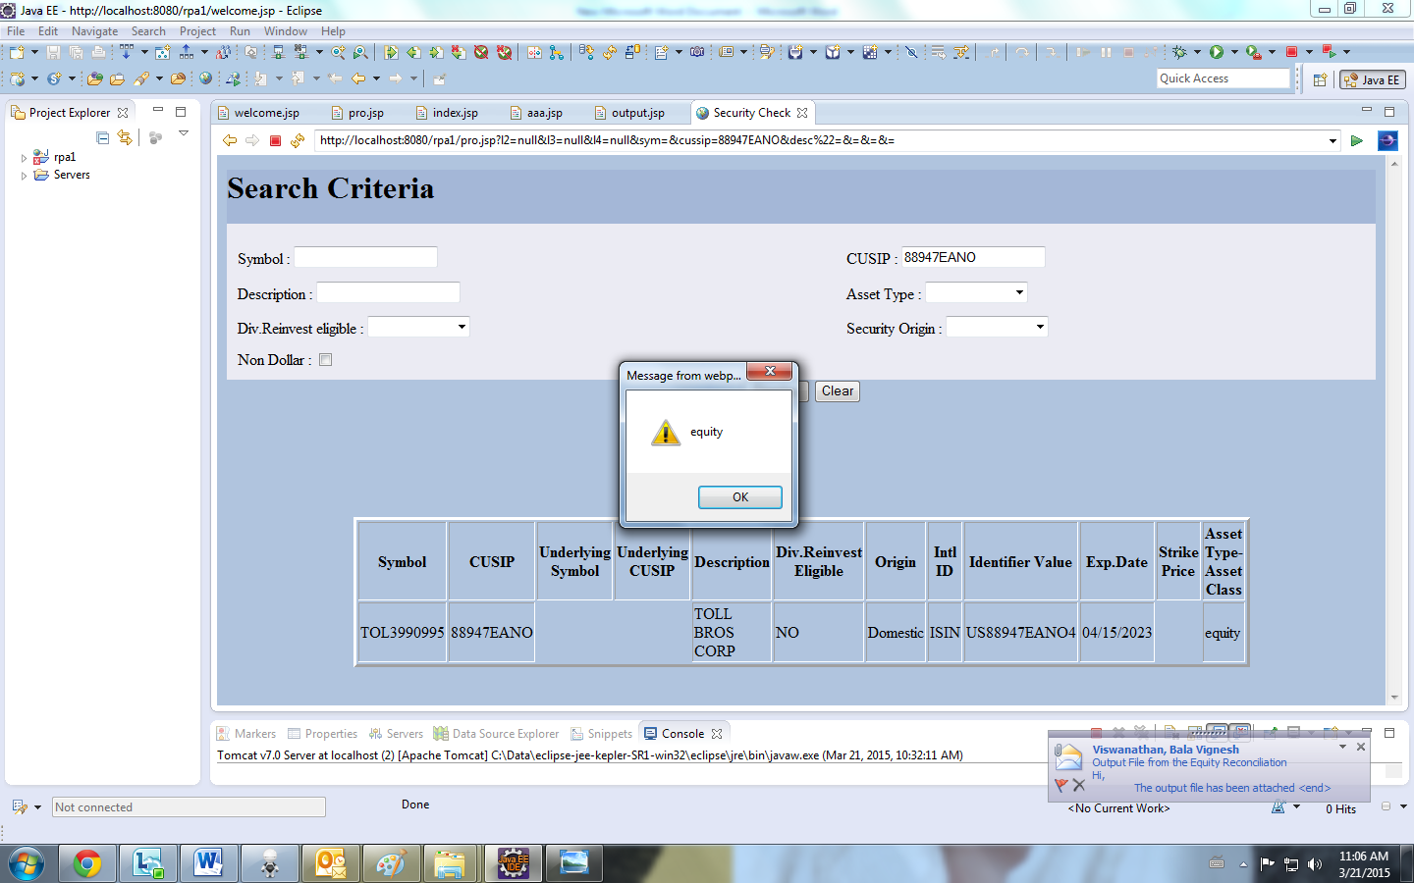

FIG 5.6 OUTPUT SCREEN WITH EQUITY RECORD

The below screen displays the result set with non-equity record.

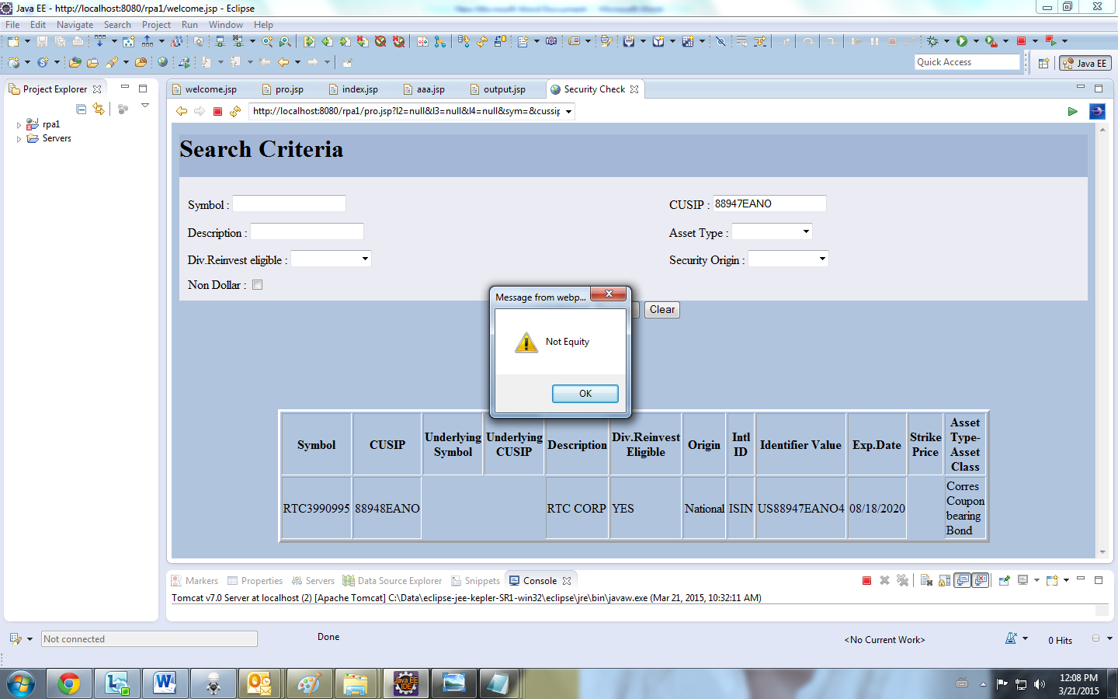

FIG 5.7 OUTPUT SCREEN WITH NON EQUITY RECORD

**Output File sent to the clients :** The output file is generated and sent the client automatically.

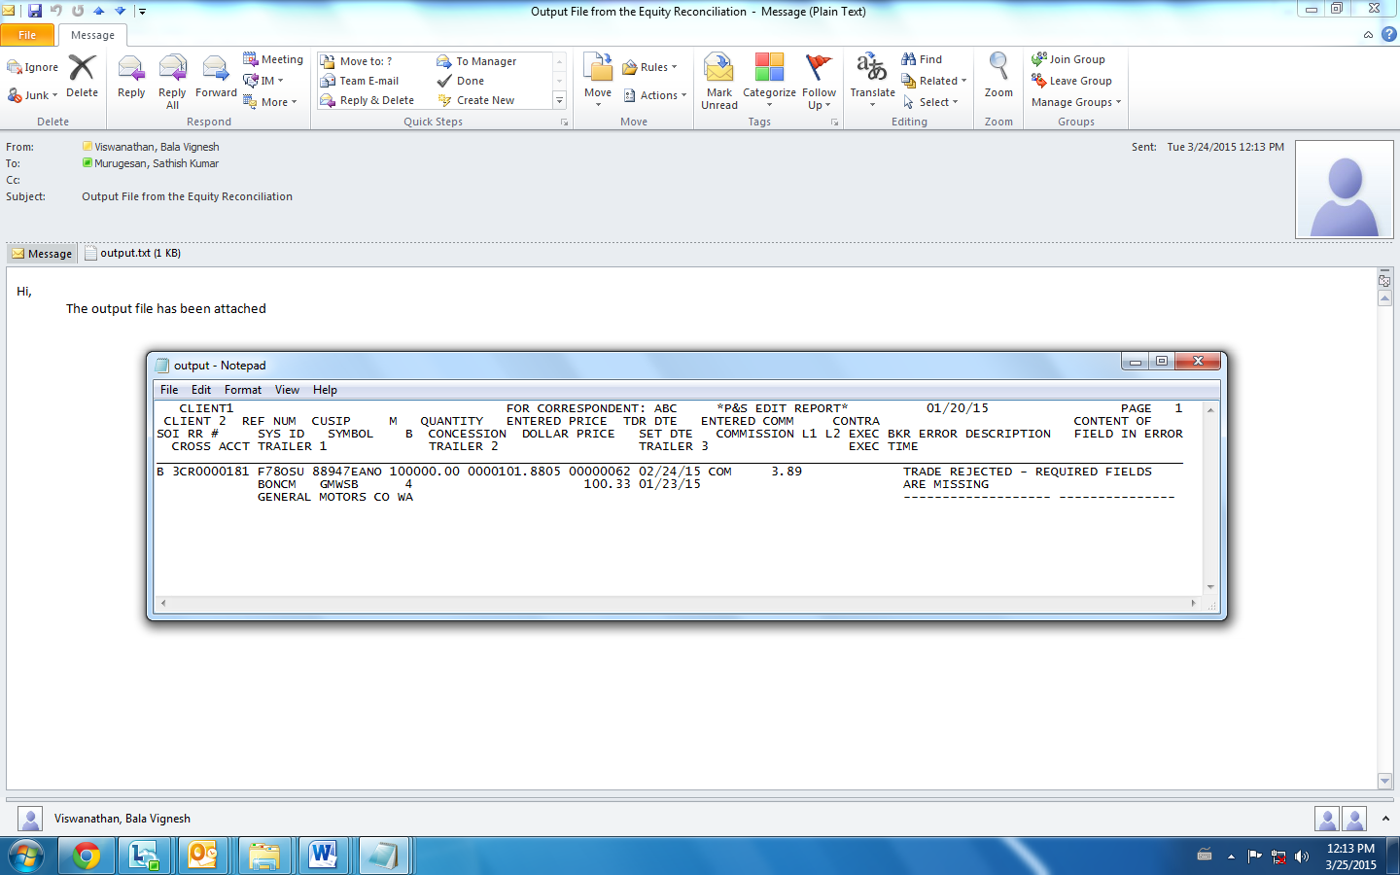

FIG 5.8 OUTPUT FILE SENT TO CLIENTS

**RPA Working Screen**

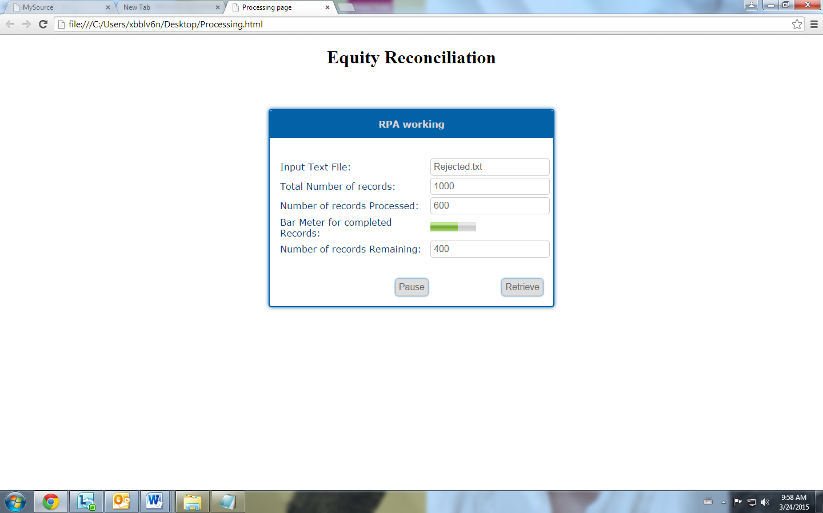

FIG 5.9 RPA WORKING SCREEN

**CHAPTER 6**

**CONCLUSION**

The project aims in implementing an software that reduces human effort in doing repeatable tasks. This can be applied, not only to **EQUITY RECONCILIATION**, but also to all types of tasks which are least complex and require a large amount of human labor and less human knowledge. Our project satisfies the following

* To provide user-friend interface
* To produce well formatted output display
* To give a exact reply format for query
* Helps in making a decision about a product
* This system satisfies the needs of the user in reasonable time.

**CHAPTER 7**

**REFERENCE**

**WEBSITES**

1. <http://www.pmhut.com/relationship-vs-task-oriented-management>
2. <http://www01.ibm.com/support/knowledgecenter/SSQH9M_6.1.0/com.ibm.websphere.bpc.610.doc/doc/bpc/ctasklifecycle.html>
3. <http://www.ganttic.com/tour/customized-data-in-scheduling-software>
4. <http://www.techrepublic.com/article/6-key-elements-for-better-task-management/>
5. W3schools for Tutorials.

**BOOKS**

1. Kevin Yank “Build Your Own Database Driven Web Site Using JSP &

MySQL.

1. Mahfudzah Othman, Siti Nurbaya Ismail, Mohd Ikhsan Md Raus (2013) ‘Robotic Process Automation’for the systems.