Task 1

The first part of this program whould be able to read the csv file, and try to convert it in to an array.  The best way would be to convert it to a 2 dimentional array. This could be done by using the  filereader funksjon inside js. I would need to seperate each element in this array by maybe using "," or "|". To write in to the html, I would need to find the table and then taking innerhtml += array detail. This should be in a loop, where we could get details for every iteration.

Task 4: start by making a function with the different calculations and return the values at the end. Thereafter it would be possible to whrit it in a table. peak and buttom are easily findable by using for loop and comparing to a varabel. Average also needs an forloop, but here you would need to sum up (+=) and divide by array.length. Type and location number would be hard, but i could try to have a for-loop with a filter that saves different elements in an empty array. The functions need’s the array and the field to run, so this must be called on from the first function (filereader) containing the array.

Task 7

The task’s where done approximately as planned, but I came across some problems. These got solved buy some research and testing. I also changed the entire structure, so it was easier to read, understand and test with. I am really not used to plan things ahead, but this helped me get some more structure over how tings where done.

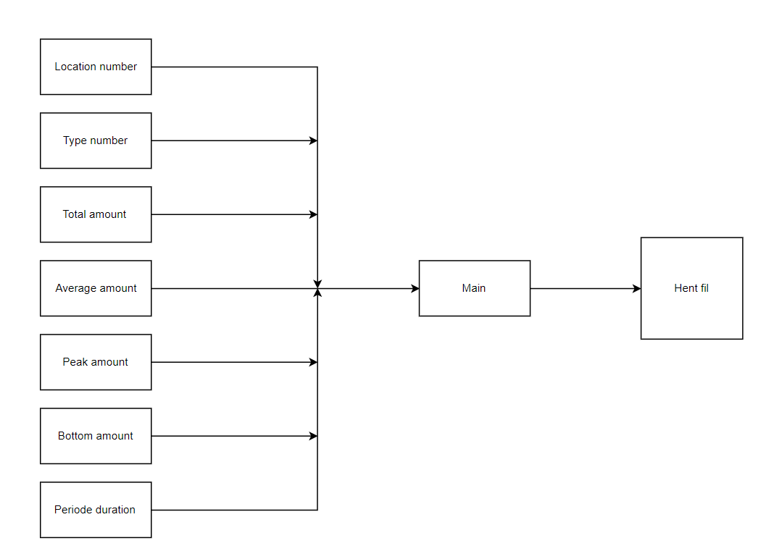

Task 8

Here it possible to check the table by using a for loop and an if statement where we could compare the input value with the tables content. By using toUpperCase we could eliminate caps and other irregularities. This function would need a input value, which would be used to search in every <tr> .

I tried this but it only works on single columns. That would not be the most efficient way. Therefor I chose to use jQuery. This would enable other functions, that could get the search functions to go true each column in every row. This would do the same thing as the last function, but it would be for the entire table, which decreases the number of input tags.