**Alexandria University**

**Faculty of Computer and Data Science**

**Course Title: Simulations 2023-2024**

**Double Server**

**Queue Simulation**

**(Bank System)**

**we developed a customer service system for a bank with tellers that divide into the traditional teller lines with human teller (that handle more detail-oriented tasks like bill payments) and the other self-serving option, the ATM for easy tasks like cash services. Both tellers are used to avoid any inconveniences or unnecessary waiting time.**

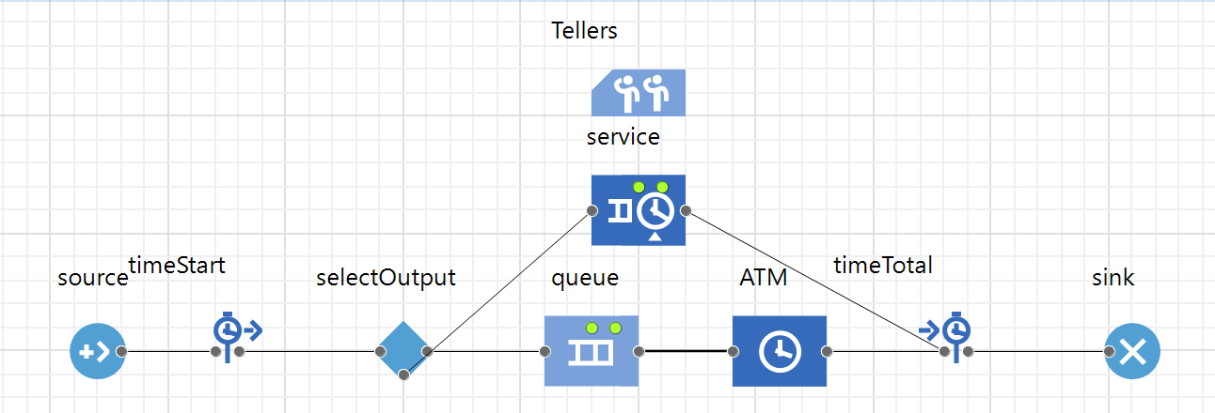

First, we used the Process Modeling library to create the essential blocks needed for the operation of the bank system and it consisted of:

- The source block: generates the agents and models customer arrival.

-The queue block: simulates a queue of customers waiting for the moment they can start using the ATM.

-The ATM block: simulates the service of the customer when using the ATM.

-The sink block: ends the process and refuses incoming agents.

-The service block: simulates the duration of a service

-The timeStart and TimeTotal blocks: records the time when an agent enters or leaves from the system.

-The selectOutput block: control the routing of the agents to both paths (ATM and Teller lines).

-The tellers block: simulates the service of the customer when standing in the teller line.

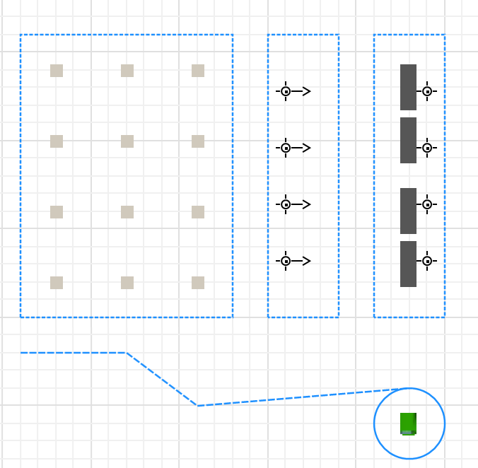

(The Node placements are important for upcoming visualizations, it affects how the model looks in the 3d versions that is why they are stacked next to each other)

To achieve this we used the “point node and 3d object ATM” inside of the Space Markup library

To create a path for the customer when walking to the ATM machine inside of the bank.

Still in the Space Markup library, we used this time three “Rectangular Nodes”

To create the waiting area, customers, and the tellers.

Rotation of the tables that the teller stand in front of was needed to face the customers

And the visible control was set to “no” in this part and the rest of the project

To avoid showing the markup of the shapes.

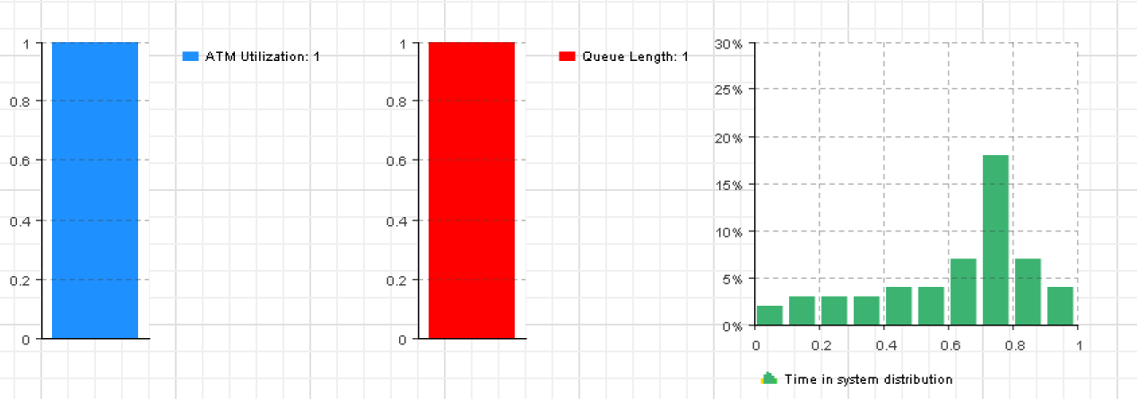

We want to know how much time a customer spends in the bank

That is why we will use the previously mentioned blocks (timeStart and timeTotal)

To measure the time agents spend in the system.

Here we are using the Analysis palette and the Process Modeling Library again but for a different cause and that is collecting basic statistics about ATM usage and queue means.

The observations made tell us how the ATM usage mean and queue mean lengths change with time.

The most suitable graphs to use for them are bar charts and a histogram

**Default settings that were changed in the graphs:**

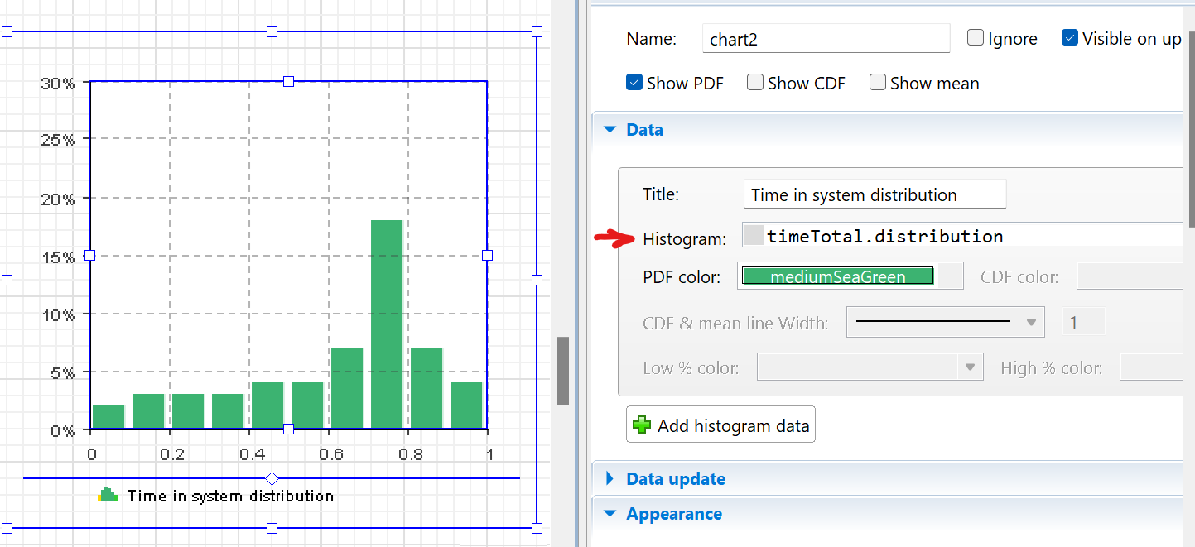

-Histogram: “timeTotal.distribution” was used as the histogram field to collect the distribution of time the agents spent in the system.

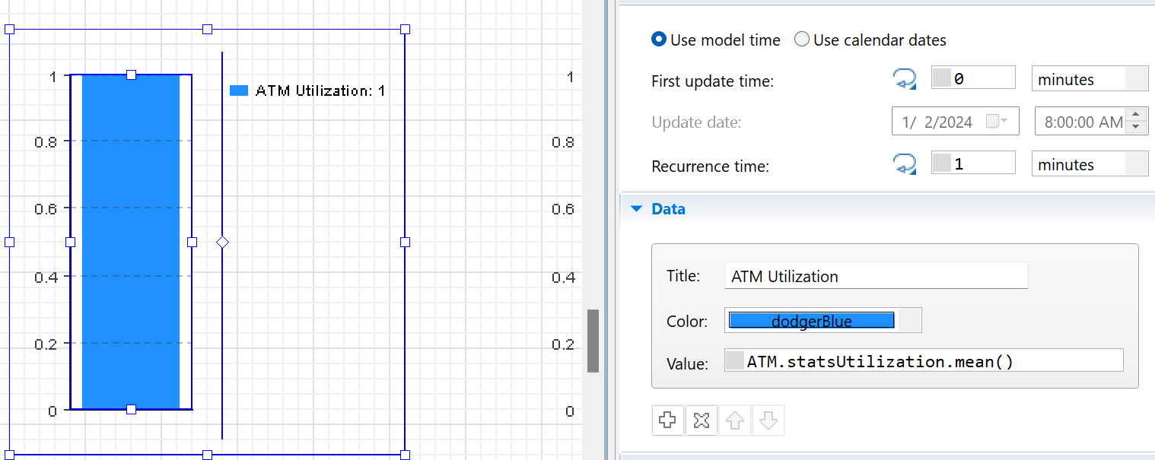

–bar chart # 1: “ATM.statsUtilization.mean()” was used as the value of the data item to get the mean of the ATM utilization or usage

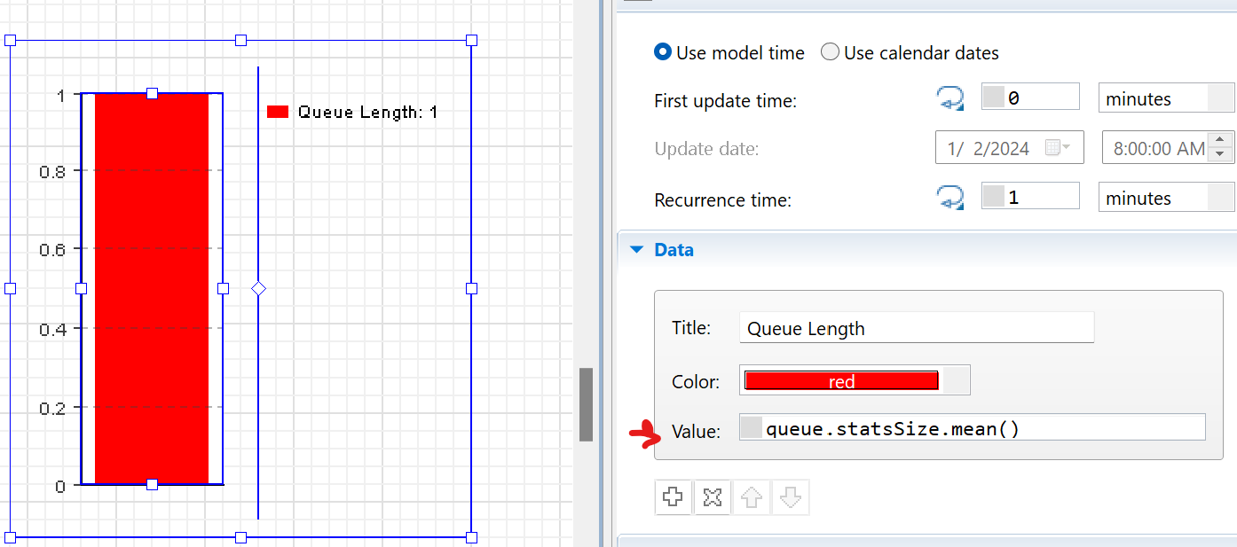

-bar chart # 2: “queue.statsSize.mean()” was used as the value of the data item to get the queue size

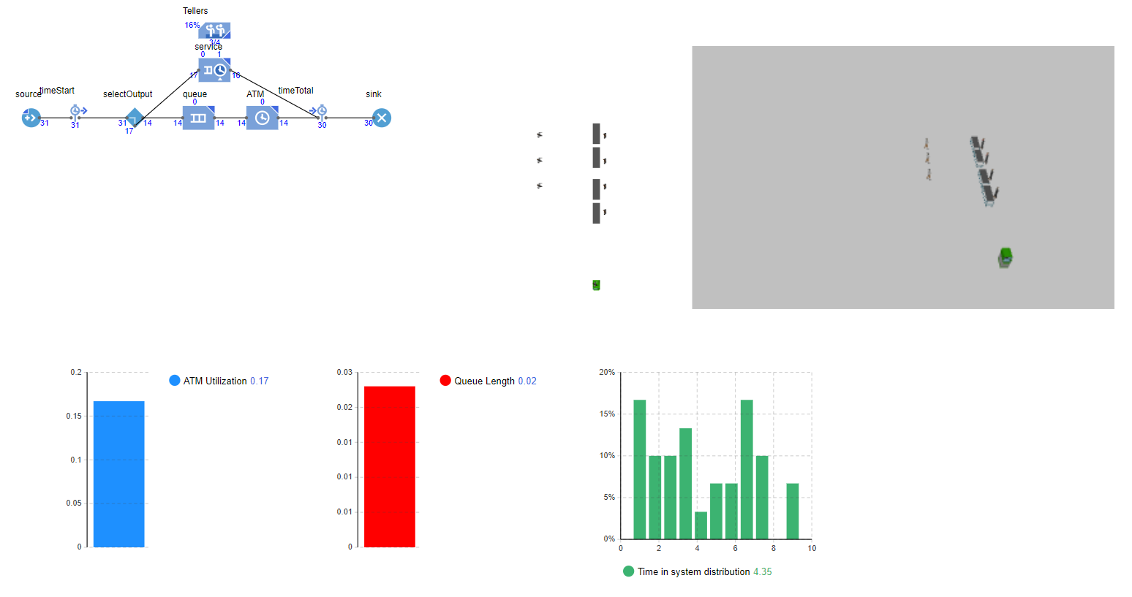

And that is the whole project wrapped in one shot, also displaying the 3D window (on the top right) that visualizes the simulation (it wasn’t as thoroughly discussed as the others because it needed dynamic processing to show and Microsoft word doesn’t support video files).