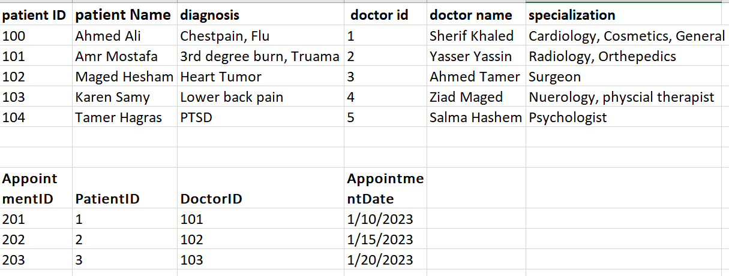

To convert 1NF we need to fix repeated values (diagnosis and specialization)

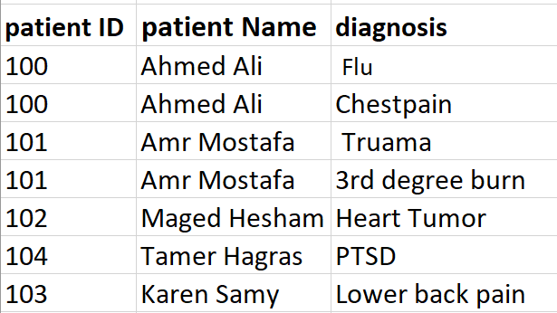Diagnosis as 1NF: Specialization as 1NF:

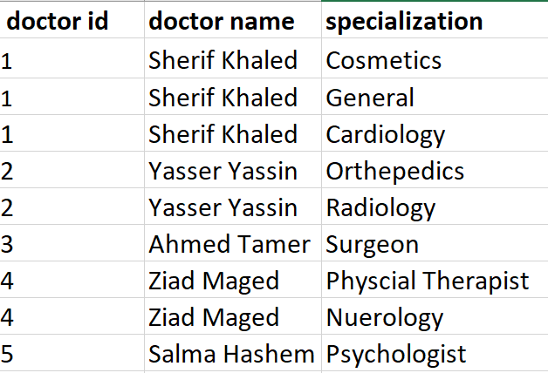

To convert to 2NF the tables need to be in 1NF form, eliminate partial dependencies so that all keys depend on the primary key.

Partial Dependencies:

* In the Patient’s Table, Patient ID and PatientName together determine the Diagnosis (Diagnosis dependent on ID and Name).
* In the Doctors Table, DoctorID and DoctorName together determine the Specialization (Specialization dependent on ID and Name).

To convert to 2NF 2 new tables were made to separate related data to into different tables:

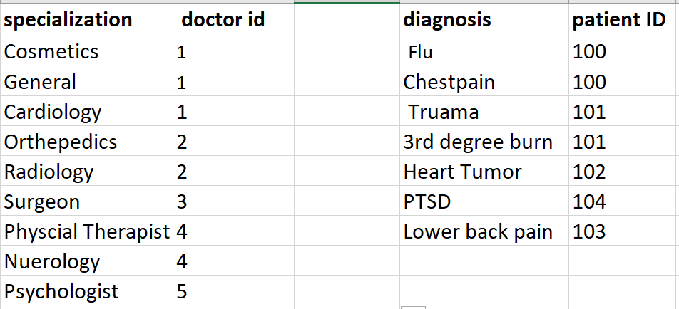

To convert to 3NF the tables need to be in 2NF form and not have Transitive dependencies (non-primary keys depending on each other)

The Tables are 3NF and don’t need further change because every key in each table depend on its respective primary key and not on other non-primary keys.

Tables before normalization:

* Patients
* Doctors
* Appointments

Tables after normalization:

* Patients (PatientID, PatientName, PatientDiagnosis)
* Doctors (DoctorID, DoctorName, Specializations)
* Appointments (AppointmentID, AppointmentDate, PatientID, DoctorID)
* Specializations (Specialization, DoctorID)
* Patient Diagnosis (PatientDiagnosisID, PatientID)