**Alexandria University**

**Faculty of Computer and Data Science**

**Department: Data Science**

**Course Title: Data Science 2023-2024**

**Heart Failure Prediction**

**In**

**Introduction to Data Science**

**Course Code: 02-24-00104**

1.Introduction:

Heart failure is a common event caused by cardiovascular diseases, in this dataset there are 11 factors that can be used to predict a possible heart disease. if there is presence of one or more risk factors of them there needs to be early detection to intervene sooner and manage it. So in our data exploration the target is to find which features contributed the most to having a heart disease. At the end of the analysis we are supposed to know which features contributed the most in a person having heart disease.

This data set was collected from people who were recruited without heart failure that received health check-ups in 2010, who were followed annually for 4 years. It was found that the probability of heart failure progressively increased as the number of predictive combinations of factors increased.

**Heart Disease factors Information**

* Age: age of the patient [years]
* Sex: sex of the patient [M: Male, F: Female]
* ChestPainType: chest pain type [TA: Typical Angina, ATA: Atypical Angina, NAP: Non-Anginal Pain, ASY: Asymptomatic]
* RestingBP: resting blood pressure [mm Hg]
* Cholesterol: serum cholesterol [mm/dl]
* FastingBS: fasting blood sugar [1: if FastingBS > 120 mg/dl, 0: otherwise]
* RestingECG: resting electrocardiogram results [Normal: Normal, ST: having ST-T wave abnormality (T wave inversions and/or ST elevation or depression of > 0.05 mV), LVH: showing probable or definite left ventricular hypertrophy by Estes' criteria]
* MaxHR: maximum heart rate achieved [Numeric value between 60 and 202]
* ExerciseAngina: exercise-induced angina [Y: Yes, N: No]
* Oldpeak: oldpeak = ST [Numeric value measured in depression]
* ST_Slope: the slope of the peak exercise ST segment [Up: upsloping, Flat: flat, Down: downsloping]
* HeartDisease: output class [1: heart disease, 0: Normal]

We will proceed with analyzing risk factors and modeling the probability of heart failure. One way to address this problem is to build a model that can accurately predict an individual’s chance of heart failure and back the prediction with evidence.

2.Methodologies used:

**Importing Dataset & Storing in data frame**



The csv data file was read and stored in variable heart we then took our heart data and stored it in the data frame called alldata to have flexibility and work more easily.

**Data Exploration**

Using head function we took a peek at the first cluster of rows in data frame it consists of the factors that contributes to having a heart disease and the last colomn is an indicator weather this person has a heart disease or not (0 no, 1 yes).

Summery(heart): from this function we know the mean, median, max, min, and etc.. of each integer value and the type of non-integers.

The data set contains 918 rows (patients) and 11 columns (factors) excluding the index colomn.

To show the structure of each colomn we used the str() function.

**Data cleaning**

Before starting our data analysis, we need to check first if our data is clean or not, meaning we need to check if an entry is duplicated or contains a null value and remove them if found.

To do so we need to install some packages.

This package is to remove duplicated packages.

Using the duplicated() method we realize that there is no duplicated rows

Is.na() is to check if there is null values , there is none.

Converting Data types:

After making sure that our data is clean we will start delving into data visualization and analysis.

**Packages Installed**

**Data Visualization**

**Using pie charts**

We used pie charts to have a better view of the Percentages of each slice in the attributes.

-par(): controls the layout of multiple plots on a single device, its dimensions are 1 row 3 colomns.

-table(): this method is used to measure the frequency of the gender, when we print the output of x it tells us that there are 193 Female patients and 725 male patients in our dataset.

-percentage: contains the paste0() method which paste the rounded percentage with the % sign without space and the calcualation round(100*x/sum(x)) gets the percentage of female and male in the sample

- pie(x, labels = percentage): This creates a pie chart using x and labels each slice with the calculated percentages.

- legend() function, in this context, is adding a legend to the plot that indicates the mapping between the colors used in the plot and the corresponding categories ("female" and "male"). The legend is positioned in the bottom-right corner of the plot.

**Using bar plots**

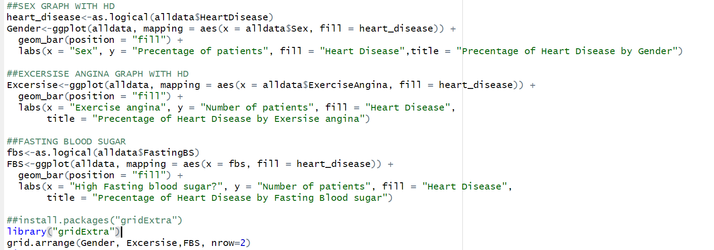

We used bar plots because our data contains categorial variables, and to represent categorial relationships between them and the heart disease.

To plot theses graphs we will use

- ggplot() method, the data will be taken from alldata dataframe ,aesthetic mappings the x aesthetic represents the variable on the x-axis , and fill specifies the variable used to fill the bars (heart_disease).

-geom_bar(position = "fill"): This adds the bars to the plot. The position = "fill" argument ensures that the bars are stacked and represent the relative proportion of each category (heart disease or no heart disease).

-labs(x = "Sex", y = "Percentage of patients", fill = "Heart Disease", title = "Percentage of Heart Disease by Gender"): This adds labels to the plot. x, y, and fill specify the labels for the x-axis, y-axis, and the legend, respectively. title adds the main title to the plot.

-grid.arrange():is used to place the two graphs in one plot, to use it we installed a package called “gridExtra”

-the function ‘ggplot’ takes has 2 parameters: data frame ‘containing x and y variables’ and data mapping ’containing aesthetics function that specifies how the plot looks like’

- the function ‘geom_bar’ positions the bars side by side (position = ‘dodged’) to compare the occurrence of different chest pain types for each level of heart disease

- the ‘labs’ function labels the entire plot and takes 4 parameteres: plot title, x-axis, y-axis, fill the bars with colors to represent different chest pain types



ggplot():This function used the alldata dataframe. The aes() function specifies the aesthetics, with x representing the variable on the x-axis (heart_disease) and fill representing the variable used to fill the bars in the bar plot (RestingBP).

Geom_bar():This adds the bar plot layer to the plot. The default position is "stack", so the bars are stacked on top of each other for each level of heart_disease. The height of each stack represents the number of patients.

**Using histogram**

Using histogram will help reveal information about the skewness , and frequencies or counts of observations within each bin.

-The ggplot function uses alldata dataframe the x-axis of the histogram is Age and the variable used to fill the bars is wheather they have heart disease or not.

-geom_histogram():This adds the histogram layer to the plot.

-The position = "dodge" : argument ensures that the bars are side-by-side for each level of HeartDisease. Each bar represents the count of occurrences within a particular age range.

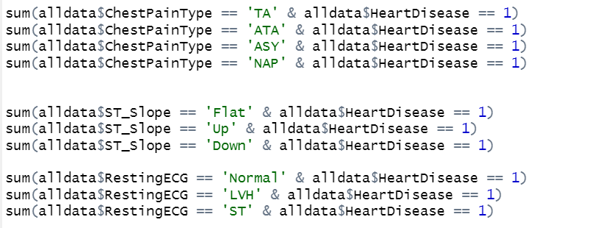

-we used the sum function to isolate certain features (ChestPainType, ST_Slope, and RestingECG) with the presense of heart disease in all patients to have better understanding of the data presented in the 3 previously mentioned bar plots.

**Using Box plot**

We used box plot because it is the most effective plot to remove the outliers to detect the outliers.

– created a new ‘ggplot’ object from the ‘ggplot’ package to show the relationship between maximum heart rates & cholesterol levels with heart disease

– added a box plot ‘geom_boxplot’ to measure the spread of heart diseases among people

– set the labels for x-axis and y-axis

– arranged both cholesterol levels and maximum heart rates in one rows

**To remove outliers**

-boxplot.stats(alldata$MaxHR)$out :calculates the outliers for the variable MaxHR in the dataset alldata using the boxplot.stats function. The result is stored in the variable outliers5.

-clean: This line creates a new dataframe clean by excluding the rows in alldata where the MaxHR values are in the outliers5 list. It essentially removes the rows with outliers from the dataset.

-boxplot: This line creates a box plot of the cleaned MaxHR data (clean$MaxHR).

The title of the box plot is set to "Boxplot of RestingBP," and the x-axis label is set to "Resting BP."

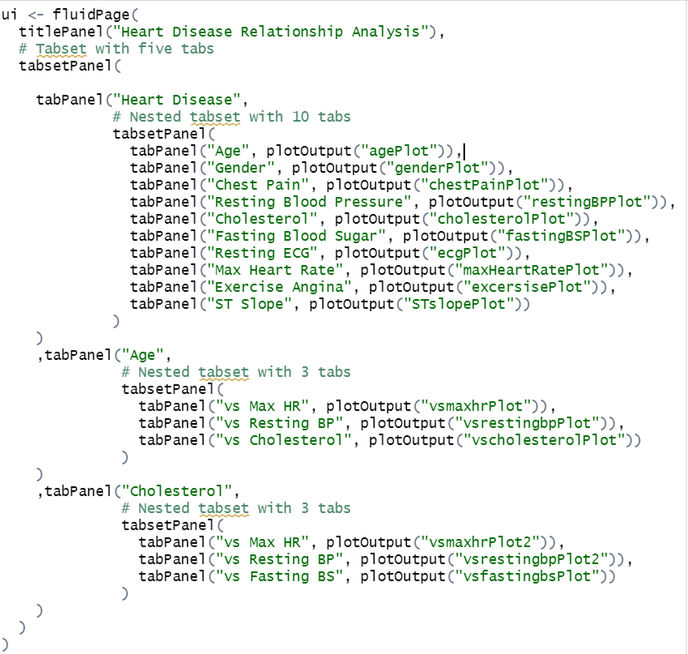

-The UI is created using **fluidpage**, which is a basic layout for Shiny applications.

-The title panel **(titlepanel)** sets the title of the application to “Heart Disease Relationship Analysis.”

**-Tabsetpanel** is used to create a tabbed interface.

-The first tab, labeled “Heart Disease,” contains another **tabsetPanel** with ten tabs, each representing a different factor related to heart disease.

-The second and third tabs, labeled, labeled “Age” and “Cholesterol,” each have a nested **tabsetPanel** with three tabs for further analysis.

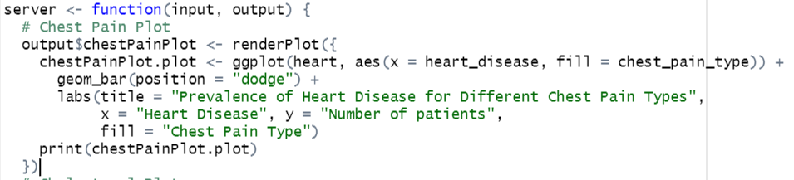

-The **server** function contains the logic for generating different plots based on the input data and selected tabs in the UI.

-Each **output$plotName** is associated with a specific plot and is rendered using **renderplot.**

-The actual **ggplot** code for each plot is not provided in the code snippet but would be written within the corresponding **renderplot** functions

-Plots cover various aspects such as **chest pain, cholesterol, maximum heart rate, resting blood pressure, age, gender, exercise angina, fasting blood sugar, ST slope, and ECG.**

-Using the ggplot2 library, we created a scatter plot with Blue dots that represent individuals without heart disease and red dots that represent those with heart disease.

-The geom_point function adds the data points to the plot.

-The geom_smooth function adds a line of best fit to the plot.

-The labs function adds a title, label, and color to the plot

-The as.logical function is used to convert heart disease variable to a logical variable, which is needed for the color-coding of the data points in the plot.

**Supervised Techniques:**

# Decision Tree

We can make 2 decision tree algorithms using rpart() with different values of parameter [method]. If method="class" is specified, it indicates that the decision tree algorithm should be used for classification. This means that the HeartDisease variable is treated as a categorical variable and the algorithm will build a decision tree to predict the class labels.

Otherwise, if the method parameter is not specified, so the default method is used. In this case, the default method is typically the decision tree algorithm for regression. This means that the HeartDisease variable is treated as a continuous variable and the algorithm will build a decision tree to predict numeric values.

## **1)decision tree algorithm for classification:**



If the output is true, then that indicates that this person is a heart patient, and if the output is false then that indicates that a person doesn’t have any heart disease.

We can see the nodes which have magenta color indicate True output, and these with grey color indicate false output.

As we can see we start with 100% (all the observations), about 57% of them don’t have ST_Slope = up and the 57% are heart patients.About 40% of them have chestPainType = ASY and they are heart patients.

So that means 40% of our observations who has ST_slop not equals up and chestPainType = ASY

Are heart patients.

And we can see that in the visualization of the features.

The code of making the decision tree:

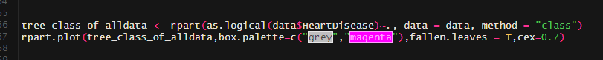

1)tree_class_of_alldata <- rpart(as.logical(data$HeartDisease)~., data = data, method = "class"):

This line creates a decision tree model using the rpart function. The formula as.logical(data$HeartDisease )~. specifies that the HeartDisease variable is the target variable and we convert the 0s and 1s to TRUE and FALSE so we can easily understand the code, and. indicates that all other variables in the dataset (data) should be used as predictors. The method = "class" argument indicates that the problem is a classification problem.

2)rpart.plot(tree_class_of_alldata, box.palette=c("grey", "magenta"),fallen.leaves = T,cex=0.7):

This line generates a plot of the decision tree model using the rpart.plot function from the rpart.plot package. The tree_class_of_alldata argument specifies the decision tree model to plot. The box.palette argument sets the color palette for the plot, grey for false and magenta for true. The fallen.leaves = T argument indicates that the plot should show fallen leaves (terminal nodes). The cex=0.7 argument sets the size of the text in the plot.

**We can make predictions if a person may be a heat patient:**

we first need to split our data into 2 groups (training data set, testing data set)

Shuffling the observations is the best way to get the training data set from different places

sample(1:nrow(data)): Generate a random list of index from 1 to 918 (i.e. the maximum number of rows).

The common practice is to split the data 80/20, 80%of the data serves to train the model, and 20% to make predictions. We need to create two separate data frames. We shouldn’t touch the test set until we finish building our model. we create a function name create_train_test() that takes three arguments.

create_train_test(df, size = 0.8, train = TRUE)

arguments:

-df: Dataset used to train the model.

-size: Size of the split. By default, 0.8. Numerical value

-train: If set to `TRUE`, the function creates the train set, otherwise the test set. Default value sets to `TRUE`. Boolean value.We need to add a Boolean parameter because R does not allow to return two data frames simultaneously.

function(data, size=0.8, train = TRUE): Add the arguments in the function

n_row = nrow(data): Count number of rows in the dataset

total_row = size*n_row: Return the nth row to construct the train set

train_sample <- 1:total_row: Select the first row to the nth rows

if (train ==TRUE){ } else { }: If condition sets to true, return the train set, else the test set.

We have splited the data set correctly. And we can make a decision tree from training data



Maybe there is some difference between this tree and the original tree of all data, and that because the training data is not accurate 100%.

The code for making the training data decision tree:



1) tree_class <- rpart(HeartDisease~., data = data_train, method = 'class')

This line creates a decision tree classifier object named tree_class.

The rpart function is used to build the decision tree.

HeartDisease~. specifies the formula for the model, where HeartDisease is the target variable and . indicates all other variables in the dataset.

data_train is the dataset used to train the decision tree.

method = 'class' specifies that the decision tree is being built for a classification task.

2) rpart.plot(tree_class,type = 2,box.palette=c("grey", "magenta"),fallen.leaves = T,cex=0.6)

This line plots the decision tree using the rpart.plot function.

tree_class is the decision tree object to be plotted.

type = 2 specifies the type of plot to be generated.

box.palette=c("magenta", "grey") defines the color palette for the boxes in the plot.

fallen.leaves = T indicates that fallen leaves should be displayed.

cex=0.6 sets the size of the text in the plot to 0.6 times the default size.

**Now we can enter some data of a person to detect if they are a heart patient or not.**

It gives 91% that this person may be a heart patient.

## 2) decision tree algorithm for regression:



The code for making the tree:

1)In rpart():

The formula HeartDisease~., which specifies the relationship between the dependent variable HeartDisease and all other variables in the dataset. The ~. symbol means to use all variables in the dataset except the dependent variable.

The data argument, which specifies the dataset to use for building the mode

2)The rpart.plot :

tree: The decision tree model object.

type: Specifies the type of plot. In this case, type = 2 indicates a plot with both the nodes and the splits.

box.palette: Specifies the color palette for the boxes in the plot. In this case, it uses a palette with white and red colors.

fallen.leaves: Specifies whether fallen leaves should be plotted. In this case, fallen.leaves = T indicates that fallen leaves should be plotted.

cex: Specifies the character expansion factor for text labels. In this case, cex = 0.8 indicates a slightly smaller text size.

Unsupervised Technique:

Using dataframe we cleaned our data from non-integral features and stored the data in ‘Cdata’

-we used the method kmeans and gave it our ‘Cdata’ as the x and it took the number of clusters(centers) we would like to make which are 3.

-fviz_cluster():this method is used to create a plot for the clusters ,it takes kmeans clusters I created, the data I created the kmeans from,

-geom=”point”: specifies the type of geometry that will be used for the visualization,in this case the data represents points,if removed the data points will be converted to the data variable(integer).

-ggtheme=”theme_bw”:this specifies the theme,in this case the theme is white background

3. Challenges in the dataset:

While dealing with the heart disease prediction dataset, our first challenge was the choice of which type of data to use and their techniques and that most of the data set was categorical; they have many categories, which can make it difficult to analyze. You may need to use different techniques to simplify that data, Numerical data on the other hand has the advantage of being more precise and easier to analyze statistically.

Although there were some numerical features, we still needed to compare each feature, like the logical heart disease feature

Our second challenge involved selecting the appropriate methodology for each plot from various types of methodologies. Creating the decision tree posed a significant challenge, as we had to distinguish whether or not a supervised or an unsupervised technique should be chosen which proved to be difficult with the varying amount of data presented and having to decide between a classification tree and a regression tree and present it in a way that is easy to comprehend.

Dealing with the Shiny GUI proved to be the most challenging task we encountered. We were learning about a new concept in a very short time, and its implementation was tough to grasp. We carefully considered the GUI and what we wanted it to display. In the end, we chose two ideas: one for a GUI that takes user data and predicts whether they have heart disease or not and another GUI that showcases all of our plots.

4.Interpretations of the results

**Data visualization**

**Compare Fasting BS by count**

**Compare Gender by count**

**Compare Exercise angina by count**

We used pie charts to visualize the percentages of each attribute by its count.

**In the left pie chart**

we see that it’s a comparison between the percentages of Female and Male patients in the sample.

-79% of the 918 patients are males which are nearly 725 patient, while 21% of the patients are females(nearly 193 female patient).

-There are more Male patients admitted in the sample than Females

**In the Middle pie chart**

The comparison is between the percentages of patients with exercise induced angina and patients without in the sample.

-60% of the 918 patients do not have exercise induced angina which are nearly 550 patient, while 40% of the patients have exercise induced angina nearly 368 patient.

-There are more patients that doesn’t have exercise induced angina than the ones that does.

**In the right pie chart**

The comparison is between the percentages of patients with high fasting BS and patients with low fasting BS in the sample.

-77% of the 918 patients have low fasting BS which are nearly 706 patient, while 23% of the patients have high fasting BS nearly 212 patient.

-There are more patients with low fasting BS than the ones with high fasting BS.

**Top left bar plot**

- we deduce that nearly 48 from the 193 Female have heart disease(25% of 193) and there are nearly 485 from the 725 Males have heart disease. Then, the gender that is mostly inflicted with the disease are males.

-in terms of Gender there are 533 out of 918 patients with heart disease approximately more than half the sample(58%).

**Top right bar plot**

-We can see that nearly 323 out of 368 patients with exercise angina

have heart disease.

-While, nearly 165 of 550 patients without exercise angina have heart disease.

-People with exercise induced angina have a bigger probability to have heart disease

-Patients without exercise angina have a low probability of having heart diseases.

- In terms of Exercise induced angina there are 488 out of 918 patients with heart disease approximately half the sample(53%).

**Bottom left bar plot**

-Nearly 353 of 706 patients with low fasting BS have heart diseases(50%)

-While, nearly 159 out of 212 patient with high fasting BS have heart disease(75%)

-People with low fasting BS have a bigger probability to have heart disease

-Patients high fasting BS have a lower probability of having heart diseases.

- In terms of fasting BS there are 512 out of 918 patients with heart disease approximately half the sample(55%).

From the histogram we realize that the age has a relationship with heart disease. The distribution of the presence of heart disease is left skewed while the distribution of the absence of heart disease appears more normally distributed. **Thes graph shows that there are more older people with heart disease than younger people with heart disease.**

**Top left corner**

-the asymptomatic type (ASY) has the highest presence of heart diseases out of all four chest pain types about (392 out of 918) patients with ASY have heart disease.

-the typical angina type (TA) has the lowest presence of heart diseases (only 20 patients with heart diseases).

-least amount of heart diseases exist in people with atypical angina (ATA)-(only 24 patients have heart disease) and non-anginal pain (NAP)-(only 72 patients have heart disease).

-There are nearly 54% of the patients suffering chest pain have heart disease

**Top right corner**

-A higher number of patients with a ‘Flat’ ST slope type have heart disease (381 out of 918) compared to those with ‘Up’ and ‘Down’ types.

-Very few patients with ‘Up’ ST slope type have been diagnosed with heart disease (78).

-Having a ‘Down’ ST_Slope may be a good sign of not being a heart patient (49).

-

**Bottom left corner**

-The number of patients with Normal resting ECG is highest for both people with (285 out of 918) and without heart disease, followed by ST and LVH

-Considerate amount of patients with ST resting ECG have heart diseases (117).

-Least amount of patients with heart disease are of the resting ECG type LV (106).

After analyzing the bar plot we can conclude that the number of patients with heart disease is higher in the TRUE category than in the FALSE for all ranges of the RestingBP and having RestingBP between 120-140 is the most marked label in both cases (**means that between 120-140, the most probability of having heart disease equals the probability of not having it**).

But, the number of people who have a heart disease based on their RestingBP is much larger than those who don’t have it.

We are using box plots specifically to show how spread out the data is and how much cholesterol levels and maximum heart rates affect whether or not someone has heart disease.

The interquartile range of cholesterol levels for people with heart disease is wider than that of individuals without heart disease. This suggests that individuals with heart disease have a wider range and higher cholesterol levels than those without heart disease.

Since people with heart disease tend to have a lower median maxHR than people without heart disease. The presence of heart disease increases when the maxHR decreases.

After removing Outliers

-As you can see in the restingBP plot the outliers were deleted.

-while in the cholesterol plots it seems that not all the outliers were deleted, but they were reduced

-that means that the cholesterol have a very large range of variables.

-The scatter plot shows the relationship between age and cholesterol levels, differentiated by the presence or absence of heart disease.

-Most data points are clustered between ages 40 to 60 and cholesterol levels of around 200 to 300.

-There is a correlation between age and cholesterol levels, that people with heart disease generally have higher cholesterol levels than those without

-The scatter shows the relationship between Maximum Heart Rate (MaxHR) and Cholesterol levels, differentiated by the presence or absence of heart disease.

- Most data points are scattered but more concentrated between 100 and 150 MaxHR and between 200 and 300 cholesterol levels.

-There is a correlation between MaxHR and cholesterol levels, with cholesterol levels generally decreasing with increasing MaxHR. It also indicates that people with heart disease generally have lower MaxHR and higher cholesterol levels than those without.

-The scatter plot shows the relationship between RestingBP and Cholesterol levels, differentiated by the presence or absence of heart disease.

-Most data points are clustered between approximately 100 to 150 RestingBP and 200 to 300 Cholesterol. A trend line shows a positive correlation between RestingBP and Cholesterol levels.

-There is a correlation between RestingBP and Cholesterol levels, with cholesterol levels generally increasing with increasing RestingBP. It also indicates that people with heart disease generally have higher RestingBP and higher cholesterol levels than those without.

-The graph shows the relationship between FastingBS and Cholesterol levels, differentiated by cases of heart disease (True or False).

-Most of (**without heart disease**) are clustered around the lower range of cholesterol levels, while (**with heart disease**) are scattered but have higher cholesterol levels.

-There is a correlation between FastingBS and Cholesterol levels, with cholesterol levels generally increasing with increasing FastingBS. It also indicates that people with heart disease generally have higher FastingBS and higher cholesterol levels than those without.

-The graph shows the relationship between age and resting blood pressure (RestinBP), differentiated by the presence or absence of heart disease.

-Most data points are clustered between the ages of 40 and 70, and RestinBP of 100 to 150.

-There is a correlation between age and RestinBP, with RestinBP generally increasing with age. It also indicates that people with heart disease generally have higher RestinBP than those without.

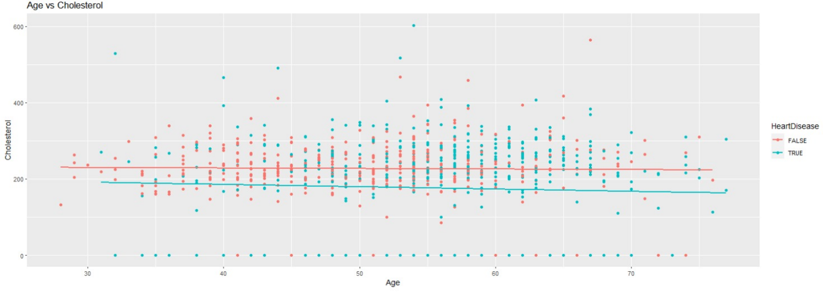

The graph shows the relationship between age and cholesterol levels, differentiated by whether or not individuals have heart disease.

Both sets of data points are scattered throughout the graph, but red points tend to be higher on the y-axis. There are two lines of best fit corresponding to each set of data points; the red line is generally above the blue one.

There is a correlation between age and cholesterol levels, with cholesterol levels generally increasing with age. It also indicates that people with heart disease generally have higher cholesterol levels than those without.

Kmeans Clustering:

-the clustering plot represents some of the integer features in our data.

-To create this plot we used the features with the strongest correlations to make the clusters.

-our data is divided into three different cluster; each entry belongs to a group.

-after analyzing the plot, it seems that the distance between the data is not large resulting in the clusters being intersected in the plot.

-it seems that the first cluster have the most variation in data as it seems the most independent from the other graphs.

5.Conclusion:

Heart disease is a common event caused by cardiovascular diseases, and early detection is crucial for effective management. In this study, we analyzed the provided data, several key findings have appeared regarding the factors that added to the probability of having heart disease. The study focused on 11 factors, including age, sex, chest pain type, resting blood pressure, cholesterol levels, fasting blood sugar, and resting Blood pressure results.

In conclusion, the factors that increase the probability of having heart disease include being male, having exercise-induced angina, having low fasting blood sugar levels, older age, higher resting blood pressure, and higher cholesterol levels.

These factors can help healthcare industries to diagnose heart diseases and take the effective measures to make sure the patient doesn’t suffer from a cardiac arrest.