Statistical Tasks Report

# Task 1: Comparison of Confidence Intervals for a Normally Distributed Population Variance

## 1. Theoretical Background

For a normally distributed population with variance σ², the theoretical (1 - α) × 100% confidence interval for variance is given by:  
 ((n-1)s² / χ²_(1−α/2), (n-1)s² / χ²_(α/2))  
Where:  
- s² is the sample variance,  
- n is the sample size,  
- χ²_(α/2) and χ²_(1−α/2) are critical values from the Chi-square distribution with n−1 degrees of freedom.

## 2. Practical Implementation with Bootstrap

Bootstrap is a resampling technique used to estimate the distribution of a statistic. Here, we estimate the variance and construct confidence intervals using three criteria:  
1. Percentile Method: 2.5th and 97.5th percentiles of the bootstrap variance distribution.  
2. Empirical Method: Uses the empirical rule assuming a normal distribution.  
3. Z-based Method: Uses mean ± z * SE from bootstrapped variances.

## 3. Findings from Visualization

The histogram shows the distribution of bootstrapped variances. All three confidence intervals are shown:  
- The Percentile CI (green) is based directly on percentiles.  
- The Empirical CI (orange) assumes a symmetric normal distribution.  
- The Z-based CI (red) uses the standard error and Z-critical values.  
All intervals are fairly close, but the Z-based interval is slightly narrower. This confirms the reliability of bootstrap methods while showing that interval width can depend on the method chosen.

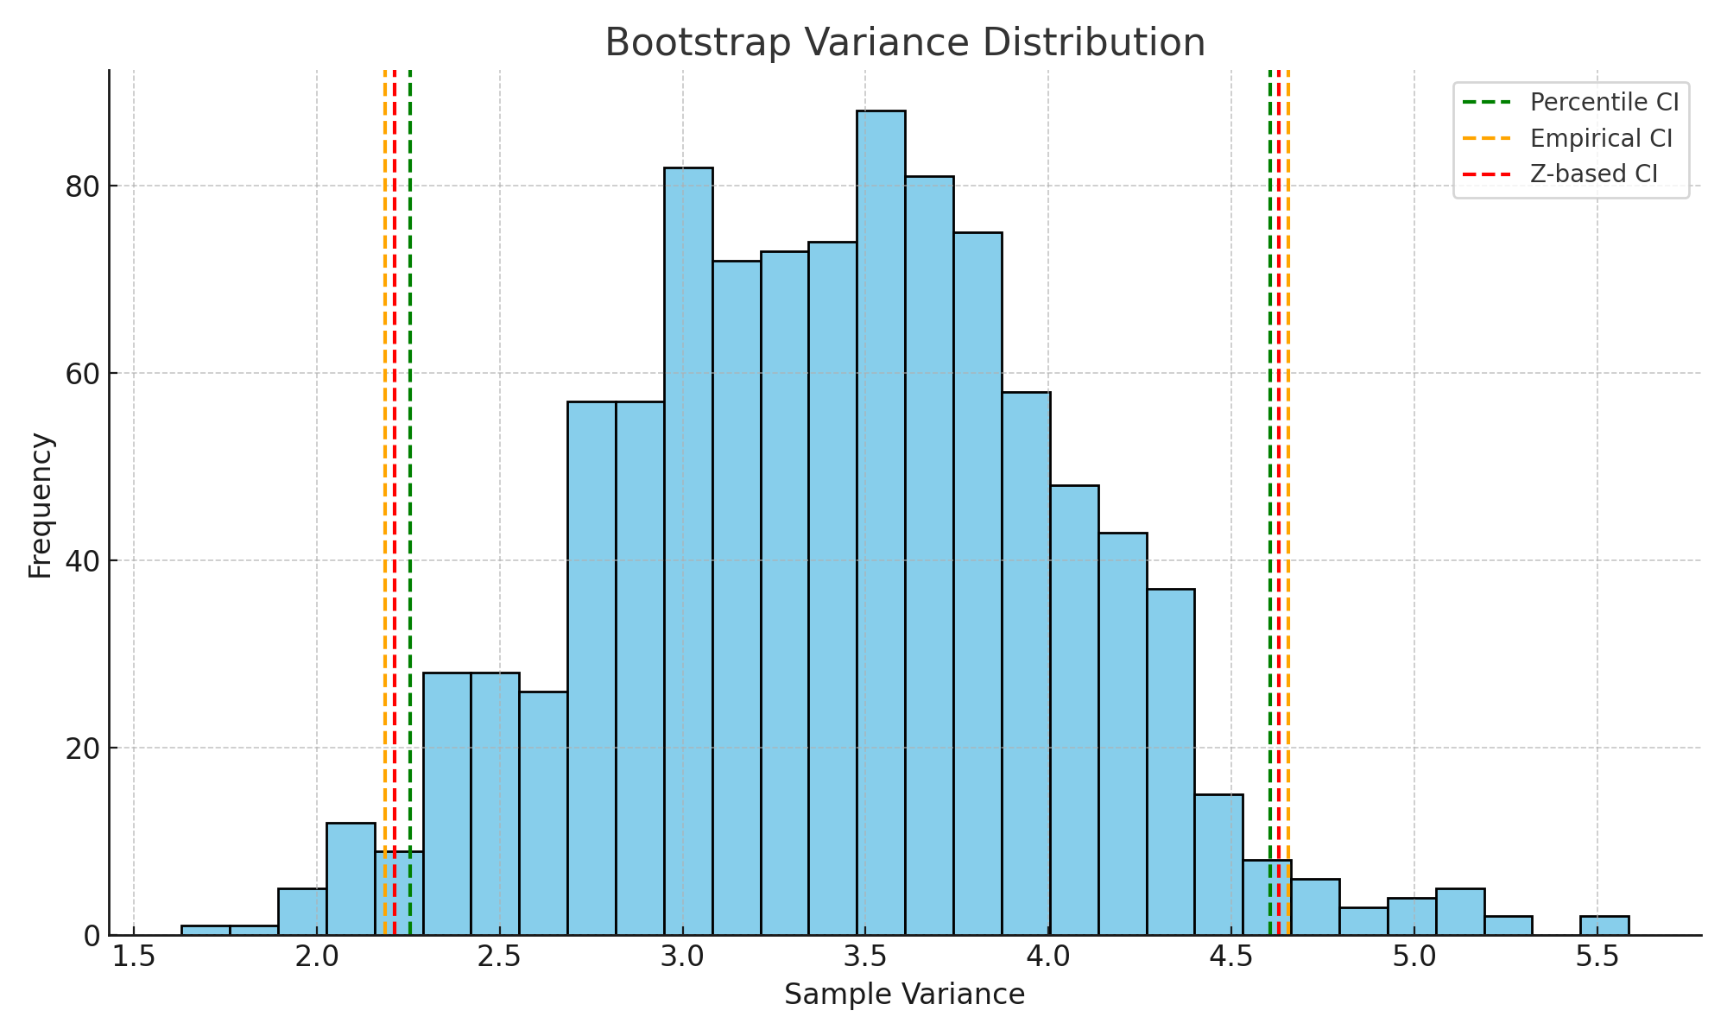

# Task 2: Estimating Parameters (a, b) for a Uniform Distribution Using Method of Moments

## 1. Theoretical Background

For a uniform distribution U(a, b):  
- Mean: μ = (a + b) / 2  
- Variance: σ² = (b - a)² / 12  
From sample mean x̄ and sample variance s², solve:  
 a + b = 2x̄ and (b - a)² = 12s²  
Solving gives:  
 a = x̄ - √(3s²), b = x̄ + √(3s²)

## 2. Findings from Visualization

The histogram of sample data from a uniform distribution shows vertical lines for the estimated bounds a and b. These estimates, obtained using the method of moments, effectively capture the true range of the distribution.

