Baroque AI: Publication Prototype

Jana Cornelius

2023-03-17

Table of contents

# 1. Title:

Author: Cornelius, Jana Lisa

ORCID: https://orcid.org/0009-0004-3404-2441

Date: 21.04.2023

DOI: 10.5281/zenodo.7852387

Repository URL: https://github.com/Janacnl/catalogue-003

## 1.1 Based on Baroque AI: Publication Prototype

## 1.2 Part of the series: Baroque TOC

[Programme instructions](https://nfdi4culture.github.io/class-ADA-CP-pipeline/)

2023-03-17

This work is licensed under a Creative Commons Attribution-ShareAlike 4.0 International License.

Book cover: Reworking of [Baroque pearl with enamelled gold mounts set with rubies](https://en.wikipedia.org/wiki/File:Pendant_in_the_form_of_a_siren_MET_DT7173.jpg). Creative Commons CC0 1.0 Universal Public Domain Dedication. This file was donated to Wikimedia Commons as part of a project by the Metropolitan Museum of Art.

This work is licensed under a Creative Commons Attribution-ShareAlike 4.0 International License.

# 2. Colophon

* Fork title: Janacnl / catalogue-003
* Author: Cornelius, Jana Lisa
* ORCID: <https://orcid.org/0009-0004-3404-2441>
* Date: 21.04.2023
* DOI: 10.5281/zenodo.7852387
* Repository URL: <https://github.com/Janacnl/catalogue-003>

PUBLISHING FROM COLLECTIONS USES OF COMPUTATIONAL PUBLISHIGN AND LINKEDOPEN DATA

Open Science Lab - TIB Hannnover

First published 2023-03-30

Copyright © The Authors 2023 Licensed as https://creativecommons.org/licenses/by-sa/4.0/

DOI: https://doi.org/10.5281/zenodo.7701161

# 3. Museums of Bavaria

Nextcloud Markdown document link: https://tib.eu/cloud/s/qBx8SbqiPBBedye

## 3.1 Part of the series: Baroque TOC

* Class instructions and all links: <https://nfdi4culture.github.io/class-ADA-CP-pipeline/>
* Demo publication: <https://nfdi4culture.github.io/catalogue-003/>
* Repo link: <https://github.com/NFDI4Culture/catalogue-003>

## 3.2 Add your name:

* Jana Cornelius

## 3.3 Text editing

**Bavaria** is a state in the south of Germany that is known for its rich culture, history, and art. The state has a number of museums and galleries that showcase the unique cultural heritage of the region.

One of the most famous museums in Bavaria is the **Bavarian National Museum**, located in Munich. The museum houses a collection of art and artifacts from the *Middle Ages to the 20th century, with a focus on Bavarian and German culture.* The museum also has a collection of traditional Bavarian clothing and folk art.

Another notable museum in Bavaria is the **Pinakothek der Moderne**, also located in Munich. The museum is dedicated to *modern and contemporary art,* with a collection that includes works by famous artists such as Pablo Picasso and Andy Warhol.

In Nuremberg, the **Germanisches Nationalmuseum** is the largest museum of *cultural history* in Germany. The museum has a collection of over 1.3 million objects that tell the story of German culture and history from prehistoric times to the present day.

ChatGPT (2023): Museums of Bavaria. Online unter https://chat.openai.com/c/6c3124a7-b1ab-47d5-86da-86a4f8f5fd8e [Abruf am 20.04.2023]

<https://openai.com/blog/chatgpt>

<https://www.perplexity.ai/>

# 4. Paintings catalogue

Wikidata link: <http://www.wikidata.org/entity/Q18689231>

Title: Maria Theresa, Archduchess of Habsburg

Year: 1730

Creator: Rosalba Carriera

Copyright: public domain

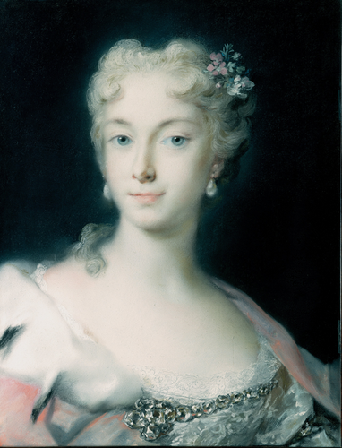

Wikidata link: <http://www.wikidata.org/entity/Q18689261>

Title: A Gentleman in a Gold Patterned Coat and Violet-Brown Cape

Year: 1727

Creator: Rosalba Carriera

Copyright: public domain

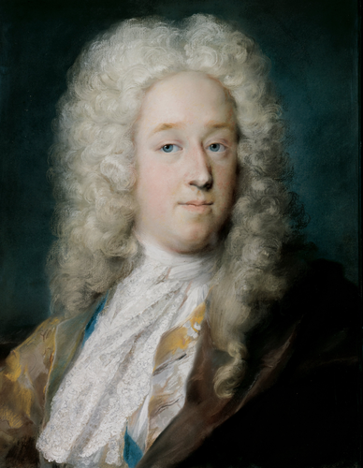

Wikidata link: <http://www.wikidata.org/entity/Q18689275>

Title: Louis XV of France as Dauphin

Year: 1720

Creator: Rosalba Carriera

Copyright: public domain

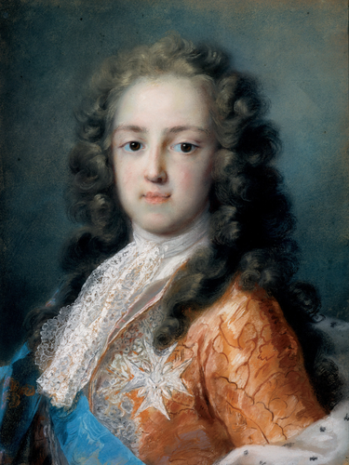

Wikidata link: <http://www.wikidata.org/entity/Q19266867>

Title: Las tres velas

Year: 1903

Creator: Joaquín Sorolla

Copyright: public domain

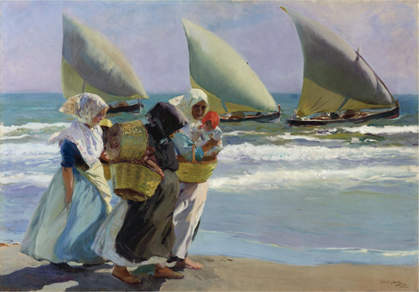

Wikidata link: <http://www.wikidata.org/entity/Q28798167>

Title: The Singer Faustina Bordoni (1697-1781) with a Musical Score

Year: 1724

Creator: Rosalba Carriera

Copyright: public domain

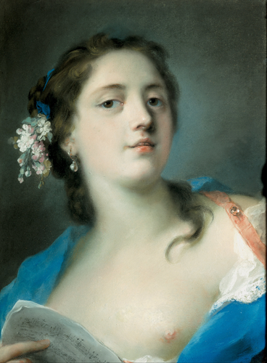

Wikidata link: <http://www.wikidata.org/entity/Q50326304>

Title: Judgement of Paris

Year: 1712

Creator: Adriaen van der Werff

Copyright: public domain

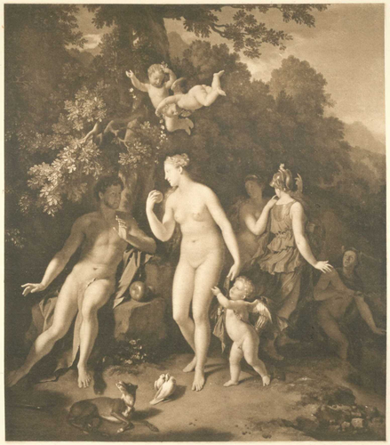

Wikidata link: <http://www.wikidata.org/entity/Q50326304>

Title: Judgement of Paris

Year: 1712

Creator: Adriaen van der Werff

Copyright: public domain

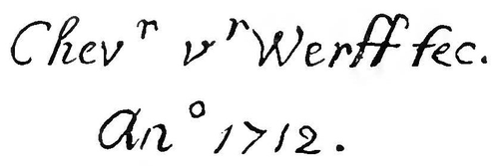

Wikidata link: <http://www.wikidata.org/entity/Q50327445>

Title: Youthful self-portrait

Year: 1765

Creator: Anton Graff

Copyright: public domain

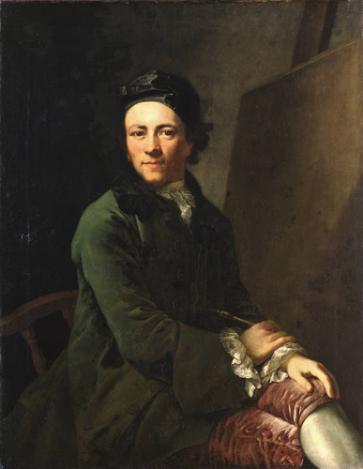

Wikidata link: <http://www.wikidata.org/entity/Q64541395>

Title: Portrait of Heinrich von Brühl

Year: 1753

Creator: Marcello Bacciarelli

Copyright: public domain

