Franz Seraph von Stirnbrand

Jana Cornelius

2023-04-28

Table of contents

# 1. Franz Seraph von Stirnbrand

Author: Cornelius, Jana Lisa

ORCID: https://orcid.org/0009-0004-3404-2441

Date: 28.04.2023

DOI: 10.5281/zenodo.7852387

Repository URL: https://github.com/Janacnl/catalogue-003

2023-03-17

Book cover: Reworking of [Jahrhundertausstellung 1906 KatNr. 1727)](https://www.wikidata.org/wiki/Q1449056#/media/File:Jahrhundertausstellung_1906_KatNr._1727.jpg). Creative Commons CC0 1.0 Universal Public Domain Dedication.

This work is licensed under a Creative Commons Attribution-ShareAlike 4.0 International License.

# 2. Colophon

* Fork title: Janacnl / catalogue-003
* Author: Cornelius, Jana Lisa
* ORCID: <https://orcid.org/0009-0004-3404-2441>
* Date: 28.04.2023
* DOI: 10.5281/zenodo.7852387
* Repository URL: <https://github.com/Janacnl/catalogue-003>

PUBLISHING FROM COLLECTIONS USES OF COMPUTATIONAL PUBLISHIGN AND LINKEDOPEN DATA

Open Science Lab - TIB Hannnover

First published 2023-03-30

Copyright © The Authors 2023 Licensed as https://creativecommons.org/licenses/by-sa/4.0/

DOI: https://doi.org/10.5281/zenodo.7701161

# 3. About the Painter

* Jana Cornelius

## 3.1 Franz Seraph von Stirnbrad: A Master of Emotive Brushstrokes

Franz Seraph von Stirnbrad (1798-1832) was a renowned painter known for his ability to infuse his works with deep emotion. His dynamic and expressive brushstrokes captured the essence of the human experience, from joy and serenity to sorrow and anguish. Stirnbrad’s paintings resonated with viewers on a profound level, evoking introspection and empathy.

One of Stirnbrad’s notable works is “The Weary Wanderer,” portraying a figure walking through a desolate landscape, conveying exhaustion and despair. Another masterpiece, “The Dance of Elation,” captures the vibrant energy of a joyous celebration with bold colors and dynamic brushwork. Stirnbrad’s style, influenced by the Romantic movement, showcased his unique approach, characterized by fluid and intense brushstrokes.

Despite his premature death at 34, Stirnbrad’s artistic legacy lives on. His paintings can be found in museums worldwide, captivating and inspiring audiences with their ability to convey emotion. Franz Seraph von Stirnbrad’s work is a testament to the power of art in capturing the complexities of the human experience and leaving a lasting impression on all who encounter it.

ChatGPT (2023): Stirnbrad. Emotive Brushstrokes. Online unter https://chat.openai.com/share/6e313857-9a53-4de0-b661-b5c98692fd5a [Abruf am 14.06.2023]

# 4. Paintings catalogue

Title: Portät König Maximilian II. von Bayern

Year: 1860

Creator: Franz Seraph von Stirnbrand

Copyright: public domain

Wikidata link: <http://www.wikidata.org/entity/Q119228942>

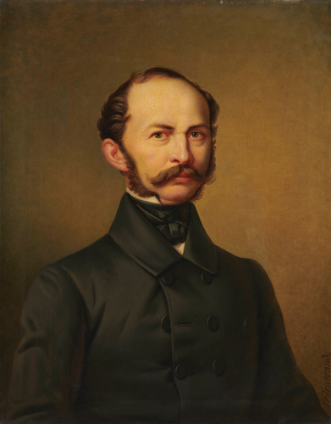

Title: Porträt Königin Pauline von Württemberg

Year: 1822

Creator: Franz Seraph von Stirnbrand

Copyright: public domain

Wikidata link: <http://www.wikidata.org/entity/Q119230131>

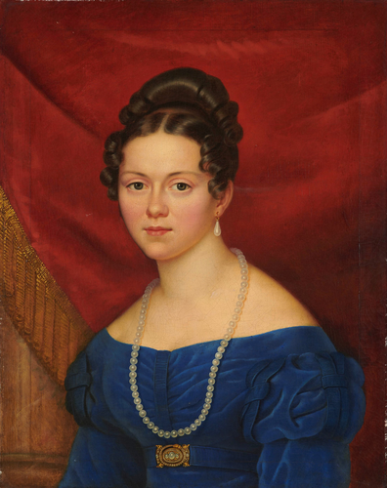

Title: Porträt Emilie Kuhn

Year: 1842

Creator: Franz Seraph von Stirnbrand

Copyright: public domain

Wikidata link: <http://www.wikidata.org/entity/Q119230133>

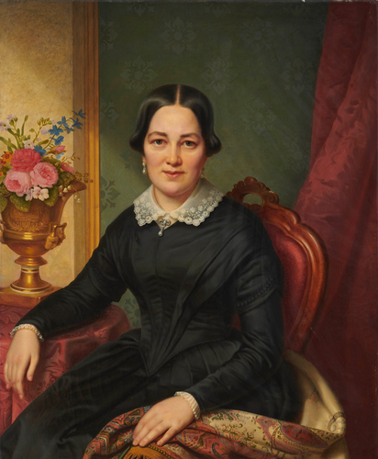

Title: Porträt Emilie Kuhn

Year: 1849

Creator: Franz Seraph von Stirnbrand

Copyright: public domain

Wikidata link: <http://www.wikidata.org/entity/Q119230135>

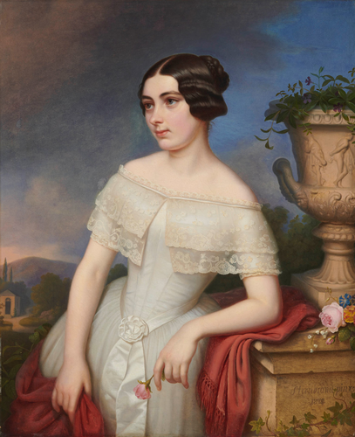

Title: Porträt König Wilhelm I. von Württemberg

Year: 1859

Creator: Franz Seraph von Stirnbrand

Copyright: public domain

Wikidata link: <http://www.wikidata.org/entity/Q119230137>

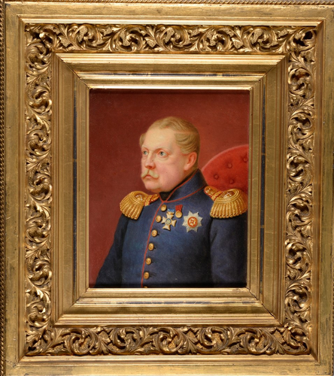

Title: Porträt König Wilhelm I. von Württemberg

Year: 1841

Creator: Franz Seraph von Stirnbrand

Copyright: public domain

Wikidata link: <http://www.wikidata.org/entity/Q119230139>

