Old Masters Gallery Dresden

Jana Cornelius

2023-04-28

Table of contents

# 1. Old Masters Gallery Dresden

Author: Cornelius, Jana Lisa

ORCID: https://orcid.org/0009-0004-3404-2441

Date: 28.04.2023

DOI: 10.5281/zenodo.7852387

Repository URL: https://github.com/Janacnl/catalogue-003

2023-03-17

Book cover: Reworking of [Dresden, Zwinger (Semperbau mit Gemäldegalerie)](https://www.wikidata.org/wiki/Q4890#/media/File:Dresden-Zwinger-Courtyard.11.JPG). Creative Commons CC0 1.0 Universal Public Domain Dedication.

This work is licensed under a Creative Commons Attribution-ShareAlike 4.0 International License.

# 2. Colophon

* Fork title: Janacnl / catalogue-003
* Author: Cornelius, Jana Lisa
* ORCID: <https://orcid.org/0009-0004-3404-2441>
* Date: 28.04.2023
* DOI: 10.5281/zenodo.7852387
* Repository URL: <https://github.com/Janacnl/catalogue-003>

PUBLISHING FROM COLLECTIONS USES OF COMPUTATIONAL PUBLISHIGN AND LINKEDOPEN DATA

Open Science Lab - TIB Hannnover

First published 2023-03-30

Copyright © The Authors 2023 Licensed as https://creativecommons.org/licenses/by-sa/4.0/

DOI: https://doi.org/10.5281/zenodo.7701161

# 3. About the Gallery

* Jana Cornelius

## 3.1 Old Masters Gallery Dresden

The **Gemäldegalerie Alte Meister**, also known as the **Old Masters Picture Gallery**, is one of the most famous art museums in Dresden, Germany. The museum was founded in 1723 and is located in the Semperbau building of the Zwinger Palace complex.

The Gemäldegalerie Alte Meister is renowned for its exceptional collection of paintings from the Baroque and Renaissance periods. The museum’s collection includes works from many famous artists such as Raphael, Titian, Rubens, and Rembrandt, to name a few. The most famous painting in the collection is undoubtedly Raphael’s “Sistine Madonna,” which is considered one of the most beautiful paintings in the world.

Visitors to the museum can also admire works by German artists such as Lucas Cranach the Elder, Hans Holbein the Younger, and Albrecht Dürer. The museum’s collection is extensive, comprising over 3,000 paintings, with around 750 of them on display at any given time.

The museum’s architecture is also noteworthy, as the Semperbau building was designed by Gottfried Semper, a famous German architect. The building was destroyed during World War II but was later reconstructed and reopened in 1960.

In conclusion, the Gemäldegalerie Alte Meister is a must-visit for anyone interested in art and history. The museum’s extensive collection of paintings and its beautiful architecture make it a fascinating destination for tourists and art enthusiasts alike.

ChatGPT (2023): Old Masters Gallery Dresden. Online unter https://chat.openai.com/c/b480a193-94a7-4ddf-bc82-13afa53e2381 [Abruf am 28.04.2023]

# 4. Paintings catalogue

Title: Portät König Maximilian II. von Bayern

Year: 1860

Creator: Franz Seraph von Stirnbrand

Copyright: public domain

Wikidata link: <http://www.wikidata.org/entity/Q119228942>

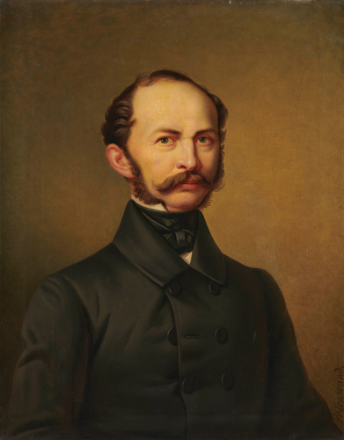

Title: Porträt Königin Pauline von Württemberg

Year: 1822

Creator: Franz Seraph von Stirnbrand

Copyright: public domain

Wikidata link: <http://www.wikidata.org/entity/Q119230131>

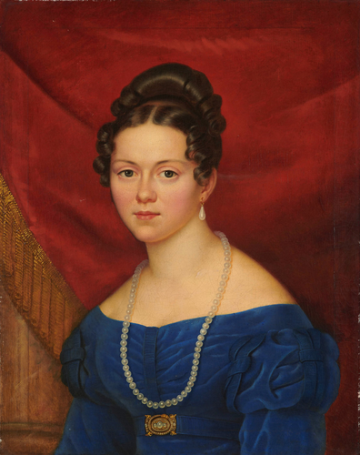

Title: Porträt Emilie Kuhn

Year: 1842

Creator: Franz Seraph von Stirnbrand

Copyright: public domain

Wikidata link: <http://www.wikidata.org/entity/Q119230133>

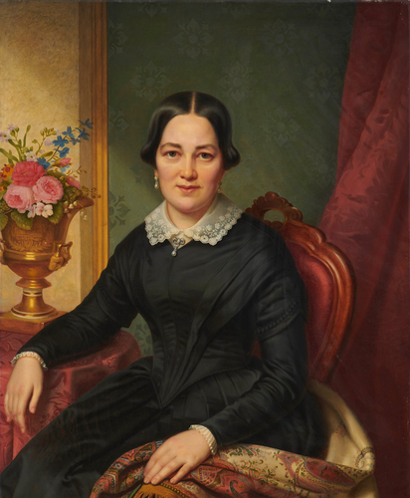

Title: Porträt Emilie Kuhn

Year: 1849

Creator: Franz Seraph von Stirnbrand

Copyright: public domain

Wikidata link: <http://www.wikidata.org/entity/Q119230135>

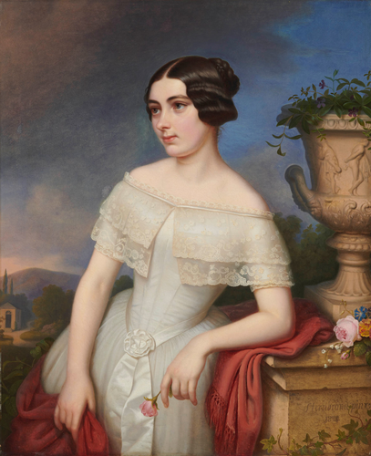

Title: Porträt König Wilhelm I. von Württemberg

Year: 1859

Creator: Franz Seraph von Stirnbrand

Copyright: public domain

Wikidata link: <http://www.wikidata.org/entity/Q119230137>

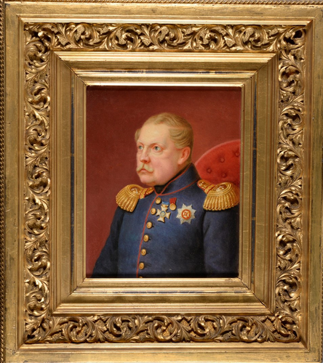

Title: Porträt König Wilhelm I. von Württemberg

Year: 1841

Creator: Franz Seraph von Stirnbrand

Copyright: public domain

Wikidata link: <http://www.wikidata.org/entity/Q119230139>

