Screen Time, Sleep and Academic Performance
A Data Analysis and Mathematical Model Formulation
Week 2 Task Report
Author: Janak J Prajapati

Abstract
The focus point of this report is to investigate whether daily screen time and sleep duration can explain the gap between the CGPA of students. We have taken the publicly available dataset of 500 students, explored visually and statistically, and used to fit for our nested regression models sourced from Kaggle. Daily screen time has no detectable association once sleep it accounted for. Whereas weekday sleep shows a strong, statistically significant positive association with CGPA. The two-predictor linear model explains 19.1% of the variance in CGPA, and an extended model adding study hours, attendance and sleep quality raises this to 33.1%. Assumptions are tested and limitations discussed, chiefly that the data are observational and self-reported, so the results describe association rather than causation.

1. Introduction and Objective
Now a days students are increasingly spending long hours on digital devices, many times at an expense of their sleep. With this a natural question arises that whether this habit translates itself into their academics or not. The objective of this report is to
- Source and clean a real dataset
- Identify patterns that can be expressed mathematically
- Formulate and compare mathematical models of CGPA
- State the assumptions and limitations of those models and their real-world implications.
The questions we have to answer are:
- Is daily screen time associated with CGPA?
- Is weekday sleep duration associated with CGPA?
- Do the two interact, or is either effect non-linear?
- How much additional explanatory power do other lifestyle variables provide?

2. Data Source and Cleaning

2.1 Dataset
The chosen data has been taken from a publicly available data Kaggle dataset, “Student sleep, screen time and academic performance”. The dataset contains 500 student records and 25 variables covering demographics, sleep habits, device use, wellbeing, study behaviour and CGPA. The variable used are:
Variable | Role | Description
CGPA | Response (Y) | Cumulative grade point average
Daily screen time in Hours | Predictor (X1) | Average total daily screen time, in hours
Average sleep hours on weekday | Predictor (X2) | Average nightly sleep on weekdays, in hours
Weekly study hours,  Class attendance percentage,  Sleep quality score,  Pre sleep screen time | Extended-model covariates | Study effort, attendance, self-rated sleep quality, screen use before bed

2.2 Cleaning steps
- Checking the three core variables for missing values
  - Screen time and sleep hours had none
  - CGPA was missing 7 students, who were removed

- Removing the exact duplicate rows (none found) and checking for physically impossible values (hours outside 0-24 range) none were found.

- Inspecting extreme values. One student had reported 19.5 hours of daily screen time. This thing can be said to be implausible but not entirely impossible, so it was kept in the main analysis and its influence was tested separately.

Result: 493 of 500 records (98.6%) were retained for modelling.

3. Exploratory Data Analysis

3.1 Descriptive statistics
Variable | Mean | Std. dev. | Min | Median | Max | Skewness
Daily screen time (h) | 5.83 | 2.05 | 0.5 | 5.8 | 19.5 | 0.51
Weekday sleep (h) | 6.61 | 1.44 | 1.5 | 6.6 | 10.5 | -0.28
CGPA | 2.83 | 0.34 | 1.89 | 2.85 | 3.95 | 0.09

CGPA is almost symmetric (skewness 0.09), which supports a linear-model treatment of the response. Screen time is mildly right-skewed because of a few very heavy users. Average sleep, at 6.6 hours, is below the 7 to 9 hours generally recommended for young adults.
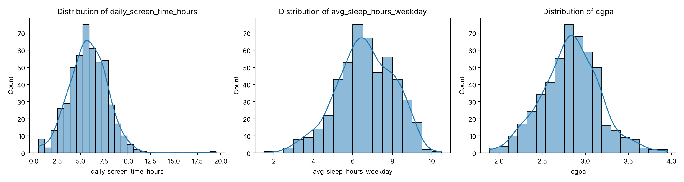
Figure 1. Distributions of screen time, weekday sleep and CGPA.

3.2 Relationships with CGPA
Pair | Pearson r | p-value | Spearman rho
Weekday sleep vs CGPA | 0.435 | < 0.001 | 0.440
Screen time vs CGPA | -0.046 | 0.305 | -0.020
Screen time vs sleep | -0.031 | - | -0.003

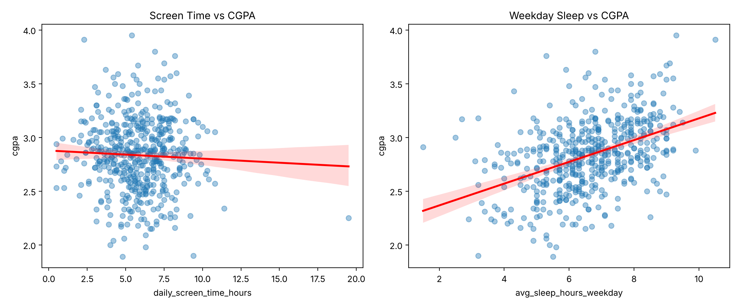
Figure 2. Scatter plots with fitted regression lines. Sleep shows a clear upward trend; screen time is essentially flat.
Two findings stand out. First, sleep has a moderate positive correlation with CGPA, and the Spearman rank correlation (0.440) agrees with the Pearson, so the relationship is not driven by outliers. Second, screen time has almost no linear correlation with CGPA. Screen time and sleep are also nearly uncorrelated with each other (r = -0.03), so each variable can be assessed on its own without one masking the other.
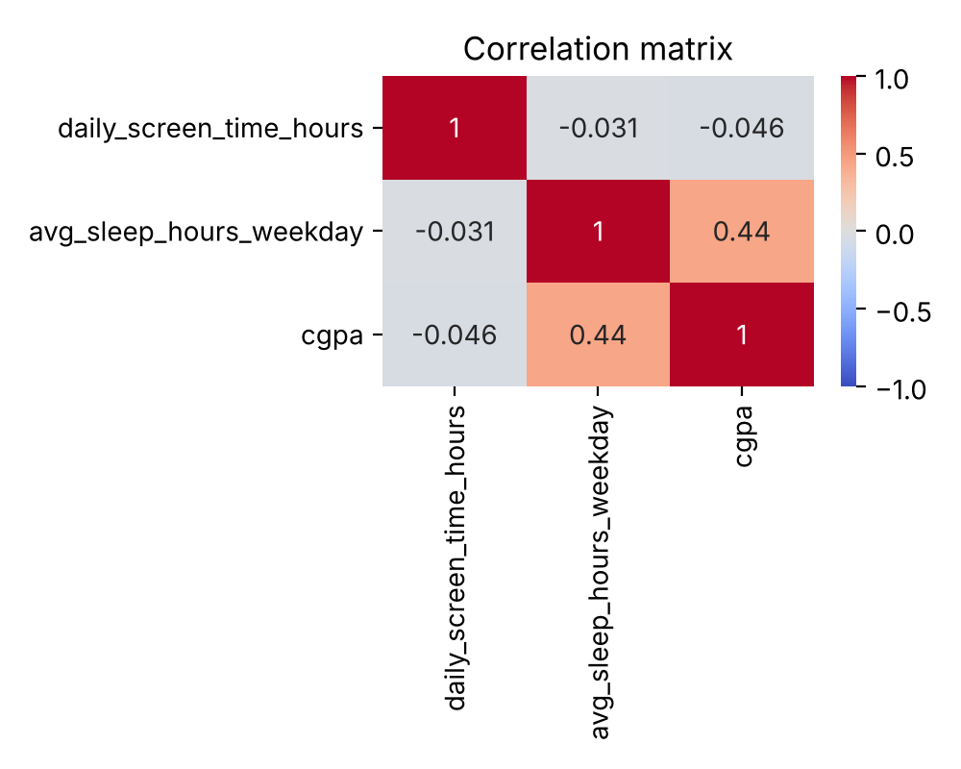
Figure 3. Correlation matrix of the three core variables.
To see the shape of the sleep relationship more clearly, students were grouped into sleep bands. Mean CGPA rises steadily from 2.61 (5 hours or less) to 3.06 (more than 8 hours), a gain of roughly 0.10 to 0.14 for each additional hour of sleep. The steady increments suggest an approximately linear pattern, with a possible mild acceleration at the upper end.

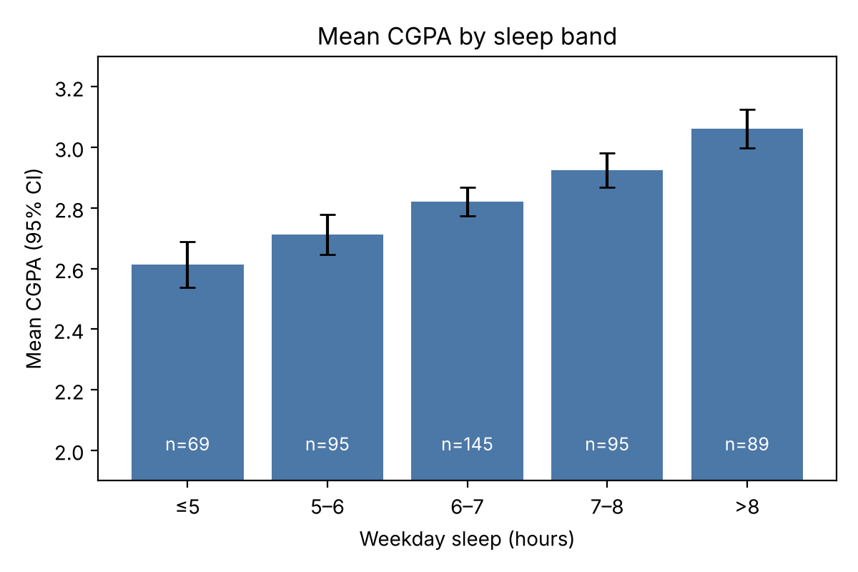
Figure 4. Mean CGPA by weekday sleep band, with 95% confidence intervals.

4. Mathematical Model Formulation
Guided by the exploratory results, a family of nested regression models was formulated. Let S denote daily screen time (hours), H denote weekday sleep (hours) and Y denote CGPA. For student i, & i is a random error.

Model A: Multiple linear regression (baseline)
Y = β0 + β1·S + β2·H + ε
Here β1 is the change in CGPA per extra hour of screen time and β2 the change per extra hour of sleep, each holding the other fixed.

Model B: Interaction model
Y = β0 + β1·S + β2·H + β3·(S·H) + ε
This tests whether the effect of screen time depends on how much a student sleeps (for example, whether heavy screen use is only harmful for short sleepers).

Model C: Quadratic model
Y = β0 + β1·S + β2·H + β3·S² + β4·H² + ε
This allows curvature, such as diminishing returns or an optimal amount of sleep.

Model D: Extended multivariable model
Y = β0 + β1·S + β2·H + β3·P + β4·T + β5·A + β6·Q + ε
where P is pre-sleep screen time (minutes), T is weekly study hours, A is class attendance (%) and Q is sleep-quality score. This tests whether the sleep effect survives after controlling for study effort and sleep quality.

Estimation
All models are estimated by ordinary least squares (OLS), which chooses the coefficients minimising the sum of squared residuals:
β̂ = argmin Σ (Yi − Xiβ)² = (XᵀX)⁻¹ XᵀY

Assumptions
- Linearity: the mean of CGPA is a linear function of the parameters (supported by Figure 2 and Figure 4).
- Independence: students are treated as independent observations (Durbin-Watson = 1.78, close to 2).
- Homoscedasticity: the error variance is constant across fitted values.
- Normal errors: the residuals are approximately normal, which matters for confidence intervals and p-values.
- No severe multicollinearity: predictors are not highly correlated with each other.
- Measurement: self-reported hours are assumed to be reasonably accurate and unbiased.

5. Results

5.1 Model A: baseline
CGPA = 2.198 − 0.0054·Screen + 0.1010·Sleep
Term | Coefficient | Std. error | t | p-value | 95% CI
Intercept | 2.1977 | 0.076 | 29.01 | < 0.001 | [2.049, 2.347]
Screen time | -0.0054 | 0.007 | -0.81 | 0.421 | [-0.018, 0.008]
Weekday sleep | 0.1010 | 0.009 | 10.68 | < 0.001 | [0.082, 0.120]

The model is jointly significant (F = 57.66, p = 3.3 × 10⁻²³) with R² = 0.191 (adjusted R² = 0.187). Each additional hour of weekday sleep is associated with a CGPA about 0.10 points higher (95% CI 0.082 to 0.120), holding screen time fixed. Because sleep has a standard deviation of 1.44 hours, a one-standard-deviation increase in sleep corresponds to about +0.145 CGPA, or roughly 0.43 standard deviations of CGPA. The screen-time coefficient is tiny (about -0.005 per hour) and its confidence interval comfortably includes zero, so there is no evidence that screen time affects CGPA in this sample.
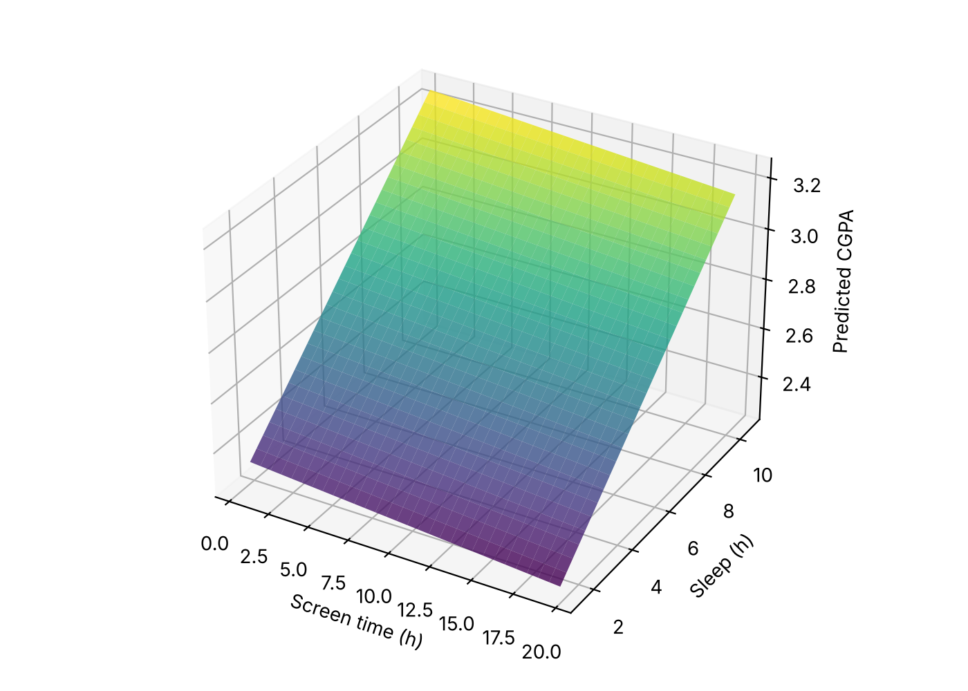
Figure 5. Fitted prediction surface of Model A. CGPA tilts steeply along the sleep axis and barely along the screen-time axis.

5.2 Model comparison
Model | R² | Adj. R² | AIC | BIC | Key finding
A: Linear | 0.1905 | 0.1872 | 220.9 | 233.5 | Sleep significant; screen time not
B: Interaction | 0.1912 | 0.1862 | 222.5 | 239.3 | Interaction p = 0.522 (none)
C: Quadratic | 0.2057 | 0.1992 | 215.6 | 236.6 | Sleep² term p = 0.003
D: Extended (n = 487) | 0.3305 | 0.3222 | 135.5 | - | Study, attendance, sleep quality significant

Model B adds nothing: the interaction coefficient is 0.003 (p = 0.522), so the effect of sleep does not depend on screen time. Model C fits slightly better on AIC (215.6 versus 220.9) and adjusted R², and the squared sleep term is significant (coefficient 0.0144, p = 0.003). The positive sign indicates a convex curve in which the benefit of each extra hour grows slightly at higher sleep levels, which matches the mild acceleration seen in Figure 4. However, BIC, which penalises complexity more heavily, prefers the simpler Model A (233.5 versus 236.6), and the R² gain is only 1.5 percentage points. Model A is therefore the most parsimonious description, and Model C is a defensible refinement if curvature matters.
Model D is not directly comparable by AIC because it uses a slightly different sample (487 rows), but its R² of 0.331 is far higher. Its coefficients are:
Term | Coefficient | p-value | Interpretation
Daily screen time | -0.0017 | 0.785 | No effect
Weekday sleep (h) | 0.0368 | 0.006 | +0.037 CGPA per hour, after controls
Pre-sleep screen time (min) | -0.0006 | 0.281 | Not significant
Weekly study hours | 0.0136 | < 0.001 | +0.014 CGPA per hour
Class attendance (%) | 0.0028 | 0.013 | +0.028 CGPA per 10 points
Sleep quality score | 0.0506 | < 0.001 | +0.051 CGPA per point

Controlling for study effort, attendance and sleep quality shrinks the sleep coefficient from 0.101 to 0.037, although it stays significant. This indicates that a large part of the raw sleep effect is shared with these other factors. Students who sleep longer also tend to sleep better and study and attend more, and the extended model separates these contributions. Screen time remains irrelevant in every specification.

5.3 Assumption diagnostics (Model A)
Check | Result | Conclusion
Multicollinearity (VIF) | 1.001 for both predictors | No collinearity
Heteroscedasticity (Breusch-Pagan) | p = 0.224 | Constant variance not rejected
Normality (Shapiro-Wilk) | p = 0.103 | Normality not rejected
Normality (Jarque-Bera) | p = 0.048 | Marginal; skew 0.20, kurtosis 3.37
Autocorrelation (Durbin-Watson) | 1.78 | No concern

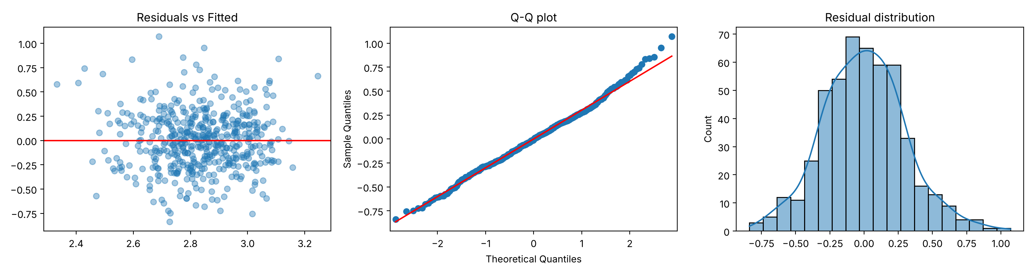
Figure 6. Residual diagnostics: residuals vs fitted values, Q-Q plot and residual histogram.
The residuals scatter evenly around zero with no funnel shape, and the Q-Q plot follows the reference line closely apart from slight tail deviation. The Jarque-Bera test is borderline (p = 0.048) but the departure (skewness 0.20, kurtosis 3.37) is mild, and with 493 observations the coefficient estimates are robust to it. The assumptions are therefore adequately met.

5.4 Predictions from the model
At the sample-mean screen time of 5.8 hours, Model A predicts a CGPA of about 2.67 for a student sleeping 5 hours, 2.97 for 8 hours and 3.18 for 10 hours. Moving from 5 to 8 hours of sleep is therefore associated with a predicted gain of about 0.30 CGPA points, which is nearly one standard deviation of CGPA (0.355).

5.5 Robustness check
Removing the single extreme screen-time record (19.5 hours) and refitting Model A gives almost identical results: sleep coefficient 0.1004 (p < 0.001), screen-time coefficient -0.0031 (p = 0.656), R² = 0.187. The conclusions are not driven by this outlier.

6. Discussion
The main finding is an asymmetric one: that sleep matters, while screen time on its own has no effect. This is in line with the idea that screen time hurts academics mainly by displacing sleep/study, rather than independently. In this dataset at least, total screen time and sleep are almost uncorrelated, and so such a displacement mechanism would not be observed. The nonsignificant effect of pre-sleep screen time in model D suggests that bedtime device use is not a significant independent predictor of grades in this context.
The best fitting simple model explained around 19% of CGPA variation, and even the extended version only 33%. So, most of what makes one student's grades differ from another's is unaccounted for: prior ability, class difficulty, motivation, health and so on. As such, while these models are helpful in describing the direction and rough magnitude of effects, they are not fit to accurately predict an individual student's CGPA.

7. Limitations

7.1 Data limitations
Research question:
- How does students screen time affect their academic performance?

I believe that the study is correlational because of the following reasons:

- Observational design: Students were not randomly assigned to sleep or screen-time categories; hence the results merely suggest an association between the two. It is possible that the better students simply had more spare time to sleep. There was reverse causation or a possibility of a lurking variable that affects both screen-time and CGPA.

- Self-reported: The sleep and screen-time measurements were most probably self-reported, hence the true values might have been overestimated, especially for the latter. This can result in a miscalculation of the variables involved.

- One sample: The study only used one sample of students; hence it is unsure how representative it is for other universities, and even less so, countries. The sample might also have been partly fabricated, since it was taken from an open source, Kaggle. The study would hence, have lesser noise, compared to real-world scenarios.

- Aggregate: The study only takes into account the total hours of screen time. It does not differentiate between students using the laptop to study and those who use it for social media and games. Averaging those opposing effects would cancel the variables out, hence, skewing the results.

- Missing data: There was no mention of how the 7 students with the missing CGPA values were dealt with. It is a small value to being with, hence, if not randomly distributed, it most probably does not affect the results much.

7.2 Model limitations
- Linear models assume constant slopes. The quadratic term suggests that this might be slightly too simple, and the model would give unrealistic predictions outside the observed range (e.g. ever higher CGPA with more sleep, or CGPA > 4.0).
- Omitted- variable bias: Models A to C ignore study effort, attendance and sleep quality, which model D reveals as important. The sleep coefficient in A is therefore picking up these factors, at least partly.
- Low explanatory power $R^{2} of 0.19 to 0.33)$ limits usefulness for prediction.

8. Real-World Implications
- Universities can focus on improving sleep health among students by implementing strategies such as later morning classes, sleep hygiene education, and reduced deadlines during the night, which may have more beneficial effects compared to restricting screen time.
- Students can view sleep as an input to their academic performance, and if the relationship is casual, the model suggests that adding 0.5 hours of sleep per night would predict a 0.05 increase in CGPA, which would be equivalent to approximately 4 additional hours of weekly study in Model D.
- The policymakers should not make any policies based on these findings since the data used is observational. Further experimental studies such as a sleep extension intervention with a control group would have to be conducted before concluding that sleep duration has a casual effect on academic performance.

9. Conclusion
Using 493 cleaned students records, this report find a positive association between weekday sleep and CGPA (roughly +0.10 per hour; r = 0.435) and no association between daily screen time and CGPA. The simple linear model (Model A) is most parsimonious, while a quadratic refinement (Model C) captures slight curvature, and an extended model (Model D) finds that study hours, attendance and sleep quality jointly explain additional variation and attenuate the putative sleep effect to about +0.04 per hour. Model assumptions hold reasonably well. The main caveats are the observational, self-reported nature of the data and modest explanatory power, so the findings should be read as evidence of association and a basis for further study.

Appendix: Reproducibility
All analysis was performed in Python 3, using pandas, NumPy, SciPy, statsmodels, matplotlib and seaborn. The data were read in from student_sleep_screen_time_academic_performance.csv and the core variables are daily_screen_time_hours, avg_sleep_hours_weekday and CGPA. The accompanying script analysis.py reproduces the tables and Figures 1 to 3, 5 and 6; Figure 4 is produced by the fig6.py.
Source: Kaggle, “Student sleep, screen time and academic performance” dataset.

