HEAPS
This short note covers an overview of binary heap, related operations and a time complexity analysis of each operation with the logic described
Binary Heap is the foundation (and that’s what this course DSA456 covers too)!!!
A binary heap is a complete binary tree + heap order property
Key Properties:
Complete Tree -> filled left to right
Heap order:
- Min heap: parent <= child
- Max heap: parent >= child
Root= highest priority
Array Representation
For node at index i:
- Left child -> 2i + 1
- Right child -> 2i + 2
- Parent -> (i – 1) // 2
No pointers needed
Compact and efficient
- INSERT
Steps:
- Insert at next available spot (end of array – right most in heap)
- Compare with parent
- If violates heap property -> swap up
- Repeat until valid
🧠 Idea:
“Insert at bottom, bubble up”
- DELETE (Percolate Down)
Steps:
- Replace root with last element (right most element)
- Remove last element
- Compare with children
- Swap with higher priority child
- Repeat until valid
🧠 Idea:
“Move last to top, push down”
- PRIORITY QUEUE
Removes highest priority, not first inserted
Heap makes:
- Insert -> O(log n)
- Delete -> O(log n)

- 🔥 HEAPIFY (IMPORTANT!)
Goal:
Convert array -> heap in-place

Steps:
- Start at first non-leaf node i = (n-2) // 2
- Move backwards to root
- Apply heapify (percolate down)
Heapify logic:
If parent violates heap property:
- Swap with higher priority child
- Heapify subtree
🧠 Idea:
“Fix from bottom → up”
5. 🚀 HEAP SORT
Steps:
- Build heap (heapify)
- Swap root with last element
- Reduce heap size
- Percolate down root
- Repeat until sorted
🧠 KEY TRICK:
For ascending sort -> use max heap
Largest element goes to end
⏱️ TIME COMPLEXITY
To understand time complexity of heap operations easily, we need to ask:
Am I moving through the height of the tree?
YES -> O(log n)
Am I touching almost all elements?
YES -> O(n)
Am I doing log n work MANY times?
YES → O(n log n)
- Insert -> O(log n)
- Delete -> O(log n)
- Heapify -> O(n) IMPORTANT!
- Heap Sort -> O(n log n)
BREAKING IT DOWN
A heap is a binary tree, and the height of a binary heap is log n
WHY??
- Each level doubles nodes -> 1, 2, 4, 8, …
- So height grows slowly -> log n
- INSERT -> O(log n)
What happens?
- You insert at the bottom
- Then percolate UP
That’s at most (Worst Case): log n steps
Intuition: How far can I move up? -> Height of tree -> log n
- DELETE -> O(log n)
What happens?
- Replace root with the last element
- Then percolate DOWN
Worst Case: log n steps
Intuition: How far can I fall -> Height of tree -> log n
- HEAPIFY -> O(n) (THIS IS THE TRICKY ONE)
KEY INSIGHT
- Bottom nodes -> no work (leaves are already heaps)
- Middle nodes -> small work
- Top nodes -> more work
BUT:
There are VERY FEW TOP NODES
There are MANY BOTTOM NODES (CHEAP)
Visualization:
Level Nodes Work per Node
Bottom many 0
Middle fewer small
Top very few log n
Most nodes do almost no work
Total work adds up to O(n)
🔥 Memory Trick:
“Heapify is fast because most nodes are near the bottom”
Summary Table of Heapify Work:
Bottom level (Leaves): n/2 nodes, 0 swaps
Level above leaves: n/4 nodes, <= 1 swap
Second level above: n/8 nodes, <= 2 swaps
Root: 1 node, <= log n swaps
- HEAP SORT -> O(n log n)
Two Phase:
Phase 1: Build heap -> O(n)
Phase 2: Remove n elements
Each delete: O(log n)
Total: n x log n = O(n log n)
Final: O(n) + O(n log n) = O(n log n)
So basically: “Do log n work, n times”
🧠 INTUITION OF BIG O:
O(log n) → grows very slowly
O(n) → grows linearly
O(n log n) → grows faster than n
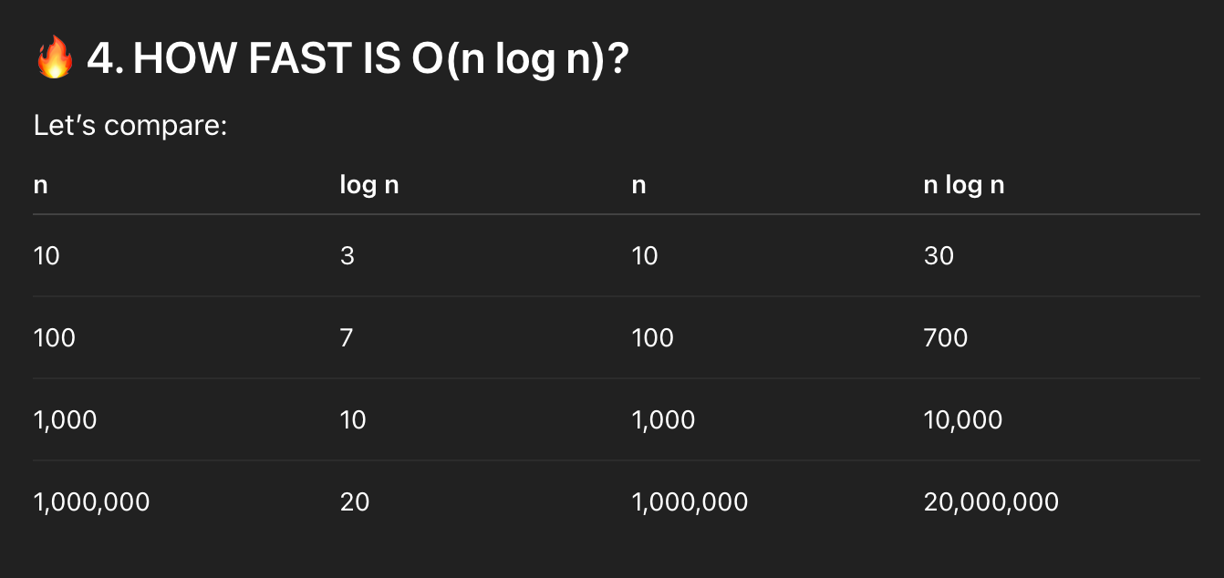
Think of it like this:
O(log n) → climbing stairs 🪜 (few steps)
O(n) → walking a straight road 🛣️
O(n log n) → walking the road but stopping briefly at each step 🚶‍♂️
O(log n) grows very slowly, O(n) grows linearly, and O(n log n) grows slightly faster than linear but is still efficient.
***Other Important Exam Points!!
- Heap is NOT fully sorted
- Only parent-child relationship matters
- Heap sort is:
  - In-place
  - Not stable
💯 QUICK MEMORY PHRASES 💯
HEAP:
“COMPLETE TREE + PARENT PRIORITY (HEAP ORDER)”
INSERT:
“ADD AT END, BUBBLE (PERCOLATE) UP”
DELETE:
“REPLACE ROOT WITH LAST, PUSH (PERCOLATE) DOWN”
HEAPIFY:
“START MIDDLE (n-2)//2, GO UPWARD” – NON-LEAF NODE
HEAP SORT:
“BUILD HEAP
SWAP ROOT WITH LAST
SHRINK HEAP
REPEAT”

