Pandit Deendayal Energy University
School of Technology
Department of ICT
Academic Year: 2022-23
Computer Communication and Networking Lab
20IC306P
Name: Janakar Patel
Roll No: 20BIT061

Experiment-9

Aim: To understand the working of NAT by using Wire-shark.

Software Tools required: Wire-shark.

NAT Measurement Scenario

Q.1 What is the IP address of the client that sends the HTTP GET request in the nat-inside-wiresharktrace1-1.pcapng trace? What is the source port number of the TCP segment in this datagram containing the HTTP GET request? What is the destination IP address of this HTTP GET request? What is the destination port number of the TCP segment in this datagram containing the HTTP GET request?

Ans: IP address of the client :192.168.10.11,
Source port number of the TCP segment in this datagram containing the HTTP GET request:53924,
Destination IP address of this HTTP GET request :138.76.29.8,
Destination port number of the TCP segment in this datagram containing the HTTP GET request :80.
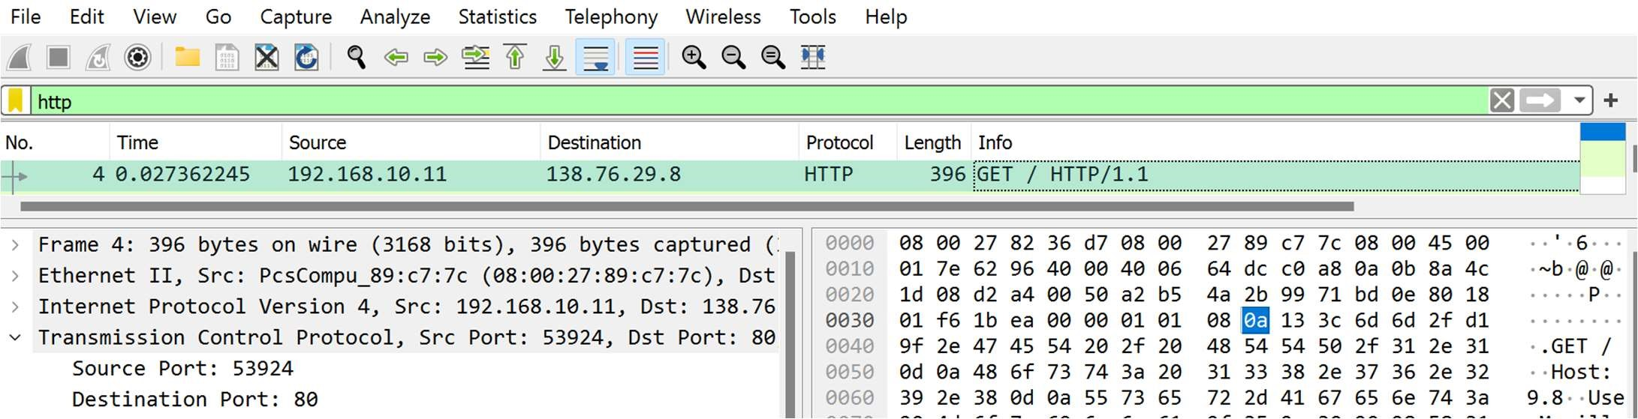

.2 At what time is the corresponding HTTP 200 OK message from the webserver forwarded by the NAT router to the client on the router’s LAN side?

Ans: Time the OK message is forwarded: 09:20:27.774683377 IST.
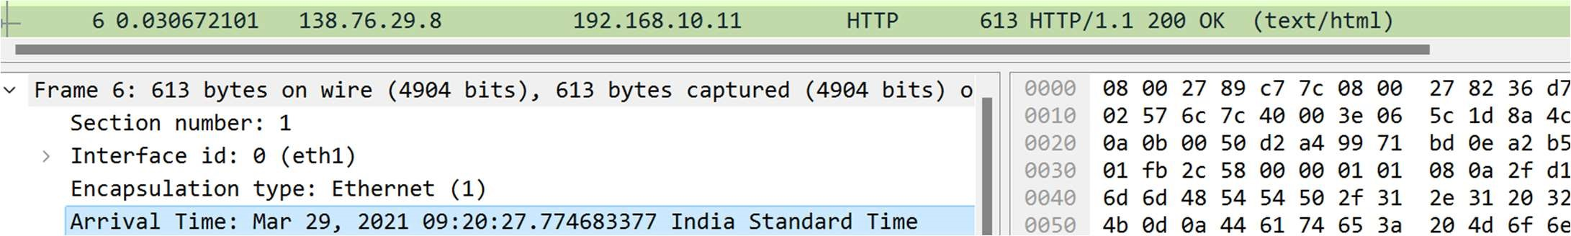

Q.3 What are the source and destination IP addresses and TCP source and destination ports on the IP datagram carrying this HTTP 200 OK message?

Ans: IP address :138.76.29.8,
Source port number of the TCP segment in this datagram carrying HTTP 200 OK message: 80, Destination IP address: 192.168.10.11,
Destination port number of the TCP segment in this datagram carrying HTTP 200 OK message :53924.

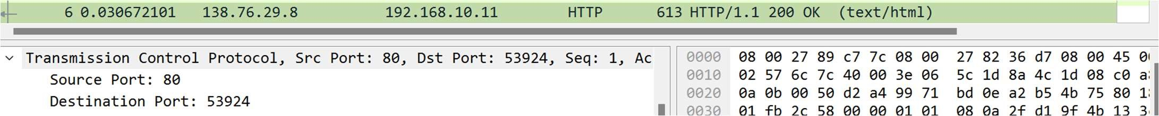

Q.4 At what time does this HTTP GET message appear in the nat-outside-wireshark-trace1-1.pcapng trace ile?

Ans: Time when the HTTP Get message appears: 09:20:27.771391145 IST.
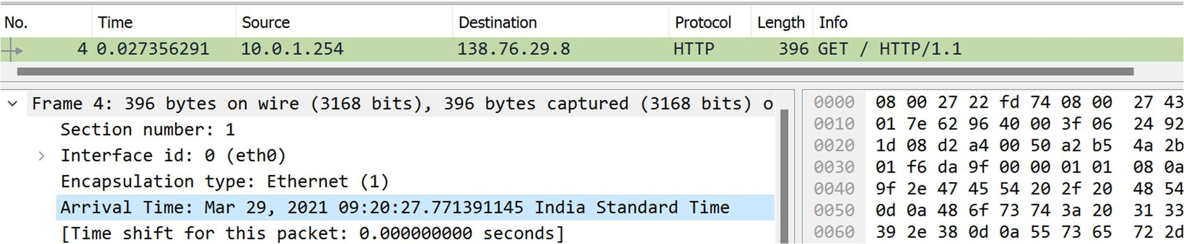

Q.5 What are the source and destination IP addresses and TCP source and destination port numbers on the IP datagram carrying this HTTP GET (as recorded in the nat-outside-wireshark-trace1-1.pcapng trace ile)?

Ans: IP address :10.0.1.254,
Source port number of the TCP segment in this datagram carrying HTTP GET message: 53924,
Destination IP address: 138.76.29.8,
Destination port number of the TCP segment in this datagram carrying HTTP GET message :80.
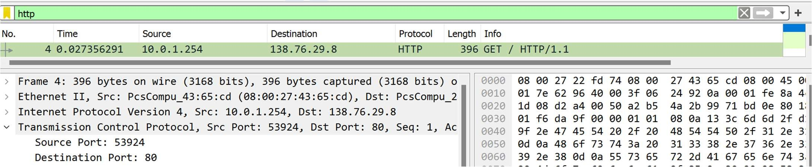

Q.6 Which of these four ields are different than in your answer to question 1 above? Ans: Source IP Address differ over here.

Q.7 Are any ields in the HTTP GET message changed?
Ans: Yes, header and header checksum for the HTTP GET message changes.

Q.8 Which of the following ields in the IP datagram carrying the HTTP GET are changed from the datagram received on the local area network (inside) to the corresponding datagram forwarded on the Internet side (outside) of the NAT router: Version, Header Length, Flags, Checksum?
Ans: As the Source IP Address changes, the value of the checksum changes but the other fields version, header length and flags remains the same.

Q.9 At what time does this message appear in the nat-outside-wireshark-trace1-1.pcapng trace ile?

Ans: Time when the HTTP OK message appears: 09:20:27.774660820 IST.
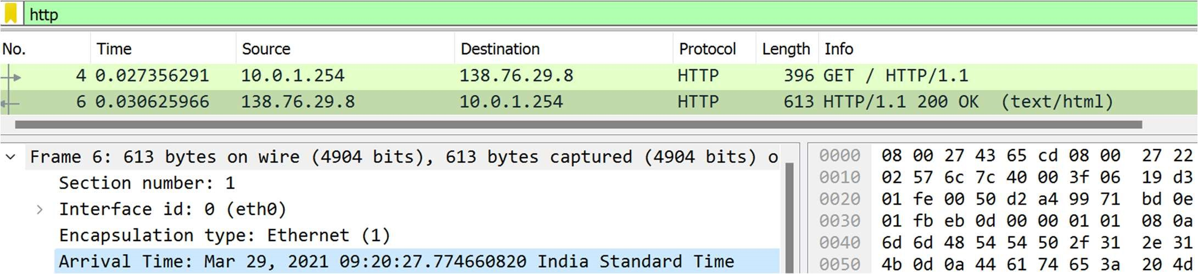

Q.10 What are the source and destination IP addresses and TCP source and destination port numbers on the IP datagram carrying this HTTP reply (“200 OK”) message (as recorded in the nat-outsidewireshark-trace1-1.pcapng trace ile)?

Ans: IP address :138.76.29.8,
Source port number of the TCP segment in this datagram carrying HTTP reply (200 OK) message: 80, Destination IP address: 10.0.1.254,
Destination port number of the TCP segment in this datagram carrying HTTP reply (200 OK) message :53924.
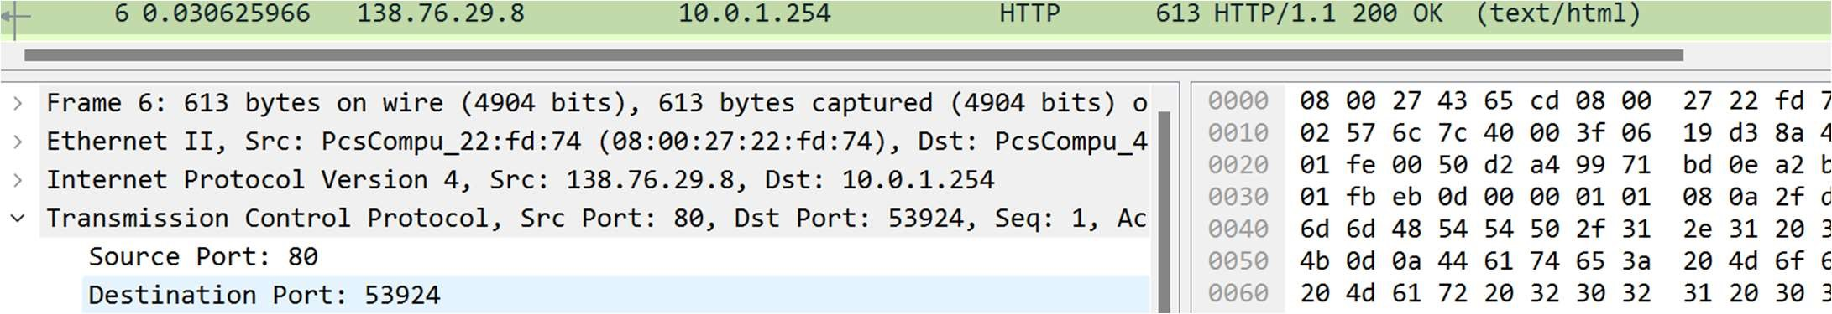

Q.11 What are the source and destination IP addresses and TCP source and destination port numbers on the IP datagram carrying the HTTP reply (“200 OK”) that is forwarded from the router to the destination host in the right of Figure 1?

Ans: IP address :138.76.29.8,
Source port number of the TCP segment in this datagram carrying HTTP reply (200 OK) message that is forwarded from the router to the destination host: 80,
Destination IP address: 192.168.10.11,
Destination port number of the TCP segment in this datagram carrying HTTP reply (200 OK) message that is forwarded from the router to the destination host:53924.

