Assign1_ADMPA

Srija

03/13/2022

# Loading the required libraries   
library(ISLR)  
library(dplyr)

##   
## Attaching package: 'dplyr'

## The following objects are masked from 'package:stats':  
##   
## filter, lag

## The following objects are masked from 'package:base':  
##   
## intersect, setdiff, setequal, union

library(glmnet)

## Loading required package: Matrix

## Loaded glmnet 4.1-3

library(caret)

## Loading required package: ggplot2

## Loading required package: lattice

attach(Carseats)  
summary(Carseats)

## Sales CompPrice Income Advertising   
## Min. : 0.000 Min. : 77 Min. : 21.00 Min. : 0.000   
## 1st Qu.: 5.390 1st Qu.:115 1st Qu.: 42.75 1st Qu.: 0.000   
## Median : 7.490 Median :125 Median : 69.00 Median : 5.000   
## Mean : 7.496 Mean :125 Mean : 68.66 Mean : 6.635   
## 3rd Qu.: 9.320 3rd Qu.:135 3rd Qu.: 91.00 3rd Qu.:12.000   
## Max. :16.270 Max. :175 Max. :120.00 Max. :29.000   
## Population Price ShelveLoc Age Education   
## Min. : 10.0 Min. : 24.0 Bad : 96 Min. :25.00 Min. :10.0   
## 1st Qu.:139.0 1st Qu.:100.0 Good : 85 1st Qu.:39.75 1st Qu.:12.0   
## Median :272.0 Median :117.0 Medium:219 Median :54.50 Median :14.0   
## Mean :264.8 Mean :115.8 Mean :53.32 Mean :13.9   
## 3rd Qu.:398.5 3rd Qu.:131.0 3rd Qu.:66.00 3rd Qu.:16.0   
## Max. :509.0 Max. :191.0 Max. :80.00 Max. :18.0   
## Urban US   
## No :118 No :142   
## Yes:282 Yes:258   
##   
##   
##   
##

# QB1) Build a Lasso regression model to predict Sales based on all other attributes (“Price”, “Advertising”, “Population”, “Age”, “Income” and “Education”). What is the best value of lambda for such a lasso model?

# Taking all the input attributes into Carseats_Filtered and then scaling the input attributes.  
Carseats_Filtered <- Carseats %>% select( "Price", "Advertising", "Population", "Age", "Income", "Education") %>% scale(center = TRUE, scale = TRUE) %>% as.matrix()  
  
# using glmnet library to convert the input attributes to matrix format.  
x <- Carseats_Filtered  
  
# storing the response variable into y in matrix format  
y <- Carseats %>% select("Sales") %>% as.matrix()

## building the model  
fit = glmnet(x, y)   
summary(fit)

## Length Class Mode   
## a0 62 -none- numeric  
## beta 372 dgCMatrix S4   
## df 62 -none- numeric  
## dim 2 -none- numeric  
## lambda 62 -none- numeric  
## dev.ratio 62 -none- numeric  
## nulldev 1 -none- numeric  
## npasses 1 -none- numeric  
## jerr 1 -none- numeric  
## offset 1 -none- logical  
## call 3 -none- call   
## nobs 1 -none- numeric

plot(fit)

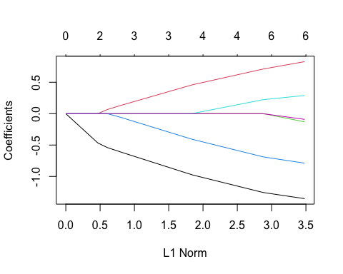

print(fit)

##   
## Call: glmnet(x = x, y = y)   
##   
## Df %Dev Lambda  
## 1 0 0.00 1.25500  
## 2 1 3.36 1.14400  
## 3 1 6.15 1.04200  
## 4 1 8.47 0.94940  
## 5 1 10.39 0.86500  
## 6 1 11.99 0.78820  
## 7 2 14.62 0.71820  
## 8 3 18.08 0.65440  
## 9 3 21.12 0.59620  
## 10 3 23.64 0.54330  
## 11 3 25.73 0.49500  
## 12 3 27.46 0.45100  
## 13 3 28.91 0.41100  
## 14 3 30.10 0.37450  
## 15 4 31.12 0.34120  
## 16 4 32.13 0.31090  
## 17 4 32.97 0.28330  
## 18 4 33.67 0.25810  
## 19 4 34.25 0.23520  
## 20 4 34.73 0.21430  
## 21 4 35.13 0.19520  
## 22 4 35.46 0.17790  
## 23 4 35.74 0.16210  
## 24 4 35.97 0.14770  
## 25 4 36.16 0.13460  
## 26 4 36.31 0.12260  
## 27 4 36.45 0.11170  
## 28 4 36.55 0.10180  
## 29 4 36.64 0.09276  
## 30 6 36.75 0.08451  
## 31 6 36.86 0.07701  
## 32 6 36.95 0.07017  
## 33 6 37.02 0.06393  
## 34 6 37.09 0.05825  
## 35 6 37.14 0.05308  
## 36 6 37.18 0.04836  
## 37 6 37.21 0.04407  
## 38 6 37.24 0.04015  
## 39 6 37.27 0.03658  
## 40 6 37.29 0.03333  
## 41 6 37.30 0.03037  
## 42 6 37.32 0.02767  
## 43 6 37.33 0.02522  
## 44 6 37.34 0.02298  
## 45 6 37.35 0.02094  
## 46 6 37.35 0.01908  
## 47 6 37.36 0.01738  
## 48 6 37.36 0.01584  
## 49 6 37.37 0.01443  
## 50 6 37.37 0.01315  
## 51 6 37.37 0.01198  
## 52 6 37.38 0.01092  
## 53 6 37.38 0.00995  
## 54 6 37.38 0.00906  
## 55 6 37.38 0.00826  
## 56 6 37.38 0.00752  
## 57 6 37.38 0.00686  
## 58 6 37.38 0.00625  
## 59 6 37.38 0.00569  
## 60 6 37.38 0.00519  
## 61 6 37.38 0.00472  
## 62 6 37.38 0.00430

cv_fit <- cv.glmnet(x, y, alpha = 1)  
  
# finding the minimum lambda value  
best_lambda <- cv_fit$lambda.min  
best_lambda

## [1] 0.01738061

plot(cv_fit)

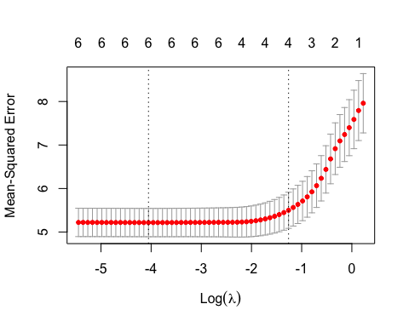 So, from the above results, we can see that only 37.38% variance in the target variable, sales with regularization and a best lambda value which is 0.0043.

# QB2. What is the coefficient for the price (normalized) attribute in the best model (i.e. model with the optimal lambda)?

best_model <- glmnet(x, y, alpha = 1, lambda = best_lambda)  
coef(best_model)

## 7 x 1 sparse Matrix of class "dgCMatrix"  
## s0  
## (Intercept) 7.49632500  
## Price -1.33889011  
## Advertising 0.81012314  
## Population -0.11054223  
## Age -0.77329377  
## Income 0.27914466  
## Education -0.07725352

The coefficient of the Price attribute with the best lambda value is -1.35384596.

# QB3. How many attributes remain in the model if lambda is set to 0.01? How that number changes if lambda is increased to 0.1? Do you expect more variables to stay in the model (i.e., to have non-zero coefficients) as we increase lambda?

# Let us see the coefficients of the attributes that are still remained if lambda is set to 0.01.  
  
best_model <- glmnet(x, y, alpha = 1, lambda = 0.01)  
coef(best_model)

## 7 x 1 sparse Matrix of class "dgCMatrix"  
## s0  
## (Intercept) 7.49632500  
## Price -1.34733223  
## Advertising 0.82026088  
## Population -0.12187685  
## Age -0.78190633  
## Income 0.28488631  
## Education -0.08502707

Above are the coefficients of the independent attributes with the lambda value 0.01. No coefficients are eliminated here.

# Let us see the coefficients of the attributes that are still remained if lambda is set to 0.1.  
  
best_model <- glmnet(x, y, alpha = 1, lambda = 0.1)  
coef(best_model)

## 7 x 1 sparse Matrix of class "dgCMatrix"  
## s0  
## (Intercept) 7.4963250  
## Price -1.2447745  
## Advertising 0.7007230  
## Population .   
## Age -0.6775428  
## Income 0.2139222  
## Education .

We can say from the above results that the values of the independent attributes have shrinked to some extent and that two of the coefficients of the attributes are eliminated when the lambda is set to 0.1.

# Let us see the coefficients of the attributes that are still remained if lambda is set to 0.3.  
  
best_model <- glmnet(x, y, alpha = 1, lambda = 0.3)  
coef(best_model)

## 7 x 1 sparse Matrix of class "dgCMatrix"  
## s0  
## (Intercept) 7.49632500  
## Price -1.02298693  
## Advertising 0.50192192  
## Population .   
## Age -0.45635365  
## Income 0.03900787  
## Education .

From the above results we can see that two of the coefficients of the attributes are eliminated and the independent attributes have shrinked further when lambda value is 0.3.

# Let us see the coefficients of the attributes that are still remained if lambda is set to 0.5.  
  
best_model <- glmnet(x, y, alpha = 1, lambda = 0.5)  
coef(best_model)

## 7 x 1 sparse Matrix of class "dgCMatrix"  
## s0  
## (Intercept) 7.4963250  
## Price -0.7929743  
## Advertising 0.2947434  
## Population .   
## Age -0.2337276  
## Income .   
## Education .

From the above results we can see that three of the coefficients of the attributes are eliminated and the independent attributes have shrinked further when lambda value is 0.5.

# QB4. Build an elastic-net model with alpha set to 0.6. What is the best value of lambda for such a model?

# Building an elastic_net model with alpha = 0.6  
el_net = glmnet(x, y, alpha = 0.6)  
plot(el_net, xvar = "lambda")

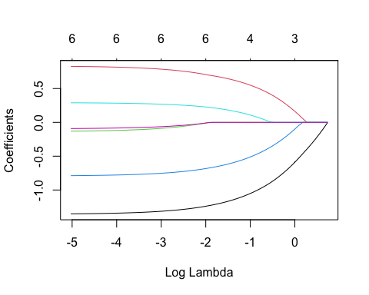

plot(cv.glmnet(x, y, alpha = 0.6))

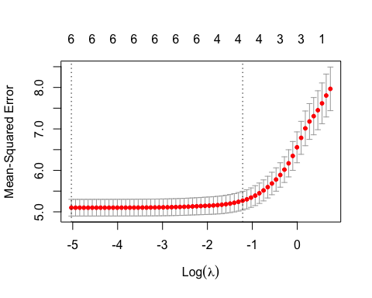

summary(el_net)

## Length Class Mode   
## a0 63 -none- numeric  
## beta 378 dgCMatrix S4   
## df 63 -none- numeric  
## dim 2 -none- numeric  
## lambda 63 -none- numeric  
## dev.ratio 63 -none- numeric  
## nulldev 1 -none- numeric  
## npasses 1 -none- numeric  
## jerr 1 -none- numeric  
## offset 1 -none- logical  
## call 4 -none- call   
## nobs 1 -none- numeric

print(el_net)

##   
## Call: glmnet(x = x, y = y, alpha = 0.6)   
##   
## Df %Dev Lambda  
## 1 0 0.00 2.09200  
## 2 1 2.67 1.90600  
## 3 1 5.03 1.73700  
## 4 1 7.09 1.58200  
## 5 1 8.90 1.44200  
## 6 1 10.47 1.31400  
## 7 2 12.89 1.19700  
## 8 3 16.00 1.09100  
## 9 3 18.95 0.99370  
## 10 3 21.49 0.90540  
## 11 3 23.67 0.82500  
## 12 3 25.55 0.75170  
## 13 3 27.15 0.68490  
## 14 3 28.52 0.62410  
## 15 4 29.75 0.56860  
## 16 4 30.91 0.51810  
## 17 4 31.89 0.47210  
## 18 4 32.72 0.43020  
## 19 4 33.43 0.39190  
## 20 4 34.02 0.35710  
## 21 4 34.52 0.32540  
## 22 4 34.93 0.29650  
## 23 4 35.29 0.27020  
## 24 4 35.58 0.24620  
## 25 4 35.83 0.22430  
## 26 4 36.04 0.20440  
## 27 4 36.21 0.18620  
## 28 4 36.36 0.16970  
## 29 4 36.48 0.15460  
## 30 6 36.60 0.14090  
## 31 6 36.73 0.12830  
## 32 6 36.84 0.11690  
## 33 6 36.93 0.10660  
## 34 6 37.01 0.09709  
## 35 6 37.07 0.08846  
## 36 6 37.12 0.08060  
## 37 6 37.17 0.07344  
## 38 6 37.20 0.06692  
## 39 6 37.23 0.06097  
## 40 6 37.26 0.05556  
## 41 6 37.28 0.05062  
## 42 6 37.30 0.04612  
## 43 6 37.31 0.04203  
## 44 6 37.33 0.03829  
## 45 6 37.34 0.03489  
## 46 6 37.34 0.03179  
## 47 6 37.35 0.02897  
## 48 6 37.36 0.02639  
## 49 6 37.36 0.02405  
## 50 6 37.37 0.02191  
## 51 6 37.37 0.01997  
## 52 6 37.37 0.01819  
## 53 6 37.37 0.01658  
## 54 6 37.38 0.01510  
## 55 6 37.38 0.01376  
## 56 6 37.38 0.01254  
## 57 6 37.38 0.01143  
## 58 6 37.38 0.01041  
## 59 6 37.38 0.00949  
## 60 6 37.38 0.00864  
## 61 6 37.38 0.00788  
## 62 6 37.38 0.00718  
## 63 6 37.38 0.00654

We can observe from the above results that the variance is 37.38 in the dependent variable (Sales) which is explained by the given attributes to apply the regularization by setting the alpha value to 0.6 and the best lambda value is 0.00654.