Topic:EXCEL

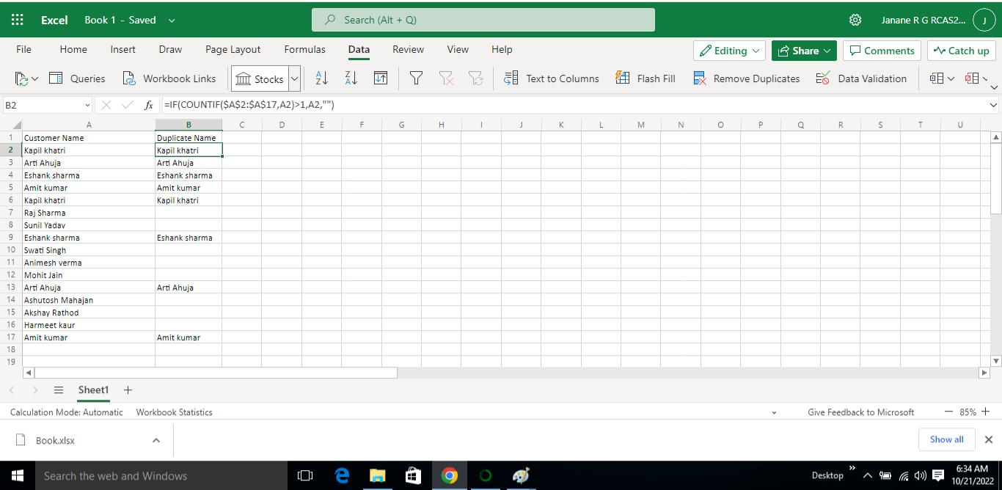

Step 1: inserting the given dataset

Step2: Then applying the formula

=IFCOUNTIF($A$2:$A$17,A2)>1,A2,”)

This formula is used to shows the duplicate names

Duplicate means repeating the same one.