Topic: Tableau

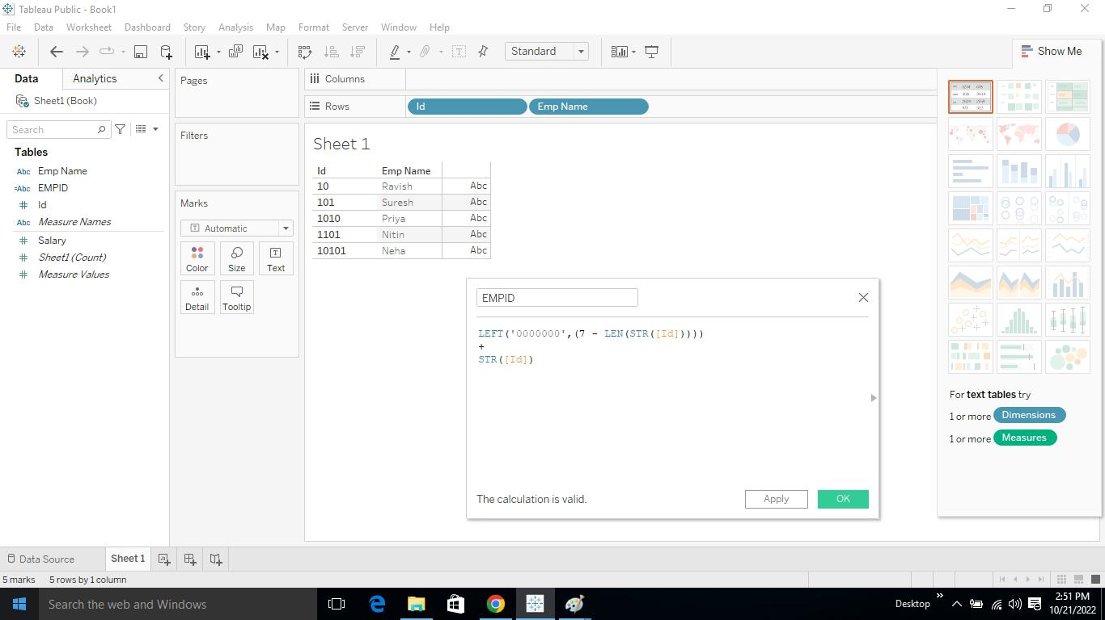

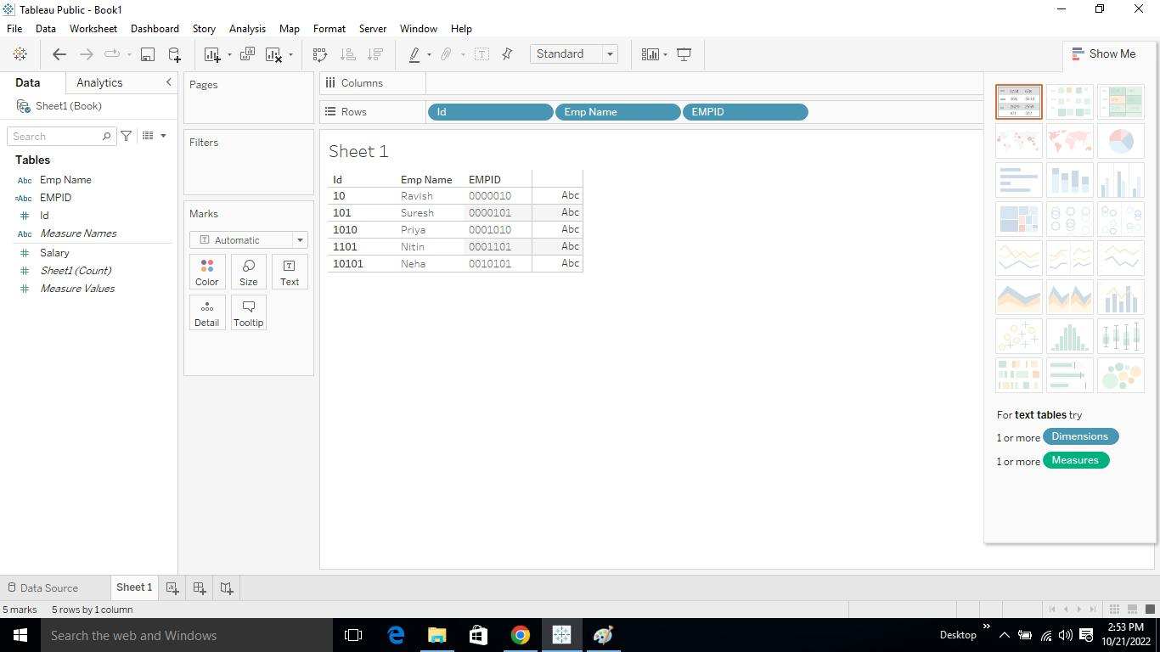

Open tableau

Upload the dataset

Drag employee name and I’d to rows

Then right click the I’d

Create- calculation

Create a new name as empid

Apply the code I am using string because it start from 0,1,2… left command used for the numbers from left side

Then the empid was created.