**TASK – 1**

***Github link :*** *https://github.com/JananeeManickam/drf_auth_task1*

--------------------------------------------------------------------------------------------------------------------------

CREATE-USER:

* <http://localhost:8000/accounts/create-user/>
* Method : POST
* To create a new user (if valid input provided).

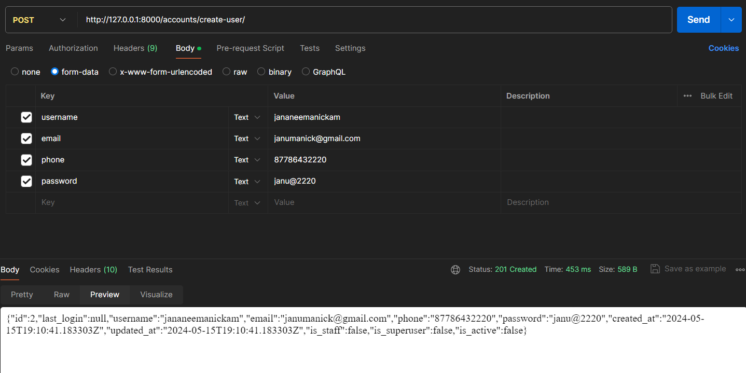

--------------------------------------------------------------------------------------------------------------------------

UPDATE-USER

* <http://localhost:8000/accounts/update-user/2/>
* Method : ‘PATCH’
* To update attributes of a particular user, User_id is passed as an argument in the URL.

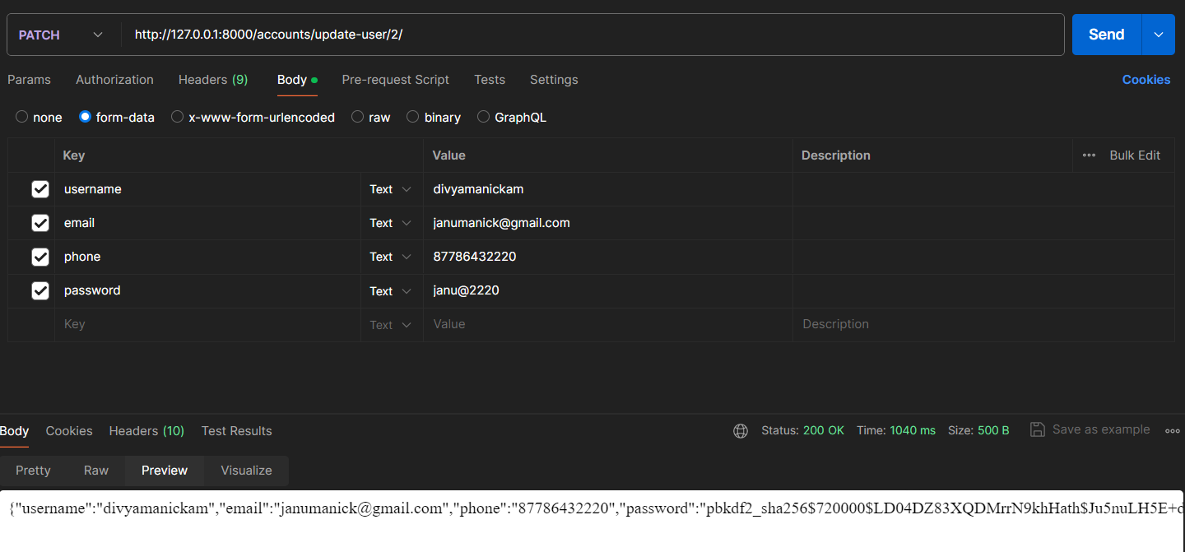

--------------------------------------------------------------------------------------------------------------------------

LOGIN-API

* <http://localhost:8000/accounts/login/>
* Method: ’POST’
* To authenticate the credentials, if wrong credentials, then error messages are raised.

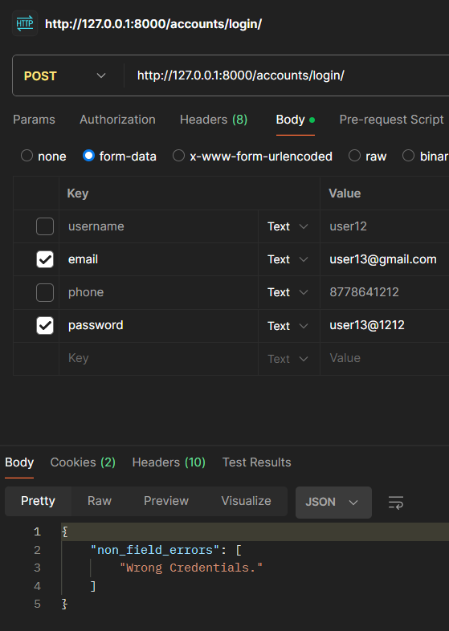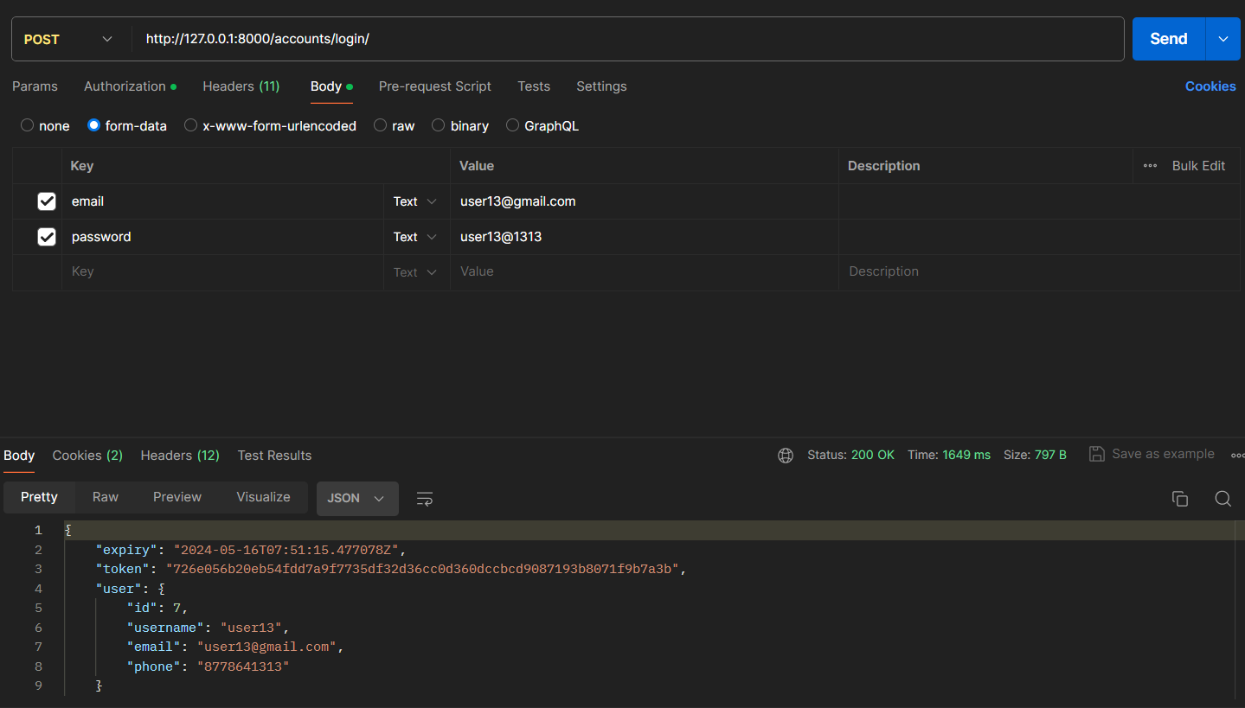

If no such user,   
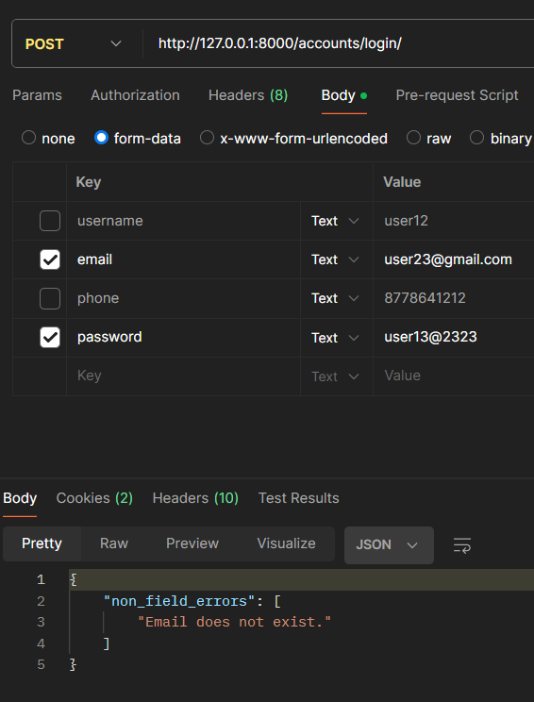

--------------------------------------------------------------------------------------------------------------------------

LOGOUT:

Here, we test the token, if it is a valid token, then it performs logout.

If token not provided: 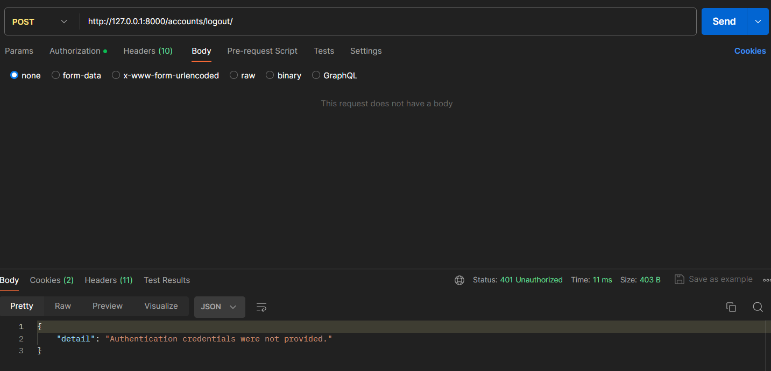

In case of wrong token provided,

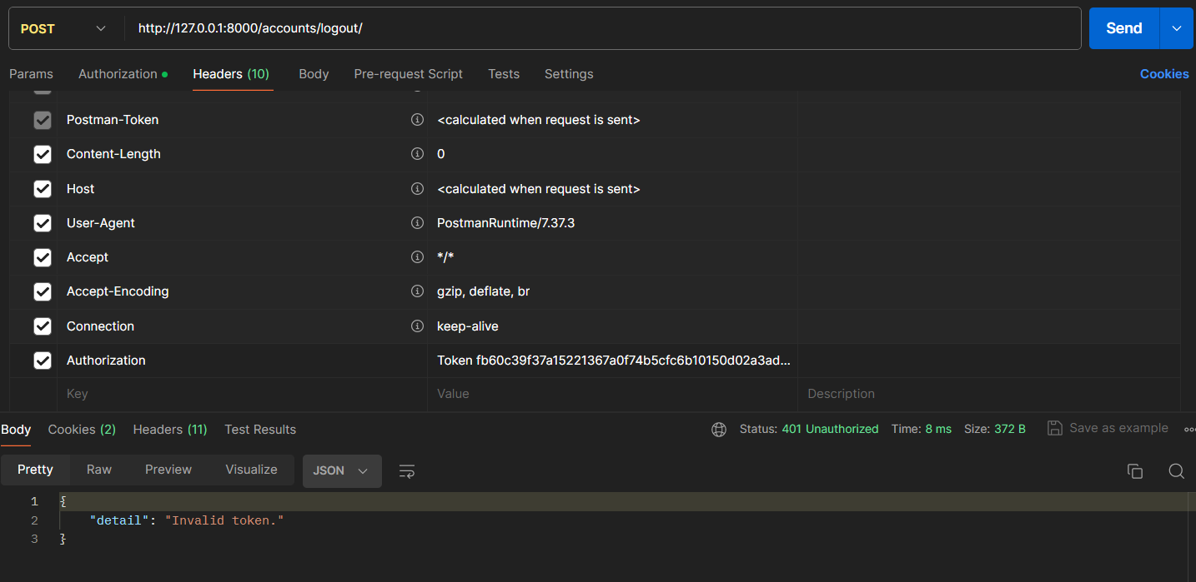

If success, it return empty screen

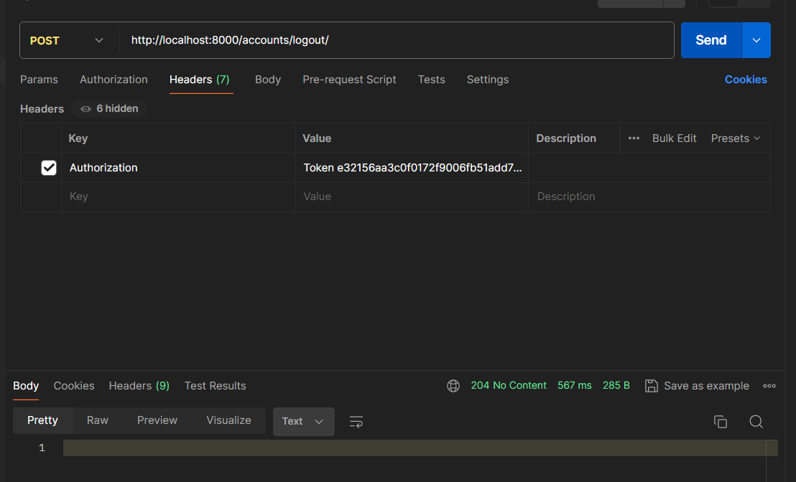

--------------------------------------------------------------------------------------------------------------------------

LOGOUT – ALL:

The same user could have different tokens (login from several machines). So logout out from all devices, we use the logout-all method inbuilt in Knox.

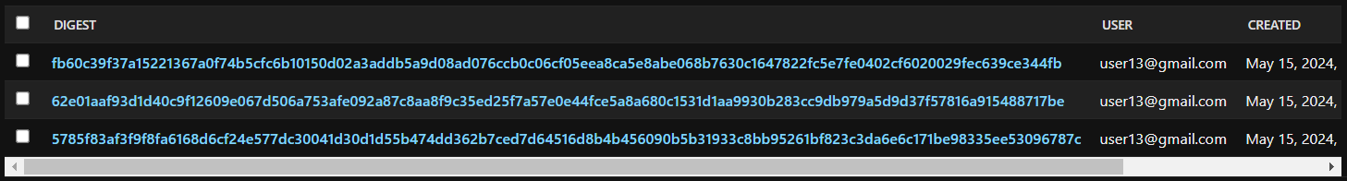

Here, user13 have 4 different tokens in database. After logout-all, no tokens are left.

