**TASK – 2**

*Github link : https://github.com/JananeeManickam/drf_crud_task2*

--------------------------------------------------------------------------------------------------------------------------

CREATE-TOY:

* <http://127.0.0.1:8000/toys/create-toy/>
* Method : POST
* 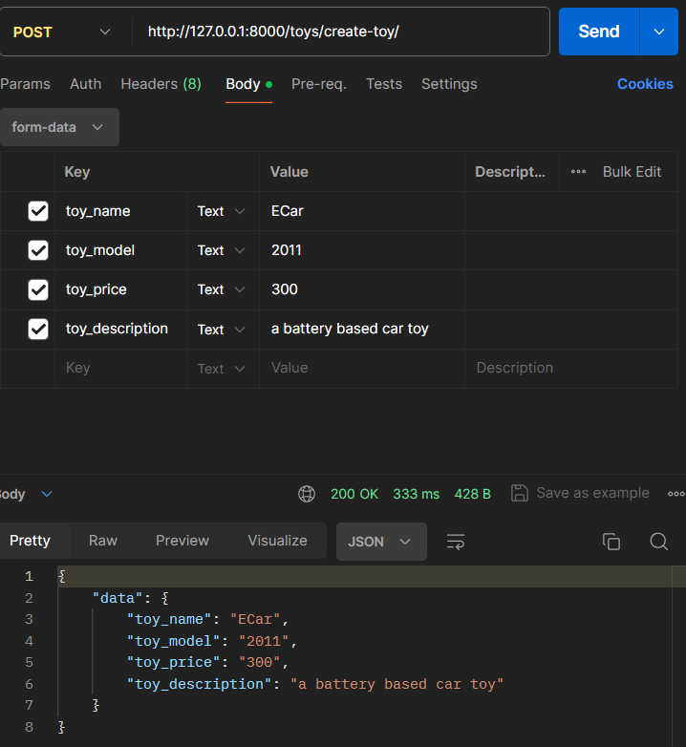To create new toy entry.
* Attributes : toy_name, toy_model, toy_price, toy_description

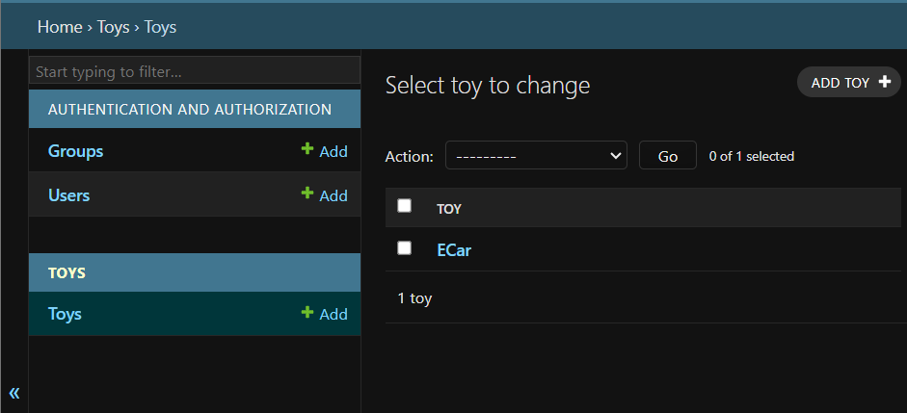

READ-TOY:

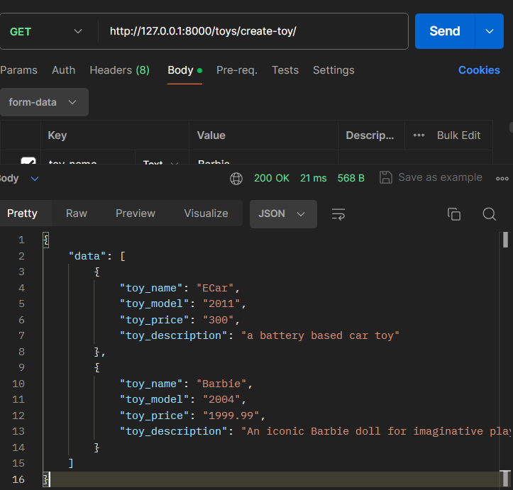

* <http://127.0.0.1:8000/toys/create-toy/>
* Method: GET
* To display list of toys.

UPDATE-TOY

* <http://127.0.0.1:8000/toys/update-toy/ECar/>
* Method : PUT
* To update an existing entry, we are here passing the ‘toy_name’ as our ‘pk’ parameter.

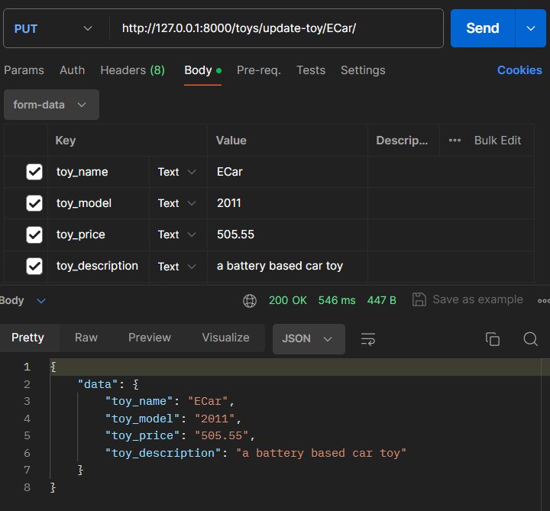

DELETE-TOY

* <http://127.0.0.1:8000/toys/delete-toy/ECar/>
* Method: DELETE
* To delete a particular entry, here we pass ‘toy_name’ as ‘pk’.
* 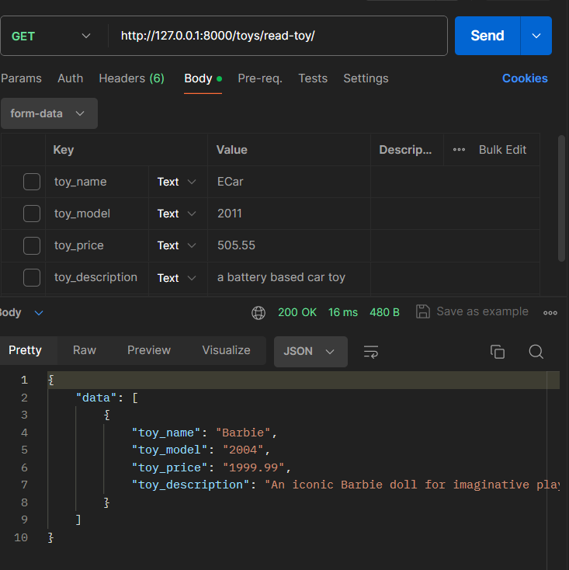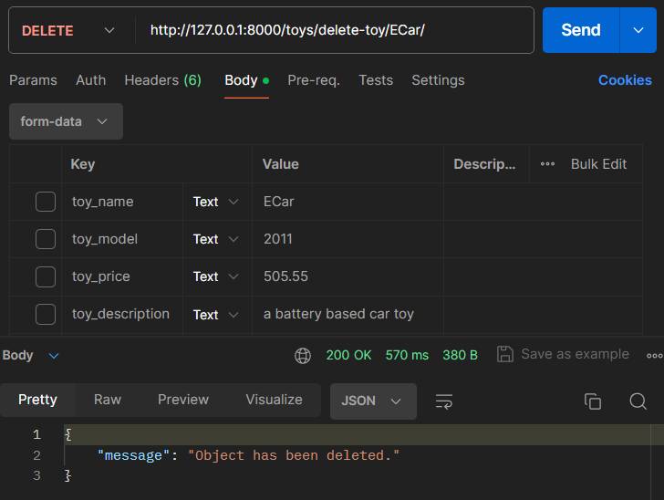After deleting, let us check by reading the list of toys.

If no such toy exist, it displays error message.



