**MINI PROJECT -1 - APPLICATION DEPLOYMENT**

Github Link: <https://github.com/Janani-977/Brain-Task-Appication/tree/main>

Application:  
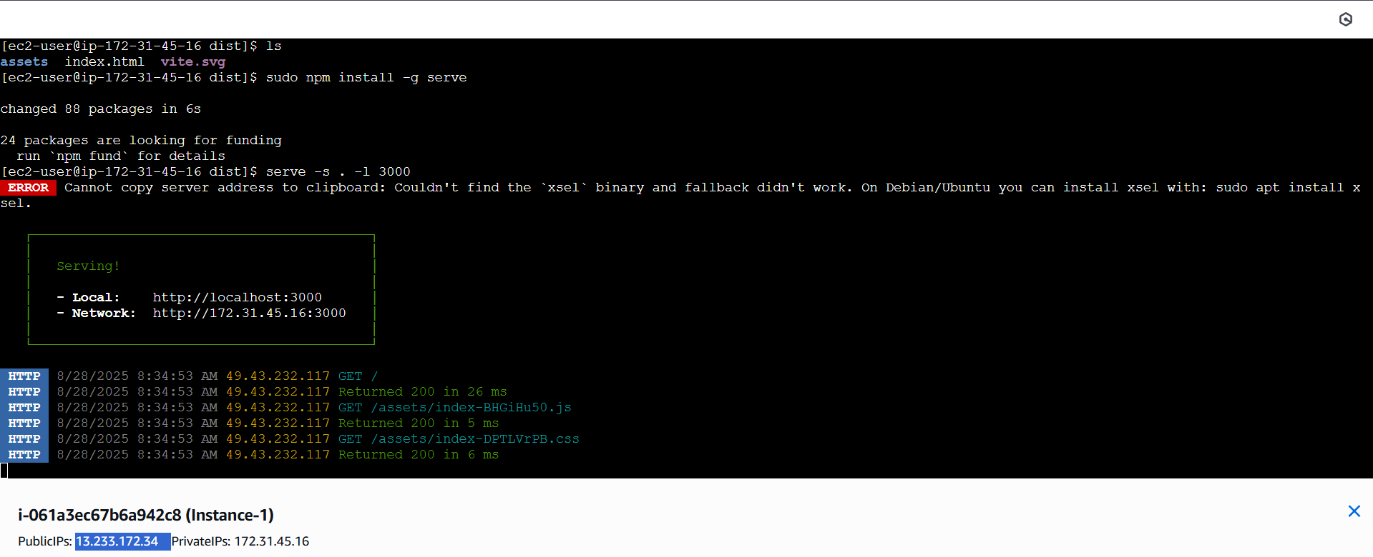

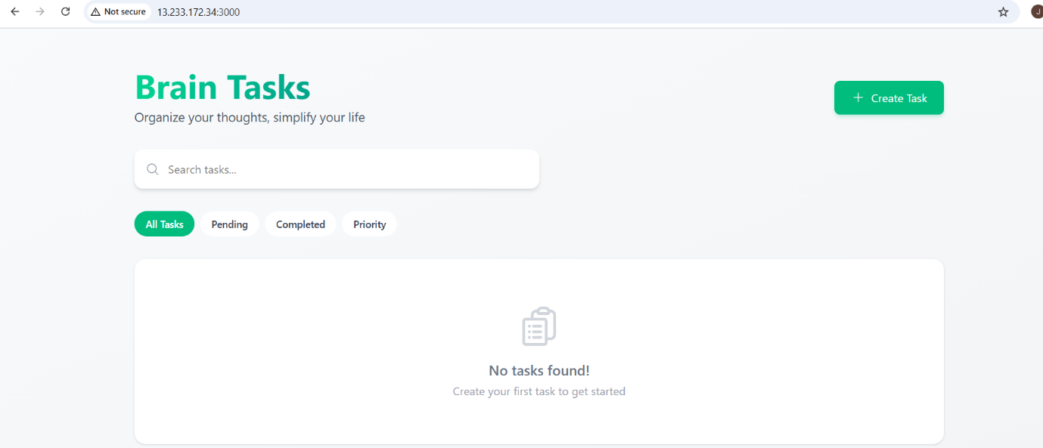

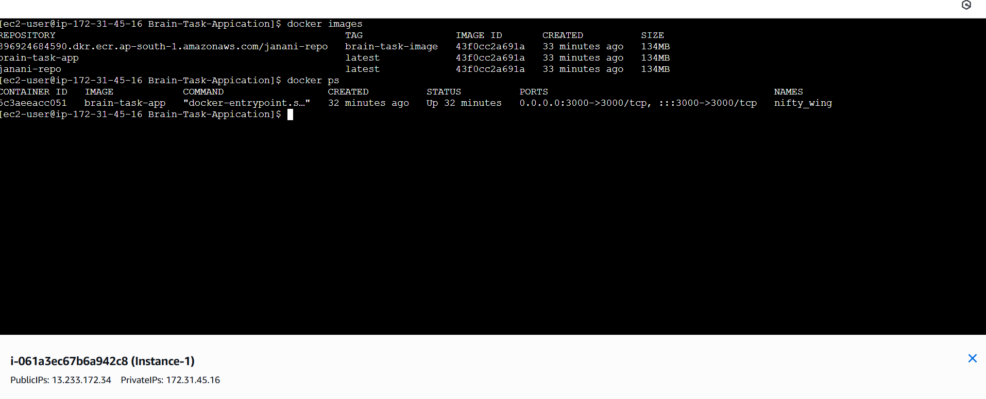Docker:

Able to view the application

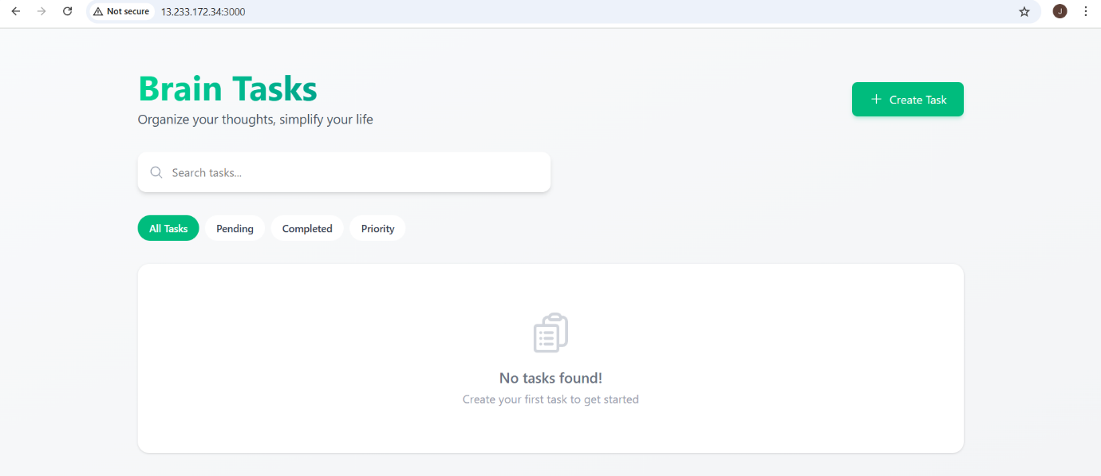

ECR:

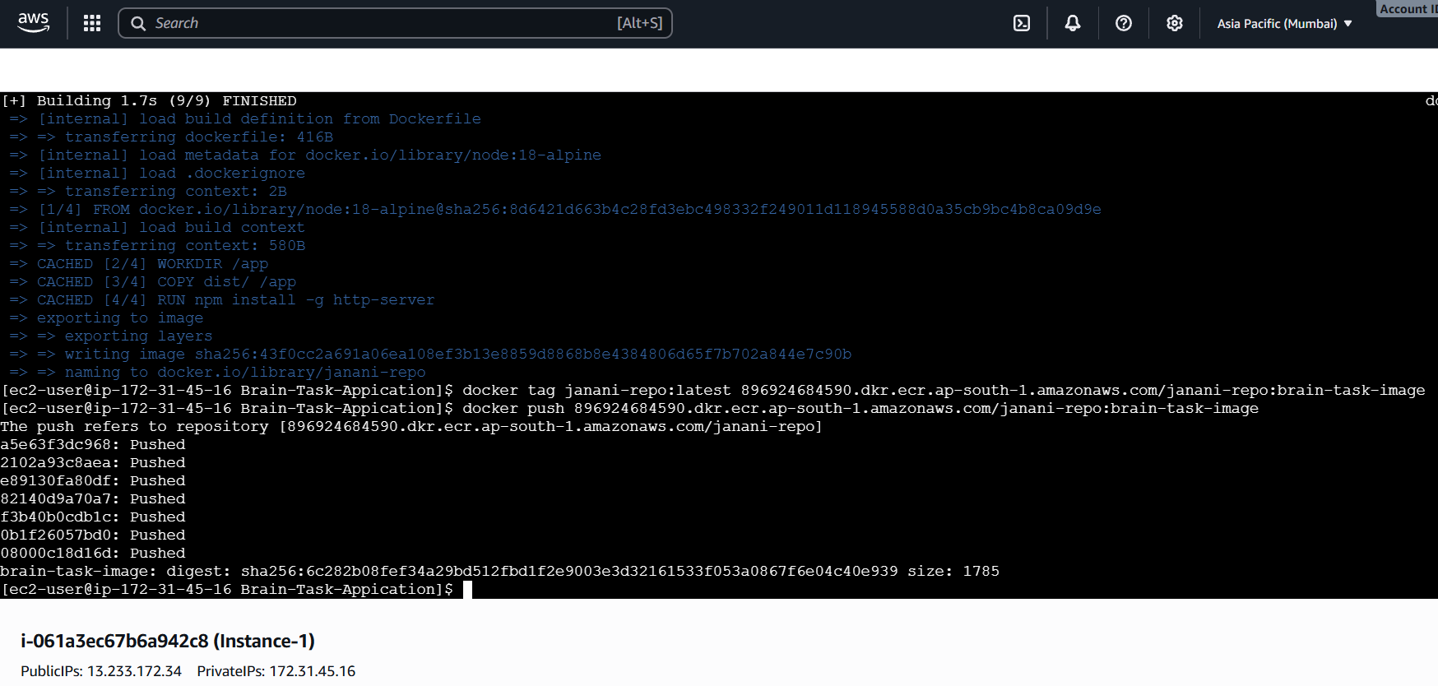

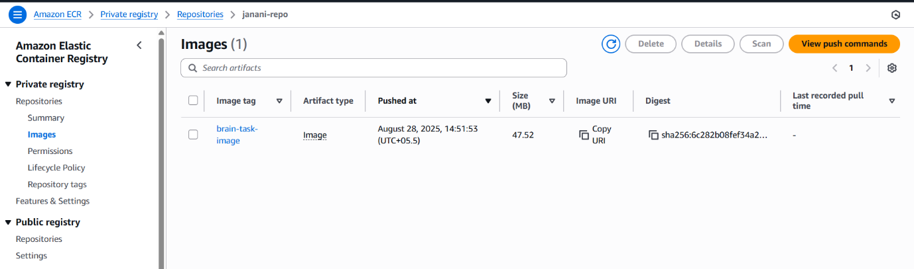

Kubernetes:

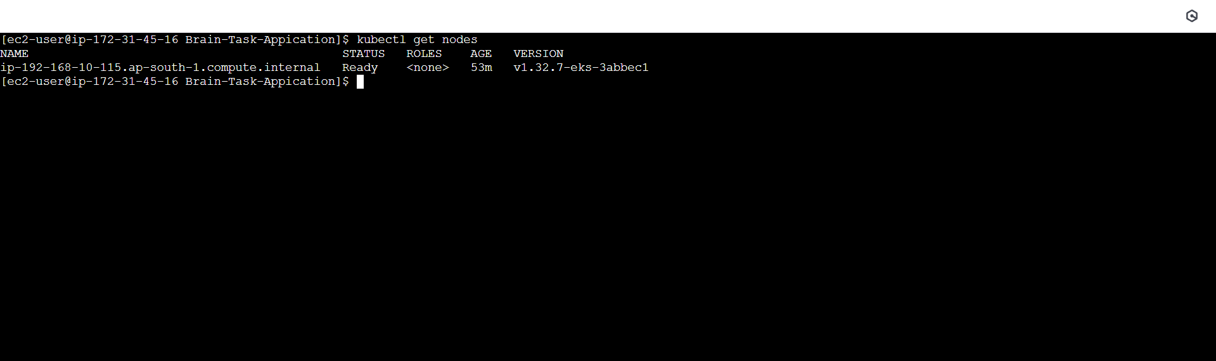

Created deployment.yaml

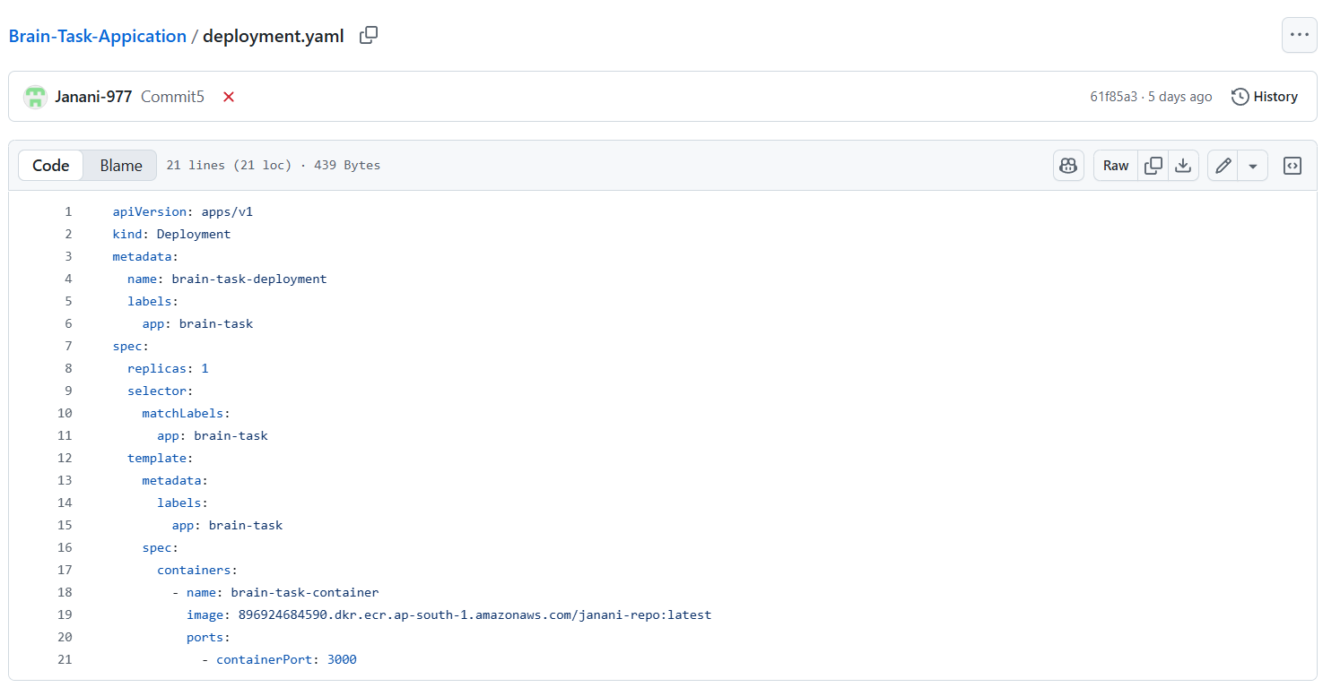

Created Service.yml

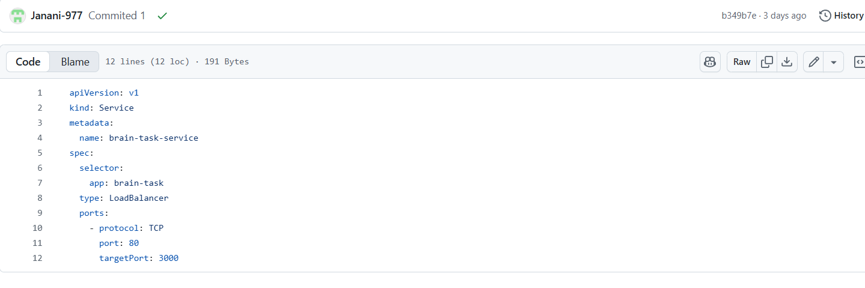

Checked manually by deploying app in EKS:

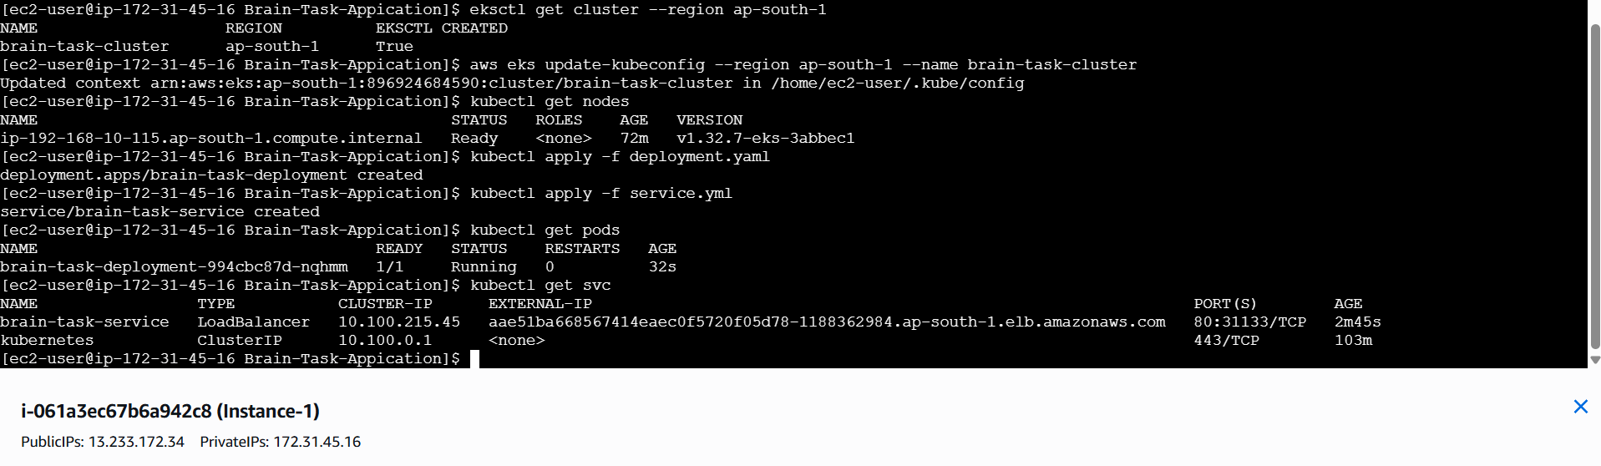

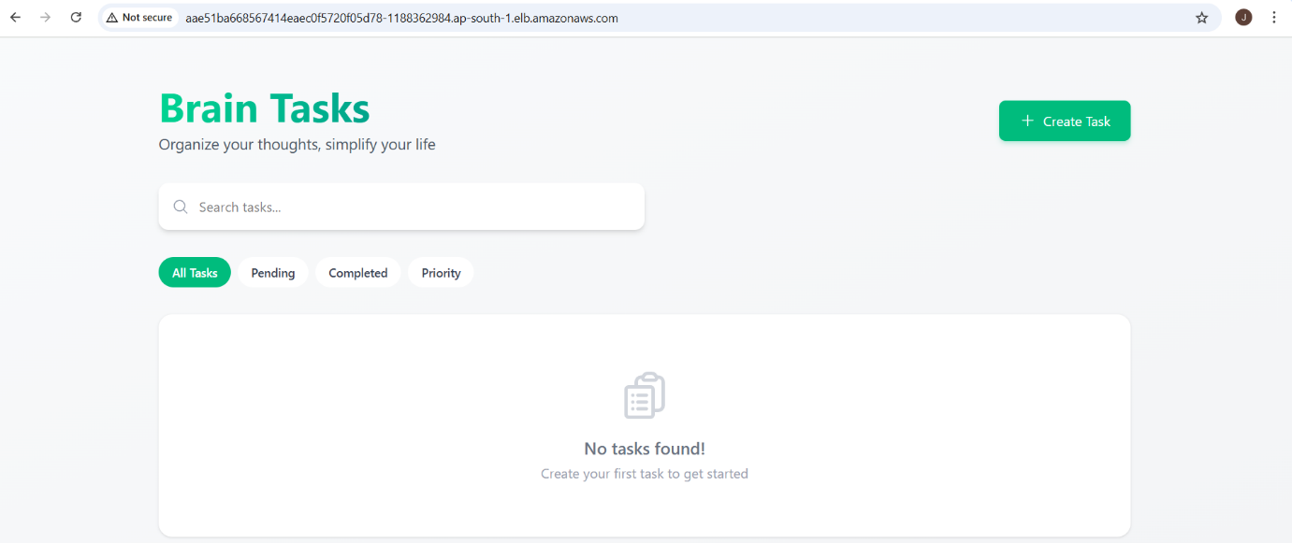

CodeBuild Creation:

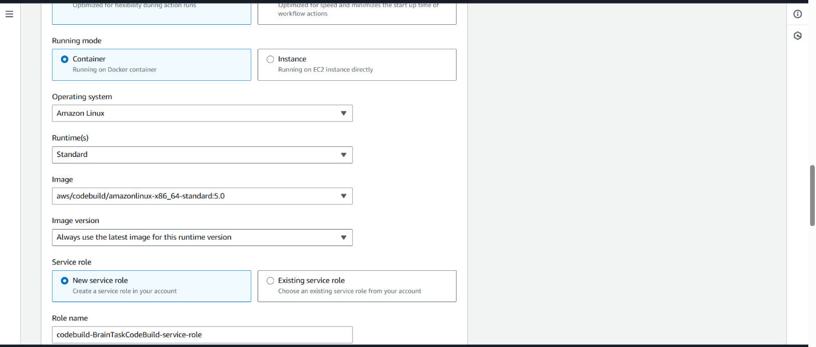

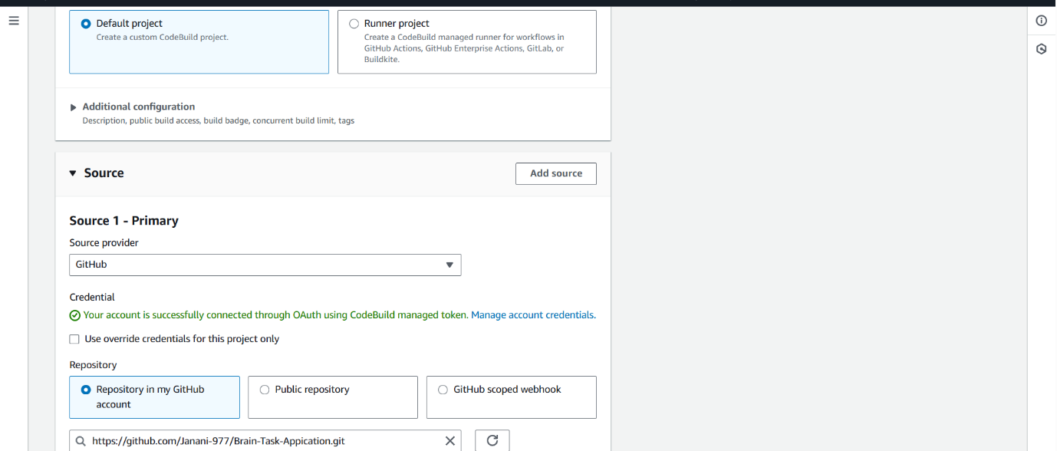

Created Buildspec:

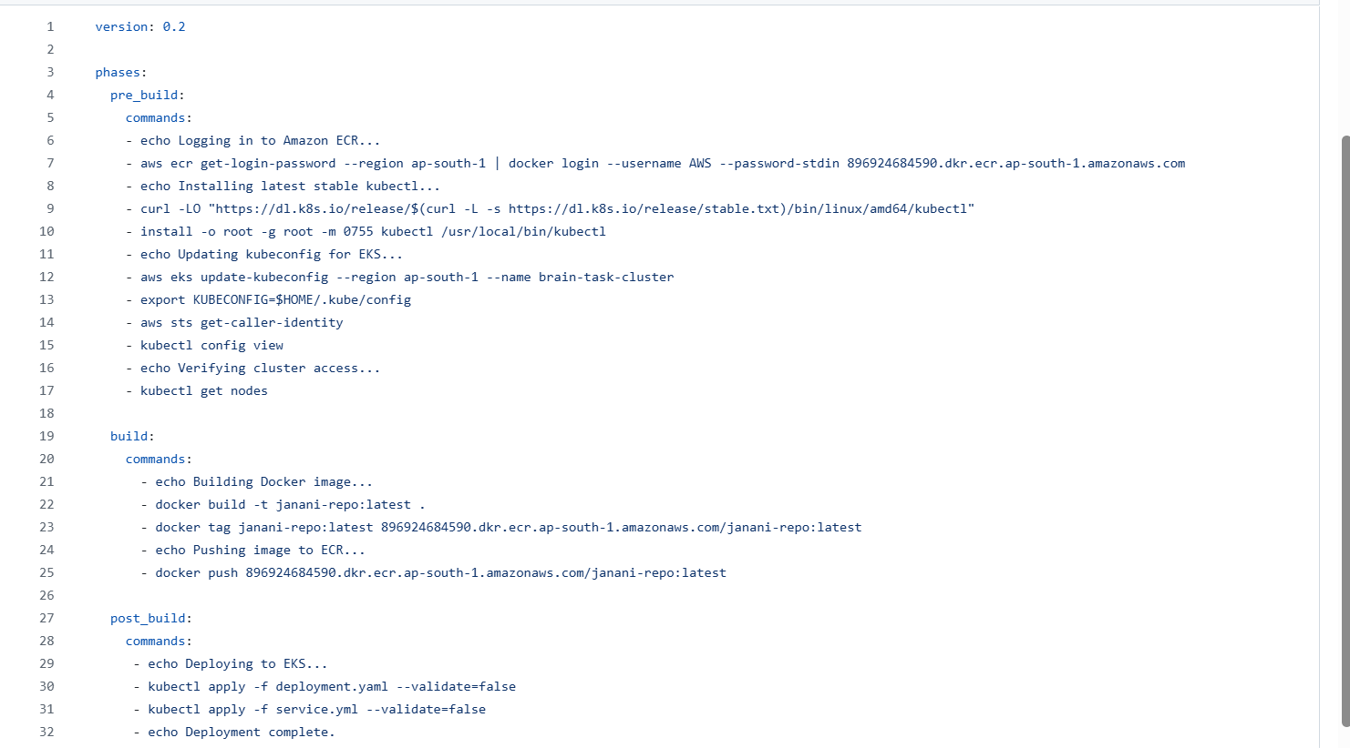

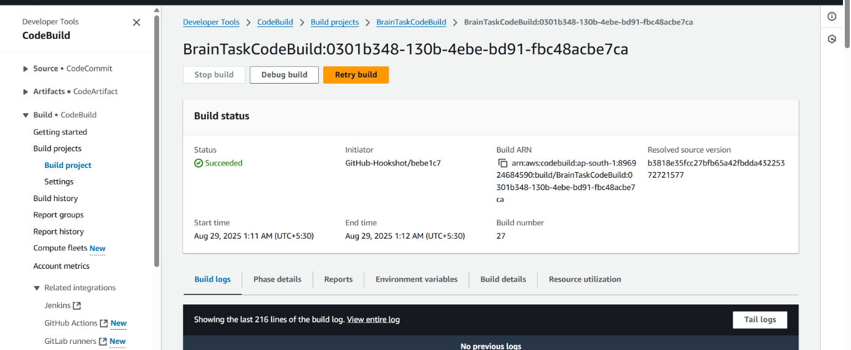CodeBuild got succeeded

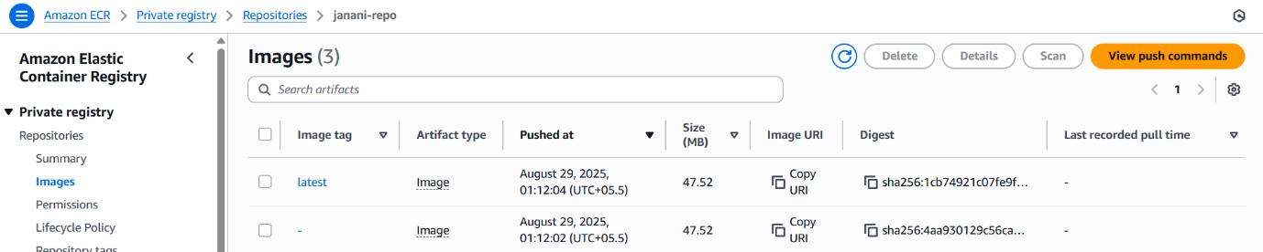ECR: Image pushed to ECR

Codepipeline:

Deployed via codedeploy through pipeline

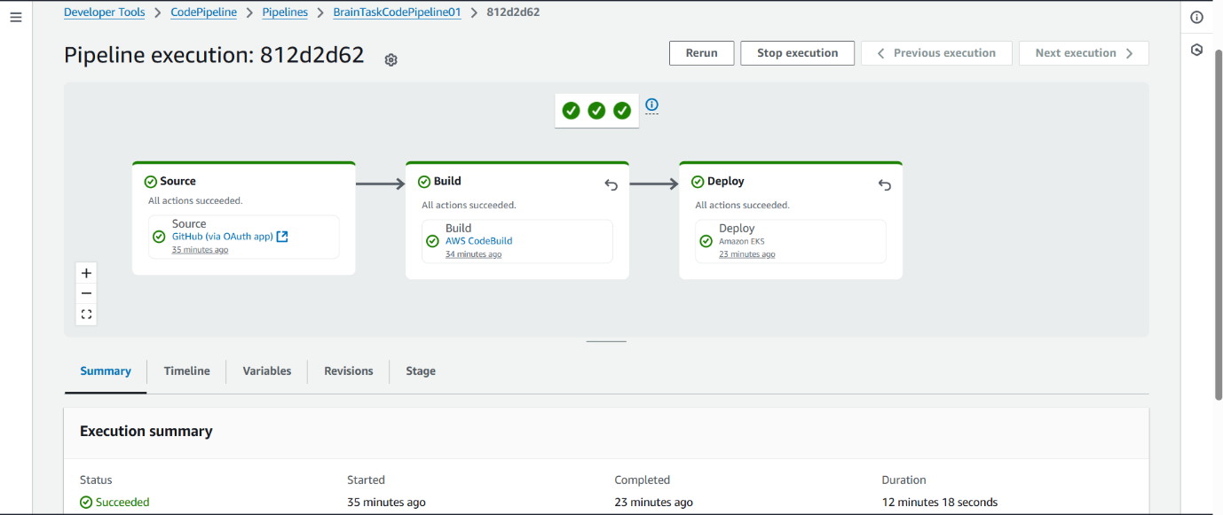

Image has been pushed successfully to ECR

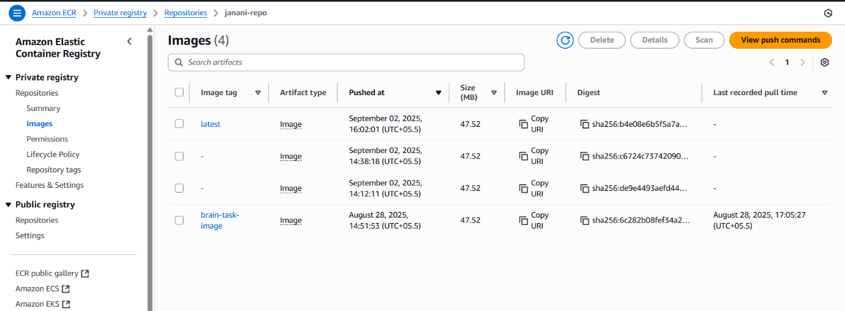

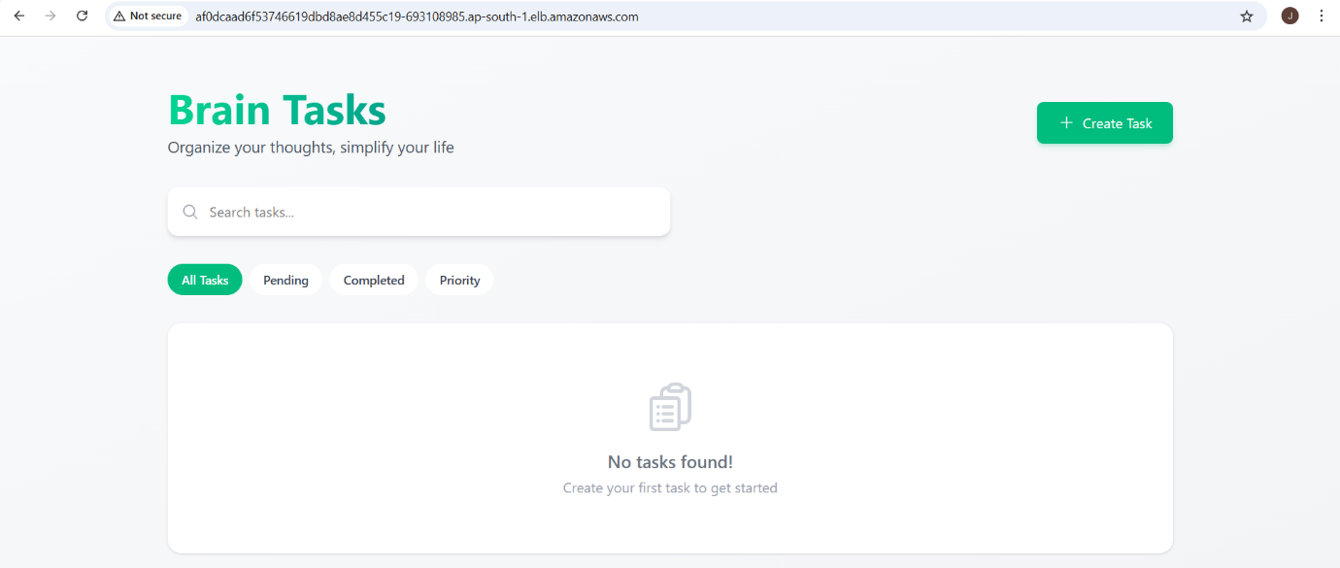After the codepipeline gets succeeded able to see the application via load balancer

Cloud Watch:

Logs has been fetched successfully

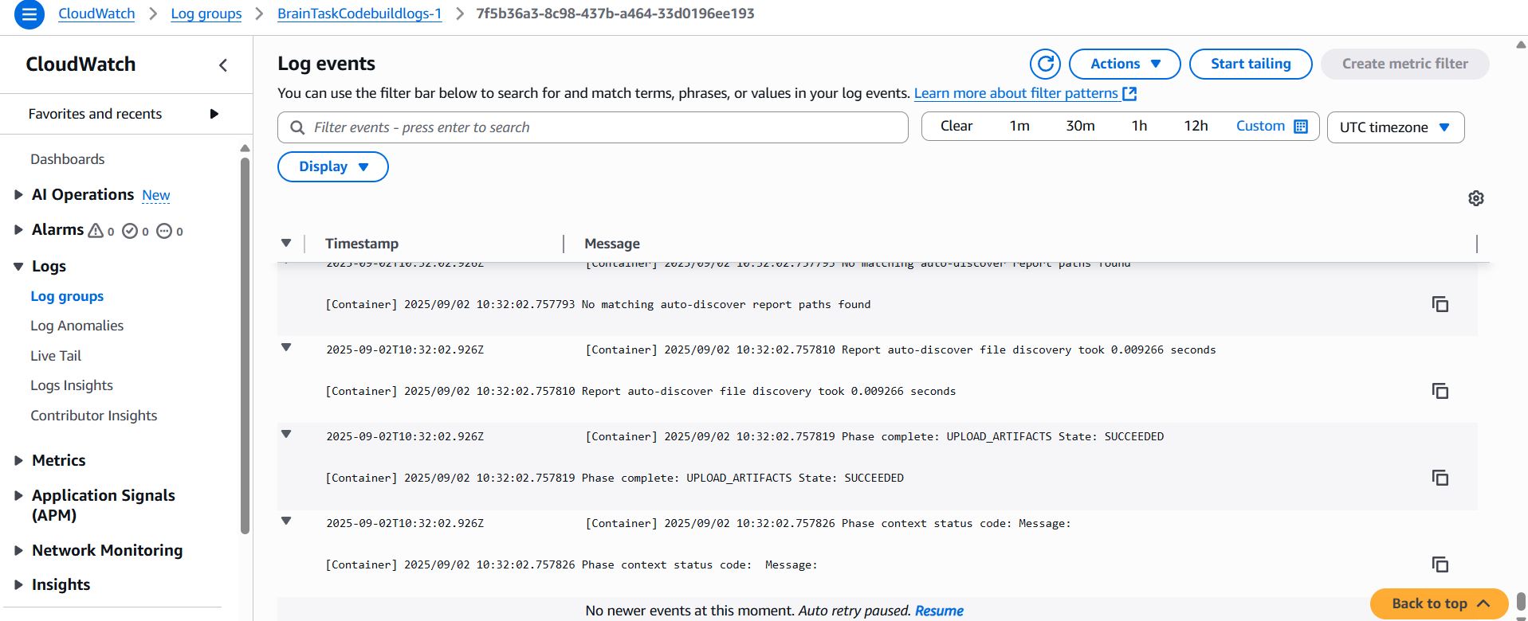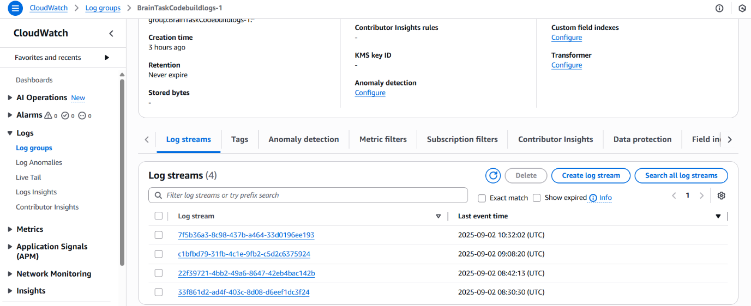



Created cluster, EC2, load balancer: Below are the services created before running codebuild and codepipeline services for the deployment

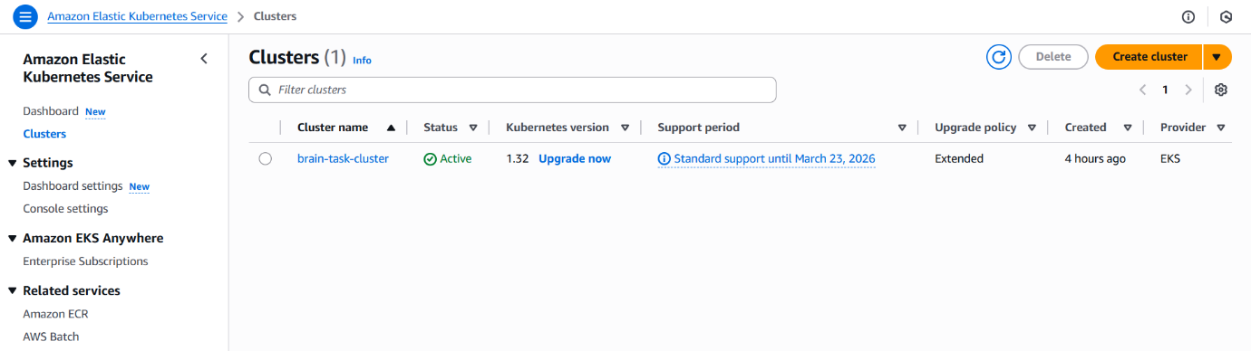

EC2

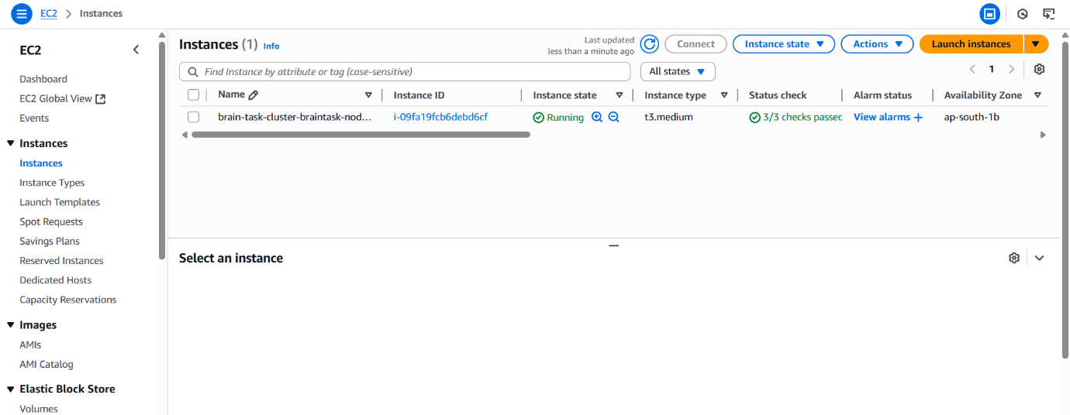

Load balancer

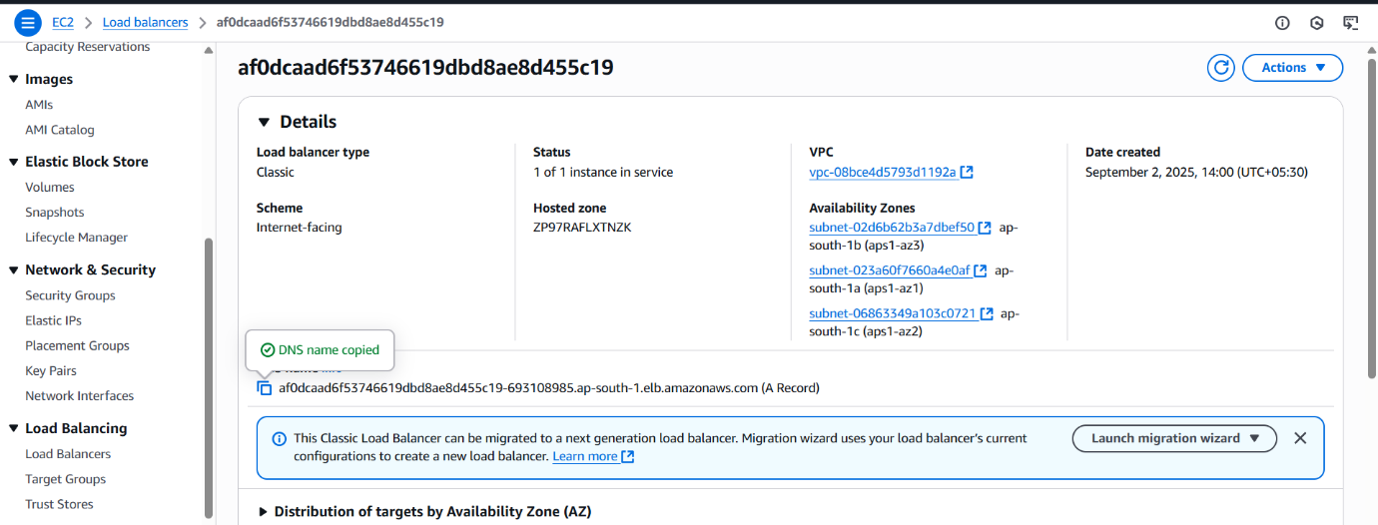

Version Control:

Pushed all the code to the github successfully

