Creating a new directory named “my_folder”

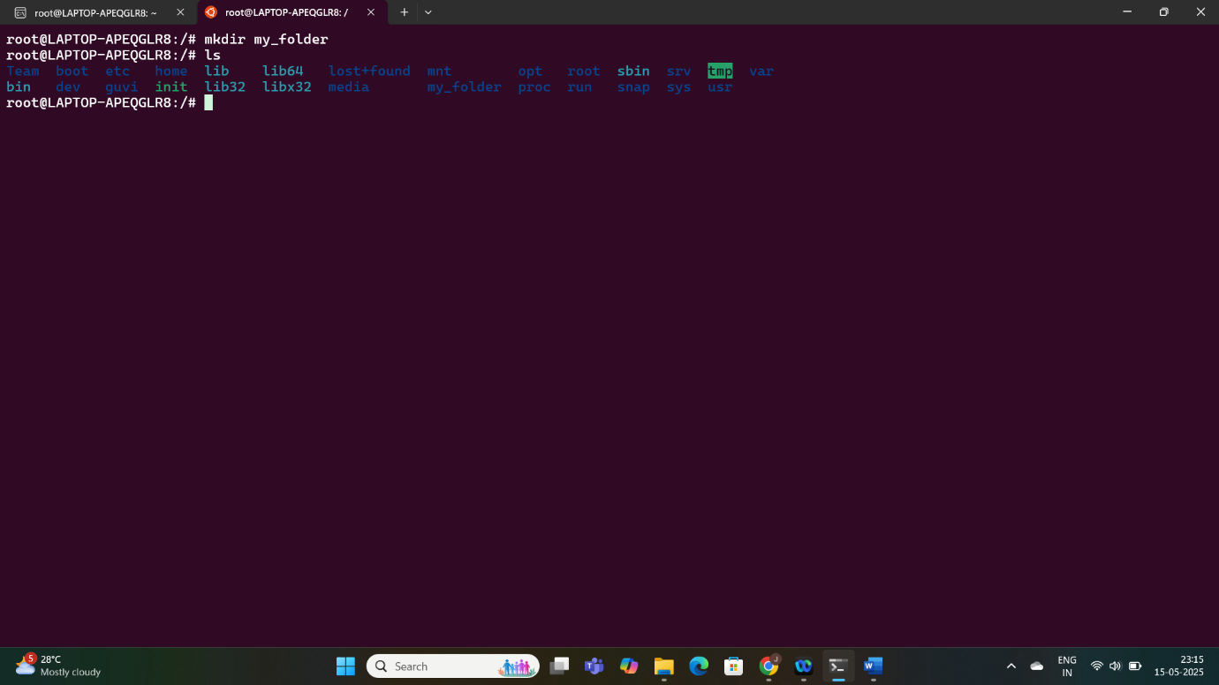

Creating a file named “my_file.txt” with some text

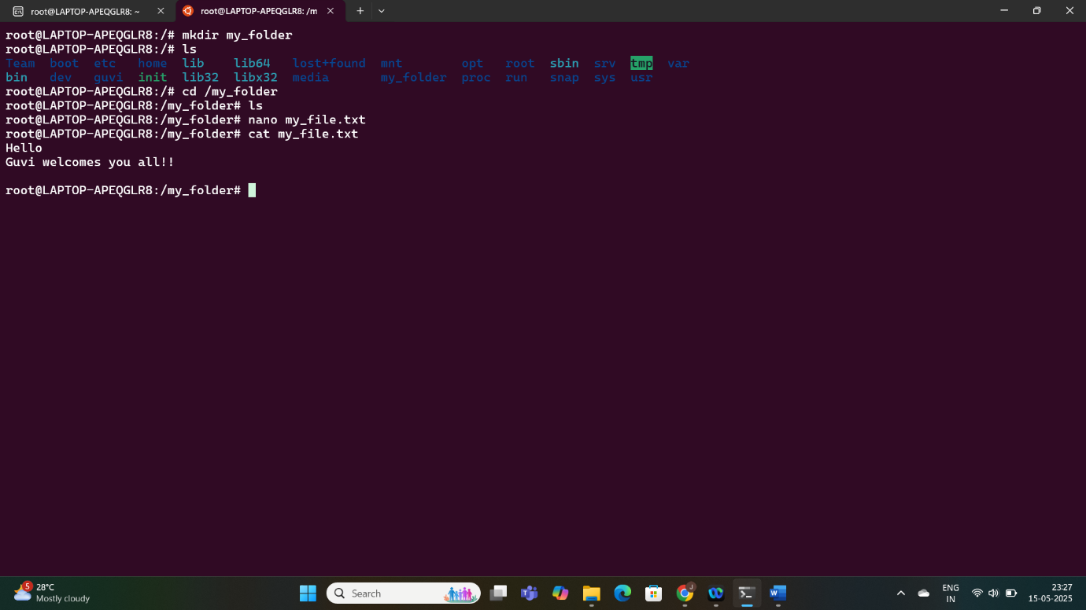

Concatenate the content of ""another_file.txt"" to ""my_file.txt"" and display the updated content

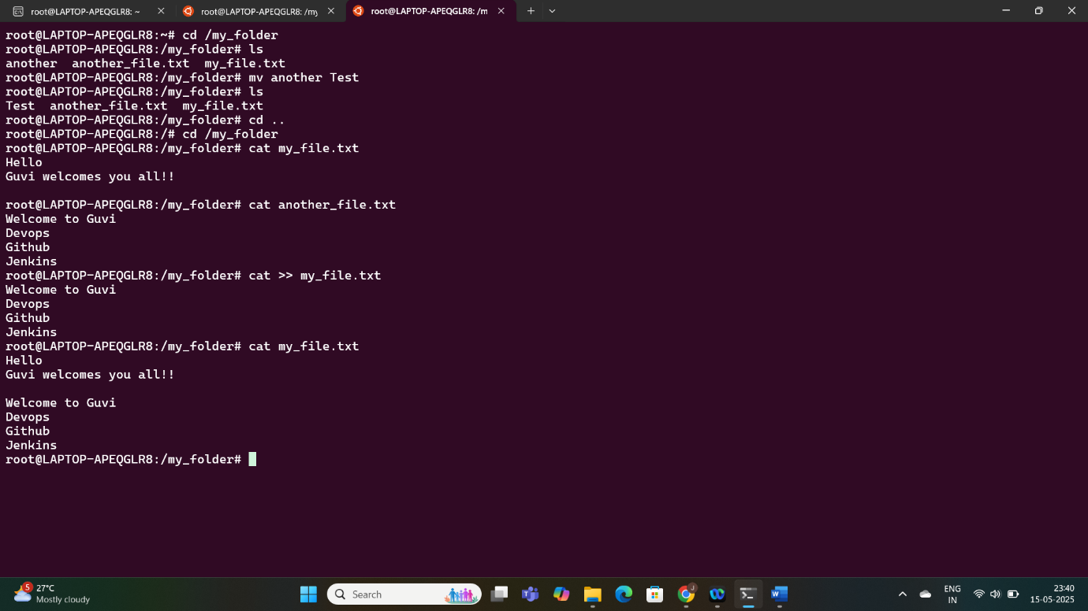

Finally list all files and directories in the current directory

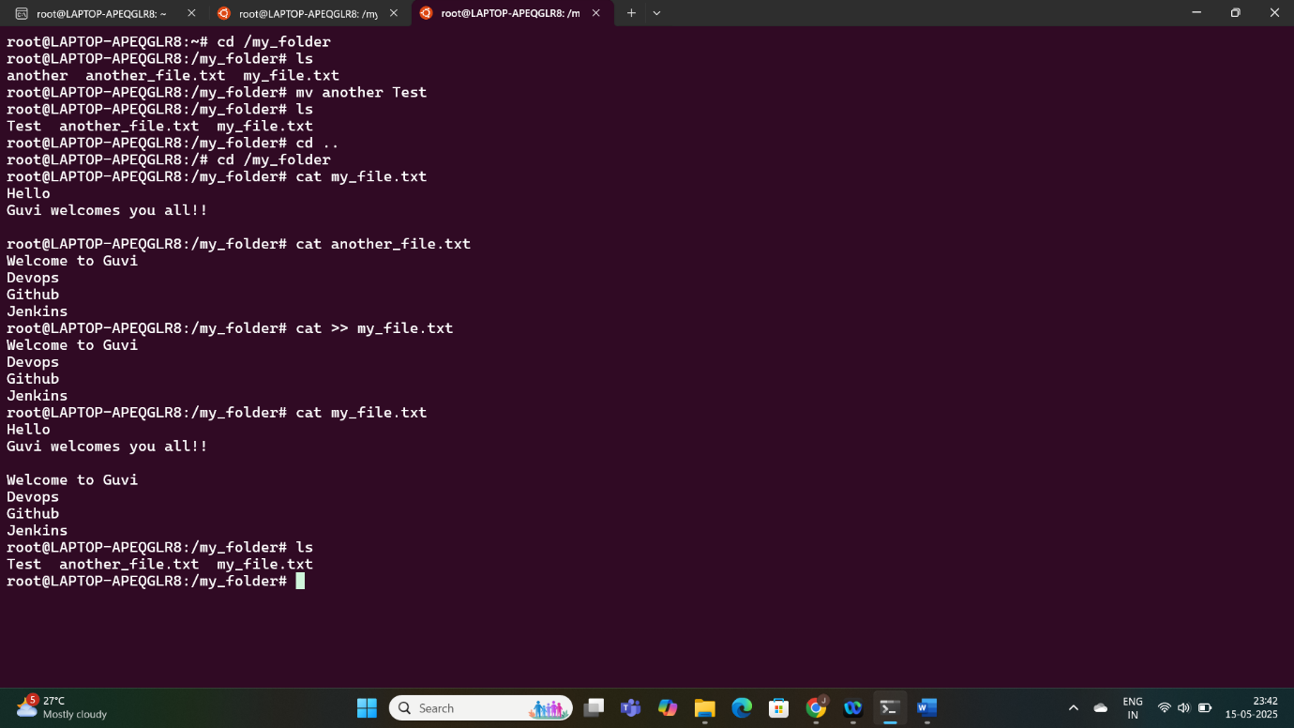

Create 20 files with .txt extensions and rename the first 5 files to .yml extension

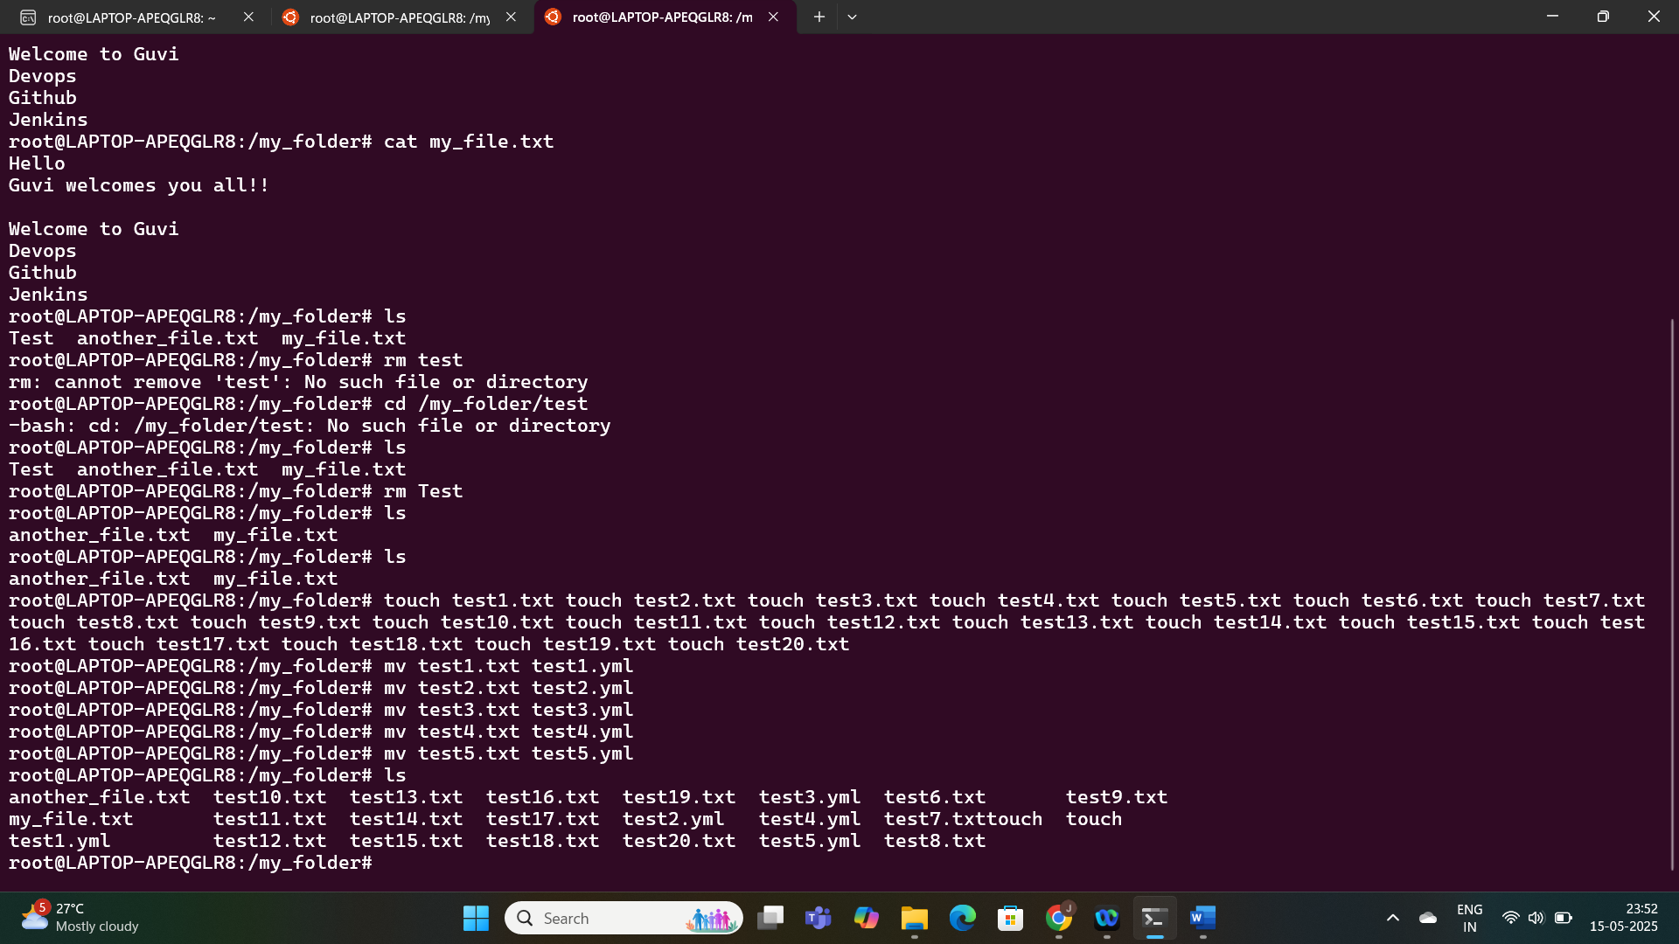

Print the latest created top 5 files among the total no of files".

