Task3 – Networking commands

Getting the IP address for a particular domain named “Guvi.in”

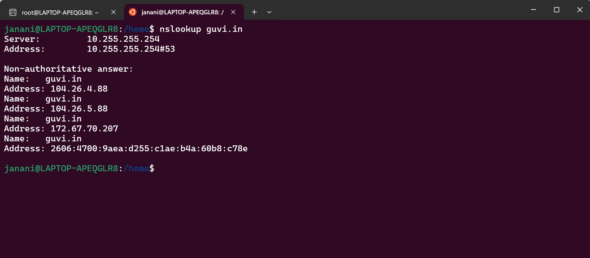

To find the CPU/memory usage of my server

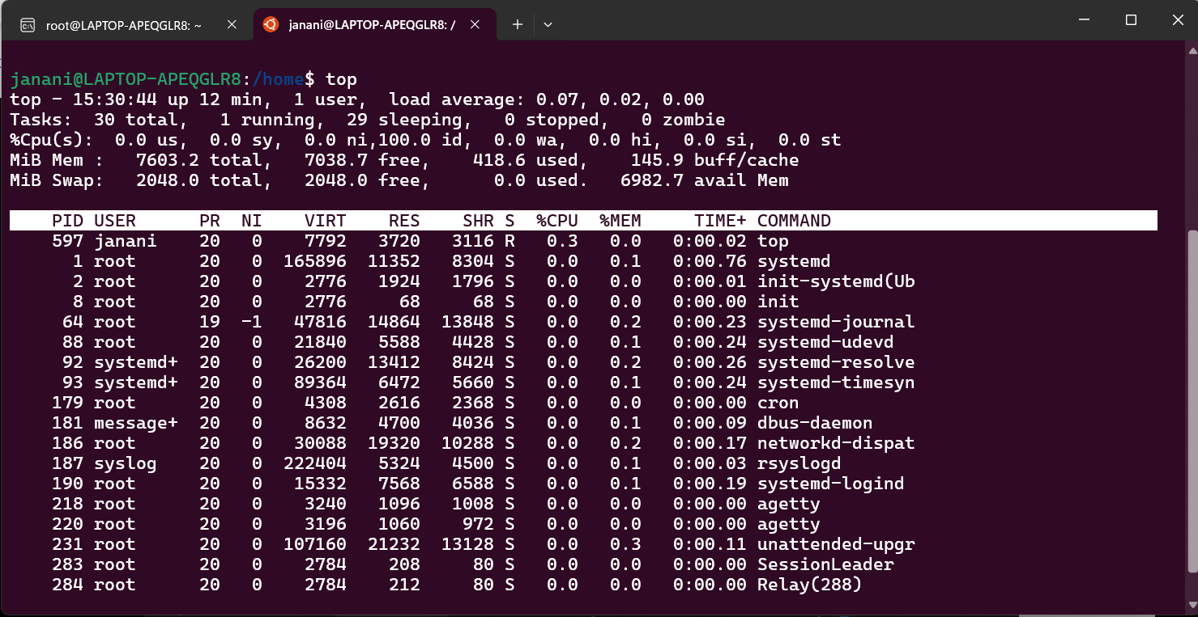

Testing the connectivity between nodes

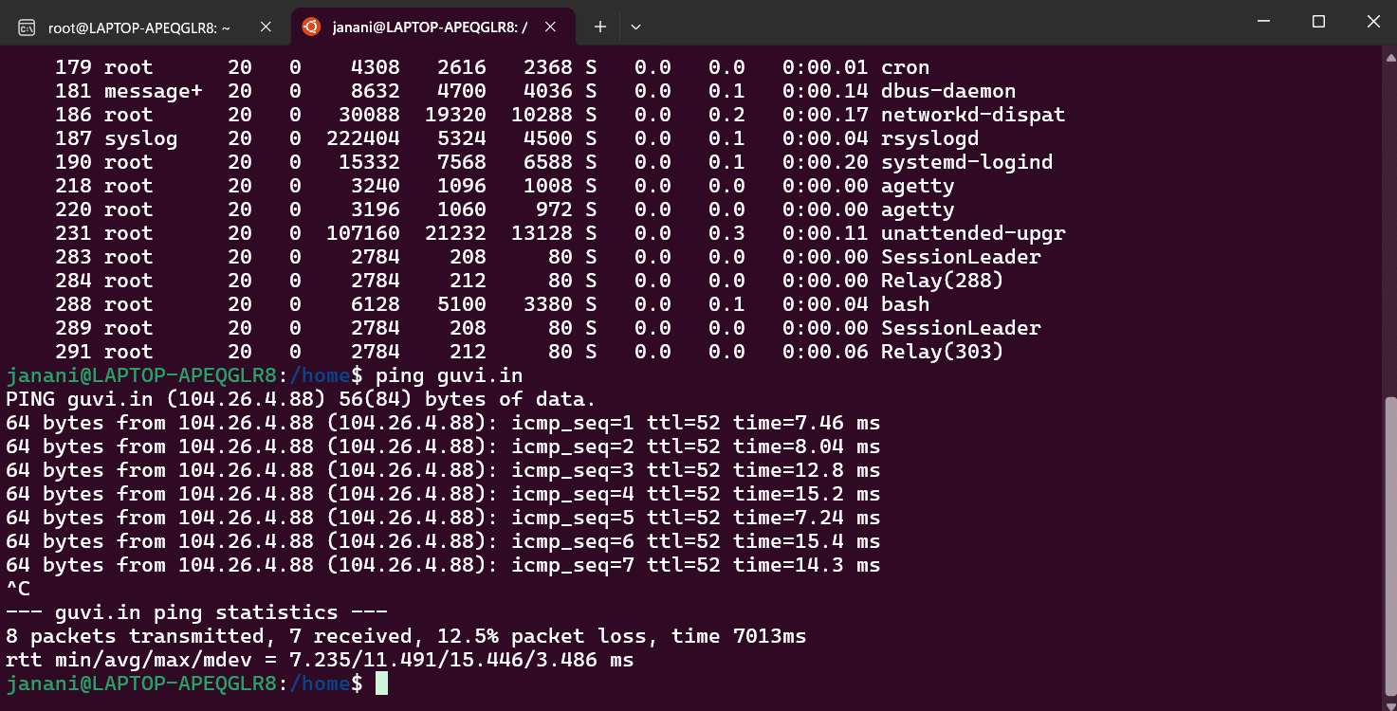

Checked by giving port(9000) to connect in guvi.com – No response….

So tried with different port “80” and “443” able to connect

