**Project No. 1: House Loan Data Analysis**

Step1: Import the required libraries import numpy as np

import pandas as pd

import pandas as pd

import sklearn

import numpy as np

import matplotlib.pyplot as plt

import os

import warnings

import seaborn as sns

Step2: Import scikit-learn from sklearn.preprocessing import OneHotEncoder

from sklearn.datasets import make_blobs

from sklearn.impute import SimpleImputer

from sklearn.pipeline import Pipeline

from sklearn.compose import ColumnTransformer

from sklearn.preprocessing import StandardScaler

from sklearn.svm import LinearSVC

from sklearn.metrics import roc_auc_score

from sklearn.linear_model import LogisticRegression

from sklearn.metrics import roc_auc_score

from sklearn.calibration import CalibratedClassifierCV

from sklearn.metrics import confusion_matrix

from sklearn.ensemble import RandomForestClassifier

from sklearn.metrics import accuracy_score

from sklearn.linear_model import SGDClassifier

import plotly.offline as py

import plotly.graph_objs as go

from plotly.offline import init_notebook_mode, iplot

from sklearn.model_selection import train_test_split

init_notebook_mode(connected=True)

import cufflinks as cf

cf.go_offline()

import pickle

import gc

import lightgbm as lgb

warnings.filterwarnings('ignore')

%matplotlib inline

Step3: Load the dataset house_loan=pd.read_csv('/content/loan_data (1).csv')

house_loan.describe()

house_loan.columns

house_loan.info()

Step4: Check for null values in the dataset

house_loan.isnull().sum()

house_loan.head()

Step5: Print percentage of default to payer of the dataset for the TARGET column

defaulters=(house_loan.TARGET==1).sum()

payers=(house_loan.TARGET==0).sum()

print((defaulters/payers)*100)

without_id=[column for column in house_loan.columns if column!='SK_ID_CURR']

Step6: check for duplicate values

na=house_loan[house_loan.duplicated(subset=without_id,keep=False)]

print("Duplicates are: ",na.shape[0])

house_loan.TARGET.value_counts().plot(kind='pie',autopct='%1.1f%%')

Step7: Balance the dataset if the data is imbalanced

import matplotlib as plt

shuffled_data=house_loan.sample(frac=1,random_state=3)

unpaid_home_loan=shuffled_data.loc[shuffled_data['TARGET']==1]

paid_home_loan=shuffled_data.loc[shuffled_data['TARGET']==0].sample(n=24825,random_state=69)

normalised_home_loan=pd.concat([unpaid_home_loan,paid_home_loan])

normalised_home_loan.TARGET.value_counts().plot(kind='pie',autopct="%1.1f%%")

Step8: importing tensorflow for model tracking

import tensorflow as tf

normalised_home_loan.info()

normalised_home_loan.head

normalised_home_loan.dropna(axis=0)

normalised_home_loan.info()

normalised_home_loan.isnull().sum()

print(pd.unique(normalised_home_loan.AMT_REQ_CREDIT_BUREAU_DAY))

print(pd.unique(normalised_home_loan.AMT_REQ_CREDIT_BUREAU_WEEK))

print(pd.unique(normalised_home_loan.AMT_REQ_CREDIT_BUREAU_MON))

print(pd.unique(normalised_home_loan.AMT_REQ_CREDIT_BUREAU_QRT))

print(pd.unique(normalised_home_loan.AMT_REQ_CREDIT_BUREAU_YEAR))

normalised_home_loan.dropna(axis=0)

print(normalised_home_loan.info())

print(normalised_home_loan.isnull().sum())

Step9: Plot the balanced data or imbalanced data

normalised_home_loan.TARGET.value_counts().plot(kind='pie',autopct="%1.1f%%")

normalised_home_loan.NAME_CONTRACT_TYPE.value_counts().plot(kind='pie',autopct="%1.1f%%")

normalised_home_loan.CODE_GENDER.value_counts().plot(kind='pie',autopct="%1.1f%%")

normalised_home_loan.FLAG_OWN_CAR.value_counts().plot(kind='pie',autopct="%1.1f%%")

normalised_home_loan.CNT_CHILDREN.value_counts().plot(kind='pie',autopct="%1.1f%%")

!pip install chart_studio

cf.set_config_file(theme='polar')

normalised_home_loan[normalised_home_loan['AMT_INCOME_TOTAL'] < 2000000]['AMT_INCOME_TOTAL'].iplot(kind='histogram', bins=100,

   xTitle = 'Total Income', yTitle ='Count of applicants',

             title='Distribution of AMT_INCOME_TOTAL')

(normalised_home_loan[normalised_home_loan['AMT_INCOME_TOTAL']>1000000]['TARGET'].value_counts())/len(normalised_home_loan[normalised_home_loan['AMT_INCOME_TOTAL'] > 1000000])*100

print((normalised_home_loan[normalised_home_loan['CNT_CHILDREN']>2]['TARGET'].value_counts())/len(normalised_home_loan[normalised_home_loan['CNT_CHILDREN'] > 2])*100)

print((normalised_home_loan[normalised_home_loan['CNT_CHILDREN']>5]['TARGET'].value_counts())/len(normalised_home_loan[normalised_home_loan['CNT_CHILDREN'] > 5])*100)

print((normalised_home_loan[normalised_home_loan['FLAG_OWN_CAR']=='N']['TARGET'].value_counts())/len(normalised_home_loan[normalised_home_loan['FLAG_OWN_CAR'] =='N'])*100)

print((normalised_home_loan[normalised_home_loan['FLAG_OWN_CAR']=='Y']['TARGET'].value_counts())/len(normalised_home_loan[normalised_home_loan['FLAG_OWN_CAR'] =='Y'])*100)

print((normalised_home_loan[normalised_home_loan['CODE_GENDER']=='M']['TARGET'].value_counts())/len(normalised_home_loan[normalised_home_loan['CODE_GENDER'] =='M'])*100)

print((normalised_home_loan[normalised_home_loan['CODE_GENDER']=='F']['TARGET'].value_counts())/len(normalised_home_loan[normalised_home_loan['CODE_GENDER'] =='F'])*100)

print((normalised_home_loan[normalised_home_loan['NAME_CONTRACT_TYPE']=='Cash loans']['TARGET'].value_counts())/len(normalised_home_loan[normalised_home_loan['NAME_CONTRACT_TYPE']=='Cash loans'])*100)

print((normalised_home_loan[normalised_home_loan['NAME_CONTRACT_TYPE']=='Revolving loans']['TARGET'].value_counts())/len(normalised_home_loan[normalised_home_loan['NAME_CONTRACT_TYPE']=='Revolving loans'])*100)

normalised_home_loan=normalised_home_loan.sample(frac=1,random_state=5)

Step10: Encode the columns that is required for the model

from sklearn.preprocessing import OrdinalEncoder

ordenc=OrdinalEncoder()

normalised_home_loan['NAME_CONTRACT_TYPE_CODE']=ordenc.fit_transform(normalised_home_loan[['NAME_CONTRACT_TYPE']])

print(normalised_home_loan[['NAME_CONTRACT_TYPE','NAME_CONTRACT_TYPE_CODE']].head(20))

print(normalised_home_loan['NAME_CONTRACT_TYPE_CODE'].value_counts())

normalised_home_loan['CODE_GENDER_CODE']=ordenc.fit_transform(normalised_home_loan[['CODE_GENDER']])

print(normalised_home_loan[['CODE_GENDER','CODE_GENDER_CODE']].head(20))

print(normalised_home_loan['CODE_GENDER_CODE'].value_counts())

normalised_home_loan.loc[normalised_home_loan['CODE_GENDER_CODE']==2]

normalised_home_loan['FLAG_OWN_CAR_CODE']=ordenc.fit_transform(normalised_home_loan[['FLAG_OWN_CAR']])

print(normalised_home_loan[['FLAG_OWN_CAR','FLAG_OWN_CAR_CODE']].head(20))

print(normalised_home_loan['FLAG_OWN_CAR_CODE'].value_counts())

normalised_home_loan['CNT_CHILDREN_CODE']=ordenc.fit_transform(normalised_home_loan[['CNT_CHILDREN']])

print(normalised_home_loan[['CNT_CHILDREN_CODE','CNT_CHILDREN']].head(20))

print(normalised_home_loan['CNT_CHILDREN_CODE'].value_counts())

normalised_home_loan=normalised_home_loan.sample(frac=1,random_state=45)

normalised_home_loan['TARGET'].value_counts()

y=normalised_home_loan.TARGET

normalised_home_loan_features=['SK_ID_CURR','NAME_CONTRACT_TYPE_CODE','CNT_CHILDREN_CODE','FLAG_OWN_CAR_CODE','CODE_GENDER_CODE']

Step11: Train the model

from sklearn.model_selection import train_test_split

X=normalised_home_loan[normalised_home_loan_features]

blobs_random_seed = 42

centers = [(0,0), (5,5)]

cluster_std = 1

frac_test_split = 0.33

num_features_for_samples = 2

num_samples_total = 49650

Step12: Generate data

inputs, targets = make_blobs(n_samples = num_samples_total, centers = centers, n_features = num_features_for_samples, cluster_std = cluster_std)

X_train,X_test,y_train,y_test=train_test_split(inputs,targets,test_size=0.33,random_state=45)

print(X_train.shape, X_test.shape, y_train.shape, y_test.shape)

plt.pyplot.scatter(X_train[:,0], X_train[:,1])

plt.pyplot.title('Linearly separable data')

plt.pyplot.xlabel('X1')

plt.pyplot.ylabel('X2')

plt.pyplot.show()

Step13: Calculate Sensitivity as a metrice

from sklearn import svm

from sklearn.metrics import plot_confusion_matrix

clf=svm.SVC(kernel='linear')

clf=clf.fit(X_train,y_train)

predictions = clf.predict(X_test)

Step14: Calculate area under receiver operating characteristics curve

matrix = plot_confusion_matrix(clf, X_test, y_test, cmap=plt.cm.Blues, normalize='true')

plt.pyplot.title('Confusion matrix for our classifier')

plt.pyplot.show(matrix)

plt.pyplot.show()

from sklearn.metrics import precision_score, recall_score,f1_score

print(precision_score(y_test, predictions))

print(recall_score(y_test, predictions))

print(f1_score(y_test,predictions,average=None))

support_vectors = clf.support_vectors_

plt.pyplot.scatter(X_train[:,0], X_train[:,1])

plt.pyplot.scatter(support_vectors[:,0], support_vectors[:,1], color='red')

plt.pyplot.title('Linearly separable data with support vectors')

plt.pyplot.xlabel('X1')

plt.pyplot.ylabel('X2')

plt.pyplot.show()

from mlxtend.plotting import plot_decision_regions

plot_decision_regions(X_test, y_test, clf=clf, legend=2)

plt.pyplot.show()

# Screenshot of the Output

## Q1. Read the data from the Given Dataset

Step3: Load the dataset house_loan=pd.read_csv('/content/loan_data (1).csv')

house_loan.describe()

house_loan.columns

house_loan.info()

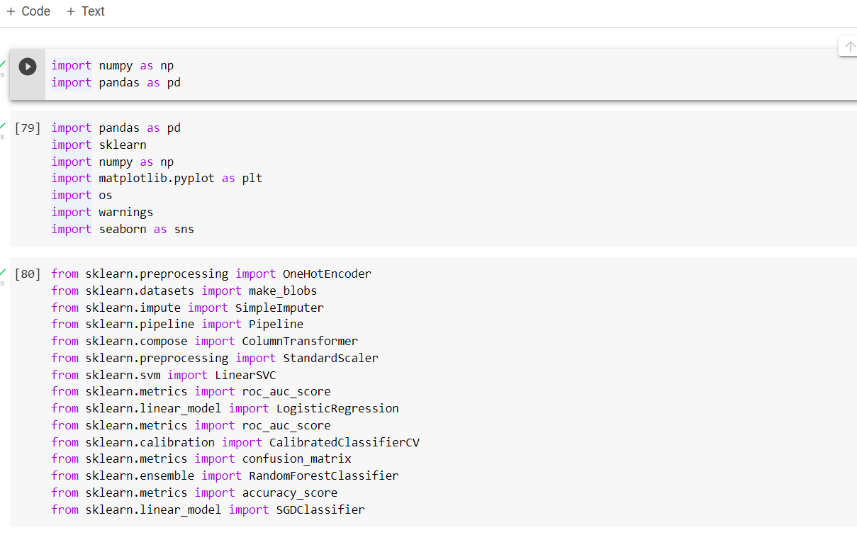

## Q2. Check for null values in the dataset

Step4: Check for null values in the dataset

house_loan.isnull().sum()

house_loan.head()

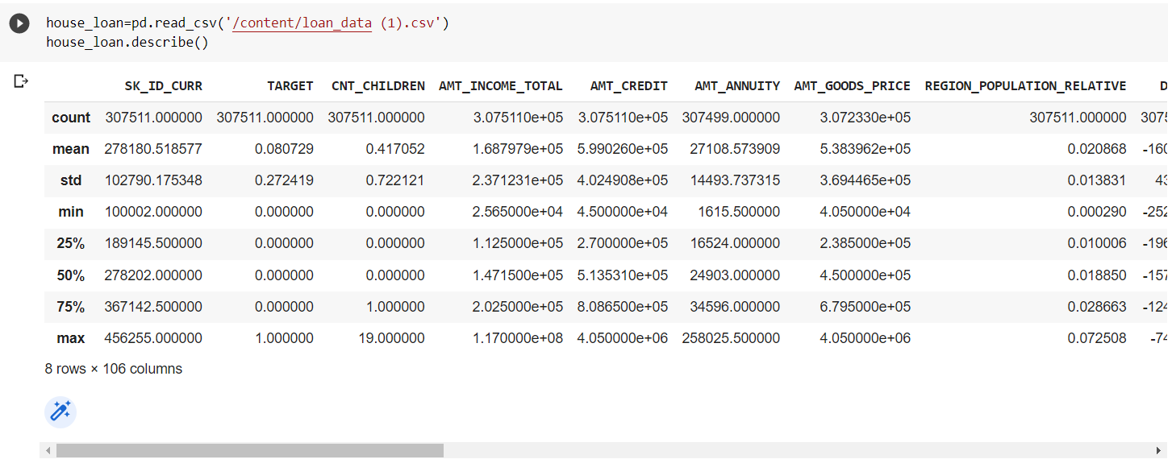

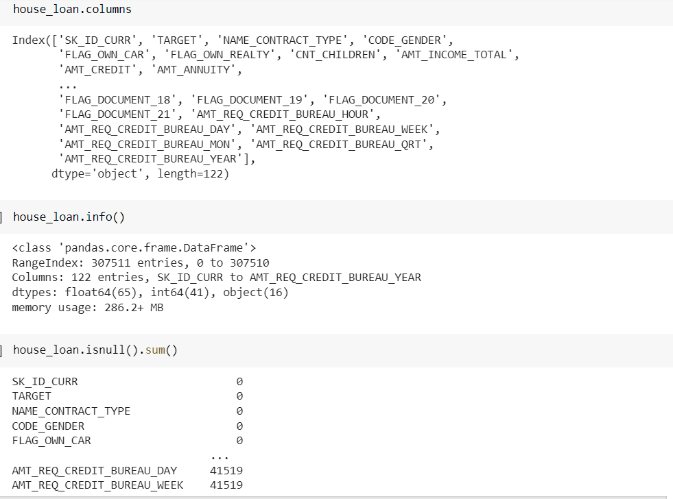

## Q3. Print percentage of default to payer of the dataset for the TARGET column

Step5: Print percentage of default to payer of the dataset for the TARGET column

defaulters=(house_loan.TARGET==1).sum()

payers=(house_loan.TARGET==0).sum()

print((defaulters/payers)*100)

without_id=[column for column in house_loan.columns if column!='SK_ID_CURR']

Step6: check for duplicate values

na=house_loan[house_loan.duplicated(subset=without_id,keep=False)]

print("Duplicates are: ",na.shape[0])

house_loan.TARGET.value_counts().plot(kind='pie',autopct='%1.1f%%')

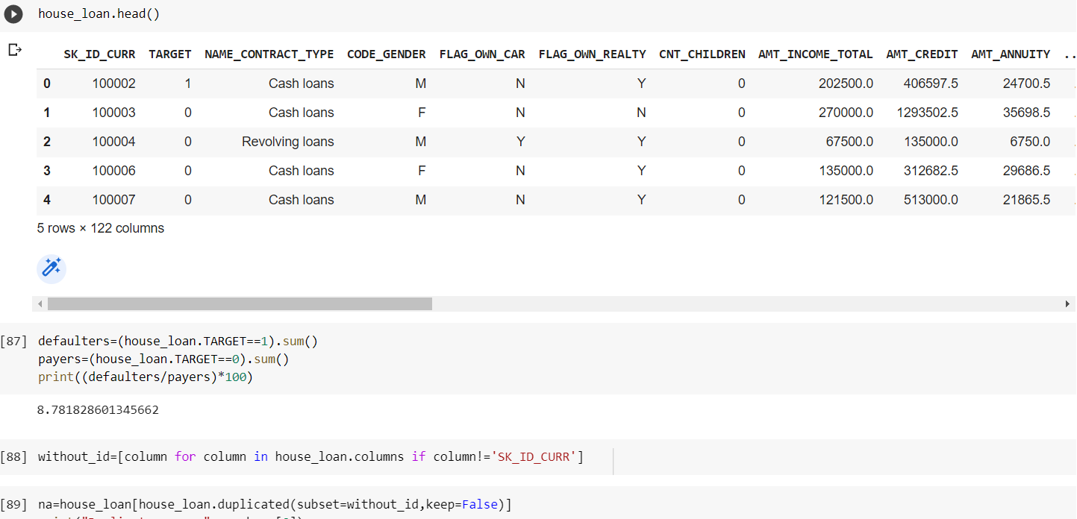

## Q4. Balance the dataset if the data is imbalanced

Step7: Balance the dataset if the data is imbalanced

import matplotlib as plt

shuffled_data=house_loan.sample(frac=1,random_state=3)

unpaid_home_loan=shuffled_data.loc[shuffled_data['TARGET']==1]

paid_home_loan=shuffled_data.loc[shuffled_data['TARGET']==0].sample(n=24825,random_state=69)

normalised_home_loan=pd.concat([unpaid_home_loan,paid_home_loan])

normalised_home_loan.TARGET.value_counts().plot(kind='pie',autopct="%1.1f%%")

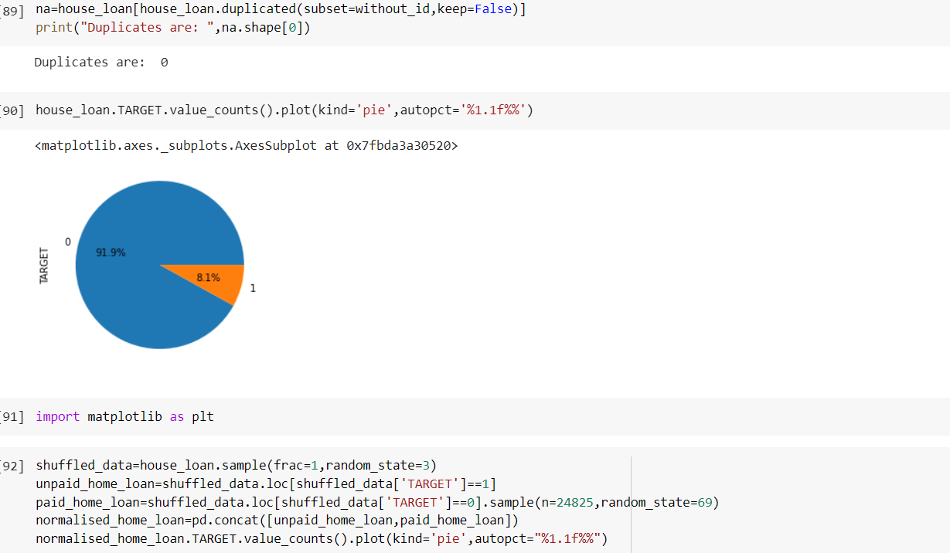

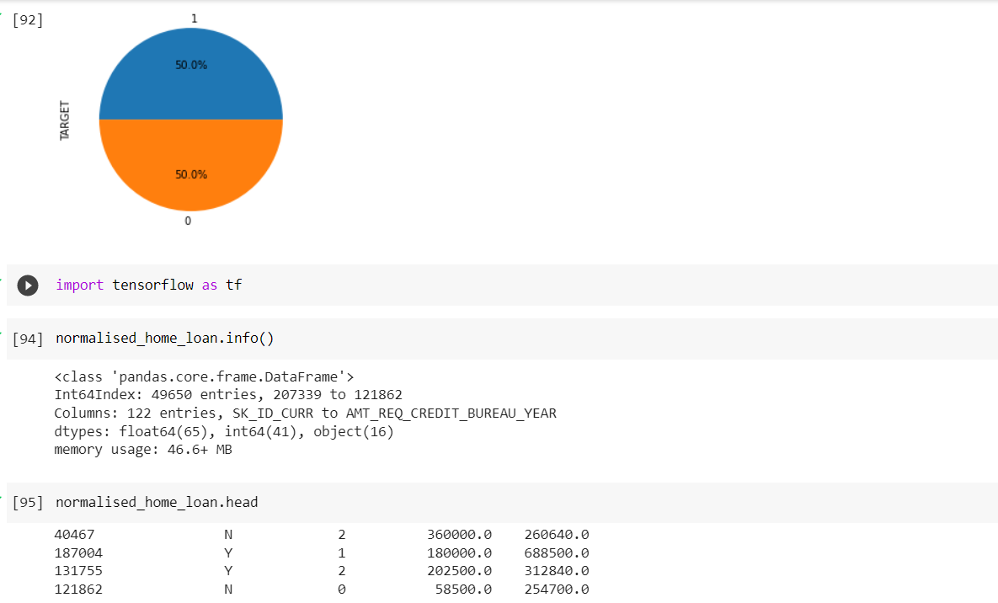

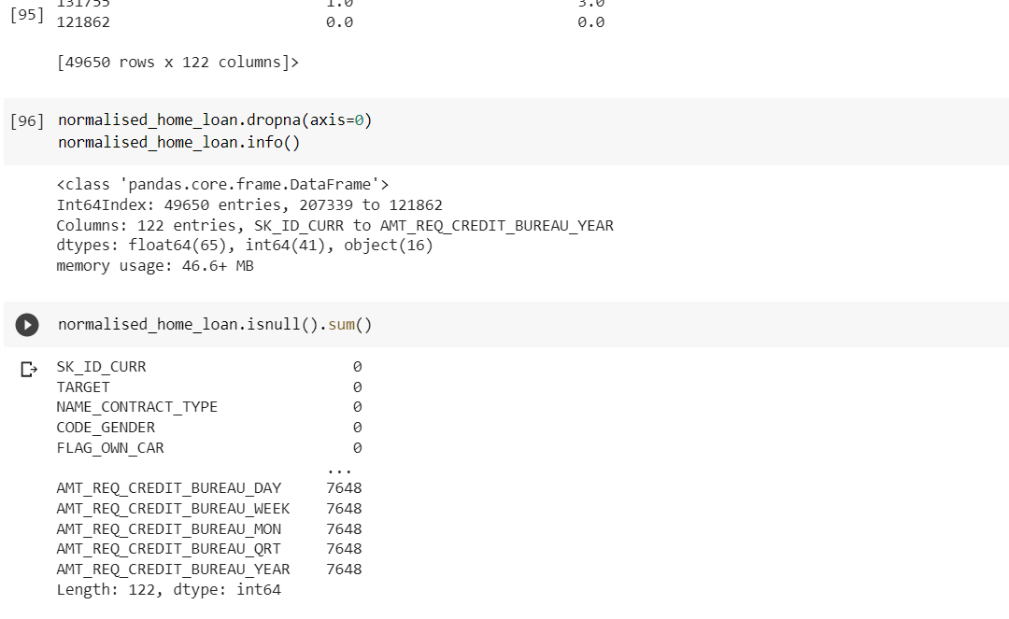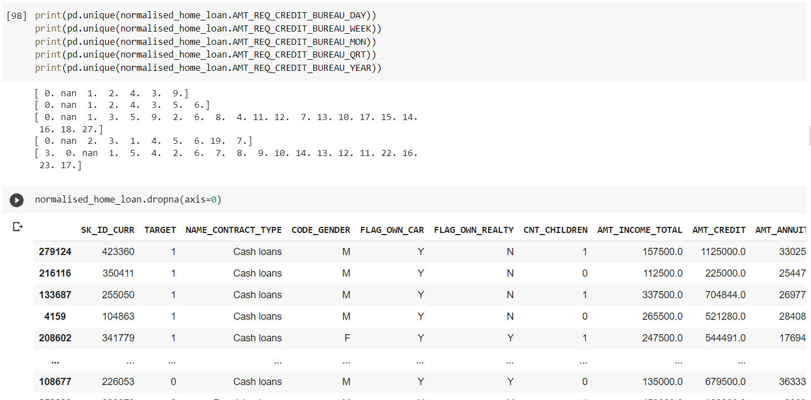

## Q5. Plot the balanced data or imbalanced data

Step9: Plot the balanced data or imbalanced data

normalised_home_loan.TARGET.value_counts().plot(kind='pie',autopct="%1.1f%%")

normalised_home_loan.NAME_CONTRACT_TYPE.value_counts().plot(kind='pie',autopct="%1.1f%%")

normalised_home_loan.CODE_GENDER.value_counts().plot(kind='pie',autopct="%1.1f%%")

normalised_home_loan.FLAG_OWN_CAR.value_counts().plot(kind='pie',autopct="%1.1f%%")

normalised_home_loan.CNT_CHILDREN.value_counts().plot(kind='pie',autopct="%1.1f%%")

!pip install chart_studio

cf.set_config_file(theme='polar')

normalised_home_loan[normalised_home_loan['AMT_INCOME_TOTAL'] < 2000000]['AMT_INCOME_TOTAL'].iplot(kind='histogram', bins=100,

   xTitle = 'Total Income', yTitle ='Count of applicants',

             title='Distribution of AMT_INCOME_TOTAL')

(normalised_home_loan[normalised_home_loan['AMT_INCOME_TOTAL']>1000000]['TARGET'].value_counts())/len(normalised_home_loan[normalised_home_loan['AMT_INCOME_TOTAL'] > 1000000])*100

print((normalised_home_loan[normalised_home_loan['CNT_CHILDREN']>2]['TARGET'].value_counts())/len(normalised_home_loan[normalised_home_loan['CNT_CHILDREN'] > 2])*100)

print((normalised_home_loan[normalised_home_loan['CNT_CHILDREN']>5]['TARGET'].value_counts())/len(normalised_home_loan[normalised_home_loan['CNT_CHILDREN'] > 5])*100)

print((normalised_home_loan[normalised_home_loan['FLAG_OWN_CAR']=='N']['TARGET'].value_counts())/len(normalised_home_loan[normalised_home_loan['FLAG_OWN_CAR'] =='N'])*100)

print((normalised_home_loan[normalised_home_loan['FLAG_OWN_CAR']=='Y']['TARGET'].value_counts())/len(normalised_home_loan[normalised_home_loan['FLAG_OWN_CAR'] =='Y'])*100)

print((normalised_home_loan[normalised_home_loan['CODE_GENDER']=='M']['TARGET'].value_counts())/len(normalised_home_loan[normalised_home_loan['CODE_GENDER'] =='M'])*100)

print((normalised_home_loan[normalised_home_loan['CODE_GENDER']=='F']['TARGET'].value_counts())/len(normalised_home_loan[normalised_home_loan['CODE_GENDER'] =='F'])*100)

print((normalised_home_loan[normalised_home_loan['NAME_CONTRACT_TYPE']=='Cash loans']['TARGET'].value_counts())/len(normalised_home_loan[normalised_home_loan['NAME_CONTRACT_TYPE']=='Cash loans'])*100)

print((normalised_home_loan[normalised_home_loan['NAME_CONTRACT_TYPE']=='Revolving loans']['TARGET'].value_counts())/len(normalised_home_loan[normalised_home_loan['NAME_CONTRACT_TYPE']=='Revolving loans'])*100)

normalised_home_loan=normalised_home_loan.sample(frac=1,random_state=5)

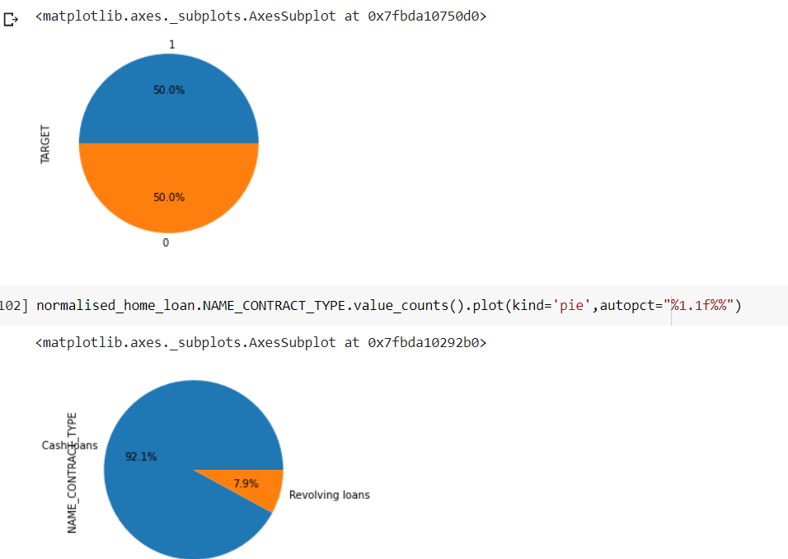

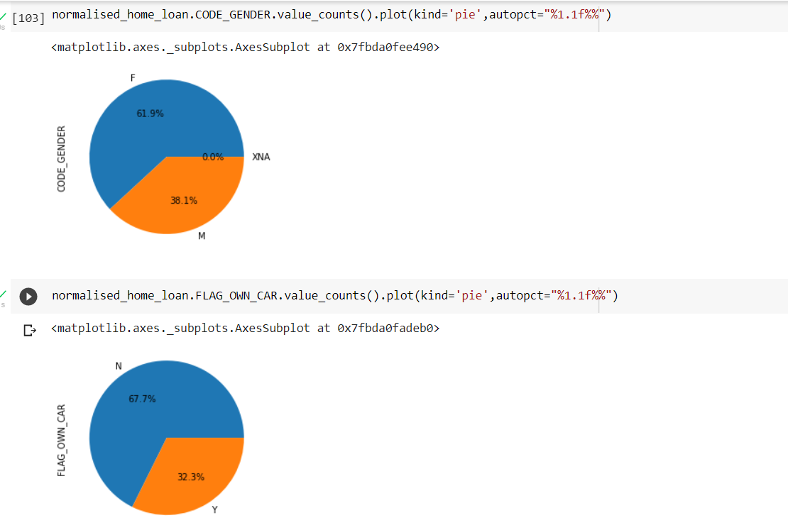

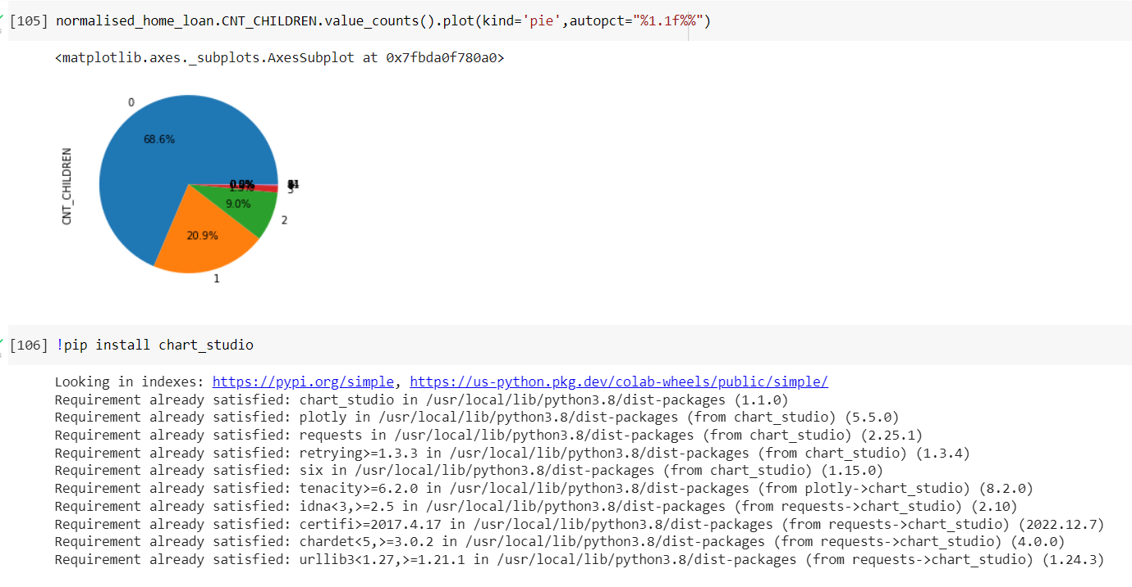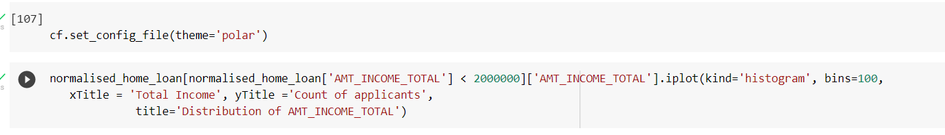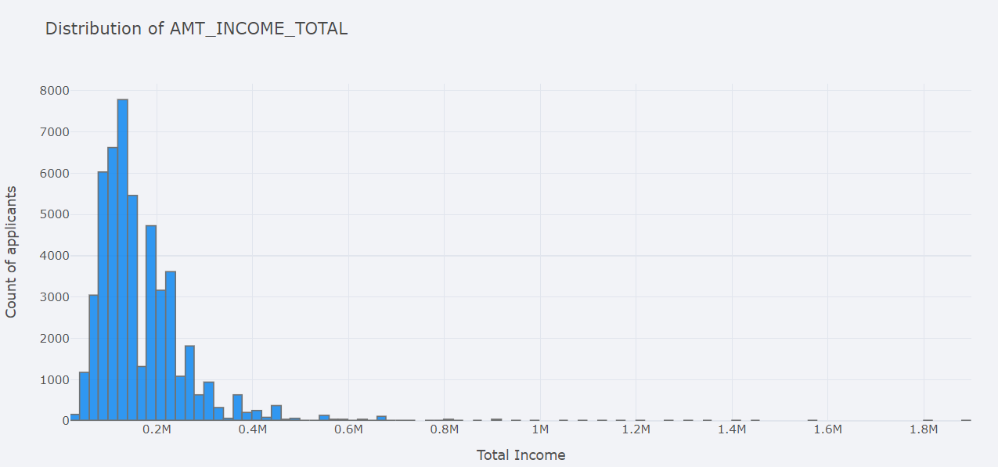

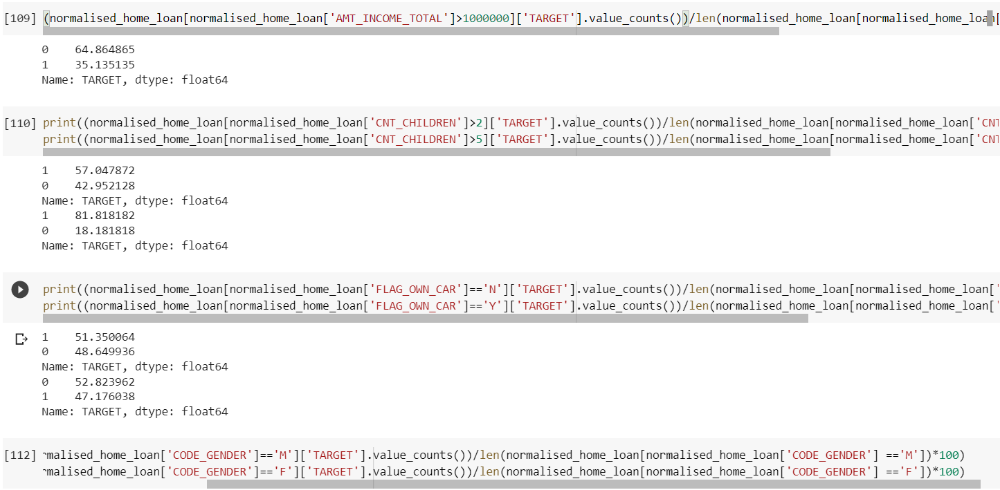

## Q6. Encode the columns that is required for the model

Step10: Encode the columns that is required for the model

from sklearn.preprocessing import OrdinalEncoder

ordenc=OrdinalEncoder()

normalised_home_loan['NAME_CONTRACT_TYPE_CODE']=ordenc.fit_transform(normalised_home_loan[['NAME_CONTRACT_TYPE']])

print(normalised_home_loan[['NAME_CONTRACT_TYPE','NAME_CONTRACT_TYPE_CODE']].head(20))

print(normalised_home_loan['NAME_CONTRACT_TYPE_CODE'].value_counts())

normalised_home_loan['CODE_GENDER_CODE']=ordenc.fit_transform(normalised_home_loan[['CODE_GENDER']])

print(normalised_home_loan[['CODE_GENDER','CODE_GENDER_CODE']].head(20))

print(normalised_home_loan['CODE_GENDER_CODE'].value_counts())

normalised_home_loan.loc[normalised_home_loan['CODE_GENDER_CODE']==2]

normalised_home_loan['FLAG_OWN_CAR_CODE']=ordenc.fit_transform(normalised_home_loan[['FLAG_OWN_CAR']])

print(normalised_home_loan[['FLAG_OWN_CAR','FLAG_OWN_CAR_CODE']].head(20))

print(normalised_home_loan['FLAG_OWN_CAR_CODE'].value_counts())

normalised_home_loan['CNT_CHILDREN_CODE']=ordenc.fit_transform(normalised_home_loan[['CNT_CHILDREN']])

print(normalised_home_loan[['CNT_CHILDREN_CODE','CNT_CHILDREN']].head(20))

print(normalised_home_loan['CNT_CHILDREN_CODE'].value_counts())

normalised_home_loan=normalised_home_loan.sample(frac=1,random_state=45)

normalised_home_loan['TARGET'].value_counts()

y=normalised_home_loan.TARGET

normalised_home_loan_features=['SK_ID_CURR','NAME_CONTRACT_TYPE_CODE','CNT_CHILDREN_CODE','FLAG_OWN_CAR_CODE','CODE_GENDER_CODE']

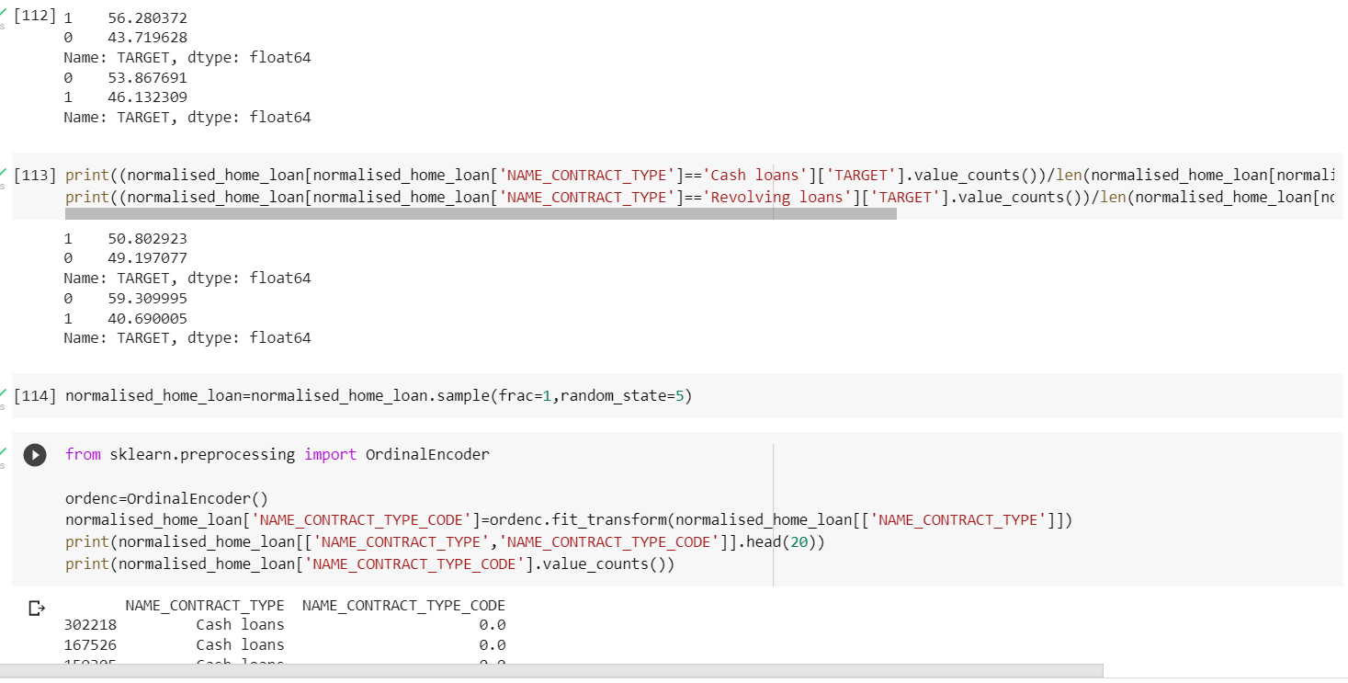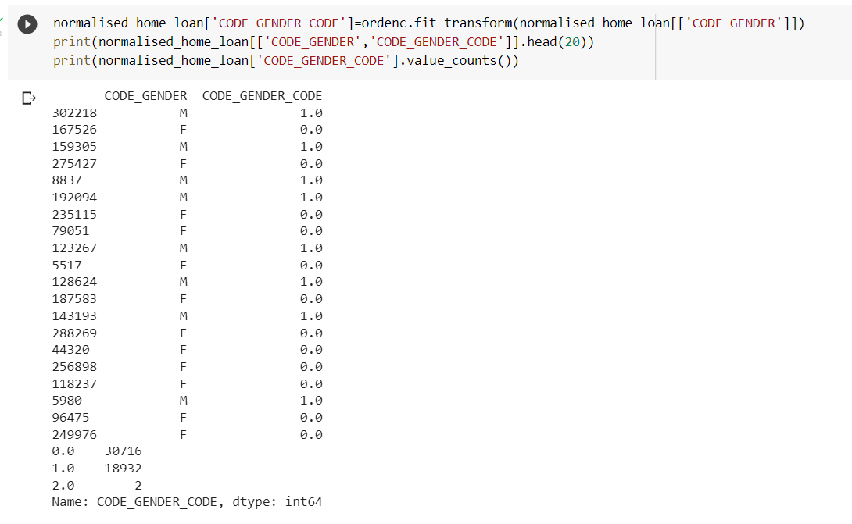

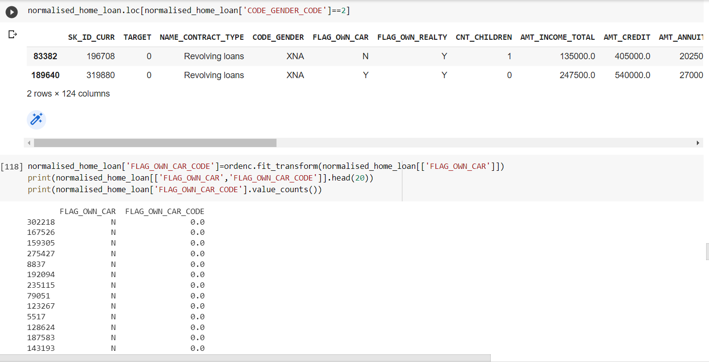

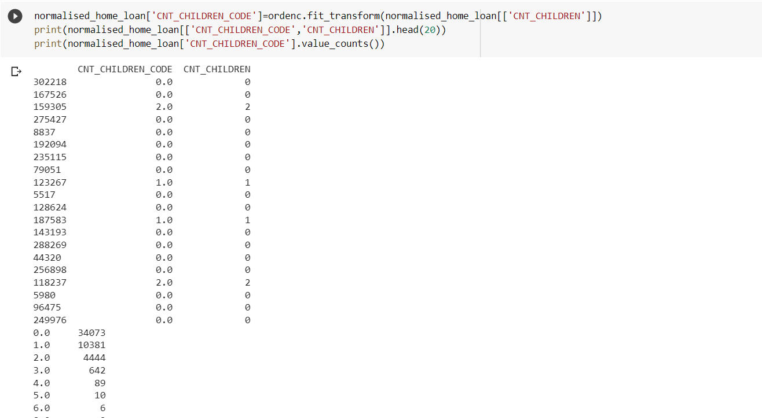

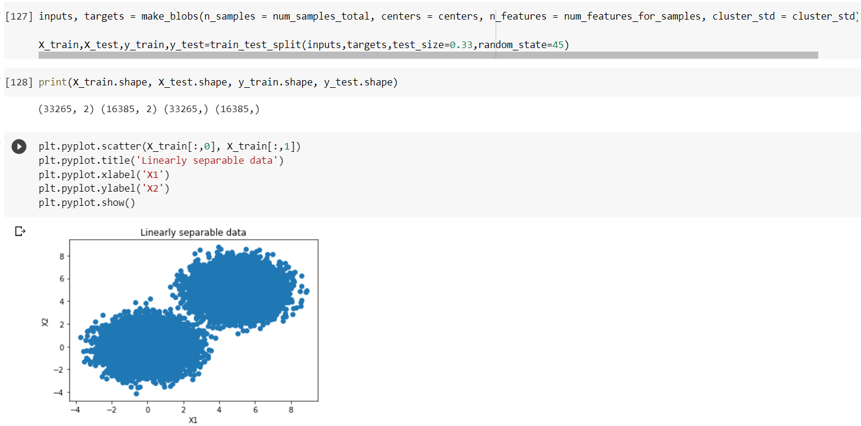

## Q7. Calculate Sensitivity as a metrice and Calculate area under receiver operating characteristics curve

Step13: Calculate Sensitivity as a metrice

from sklearn import svm

from sklearn.metrics import plot_confusion_matrix

clf=svm.SVC(kernel='linear')

clf=clf.fit(X_train,y_train)

predictions = clf.predict(X_test)

Step14: Calculate area under receiver operating characteristics curve

matrix = plot_confusion_matrix(clf, X_test, y_test,cmap=plt.cm.Blues, normalize='true')

plt.pyplot.title('Confusion matrix for our classifier')

plt.pyplot.show(matrix)

plt.pyplot.show()

from sklearn.metrics import precision_score, recall_score,f1_score

print(precision_score(y_test, predictions))

print(recall_score(y_test, predictions))

print(f1_score(y_test,predictions,average=None))

support_vectors = clf.support_vectors_

plt.pyplot.scatter(X_train[:,0], X_train[:,1])

plt.pyplot.scatter(support_vectors[:,0], support_vectors[:,1], color='red')

plt.pyplot.title('Linearly separable data with support vectors')

plt.pyplot.xlabel('X1')

plt.pyplot.ylabel('X2')

plt.pyplot.show()

from mlxtend.plotting import plot_decision_regions

plot_decision_regions(X_test, y_test, clf=clf, legend=2)

plt.pyplot.show()

