RAID (Redundant Array of Independent Disks) is like having backup copies of your important files stored in different places on several hard drives or solid-state drives (SSDs). If one drive stops working, your data is still safe because you have other copies stored on the other drives. It’s like having a safety net to protect your files from being lost if one of your drives breaks down.
RAID (Redundant Array of Independent Disks) in a Database Management System (DBMS) is a technology that combines multiple physical disk drives into a single logical unit for data storage. The main purpose of RAID is to improve data reliability, availability, and performance. There are different levels of RAID, each offering a balance of these benefits.
How RAID Works?
Let us understand How RAID works with an example- Imagine you have a bunch of friends, and you want to keep your favorite book safe. Instead of giving the book to just one friend, you make copies and give a piece to each friend. Now, if one friend loses their piece, you can still put the book together from the other pieces. That’s similar to how RAID works with hard drives. It splits your data across multiple drives, so if one drive fails, your data is still safe on the others. RAID helps keep your information secure, just like spreading your favorite book among friends keeps it safe
What is a RAID Controller?
A RAID controller is like a boss for your hard drives in a big storage system. It works between your computer’s operating system and the actual hard drives, organizing them into groups to make them easier to manage. This helps speed up how fast your computer can read and write data, and it also adds a layer of protection in case one of your hard drives breaks down. So, it’s like having a smart helper that makes your hard drives work better and keeps your important data safer.
Types of RAID Controller
There are three types of RAID controller:
Hardware Based: In hardware-based RAID, there’s a physical controller that manages the whole array. This controller can handle the whole group of hard drives together. It’s designed to work with different types of hard drives, like SATA (Serial Advanced Technology Attachment) or SCSI (Small Computer System Interface). Sometimes, this controller is built right into the computer’s main board, making it easier to set up and manage your RAID system. It’s like having a captain for your team of hard drives, making sure they work together smoothly.
Software Based: In software-based RAID, the controller doesn’t have its own special hardware. So it use computer’s main processor and memory to do its job. It perform the same function as a hardware-based RAID controller, like managing the hard drives and keeping your data safe. But because it’s sharing resources with other programs on your computer, it might not make things run as fast. So, while it’s still helpful, it might not give you as big of a speed boost as a hardware-based RAID system
Firmware Based: Firmware-based RAID controllers are like helpers built into the computer’s main board. They work with the main processor, just like software-based RAID. But they only implement when the computer starts up. Once the operating system is running, a special driver takes over the RAID job. These controllers aren’t as expensive as hardware ones, but they make the computer’s main processor work harder. People also call them hardware-assisted software RAID, hybrid model RAID, or fake RAID.
Why Data Redundancy?
Data redundancy, although taking up extra space, adds to disk reliability. This means, that in case of disk failure, if the same data is also backed up onto another disk, we can retrieve the data and go on with the operation. On the other hand, if the data is spread across multiple disks without the RAID technique, the loss of a single disk can affect the entire data.
Key Evaluation Points for a RAID System
- Reliability: How many disk faults can the system tolerate?
- Availability: What fraction of the total session time is a system in uptime mode, i.e. how available is the system for actual use?
- Performance: How good is the response time? How high is the throughput (rate of processing work)? Note that performance contains a lot of parameters, not just the two.
- Capacity: Given a set of N disks each with B blocks, how much useful capacity is available to the user?
RAID is very transparent to the underlying system. This means, that to the host system, it appears as a single big disk presenting itself as a linear array of blocks. This allows older technologies to be replaced by RAID without making too many changes to the existing code.
Different RAID Levels
- RAID-0 (Stripping)
- RAID-1 (Mirroring)
- RAID-2 (Bit-Level Stripping with Dedicated Parity)
- RAID-3 (Byte-Level Stripping with Dedicated Parity)
- RAID-4 (Block-Level Stripping with Dedicated Parity)
- RAID-5 (Block-Level Stripping with Distributed Parity)
- RAID-6 (Block-Level Stripping with two Parity Bits)
- Question 1: what is the difference raid 1 and raid 5?
Answer: On most situations you will be using one of the following four levels of RAIDs.
~ RAID 0
~ RAID 1
~ RAID 5
~ RAID 10 (also known as RAID 1+0)
- RAID 0
- Following are the key points to remember for RAID level 0.
~ Minimum 2 disks.
~ Excellent performance ( as blocks are striped ).
~ No redundancy ( no mirror, no parity ).
~ Don’t use this for any critical system.
In all the diagrams mentioned below:
~ A, B, C, D, E and F – represents blocks
~ p1, p2, and p3 – represents parity
- 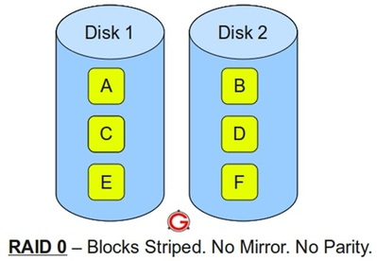
- RAID 1
- Following are the key points to remember for RAID level 1.
~ Minimum 2 disks.
~ Good performance ( no striping. no parity ).
~ Excellent redundancy ( as blocks are mirrored ).
- 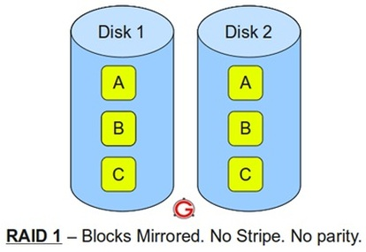
- RAID 5
- Following are the key points to remember for RAID level 5.
~ Minimum 3 disks.
~ Good performance ( as blocks are striped ).
~ Good redundancy ( distributed parity ).
~ Best cost effective option providing both performance and redundancy. Use this for DB that is heavily read oriented. Write operations will be slow.
- 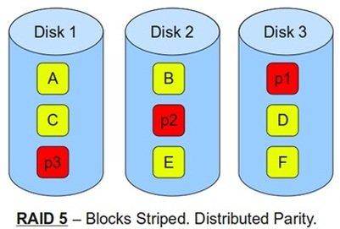
- RAID 10
- Following are the key points to remember for RAID level 10.
~ Minimum 4 disks.
~ This is also called as “stripe of mirrors”
~ Excellent redundancy ( as blocks are mirrored )
~ Excellent performance ( as blocks are striped )
~ If you can afford the dollar, this is the BEST option for any mission critical applications (especially databases).
- 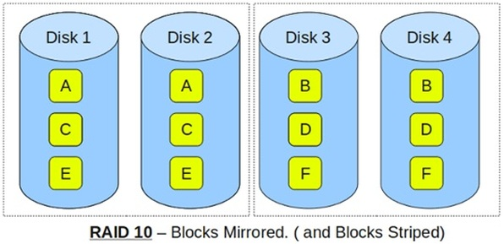
- Question 2: Explain Different RAID ?
Answer: However there are several non-standard raids, which are not used except in some rare situations. It is good to know what they are.
This article explains with a simple diagram how RAID 2, RAID 3, RAID 4, and RAID 6 works.
- RAID 2
- 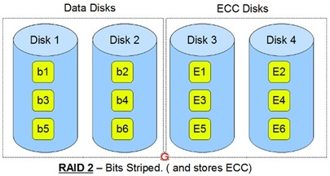
- ~ This uses bit level striping. i.e Instead of striping the blocks across the disks, it stripes the bits across the disks.
~ In the above diagram b1, b2, b3 are bits. E1, E2, E3 are error correction codes.
~ You need two groups of disks. One group of disks are used to write the data, another group is used to write the error correction codes.
~ This uses Hamming error correction code (ECC), and stores this information in the redundancy disks.
~ When data is written to the disks, it calculates the ECC code for the data on the fly, and stripes the data bits to the data-disks, and writes the ECC code to the redundancy disks.
~ When data is read from the disks, it also reads the corresponding ECC code from the redundancy disks, and checks whether the data is consistent.
If required, it makes appropriate corrections on the fly.
~ This uses lot of disks and can be configured in different disk configuration. Some valid configurations are 1) 10 disks for data and 4 disks for ECC 2)
4 disks for data and 3 disks for ECC
~ This is not used anymore. This is expensive and implementing it in a RAID controller is complex, and ECC is redundant now-a-days, as the hard disk
themselves can do this.

- RAID 3
- 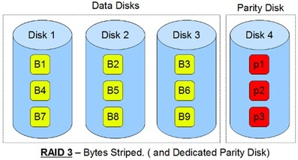
- ~ This uses byte level striping. i.e Instead of striping the blocks across the disks, it stripes the bits across the disks.
~ In the above diagram B1, B2, B3 are bytes. p1, p2, p3 are parities.
~ Uses multiple data disks, and a dedicated disk to store parity.
~ The disks have to spin in sync to get to the data.
~ Sequential read and write will have good performance.
~ Random read and write will have worst performance.
~ This is not commonly used.

- RAID 4
- 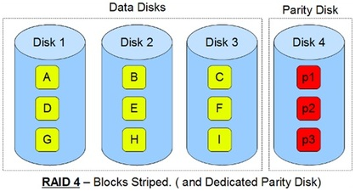
- ~ This uses block level striping.
~ In the above diagram B1, B2, B3 are blocks. p1, p2, p3 are parities.
~ Uses multiple data disks, and a dedicated disk to store parity.
~ Minimum of 3 disks (2 disks for data and 1 for parity)
~ Good random reads, as the data blocks are striped.
~ Bad random writes, as for every write, it has to write to the single parity disk.
~ It is somewhat similar to RAID 3 and 5, but little different.
~ This is just like RAID 3 in having the dedicated parity disk, but this stripes blocks.
~ This is just like RAID 5 in striping the blocks across the data disks, but this has only one parity disk.
~ This is not commonly used.

- RAID 6
- 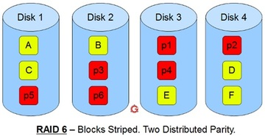
- ~ Just like RAID 5, this does block level striping. However, it uses dual parity.
~ In the above diagram A, B, C are blocks. p1, p2, p3 are parities.
~ This creates two parity blocks for each data block.
~ Can handle two disk failure
~ This RAID configuration is complex to implement in a RAID controller, as it has to
calculate two parity data for each data block.

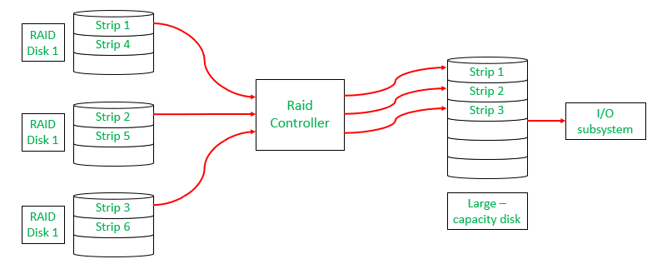
Raid Controller
1. RAID-0 (Stripping)
- Blocks are “stripped” across disks.
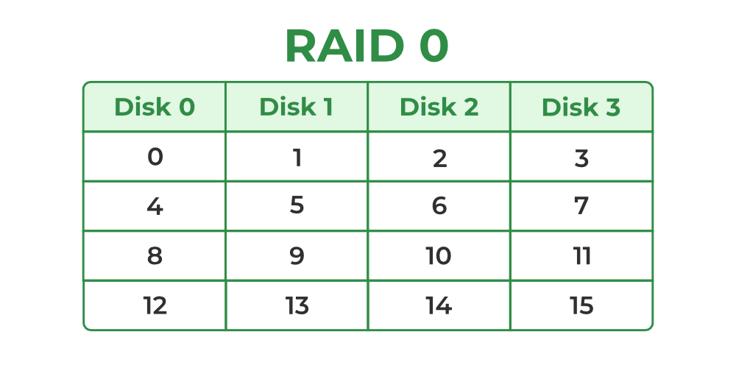
RAID-0
- In the figure, blocks “0,1,2,3” form a stripe.
- Instead of placing just one block into a disk at a time, we can work with two (or more) blocks placed into a disk before moving on to the next one.
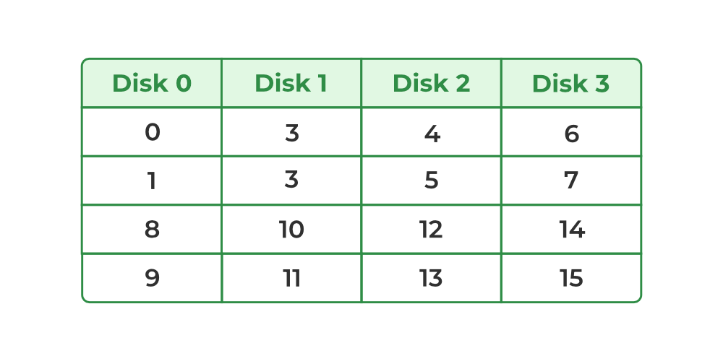
Raid-0
Evaluation
- Reliability: 0
There is no duplication of data. Hence, a block once lost cannot be recovered.
- Capacity: N*B
The entire space is being used to store data. Since there is no duplication, N disks each having B blocks are fully utilized.
Advantages
- It is easy to implement.
- It utilizes the storage capacity in a better way.
Disadvantages
- A single drive loss can result in the complete failure of the system.
- It’s not a good choice for a critical system.
2. RAID-1 (Mirroring)
- More than one copy of each block is stored in a separate disk. Thus, every block has two (or more) copies, lying on different disks.
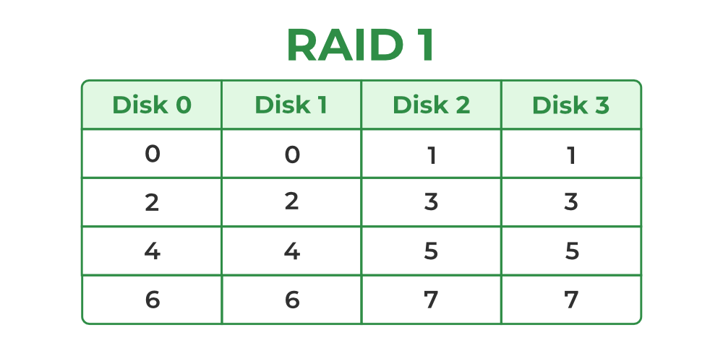
Raid-1
- The above figure shows a RAID-1 system with mirroring level 2.
- RAID 0 was unable to tolerate any disk failure. But RAID 1 is capable of reliability.
Evaluation
Assume a RAID system with mirroring level 2.
- Reliability: 1 to N/2
1 disk failure can be handled for certain because blocks of that disk would have duplicates on some other disk. If we are lucky enough and disks 0 and 2 fail, then again this can be handled as the blocks of these disks have duplicates on disks 1 and 3. So, in the best case, N/2 disk failures can be handled.
- Capacity: N*B/2
Only half the space is being used to store data. The other half is just a mirror of the already stored data.
Advantages
- It covers complete redundancy.
- It can increase data security and speed.
Disadvantages
- It is highly expensive.
- Storage capacity is less.
3. RAID-2 (Bit-Level Stripping with Dedicated Parity)
- In Raid-2, the error of the data is checked at every bit level. Here, we use Hamming Code Parity Method to find the error in the data.
- It uses one designated drive to store parity.
- The structure of Raid-2 is very complex as we use two disks in this technique. One word is used to store bits of each word and another word is used to store error code correction.
- It is not commonly used.
Advantages
- In case of Error Correction, it uses hamming code.
- It Uses one designated drive to store parity.
Disadvantages
- It has a complex structure and high cost due to extra drive.
- It requires an extra drive for error detection.
4. RAID-3 (Byte-Level Stripping with Dedicated Parity)
- It consists of byte-level striping with dedicated parity striping.
- At this level, we store parity information in a disc section and write to a dedicated parity drive.
- Whenever failure of the drive occurs, it helps in accessing the parity drive, through which we can reconstruct the data.
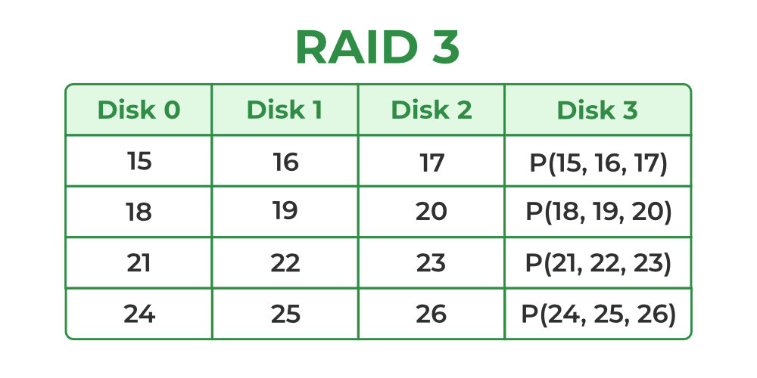
Raid-3
- Here Disk 3 contains the Parity bits for Disk 0, Disk 1, and Disk 2. If data loss occurs, we can construct it with Disk 3.
Advantages
- Data can be transferred in bulk.
- Data can be accessed in parallel.
Disadvantages
- It requires an additional drive for parity.
- In the case of small-size files, it performs slowly.
5. RAID-4 (Block-Level Stripping with Dedicated Parity)
- Instead of duplicating data, this adopts a parity-based approach.
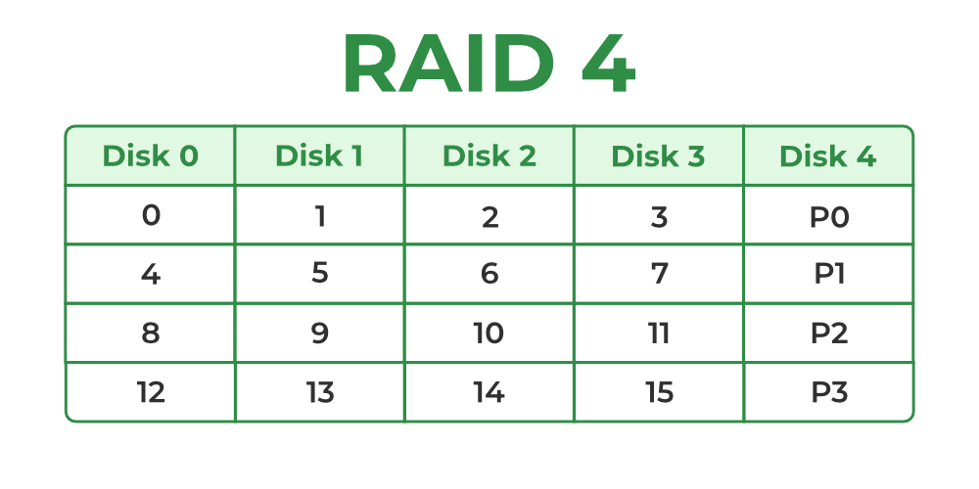
Raid-4
- In the figure, we can observe one column (disk) dedicated to parity.
- Parity is calculated using a simple XOR function. If the data bits are 0,0,0,1 the parity bit is XOR(0,0,0,1) = 1. If the data bits are 0,1,1,0 the parity bit is XOR(0,1,1,0) = 0. A simple approach is that an even number of ones results in parity 0, and an odd number of ones results in parity 1.
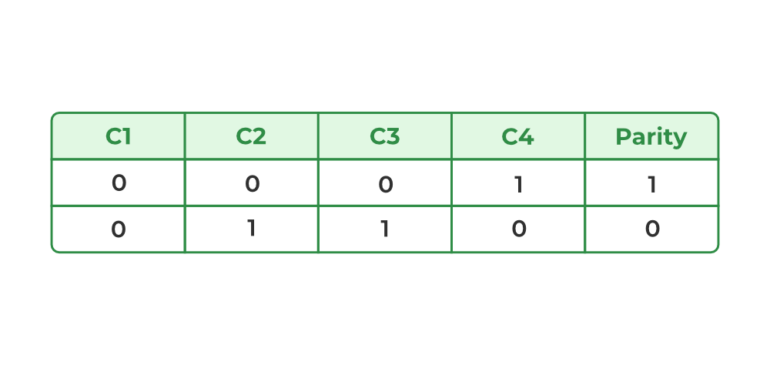
Raid-4
- Assume that in the above figure, C3 is lost due to some disk failure. Then, we can recompute the data bit stored in C3 by looking at the values of all the other columns and the parity bit. This allows us to recover lost data.
Evaluation
- Reliability: 1
RAID-4 allows recovery of at most 1 disk failure (because of the way parity works). If more than one disk fails, there is no way to recover the data.
- Capacity: (N-1)*B
One disk in the system is reserved for storing the parity. Hence, (N-1) disks are made available for data storage, each disk having B blocks.
Advantages
- It helps in reconstructing the data if at most one data is lost.
Disadvantages
- It can’t help reconstructing data when more than one is lost.
6. RAID-5 (Block-Level Stripping with Distributed Parity)
- This is a slight modification of the RAID-4 system where the only difference is that the parity rotates among the drives.
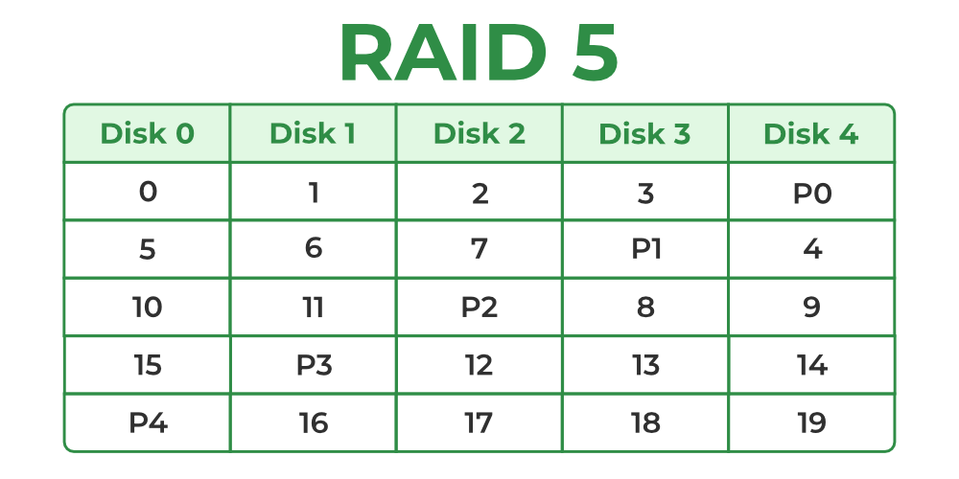
Raid-5
- In the figure, we can notice how the parity bit “rotates”.
- This was introduced to make the random write performance better.
Evaluation
- Reliability: 1
RAID-5 allows recovery of at most 1 disk failure (because of the way parity works). If more than one disk fails, there is no way to recover the data. This is identical to RAID-4.
- Capacity: (N-1)*B
Overall, space equivalent to one disk is utilized in storing the parity. Hence, (N-1) disks are made available for data storage, each disk having B blocks.
Advantages
- Data can be reconstructed using parity bits.
- It makes the performance better.
Disadvantages
- Its technology is complex and extra space is required.
- If both discs get damaged, data will be lost forever.
7. RAID-6 (Block-Level Stripping with two Parity Bits)
- Raid-6 helps when there is more than one disk failure. A pair of independent parities are generated and stored on multiple disks at this level. Ideally, you need four disk drives for this level.
- There are also hybrid RAIDs, which make use of more than one RAID level nested one after the other, to fulfill specific requirements.
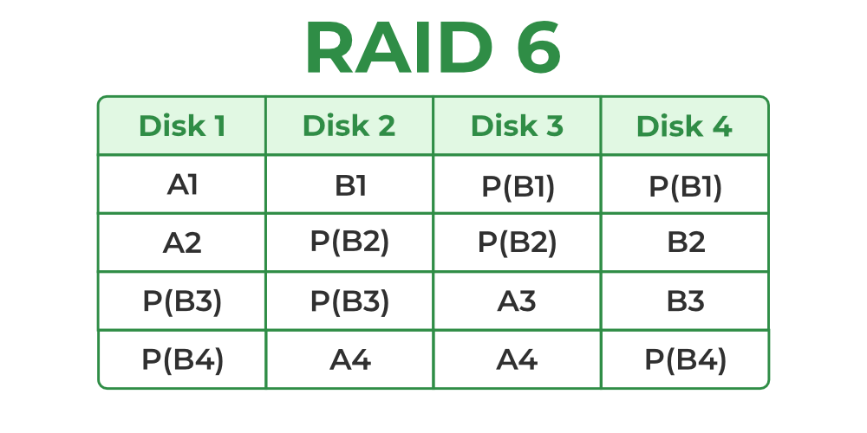
Raid-6
Advantages
- Very high data Accessibility.
- Fast read data transactions.
Disadvantages
- Due to double parity, it has slow write data transactions.
- Extra space is required.
Advantages of RAID
- Data redundancy: By keeping numerous copies of the data on many disks, RAID can shield data from disk failures.
- Performance enhancement: RAID can enhance performance by distributing data over several drives, enabling the simultaneous execution of several read/write operations.
- Scalability: RAID is scalable, therefore by adding more disks to the array, the storage capacity may be expanded.
- Versatility: RAID is applicable to a wide range of devices, such as workstations, servers, and personal PCs
Disadvantages of RAID
- Cost: RAID implementation can be costly, particularly for arrays with large capacities.
- Complexity: The setup and management of RAID might be challenging.
- Decreased performance: The parity calculations necessary for some RAID configurations, including RAID 5 and RAID 6, may result in a decrease in speed.
- Single point of failure: RAID is not a comprehensive backup solution while offering data redundancy. The array’s whole contents could be lost if the RAID controller malfunctions.
Conclusion
In Conclusion, RAID technology in database management systems distributes and replicates data across several drives to improve data performance and reliability. It is a useful tool in contemporary database setups since it is essential to preserving system availability and protecting sensitive data.
Frequently Asked Questions on RAID – FAQs
What is RAID 50?
RAID 50, also called RAID 5+0. RAID 50 combines distributed parity (RAID 5) with striping (RAID 0).
What is the best RAID type?
The best RAID configuration for your system will depend on wether you give importance to speed, data redundancy or both. If you give importance to speed most of all, choose RAID 0.
How to calculate RAID 6?
RAID 6 is calculated by multiplying (N — 2) by the smallest disk size (S).
What are the four types of RAID?
The most common four types of RAID are-
- RAID 0 (striping).
- RAID 1 (mirroring).
- RAID 5 (distributed parity).
- RAID 6 (dual parity).
Refer this https://www.linuxforfreshers.com/p/normal-0-false-false-false-en-us-x-none.html

In infoys asked :

What is RAID Server and Types?

Upvote


4 Answer

Share


AnswerBot
1y

RAID (Redundant Array of Independent Disks) is a data storage technology that combines multiple physical drives into a single logical unit.
- RAID provides improved performance, fault tolerance, and data protection.
- There are several types of RAID configurations, including RAID 0, RAID 1, RAID 5, RAID 10, etc.
- RAID 0 offers improved performance by striping data across multiple drives, but it lacks redundancy.
- RAID 1 mirrors data across multiple drives for redundancy but doesn't provide performance improvement.
- RAID 5 uses block-level striping with distributed parity, offering both performance and fault tolerance.
- RAID 10 combines mirroring and striping, providing both redundancy and performance benefits.


Reply

afzal khan
2y

When it comes to server disk capacity optimization or data security, the sure solution for any organization is RAID.
RAID is an acronym for the term “Redundant Array of Inexpensive (or “Independent”) Disks.” In a RAID set up, the data of an organization is copied into multiple disks, thus creating a fail-proof system where data is better optimized, and data loss is prevented. A RAID system usually involves the use of two or more disks.
BASIC WAYS OF RUNNING RAID
There are basically two ways of running RAID: the software RAID and the hardware RAID.
The hardware RAID works with a special controller. All the disks are connected to this singular controller. The RAID calculations are carried out by an onboard processor, reducing the workload on the CPU of the host system. Today’s CPUs are efficient enough to carry the extra load of the varying disks and eliminating the place of the onboard processor which is now seen by many as an obsolete method.
The software raid, on the other hand, is part and parcel of the server OS. It is cost-effective and easy to implement and maintain. It doesn’t need any additional hardware(s) (which are usually expensive) to run. All modern Unix-like operating systems and Windows operating systems support software RAID.
VARIOUS RAID LEVELS; THEIR ADVANTAGES AND DISADVANTAGES
When it comes to choosing a RAID type, there are many options that you can select from. But how do you know the RAID type that is suitable for you?
Below is a rundown of raid types, their features, requirements, advantages, disadvantages, as well as GTHost special recommendations.
RAID 0
The RAID 0 is also known as disk stripping.
Features
In RAID 0, the data is actually split between two or more disks. Some people do not even consider it as a RAID type. This is because data is not actually stored into all disks but split among the different disks. The resulting consequence is that the work the computer does is handled by multiple disks instead of one.
Requirements
- can run on software or hardware platforms;
- needs at least 2 disks to run;
Advantages
- Speed in performance is the advantage of RAID 0. Read and write actions are performed at a much faster rate. Since multiple disks are responsible for the job of one disk.
- Less space is needed for striping.
Disadvantages
- In striping, the data is not duplicated to multiple discs, but actually stripped or spread across. The consequence of this is that there is little or no fault tolerance. This means that there is a very high possibility of data loss. If anything were to happen to any of the disks, all the data would be lost.
GTHost Recommendation
If your work relies more on performance speed e.g. live streaming, POV, VOD Edge Server, etc., then you should consider using the RAID 0.
RAID 1
RAID 1 is also known as data mirroring
Features
In RAID, the data is duplicated into two or more drives. This mirroring effect makes for safe data storage.
Requirements
- works with hardware or software platforms;
- needs at least two disks in server to run;
Advantages
- In mirroring, there is redundancy. This means that data loss is less likely in this type of RAID, especially since data is duplicated. Hence, the loss of one disk is not a loss of data.
- Read operations can be carried out at a faster speed
Disadvantages
- Writing speed performance is slow.
- For redundancy sake, more space is consumed in keeping similar data.
GTHost Recommendation
If your business is more data reliant, then the RAID 1 is a valid option to hold unto.
RAID 5
This RAID type works through stripping by parity.
Features
This RAID type uses stripping just like RAID 0 but with the added advantage of parity. While data is spread across all disks, a little bit of space (one third) of each disk is used to save parity information: a small amount of data that can be used to describe and recreate a larger amount. So if a disk crashes, it can be replaced easily using the parity information.
This can be done without disrupting the functionality of the server or NAS.
Requirements
- a minimum of three disks are required to run the RAID 5;
Advantages
- Better read and write speed performance.
- Reduced cost for redundancy.
- The server functions even when a disk fails.
- Allows for disk swap in case of a disk crash or failure.
Disadvantages
- Can’t handle more than a single disk failure.
- Lagging performance for servers with a high write operation.
GTHost Recommendations
RAID 5 has performance, speed, and redundancy. This makes it an option for anyone who wants to achieve speed and data security on the go. It would prove very useful for file storage servers and application servers.
RAID 6
RAID 6 is similar to RAID 5 except that the former offers double parity.
Features
The RAID 6 stores an extra parity block that offers more data security and reliability. With this, you can have two disks down and still have your server running.
Requirements
- a minimum of four discs are required to run RAID 6;
Advantages
- Better data security and redundancy. It can work in spite of two disk failures.
- Increase in reading performance.
Disadvantages
- Low performance in servers with a ton of write operations.
GTHost Recommendations
With better performance and security, RAID 6 is a good choice for large file storage servers and application servers.
RAID 10
RAID 10 is the combination of RAIDs 1 and 0(RAID 1+0). The resultant is the hybrid of stripping and mirroring.
Features
This hybrid has the redundancy of RAID 1, and the increased performance of RAID 0, making it a more effective option.
Requirements
- a minimum of four disks are required to run the RAID 10;
- can run on both software and hardware platforms. However, using the software platform may mitigate the benefits of RAID 10.
Advantages
- The optimal performance level guaranteed.
- Great redundancy and fault tolerance.
Disadvantages
- Data mirroring increases the cost of memory.
GTHost Recommendation
With the best of both worlds in security and performance, the RAID 10 is the best pick if you require optimal security and performance.

