1) What is Buffer?
A buffer is a memory area that stores data being transferred between two devices or between a device and an application.
2) What are the benefits of multithreaded programming?
It makes the system more responsive and enables resource sharing. It leads to the use of multiprocess architecture. It is more economical and preferred.
3)What is the time-sharing system?
Time-sharing is a logical extension of multiprogramming. The CPU performs many tasks by switches that are so frequent that the user can interact with each program while it is running. A time-shared operating system allows multiple users to share computers simultaneously.
4) Give some benefits of multithreaded programming?
A thread is also known as a lightweight process. The idea is to achieve parallelism by dividing a process into multiple threads. Threads within the same process run in shared memory space,
5)What is the RR scheduling algorithm?
A round-robin scheduling algorithm is used to schedule the process fairly for each job in a time slot or quantum and interrupting the job if it is not completed by then the job comes after the other job which is arrived in the quantum time makes these scheduling fairly.
- Round-robin is cyclic in nature, so starvation doesn’t occur
- Round-robin is a variant of first-come, first-served scheduling
- No priority or special importance is given to any process or task
- RR scheduling is also known as Time slicing scheduling

6) Enumerate the different RAID levels?
A redundant array of independent disks is a set of several physical disk drives that the operating system sees as a single logical unit. It played a significant role in narrowing the gap between increasingly fast processors and slow disk drives. RAID has different levels:
- Level-0
- Level-1
- Level-2
- Level-3
- Level-4
- Level-5
- Level-6
7) What is Banker’s algorithm?
The banker’s algorithm is a resource allocation and deadlock avoidance algorithm that tests for safety by simulating the allocation for the predetermined maximum possible amounts of all resources, then makes an “s-state” check to test for possible activities, before deciding whether allocation should be allowed to continue.
8) What is spooling?
Spooling refers to simultaneous peripheral operations online, spooling refers to putting jobs in a buffer, a special area in memory, or on a disk where a device can access them when it is ready. Spooling is useful because devices access data at different rates.
9) What are interrupts?
The interrupts are a signal emitted by hardware or software when a process or an event needs immediate attention. It alerts the processor to a high-priority process requiring interruption of the current working process. In I/O devices one of the bus control lines is dedicated to this purpose and is called the Interrupt Service Routine (ISR).
10) What is IPC?
Inter-process communication (IPC) is a mechanism that allows processes to communicate with each other and synchronize their actions. The communication between these processes can be seen as a method of cooperation between them.
11) What is the zombie process?
A process that has finished the execution but still has an entry in the process table to report to its parent process is known as a zombie process. A child process always first becomes a zombie before being removed from the process table. The parent process reads the exit status of the child process which reaps off the child process entry from the process table.
12) What are orphan processes?
A process whose parent process no more exists i.e. either finished or terminated without waiting for its child process to terminate is called an orphan process.

14) What is Context Switching?
Switching of CPU to another process means saving the state of the old process and loading the saved state for the new process. In Context Switching the process is stored in the Process Control Block to serve the new process so that the old process can be resumed from the same part it was left.
15) What is PCB?
the process control block (PCB) is a block that is used to track the process’s execution status. A process control block (PCB) contains information about the process, i.e. registers, quantum, priority, etc. The process table is an array of PCBs, that means logically contains a PCB for all of the current processes in the system.
16) What is Cycle Stealing?
cycle stealing is a method of accessing computer memory (RAM) or bus without interfering with the CPU. It is similar to direct memory access (DMA) for allowing I/O controllers to read or write RAM without CPU intervention.
17) What is a dispatcher?
The dispatcher is the module that gives process control over the CPU after it has been selected by the short-term scheduler. This function involves the following:
- Switching context
- Switching to user mode
- Jumping to the proper location in the user program to restart that program
Operating Systems handle process scheduling, memory allocation, file management, and concurrency control, making these topics central to interviews in both core and system-level roles.
1. What is a process and process table?
A process is an instance of a program in execution. For example, a Web Browser is a process, and a shell (or command prompt) is a process. The operating system is responsible for managing all the processes that are running on a computer and allocates each process a certain amount of time to use the processor. In addition, the operating system also allocates various other resources that processes will need, such as computer memory or disks. To keep track of the state of all the processes, the operating system maintains a table known as the process table. Inside this table, every process is listed along with the resources the process is using and the current state of the process.
Process Table
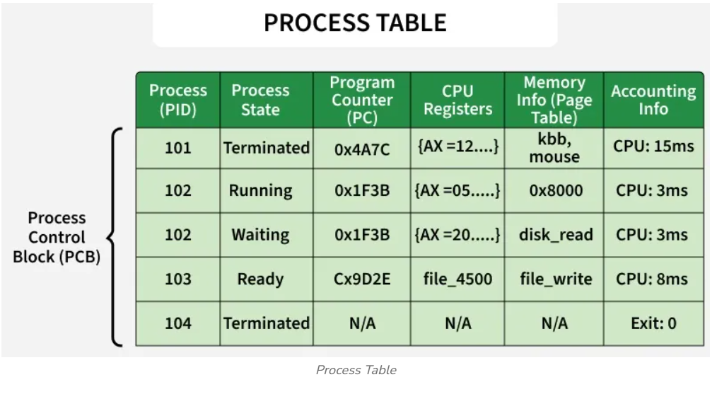
A buffer in an operating system is a temporary, high-speed memory area (usually in RAM) used to hold data while it is being transferred between two devices or a device and an application. It acts as a staging area to bridge speed differences, manage varying data transfer sizes, and optimize input/output (I/O) efficiency.
Naukri.com +2
Key Aspects of Buffering in OS:
- Purpose: Buffers reduce system wait times by allowing data producers and consumers to work at different speeds. For example, they enable a fast CPU to send data to a slow printer without waiting for each page to print.
- Common Use Cases:
Video streaming (pre-loading data for smooth playback), handling input from devices like keyboards/mice, and improving disk I/O performance.
- Types of Buffering Techniques:
  - Single Buffering: One system buffer handles I/O; the system waits while it fills/empties.
  - Double Buffering: Two buffers are used; while one is being filled by an input device, the other is processed by the CPU, allowing parallel operation.
  - Circular Buffering: Multiple buffers arranged in a ring to handle rapid, sustained data bursts.
- Benefits: Buffering significantly improves system performance by reducing the need for constant, slow physical I/O operations and by allowing CPU processing to overlap with I/O transfers.

2. What are the different states of the process?
Processes can be in one of three states: running, ready, or waiting. The running state means that the process has all the resources it needs for execution and it has been given permission by the operating system to use the processor. Only one process can be in the running state at any given time. The remaining processes are either in a waiting state (i.e., waiting for some external event to occur such as user input or disk access) or a ready state (i.e., waiting for permission to use the processor). In a real operating system, the waiting and ready states are implemented as queues that hold the processes in these states.
Different states of a process
For more details you can refer States of a Process in Operating Systems.
3. What is a Thread?
A thread is a single sequence stream within a process. Because threads have some of the properties of processes, they are sometimes called lightweight processes. Threads are a popular way to improve the application through parallelism. For example, in a browser, multiple tabs can be different threads. MS Word uses multiple threads, one thread to format the text, another thread to process inputs, etc.
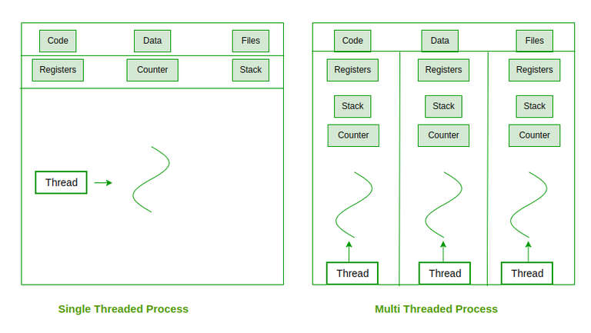Threads
4. What are the differences between process and thread?
Aspect | Process | Thread
Execution Unit | Independent program under execution managed by the OS | Smallest unit of CPU scheduling within a process
Memory Usage | Has its own address space (code, data, stack, heap) | Shares code, data, and heap of the parent process; has its own stack, registers, and program counter.
Communication | Uses Inter-Process Communication (IPC) — slower | Communicates through shared memory faster
Context Switching | Heavy; requires saving/restoring complete process state | Lightweight; only thread-specific registers and stack are switched.
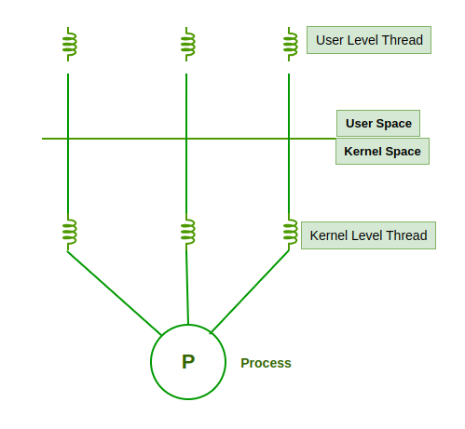
For more details you can refer Difference between Process and Thread published article.
5. What are the benefits of multithreaded programming?
Multithreaded programming makes the system more responsive and enables resource sharing. It leads to the use of multiprocess architecture. It is more economical and preferred.
6. What is Thrashing?
Thrashing is a situation when the performance of a computer degrades or collapses. Thrashing occurs when a system spends more time processing page faults than executing transactions. While processing page faults is necessary in order to appreciate the benefits of virtual memory, thrashing has a negative effect on the system. As the page fault rate increases, more transactions need processing from the paging device. The queue at the paging device increases, resulting in increased service time for a page fault.
Curve of thrashing
7. What is Buffer?
A buffer is a memory area that stores data being transferred between two devices or between a device and an application.
8. What is virtual memory?
Virtual memory creates an illusion that each user has one or more contiguous address spaces, each beginning at address zero. The sizes of such virtual address spaces are generally very high. The idea of virtual memory is to use disk space to extend the RAM. Running processes don't need to care whether the memory is from RAM or disk. The illusion of such a large amount of memory is created by subdividing the virtual memory into smaller pieces, which can be loaded into physical memory whenever they are needed by a process.
Virtual Memory
9. Explain the main purpose of an operating system?
An operating system acts as an intermediary between the user of a computer and computer hardware. The purpose of an operating system is to provide an environment in which a user can execute programs conveniently and efficiently.
An operating system is a software that manages computer hardware. The hardware must provide appropriate mechanisms to ensure the correct operation of the computer system and to prevent user programs from interfering with the proper operation of the system.
10. What is demand paging and how it works?
The process of loading the page into memory on demand (whenever a page fault occurs) is known as demand paging.
Working of Demand paging:
- Process: Only the required memory pages of a process are loaded into RAM when needed, not the entire process.
- Page Table: Keeps track of which pages are in memory and which are on disk.
- Page Fault: Occurs when a referenced page is not in RAM, the OS loads it from secondary storage.
- Loading: The missing page is brought into an empty frame in memory, and the page table is updated.
- Execution Resumes: After the page is loaded, the process continues execution from where it was interrupted.
Working structure of demand paging
11. What is a kernel?
A kernel is the central component of an operating system that manages the operations of computers and hardware. It basically manages operations of memory and CPU time. It is a core component of an operating system. Kernel acts as a bridge between applications and data processing performed at the hardware level using inter-process communication and system calls.
Kernal
12. What are the different scheduling algorithms?
- First-Come, First-Served (FCFS) Scheduling
- Shortest-Job-Next (SJN) Scheduling
- Priority Scheduling
- Shortest Remaining Time
- Round Robin(RR) Scheduling
- Multiple-Level Queues Scheduling
13. Describe the objective of multi-programming?
Multi-programming increases CPU utilization by organizing jobs (code and data) so that the CPU always has one to execute. The main objective of multi-programming is to keep multiple jobs in the main memory. If one job gets occupied with IO, the CPU can be assigned to other jobs.
Multiprogramming
14. What is the time-sharing system?
Time-sharing is a logical extension of multiprogramming. The CPU performs many tasks by switches that are so frequent that the user can interact with each program while it is running. A time-shared operating system allows multiple users to share computers simultaneously.
Time sharing
15. What problem we face in computer system without OS?
- Poor resource management
- Lack of User Interface
- No File System
- No Networking
- Error handling
16. Give some benefits of multithreaded programming?
A thread is also known as a lightweight process. The idea is to achieve parallelism by dividing a process into multiple threads. Threads within the same process run in shared memory space,
17. Briefly explain FCFS?
FCFS stands for First Come First served. In the FCFS scheduling algorithm, the job that arrived first in the ready queue is allocated to the CPU and then the job that came second and so on. FCFS is a non-preemptive scheduling algorithm as a process that holds the CPU until it either terminates or performs I/O. Thus, if a longer job has been assigned to the CPU then many shorter jobs after it will have to wait.
18. What is the RR scheduling algorithm?
A round-robin scheduling algorithm is used to schedule the process fairly for each job in a time slot or quantum and interrupting the job if it is not completed by then the job comes after the other job which is arrived in the quantum time makes these scheduling fairly.
- Round-robin is cyclic in nature, so starvation doesn't occur
- Round-robin is a variant of first-come, first-served scheduling
- No priority or special importance is given to any process or task
- RR scheduling is also known as Time slicing scheduling
19. Enumerate the different RAID levels?
A redundant array of independent disks is a set of several physical disk drives that the operating system sees as a single logical unit. It played a significant role in narrowing the gap between increasingly fast processors and slow disk drives. RAID has different levels:
- Level-0
- Level-1
- Level-2
- Level-3
- Level-4
- Level-5
- Level-6
20. What is Banker's algorithm?
The banker's algorithm is a resource allocation and deadlock avoidance algorithm that tests for safety by simulating the allocation for the predetermined maximum possible amounts of all resources, then makes an "s-state" check to test for possible activities, before deciding whether allocation should be allowed to continue.
21. State the main difference between logical and physical address space?
Parameter | LOGICAL ADDRESS | PHYSICAL ADDRESS
Basic | Logical address is generated by the CPU. | It is located in a memory unit.
Address Space | Logical Address Space is a set of all logical addresses generated by the CPU in reference to a program. | Physical Address is a set of all physical addresses mapped to the corresponding logical addresses.
Visibility | Users can view the logical address of a program. | Users can never view the physical address of the program.
Generation | generated by the CPU. | Computed by MMU.
Access | The user can use the logical address to access the physical address. | The user can indirectly access physical addresses but not directly.
22. How does dynamic loading aid in better memory space utilization?
With dynamic loading, a routine is not loaded until it is called. This method is especially useful when large amounts of code are needed in order to handle infrequently occurring cases such as error routines.
23. What are overlays?
The concept of overlays is that whenever a process is running it will not use the complete program at the same time, it will use only some part of it. Then overlay concept says that whatever part you required, you load it and once the part is done, then you just unload it, which means just pull it back and get the new part you required and run it. Formally, “The process of transferring a block of program code or other data into internal memory, replacing what is already stored”.
24. What is fragmentation?
Processes are stored and removed from memory, which makes free memory space, which is too little to even consider utilizing by different processes. Suppose, that process is not ready to dispense to memory blocks since its little size and memory hinder consistently staying unused is called fragmentation. This kind of issue occurs during a dynamic memory allotment framework when free blocks are small, so it can't satisfy any request.
Internal fragmentation
25. What is the basic function of paging?
Paging divides the memory into the fxex size
Paging is a method or technique which is used for non-contiguous memory allocation. It is a fixed-size partitioning theme (scheme). In paging, both main memory and secondary memory are divided into equal fixed-size partitions. Paging is a memory management technique where secondary memory is divided into pages and main memory into frames. Each process is split into fixed-size pages that are loaded into available frames in main memory. The last page may be smaller than the standard page size. This method enables efficient and flexible use of memory.
26. How does swapping result in better memory management?
Swapping is a simple memory/process management technique used by the operating system(os) to increase the utilization of the processor by moving some blocked processes from the main memory to the secondary memory thus forming a queue of the temporarily suspended processes and the execution continues with the newly arrived process. During regular intervals that are set by the operating system, processes can be copied from the main memory to a backing store and then copied back later. Swapping allows more processes to be run that can fit into memory at one time
Swapping
27. Write a name of classic synchronization problems?
- Bounded-buffer
- Readers-writers
- Dining philosophers
- Sleeping barber
28. What is the Direct Access Method?
The direct Access method is based on a disk model of a file, such that it is viewed as a numbered sequence of blocks or records. It allows arbitrary blocks to be read or written. Direct access is advantageous when accessing large amounts of information. Direct memory access (DMA) is a method that allows an input/output (I/O) device to send or receive data directly to or from the main memory, bypassing the CPU to speed up memory operations. The process is managed by a chip known as a DMA controller (DMAC).
29. When does thrashing occur?
Thrashing occurs when processes on the system frequently access pages, not available memory.
30. What is the best page size when designing an operating system?
The best paging size varies from system to system, so there is no single best when it comes to page size. There are different factors to consider in order to come up with a suitable page size, such as page table, paging time, and its effect on the overall efficiency of the operating system.
31. What is multitasking?
Multitasking is a logical extension of a multiprogramming system that supports multiple programs to run concurrently. In multitasking, more than one task is executed at the same time. In this technique, the multiple tasks, also known as processes, share common processing resources such as a CPU.
Multitasking
32. What is caching?
The cache is a smaller and faster memory that stores copies of the data from frequently used main memory locations. There are various different independent caches in a CPU, which store instructions and data. Cache memory is used to reduce the average time to access data from the Main memory.
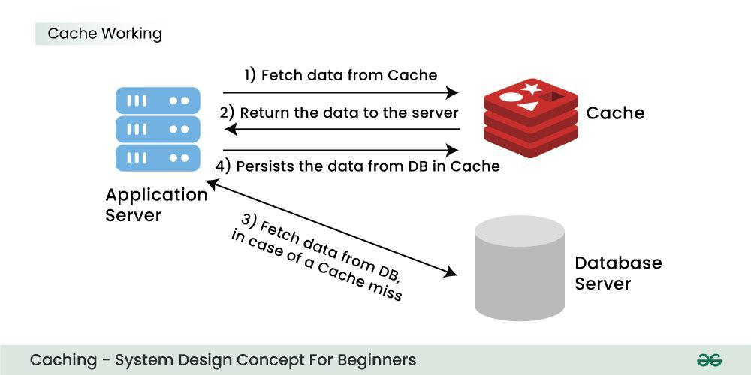Working of Caching
33. What is spooling?
Spooling is a process where data or jobs are temporarily stored in a buffer - usually in memory or on disk - before being sent to a peripheral device. It allows the CPU to continue working while slower devices (like printers or disk drives) access the data at their own pace, ensuring efficient and asynchronous operation between devices with different speeds.
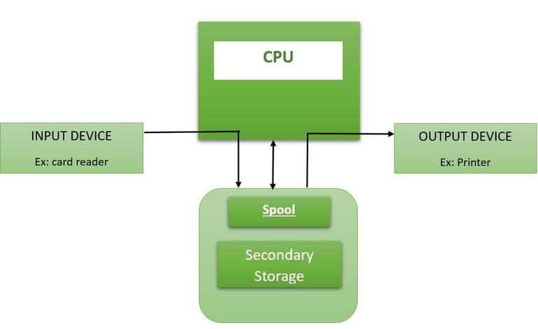Spooling
34. What is the functionality of an Assembler?
The Assembler is used to translate the program written in Assembly language into machine code. The source program is an input of an assembler that contains assembly language instructions. The output generated by the assembler is the object code or machine code understandable by the computer.
35. What are interrupts?
The interrupts are a signal emitted by hardware or software when a process or an event needs immediate attention. It alerts the processor to a high-priority process requiring interruption of the current working process. In I/O devices one of the bus control lines is dedicated to this purpose and is called the Interrupt Service Routine (ISR).
36. What is GUI?
GUI is short for Graphical User Interface. It provides users with an interface wherein actions can be performed by interacting with icons and graphical symbols.
37. What is preemptive multitasking?
Preemptive multitasking is a type of multitasking that allows computer programs to share operating systems (OS) and underlying hardware resources. It divides the overall operating and computing time between processes, and the switching of resources between different processes occurs through predefined criteria.
38. What is a pipe and when is it used?
A Pipe is a technique used for inter-process communication. A pipe is a mechanism by which the output of one process is directed into the input of another process. Thus it provides a one-way flow of data between two related processes.
39. What are the advantages of semaphores?
- They are machine-independent.
- Easy to implement.
- Correctness is easy to determine.
- Can have many different critical sections with different semaphores.
- Semaphores acquire many resources simultaneously.
- No waste of resources due to busy waiting.
40. What is a bootstrap program in the OS?
Bootstrapping is the process of loading a set of instructions when a computer is first turned on or booted. During the startup process, diagnostic tests are performed, such as the power-on self-test (POST), which set or checks configurations for devices and implements routine testing for the connection of peripherals, hardware, and external memory devices. The bootloader or bootstrap program is then loaded to initialize the OS.
41. What is IPC?
Inter-process communication (IPC) is a mechanism that allows processes to communicate with each other and synchronize their actions. The communication between these processes can be seen as a method of cooperation between them.
42. What are the different IPC mechanisms?
These are the methods in IPC:
- Pipes (Same Process): This allows a flow of data in one direction only. Analogous to simplex systems (Keyboard). Data from the output is usually buffered until the input process receives it which must have a common origin.
- Named Pipes (Different Processes): This is a pipe with a specific name it can be used in processes that don’t have a shared common process origin. E.g. FIFO where the details written to a pipe are first named.
- Message Queuing: This allows messages to be passed between processes using either a single queue or several message queues. This is managed by the system kernel these messages are coordinated using an API.
- Semaphores: This is used in solving problems associated with synchronization and avoiding race conditions. These are integer values that are greater than or equal to 0.
- Shared Memory: This allows the interchange of data through a defined area of memory. Semaphore values have to be obtained before data can get access to shared memory.
- Sockets: This method is mostly used to communicate over a network between a client and a server. It allows for a standard connection which is computer and OS independent
43. What is the difference between preemptive and non-preemptive scheduling?
Aspect | Preemptive Scheduling | Non-Preemptive Scheduling
CPU Allocation | CPU is allocated for a limited time. | CPU is allocated until the process terminates or enters waiting state
Interruption | The executing process can be interrupted if a higher-priority process arrives. | The executing process is not interrupted and continues until completion.
Overhead | Has overhead of switching processes and maintaining the ready queue. | No overhead of switching from running to ready state.
Starvation | Low-priority processes may starve if high-priority ones arrive frequent | Processes with small burst times may starve if a long process is executing
Flexibility | More flexible allows critical processes immediate CPU access. | Rigid does not allow interruption for critical processes.
Data Integrity & Cost | Must maintain shared data integrity; higher cost. | Simpler, no extra cost for maintaining data integrity.
44. What is the zombie process?
A process that has finished the execution but still has an entry in the process table to report to its parent process is known as a zombie process. A child process always first becomes a zombie before being removed from the process table. The parent process reads the exit status of the child process which reaps off the child process entry from the process table.
45. What are orphan processes?
A process whose parent process no more exists i.e. either finished or terminated without waiting for its child process to terminate is called an orphan process.
46. What are starvation and aging in OS?
Starvation: Starvation is a resource management problem where a process does not get the resources it needs for a long time because the resources are being allocated to other processes.
Aging: Aging is a technique to avoid starvation in a scheduling system. It works by adding an aging factor to the priority of each request. The aging factor must increase the priority of the request as time passes and must ensure that a request will eventually be the highest priority request
47. Write about monolithic kernel?
A Monolithic Kernel is another classification of Kernel. Like microkernel, this one also manages system resources between application and hardware, but user services and kernel services are implemented under the same address space. It increases the size of the kernel, thus increasing the size of an operating system as well. This kernel provides CPU scheduling, memory management, file management, and other operating system functions through system calls. As both services are implemented under the same address space, this makes operating system execution faster.
48. What is Context Switching?
Switching of CPU to another process means saving the state of the old process and loading the saved state for the new process. In Context Switching the process is stored in the Process Control Block to serve the new process so that the old process can be resumed from the same part it was left.
49. What is the difference between the Operating system and kernel?
Operating System | Kernel
Operating System is system software. | The kernel is a core component of an operating system and serves as the main interface between the computer's physical hardware and the processes running on it.
Operating System provides an interface between the user and the computer hardware. | The kernel provides an interface between the application and hardware.
Its main purpose is memory management, disk management, process management and task management. | It manages the system resources, including processor, memory and device drivers.
Type of operating system includes single and multiuser OS, multiprocessor OS, real-time OS, Distributed OS. | Type of kernel includes Monolithic and Microkernel.
50. What is the difference between process and thread?
Process | Thread
Process means any program is in execution. | Thread means a segment of a process.
The process is less efficient in terms of communication. | Thread is more efficient in terms of communication.
The process is isolated. | Threads share memory.
The process is called heavyweight the process. | Thread is called lightweight process.
Process switching uses, another process interface in operating system. | Thread switching does not require to call an operating system and cause an interrupt to the kernel.
If one process is blocked then it will not affect the execution of other process | The second, thread in the same task could not run, while one server thread is blocked.
The process has its own Process Control Block, Stack and Address Space. | Thread has Parents’ PCB, its own Thread Control Block and Stack and common Address space.
51. What is PCB?
The process control block (PCB) is a block that is used to track the process’s execution status. It contains information about the process, i.e. registers, quantum, priority, etc. The process table is an array of PCBs, that means logically contains a PCB for all of the current processes in the system.
52. When is a system in a safe state?
The set of dispatchable processes is in a safe state if there exists at least one temporal order in which all processes can be run to completion without resulting in a deadlock.
53. What is Cycle Stealing?
Cycle stealing is a method of accessing computer memory (RAM) or bus without interfering with the CPU. It is similar to direct memory access (DMA) for allowing I/O controllers to read or write RAM without CPU intervention.
54. What are a Trap and Trapdoor?
A trap is a software interrupt, usually the result of an error condition, and is also a non-maskable interrupt and has the highest priority Trapdoor is a secret undocumented entry point into a program used to grant access without normal methods of access authentication.
55. Write a difference between program and process?
Program | Process
Program contains a set of instructions designed to complete a specific task. | Process is an instance of an executing program.
Program is a passive entity as it resides in the secondary memory. | Process is an active entity as it is created during execution and loaded into the main memory.
The program exists in a single place and continues to exist until it is deleted. | Process exists for a limited span of time as it gets terminated after the completion of a task.
A program is a static entity. | The process is a dynamic entity.
Program does not have any resource requirement, it only requires memory space for storing the instructions. | Process has a high resource requirement, it needs resources like CPU, memory address, and I/O during its lifetime.
The program does not have any control block. | The process has its own control block called Process Control Block.
56. What is a dispatcher?
The dispatcher is the module that gives process control over the CPU after it has been selected by the short-term scheduler. This function involves the following:
- Switching context
- Switching to user mode
- Jumping to the proper location in the user program to restart that program
57. Define the term dispatch latency?
Dispatch latency can be described as the amount of time it takes for a system to respond to a request for a process to begin operation. With a scheduler written specifically to honor application priorities, real-time applications can be developed with a bounded dispatch latency.
58. What are the goals of CPU scheduling?
- Max CPU utilization [Keep CPU as busy as possible]Fair allocation of CPU.
- Max throughput [Number of processes that complete their execution per time unit]
- Min turnaround time [Time taken by a process to finish execution]
- Min waiting time [Time a process waits in ready queue]
- Min response time [Time when a process produces the first response]
59. What is a critical- section?
When more than one processes access the same code segment that segment is known as the critical section. The critical section contains shared variables or resources which are needed to be synchronized to maintain the consistency of data variables. In simple terms, a critical section is a group of instructions/statements or regions of code that need to be executed atomically such as accessing a resource (file, input or output port, global data, etc.).
60. Write the name of synchronization techniques?
- Mutexes
- Condition variables
- Semaphores
- File locks
Intermediate OS Interview Questions
61. Write a difference between a user-level thread and a kernel-level thread?
User-level thread | Kernel level thread
User threads are implemented by users. | kernel threads are implemented by OS.
OS doesn’t recognize user-level threads. | Kernel threads are recognized by OS.
Implementation of User threads is easy. | Implementation of the perform kernel thread is complicated.
Context switch time is less. | Context switch time is more.
Context switch requires no hardware support. | Hardware support is needed.
If one user-level thread performs a blocking operation then entire process will be blocked. | If one kernel thread perform a the blocking operation then another thread can continue execution.
User-level threads are designed as dependent threads. | Kernel level threads are designed as independent threads.
62. Write down the advantages of multithreading?
- Improved throughput with concurrent computation and I/O operations.
- Efficient use of multiple processors simultaneously.
- Better application responsiveness, i.e., no freezing or blocking during requests.
- Enhanced server performance as slow requests don’t block others.
- Lower system resource usage with lightweight thread management.
- Simplified program structure for complex or multitasking applications.
- Faster and more efficient communication between threads within the same process.
63. Difference between Multithreading and Multitasking?
Multi-threading | Multi-tasking
Multiple threads are executing at the same time at the same or different part of the program. | Several programs are executed concurrently.
CPU switches between multiple threads. | CPU switches between multiple tasks and processes.
It is the process of a lightweight part. | It is a heavyweight process.
It is a feature of the process. | It is a feature of the OS.
Multi-threading is sharing of computing resources among threads of a single process. | Multitasking is sharing of computing resources(CPU, memory, devices, etc.) among processes.
64. What are the drawbacks of semaphores?
- Priority Inversion is a big limitation of semaphores.
- Their use is not enforced but is by convention only.
- The programmer has to keep track of all calls to wait and signal the semaphore.
- With improper use, a process may block indefinitely. Such a situation is called Deadlock.
65. What is Peterson's approach?
It is a concurrent programming algorithm. It is used to synchronize two processes that maintain the mutual exclusion for the shared resource. It uses two variables, a bool array flag of size 2 and an int variable turn to accomplish it.
66. Define the term Bounded waiting?
A system is said to follow bounded waiting conditions if a process wants to enter into a critical section will enter in some finite time.
67. What are the solutions to the critical section problem?
There are three solutions to the critical section problem:
- Software solutions
- Hardware solutions
- Semaphores
68. What is a Banker's algorithm?
The banker’s algorithm is a resource allocation and deadlock avoidance algorithm that tests for safety by simulating the allocation for the predetermined maximum possible amounts of all resources, then makes an "s-state" check to test for possible activities, before deciding whether allocation should be allowed to continue.
69. What is concurrency?
A state in which a process exists simultaneously with another process than those it is said to be concurrent.
70. Write a drawback of concurrency?
- It is required to protect multiple applications from one another.
- It is required to coordinate multiple applications through additional mechanisms.
- Additional performance overheads and complexities in operating systems are required for switching among applications.
- Sometimes running too many applications concurrently leads to severely degraded performance.
71. What are the necessary conditions which can lead to a deadlock in a system?
Mutual Exclusion: There is a resource that cannot be shared.
Hold and Wait: A process is holding at least one resource and waiting for another resource, which is with some other process.
No Preemption: The operating system is not allowed to take a resource back from a process until the process gives it back.
Circular Wait: A set of processes waiting for each other in circular form.
72. What are the issues related to concurrency?
- Non-atomic: Operations that are non-atomic but interruptible by multiple processes can cause problems.
- Race conditions: A race condition occurs of the outcome depends on which of several processes gets to a point first.
- Blocking: Processes can block waiting for resources. A process could be blocked for a long period of time waiting for input from a terminal. If the process is required to periodically update some data, this would be very undesirable.
- Starvation: It occurs when a process does not obtain service to progress.
- Deadlock: It occurs when two processes are blocked and hence neither can proceed to execute
73. Why do we use precedence graphs?
A precedence graph is a directed acyclic graph that is used to show the execution level of several processes in the operating system. It has the following properties also:
- Nodes of graphs correspond to individual statements of program code.
- An edge between two nodes represents the execution order.
- A directed edge from node A to node B shows that statement A executes first and then Statement B executes
74. Explain the resource allocation graph?
The resource allocation graph is explained to us what is the state of the system in terms of processes and resources. One of the advantages of having a diagram is, sometimes it is possible to see a deadlock directly by using RAG.
75. What is a deadlock?
Deadlock is a situation when two or more processes wait for each other to finish and none of them ever finish. Consider an example when two trains are coming toward each other on the same track and there is only one track, none of the trains can move once they are in front of each other. A similar situation occurs in operating systems when there are two or more processes that hold some resources and wait for resources held by other(s).
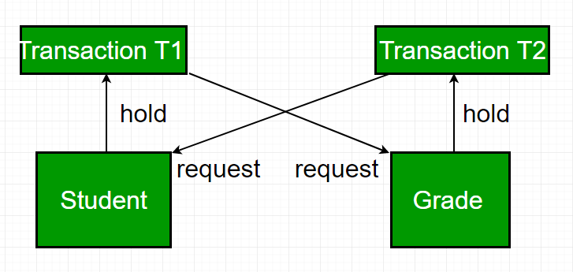Diagram for deadlock
76. What is the goal and functionality of memory management?
The goal and functionality of memory management are as follows;
- Relocation
- Protection
- Sharing
- Logical organization
- Physical organization
77. Write a difference between physical address and logical address?
Parameters | Logical address | Physical Address
Basic | It is the virtual address generated by CPU. | The physical address is a location in a memory unit.
Address | Set of all logical addresses generated by the CPU in reference to a program is referred to as Logical Address Space. | Set of all physical addresses mapped to the corresponding logical addresses is referred to as a Physical Address.
Visibility | The user can view the logical address of a program. | The user can never view the physical address of the program
Access | The user uses the logical address to access the physical address. | The user can not directly access the physical address
Generation | The Logical Address is generated by the CPU | Physical Address is Computed by MMU
78. Explain address binding?
The Association of program instruction and data to the actual physical memory locations is called Address Binding.
79. Write different types of address binding?
Address Binding is divided into three types as follows.
- Compile-time Address Binding
- Load time Address Binding
- Execution time Address Binding
80. Write an advantage of dynamic allocation algorithms?
- When we do not know how much amount of memory would be needed for the program beforehand.
- When we want data structures without any upper limit of memory space.
- When you want to use your memory space more efficiently.
- Dynamically created lists insertions and deletions can be done very easily just by the manipulation of addresses whereas in the case of statically allocated memory insertions and deletions lead to more movements and wastage of memory.
- When you want to use the concept of structures and linked lists in programming, dynamic memory allocation is a must.
81. Write a difference between internal fragmentation and external fragmentation?
Internal fragmentation | External fragmentation
In internal fragmentation fixed-sized memory, blocks square measure appointed to process. | In external fragmentation, variable-sized memory blocks square measure appointed to the method.
Internal fragmentation happens when the method or process is larger than the memory. | External fragmentation happens when the method or process is removed.
The solution to internal fragmentation is the best-fit block. | Solution for external fragmentation is compaction, paging and segmentation.
Internal fragmentation occurs when memory is divided into fixed-sized partitions. | External fragmentation occurs when memory is divided into variable-size partitions based on the size of processes.
The difference between memory allocated and required space or memory is called Internal fragmentation. | The unused spaces formed between non-contiguous memory fragments are too small to serve a new process, which is called External fragmentation.
82. Define the Compaction?
The process of collecting fragments of available memory space into contiguous blocks by moving programs and data in a computer's memory or disk.
83. Write about the advantages and disadvantages of a hashed-page table?
Advantages
- The main advantage is synchronization.
- In many situations, hash tables turn out to be more efficient than search trees or any other table lookup structure. For this reason, they are widely used in many kinds of computer software, particularly for associative arrays, database indexing, caches, and sets.
Disadvantages
- Hash collisions are practically unavoidable. when hashing a random subset of a large set of possible keys.
- Hash tables become quite inefficient when there are many collisions.
- Hash table does not allow null values, like a hash map.
- Define Compaction.
84. Write a difference between paging and segmentation?
Paging | Segmentation
In paging, program is divided into fixed or mounted-size pages. | In segmentation, the program is divided into variable-size sections.
For the paging operating system is accountable. | For segmentation compiler is accountable.
Page size is determined by hardware. | Here, the section size is given by the user.
It is faster in comparison of segmentation. | Segmentation is slow.
Paging could result in internal fragmentation. | Segmentation could result in external fragmentation.
In paging, logical address is split into that page number and page offset. | Here, logical address is split into section number and section offset.
Paging comprises a page table which encloses the base address of every page. | While segmentation also comprises the segment table which encloses the segment number and segment offset.
A page table is employed to keep up the page data. | Section Table maintains the section data.
In paging, operating system must maintain a free frame list. | In segmentation, the operating system maintains a list of holes in the main memory.
Paging is invisible to the user. | Segmentation is visible to the user.
In paging, processor needs page number, offset to calculate the absolute address. | In segmentation, the processor uses segment number, and offset to calculate the full address.
85. Write a definition of Associative Memory and Cache Memory?
Associative Memory | Cache Memory
A memory unit accessed by content is called associative memory. | Fast and small memory is called cache memory.
It reduces the time required to find the item stored in memory. | It reduces the average memory access time.
Here data is accessed by its content. | Here, data are accessed by their address.
It is used where search time is very short. | It is used when a particular group of data is accessed repeatedly.
Its basic characteristic is its logic circuit for matching its content. | Its basic characteristic is its fast access
86. What is "Locality of reference"?
The locality of reference refers to a phenomenon in which a computer program tends to access the same set of memory locations for a particular time period. In other words, Locality of Reference refers to the tendency of the computer program to access instructions whose addresses are near one another.
87. Write down the advantages of virtual memory?
- A higher degree of multiprogramming.
- Allocating memory is easy and cheap
- Eliminates external fragmentation
- Data (page frames) can be scattered all over the PM
- Pages are mapped appropriately anyway
- Large programs can be written, as the virtual space available is huge compared to physical memory.
- Less I/O required leads to faster and easy swapping of processes.
- More physical memory is available, as programs are stored on virtual memory, so they occupy very less space on actual physical memory.
- More efficient swapping
88. How to calculate performance in virtual memory?
The performance of virtual memory of a virtual memory management system depends on the total number of page faults, which depend on "paging policies" and "frame allocation".
Effective access time = (1-p) x Memory access time + p x page fault time
89. Write down the basic concept of the file system?
A file is a collection of related information that is recorded on secondary storage. Or file is a collection of logically related entities. From the user’s perspective, a file is the smallest allotment of logical secondary storage.
90. Write the names of different operations on file?
Operation on file:
- Create
- Open
- Read
- Write
- Rename
- Delete
- Append
- Truncate
- Close
91. Define the term Bit-Vector?
A Bitmap or Bit Vector is a series or collection of bits where each bit corresponds to a disk block. The bit can take two values: 0 and 1: 0 indicates that the block is allocated and 1 indicates a free block.
92. What is a File allocation table?
FAT stands for File Allocation Table and this is called so because it allocates different files and folders using tables. This was originally designed to handle small file systems and disks. A file allocation table (FAT) is a table that an operating system maintains on a hard disk that provides a map of the cluster (the basic units of logical storage on a hard disk) that a file has been stored in.
93. What is rotational latency?
Rotational Latency: Rotational Latency is the time taken by the desired sector of the disgeek to rotate into a position so that it can access the read/write heads. So the disk scheduling algorithm that gives minimum rotational latency is better.
94. What is seek time?
Seek Time: Seek time is the time taken to locate the disk arm to a specified track where the data is to be read or written. So the disk scheduling algorithm that gives a minimum average seek time is better.
Advanced OS Interview Questions
95. What is Belady's Anomaly?
Bélády's anomaly is an anomaly with some page replacement policies increasing the number of page frames resulting in an increase in the number of page faults. It occurs when the First In First Out page replacement is used.
96. What happens if a non-recursive mutex is locked more than once?
Deadlock. If a thread that had already locked a mutex, tries to lock the mutex again, it will enter into the waiting list of that mutex, which results in a deadlock. It is because no other thread can unlock the mutex. An operating system implementer can exercise care in identifying the owner of the mutex and return it if it is already locked by the same thread to prevent deadlocks.
97. What are the advantages of a multiprocessor system?
There are some main advantages of a multiprocessor system:
- Enhanced performance.
- Multiple applications.
- Multi-tasking inside an application.
- High throughput and responsiveness.
- Hardware sharing among CPUs.
98. What are real-time systems?
A real-time system means that the system is subjected to real-time, i.e., the response should be guaranteed within a specified timing constraint or the system should meet the specified deadline.
99. How to recover from a deadlock?
- Process termination: Abort all deadlocked processes or terminate one at a time until the deadlock is resolved.
- Resource preemption: Temporarily take resources from processes and use rollback to restore safe states.
- Selecting a victim: Choose the process for preemption that causes the least overall system cost.
100. What factors determine whether a detection algorithm must be utilized in a deadlock avoidance system?
One is that it depends on how often a deadlock is likely to occur under the implementation of this algorithm. The other has to do with how many processes will be affected by deadlock when this algorithm is applied.
101. Explain the resource allocation graph?
The resource allocation graph is explained to us what is the state of the system in terms of processes and resources. One of the advantages of having a diagram is, sometimes it is possible to see a deadlock directly by using RAG.
Also check:Last Minute Notes – Operating Systems
We will soon be covering more Operating System questions.
Topic-wise Interview Questions:
- Process Management
- Memory Management
- File & I/O Management
- Synchronization & Concurrency
Relevant Resources
To do well in interviews, you need to understand core concepts, memory management, Synchronization, I/O and Disk management.
1. Core Concepts:Kernel, System Call, Process, Threads, CPU Scheduling, Paging, Segmentation, Page Replacement Algorithms, Virtual Memory, Disk Scheduling.
2. Advanced Topics:Inter Process Communication, Process Synchronization, Semaphores, IPC Problems, Deadlock, Multithreading, File systems.
Comment

K

kartik
436
Article Tags:
Operating Systems
Interview-Questions
Fresher JobsExperienced Jobs


ServiceNow Interns
ITnow Inc
Internship • Remote -
Apply by Fri Apr 10 2026


Associate - Video & Data Annotation
Awign
Fresher • Onsite - Bengaluru (Karnataka)
Apply by Fri Apr 10 2026


Software Engineer Intern/Software Engineer in Test Intern
SimStar
Internship + PPO • Onsite - Bengaluru (Karnataka)
Apply by Mon Apr 13 2026

View All
→

Upcoming Courses

GATE CSIT 2027 ( Live + Placement ) Batch A
Starting from - January 26, 2026
• LIVE

4.6

GATE DA 2027 ( Live + Placement ) Batch A
Starting from - January 26, 2026
• LIVE

4.6

GATE CSIT + DA Combo 2027 ( Live + Placement ) Batch A
Starting from - January 26, 2026
• LIVE

4.6
View All
→

Trending Posts


Gulfam Siddique
The CSS is in charge. You're just there to watch. 😭 Tag a web dev who knows this pain 👇 #TechMemeChallenge #GFGConnect #CodingLife #WebDev #CSS #ProgrammerHumor


GOURAV PANDEY
Day - 8 - Hashing (Fast search shortcut) Kabhi notice kiya? Tum baar baar same cheez dhoond rahe ho Aur har baar pura data scan karna padta hai That’s where Has


Kapurapu Yaswanth Reddy
The GfG Snippet Experience: A Two-Act Play 🎭 Act 1: The architecture that holds everything together. Act 2: Why we keep coming back, even when we have the 'offi


Tanmay Singh
🚀 Exploring the Game-Changing Features of Java 8 Released in March 2014, Java 8 marked a major shift in how developers write cleaner, more efficient, and scalab


Nirmal Sharma
Hi Yogini Horake , Hope you are doing well. I noticed you tried to connect with me while I was offline. I am online now and available to connect. Please feel fr

View All
→



Corporate & Communications Address:
A-143, 7th Floor, Sovereign Corporate Tower, Sector- 136, Noida, Uttar Pradesh (201305)

Registered Address:
K 061, Tower K, Gulshan Vivante Apartment, Sector 137, Noida, Gautam Buddh Nagar, Uttar Pradesh, 201305

- Company
- About Us
- Legal
- Privacy Policy
- Careers
- Contact Us
- Corporate Solution
- Campus Training Program
- Explore
- POTD
- Practice Problems
- Connect
- Blogs
- Upskill Courses
- Tutorials
- Programming Languages
- DSA
- Web Technology
- AI, ML & Data Science
- DevOps
- CS Core Subjects
- GATE
- School Subjects
- Software and Tools
- Courses
- ML and Data Science
- DSA and Placements
- Web Development
- Data Science
- Programming Languages
- DevOps & Cloud
- GATE
- Trending Technologies
- Offline Centers
- Noida
- Bengaluru
- Hyderabad
- Kolkata
- Preparation Corner
- Interview Corner
- Aptitude
- Puzzles
- GfG 160
- System Design
@GeeksforGeeks, Sanchhaya Education Private Limited, All rights r

18) What is Peterson’s approach?
It is a concurrent programming algorithm. It is used to synchronize two processes that maintain the mutual exclusion for the shared resource. It uses two variables, a bool array flag of size 2 and an int variable turn to accomplish it.
19) Define the term Bounded waiting?
A system is said to follow bounded waiting conditions if a process wants to enter into a critical section will enter in some finite time

20) What is a deadlock?
Deadlock is a situation when two or more processes wait for each other to finish and none of them ever finish. Consider an example when two trains are coming toward each other on the same track and there is only one track, none of the trains can move once they are in front of each other. A similar situation occurs in operating systems when there are two or more processes that hold some resources and wait for resources held by other(s).
Advance OS concepts
21) How to recover from a deadlock?
We can recover from a deadlock by following methods:
- Process termination
  - Abort all the deadlock processes
  - Abort one process at a time until the deadlock is eliminated
- Resource preemption
  - Rollback
  - Selecting a victim
22) What is Belady’s Anomaly?
Bélády’s anomaly is an anomaly with some page replacement policies increasing the number of page frames resulting in an increase in the number of page faults. It occurs when the First In First Out page replacement is used.

23) What happens if a non-recursive mutex is locked more than once?
Deadlock. If a thread that had already locked a mutex, tries to lock the mutex again, it will enter into the waiting list of that mutex, which results in a deadlock. It is because no other thread can unlock the mutex. An operating system implementer can exercise care in identifying the owner of the mutex and return it if it is already locked by the same thread to prevent deadlocks.

24) What factors determine whether a detection algorithm must be utilized in a deadlock avoidance system?
One is that it depends on how often a deadlock is likely to occur under the implementation of this algorithm. The other has to do with how many processes will be affected by deadlock when this algorithm is applied.
Got it—let’s build a clear conceptual foundation first. I’ll explain RAID, Storage, and DMA in a way that makes scenario questions easy to solve.

🧠 1. RAID (Redundant Array of Independent Disks)
🔹 What is RAID?
RAID is a technique to combine multiple physical disks into one logical unit to improve:
- Performance 🚀
- Reliability 🛡️
- Or both

🔹 Core Concepts
1. Striping (Performance)
- Data is split into chunks and spread across disks
- Example: File → split → Disk 1 + Disk 2
👉 Result: Parallel access → faster reads/writes

2. Mirroring (Reliability)
- Same data written to multiple disks
👉 If one disk fails → data still available

3. Parity (Fault Tolerance)
- Extra data stored to reconstruct lost data
- Uses XOR logic
👉 Enables recovery without full duplication

🔹 RAID Levels (Most Important)
🔸 RAID 0 (Striping only)
- ✅ Very fast
- ❌ No fault tolerance
👉 Use case: Temporary data

🔸 RAID 1 (Mirroring)
- ✅ High reliability
- ❌ Storage cost doubles

🔸 RAID 5 (Striping + Parity)
- ✅ Good performance + fault tolerance
- ❌ Slower writes (parity calculation)
- Tolerates: 1 disk failure

🔸 RAID 6
- Like RAID 5 but:
- Tolerates: 2 disk failures

🔸 RAID 10 (1+0)
- Combines mirroring + striping
- ✅ Fast + reliable
- ❌ Expensive

🔹 Key Trade-offs
RAID | Speed | Reliability | Cost
0 | High | None | Low
1 | Medium | High | High
5 | High Read | Medium | Medium
10 | Very High | Very High | Very High

💾 2. Storage Concepts
🔹 HDD vs SSD
HDD (Hard Disk Drive)
- Mechanical (spinning disk)
- Has:
  - Seek time
  - Rotational latency
👉 Slower

SSD (Solid State Drive)
- No moving parts
- Uses flash memory
👉 Faster, no seek delay

🔹 Disk Access Time
Total time =
- Seek time (move head)
- Rotational latency
- Transfer time
👉 Important for performance tuning

🔹 Disk Scheduling Algorithms
These decide which request to serve next.
1. FCFS (First Come First Serve)
- Simple
- ❌ Poor performance

2. SSTF (Shortest Seek Time First)
- Picks nearest request
- ✅ Faster
- ❌ Can starve far requests

3. SCAN (Elevator Algorithm)
- Moves like an elevator
- Services requests in one direction
👉 Balanced performance

4. C-SCAN
- Only services in one direction
- Jump back to start
👉 More uniform wait time

🔹 Fragmentation
Internal Fragmentation
- Wasted space inside blocks
External Fragmentation
- Free space scattered
👉 Causes slower file access

🔹 File System Basics
Metadata
- Stores file info (name, location, size)

File Deletion
- Only metadata removed
- Data still exists until overwritten

Journaling
- Logs operations before execution
👉 Helps recovery after crash

⚡ 3. DMA (Direct Memory Access)
🔹 What is DMA?
DMA allows devices (disk, network card) to transfer data directly to/from memory without CPU involvement

🔹 Without DMA (Programmed I/O)
Flow:
- CPU reads from device
- CPU writes to memory
- Repeats for every byte
👉 CPU becomes bottleneck 😓

🔹 With DMA
Flow:
- CPU gives instruction to DMA controller
- DMA transfers entire block
- Interrupt sent when done
👉 CPU is free for other tasks 🚀

🔹 DMA Components
- DMA Controller
- System Bus
- Memory

🔹 Types of DMA
1. Burst Mode
- Transfers all data at once
- CPU paused

2. Cycle Stealing
- DMA takes bus intermittently

3. Transparent Mode
- Uses bus only when CPU idle

🔹 Key Benefits
- Reduces CPU load
- Improves throughput
- Efficient for large transfers

🔹 Challenges
Cache Coherency Problem
- CPU cache may have old data
- DMA updates memory directly
👉 Needs synchronization

🔗 How All Three Connect
- RAID → improves storage reliability/performance
- Storage algorithms → optimize access speed
- DMA → speeds up data transfer
👉 Together they define I/O system performance

🧩 Simple Analogy
- RAID = multiple workers handling files
- Disk scheduling = deciding which task first
- DMA = worker directly delivering files without manager (CPU)

If you want next:
👉 I can now give scenario questions with full answers step-by-step (very useful for interviews)
Here are OS scenario-based interview questions focused on RAID, Storage, and DMA, along with what the interviewer is really testing and hints to approach them.

🧠 RAID (Redundant Array of Independent Disks)
1. Scenario: Disk Failure in Production
Your system uses RAID 5. One disk fails, but the system is still running. Suddenly, another disk fails during rebuild. What happens?
What they’re testing:
- Understanding of fault tolerance
Key Insight:
- RAID 5 tolerates only one disk failure
- Second failure → data loss

2. Scenario: Performance Issue
A database server using RAID 1 is facing slow write performance. Why?
What they’re testing:
- RAID trade-offs
Key Insight:
- Writes must happen on both disks → write latency increases

3. Scenario: Choosing RAID Level
You’re designing storage for a video streaming service with high read and moderate write. Which RAID level would you pick?
Expected Answer Direction:
- RAID 5 or RAID 6 → good read performance + redundancy
- RAID 10 → if performance is critical

4. Scenario: Rebuild Impact
Why does RAID rebuild significantly degrade system performance?
Concepts:
- Disk I/O contention
- Parity recalculation (RAID 5/6)

5. Scenario: RAID 0 Usage
A team proposes RAID 0 for a financial transaction system. Do you agree?
Expected Thought:
- RAID 0 = no redundancy → high risk
- Not suitable for critical data

💾 Storage (Disk Scheduling, File Systems, etc.)
6. Scenario: Disk Scheduling Optimization
Your system is experiencing high seek times. Which disk scheduling algorithm would you use?
Concepts:
- SSTF (Shortest Seek Time First)
- SCAN / C-SCAN
Follow-up:
- SSTF → can cause starvation
- SCAN → more balanced

7. Scenario: Fragmentation Issue
A system’s performance degrades over time due to file fragmentation. Why?
Key Idea:
- Increased seek time due to scattered blocks

8. Scenario: SSD vs HDD
Why is disk scheduling less important in SSDs compared to HDDs?
Answer Insight:
- SSD has no seek time
- Access time is nearly uniform

9. Scenario: File Deletion
When a file is deleted, is the data actually removed?
Expected Answer:
- No → metadata removed, data still exists until overwritten

10. Scenario: Journaling File System
After a crash, your system recovers quickly. Why?
Concept:
- Journaling logs changes → faster recovery

⚡ DMA (Direct Memory Access)
11. Scenario: CPU Bottleneck
Your system CPU usage is very high during heavy I/O operations. What could improve this?
Expected Answer:
- Use DMA → offloads CPU

12. Scenario: Data Transfer
Without DMA, how does data transfer happen between disk and memory?
Answer:
- CPU handles all transfers → inefficient

13. Scenario: Interrupt Overhead
Why does DMA reduce interrupt overhead?
Concept:
- DMA sends one interrupt after block transfer, not per byte

14. Scenario: Real-time System
In a real-time system, why is DMA preferred?
Answer Insight:
- Frees CPU for critical tasks
- Ensures predictable performance

15. Scenario: Cache Coherency Issue
DMA writes data to memory, but CPU reads stale data. Why?
Concept:
- Cache coherence problem
- CPU cache not updated

🔥 Mixed Scenario Questions (High-Level Thinking)
16. Scenario: High Throughput System
You need to design a system for high-speed data ingestion (e.g., logs). What combination would you choose?
Good Answer Mix:
- RAID 10 (performance + redundancy)
- DMA (efficient transfer)
- SSD storage

17. Scenario: System Crash During Write
What happens if a system crashes while writing data in RAID 5?
Concept:
- Parity inconsistency → possible data corruption

18. Scenario: Large File Transfer
Why is DMA better than programmed I/O for large file transfers?
Key Point:
- Bulk transfer without CPU involvement

19. Scenario: Multi-user Storage System
How do you ensure both performance and reliability?
Expected Concepts:
- RAID levels
- Caching
- Scheduling algorithms

20. Scenario: Debugging Slow I/O
Your system has slow disk I/O. How would you debug it?
Approach:
- Check:
  - Disk utilization
  - RAID level
  - Fragmentation
  - Scheduling algorithm
  - DMA usage

💡 Pro Tip for Interviews
When answering scenario questions:
- State assumptions
- Explain trade-offs
- Mention alternatives
- Conclude with best choice

If you want, I can:
- Turn these into mock interview Q&A with ideal answers
- Give MCQs for practice
- Or create a cheat sheet for quick revision

