WEEK 1 TASK
DATA CLEANING AND PRELIMINARY ANALYSIS WITH R
UCI Adult (Census Income) Dataset
Student Name: ______________________________
Course: B.Sc. Information Technology
Week: 1
Date: August 2026

1. Introduction
This project demonstrates a complete introductory data-cleaning and preliminary exploratory analysis workflow in R. The UCI Adult dataset, also called the Census Income dataset, was selected because it contains both numerical/integer and categorical variables and documented missing values. The prediction target is whether a person's annual income exceeds $50,000. The dataset contains 48,842 instances and 14 features and is publicly available through the UCI Machine Learning Repository. These characteristics make it suitable for practicing missing-value treatment, outlier detection, normalization, categorical encoding, descriptive statistics, correlation analysis, and visualization.
Source: UCI Machine Learning Repository – Census Income (Adult) dataset. The repository reports 48,842 instances, 14 features, mixed categorical/integer data types, and missing values.

2. Dataset Overview
Variable | Type | Example values | Role
age | Numerical | 17–90 | Predictor
workclass | Categorical | Private, Local-gov, Self-emp | Predictor
fnlwgt | Numerical | Census final weight | Predictor
education | Categorical | Bachelors, HS-grad, Masters | Predictor
education_num | Numerical | 1–16 | Predictor
marital_status | Categorical | Married, Divorced, Never-married | Predictor
occupation | Categorical | Tech-support, Sales, Craft-repair | Predictor
relationship | Categorical | Husband, Wife, Own-child | Predictor
race | Categorical | White, Black, Asian-Pac-Islander | Predictor
sex | Categorical | Female, Male | Predictor
capital_gain/loss | Numerical | 0 and positive values | Predictor
hours_per_week | Numerical | 1–99 | Predictor
native_country | Categorical | United-States, India, Mexico | Predictor
income | Categorical | <=50K, >50K | Target

3. Dataset Selection and Import in R
The dataset was selected from the UCI Machine Learning Repository because it satisfies the assignment requirements for mixed data types and missing values.
# Install packages once if required
install.packages(c("tidyverse", "caret"))
library(tidyverse)
library(caret)
# Download the UCI Adult data file
url <- "https://archive.ics.uci.edu/ml/machine-learning-databases/adult/adult.data"
adult <- read.csv(url, header = FALSE, strip.white = TRUE,
na.strings = "?")
# Assign column names
names(adult) <- c("age","workclass","fnlwgt","education",
"education_num","marital_status","occupation",
"relationship","race","sex","capital_gain",
"capital_loss","hours_per_week",
"native_country","income")
str(adult)
summary(adult)

4. Initial Data Inspection
The first inspection uses str(), summary(), head(), and dimension checks. These functions help identify variable types, ranges, unusual values, and the overall size of the dataset.
# Basic inspection
dim(adult)
head(adult)
str(adult)
summary(adult)
# Count missing values in each column
missing_count <- sapply(adult, function(x) sum(is.na(x)))
missing_count

5. Missing Value Handling
Missing values are represented by '?' in the original Adult data and are converted to NA during import. The UCI documentation identifies missing values in categorical fields such as workclass and related variables. For this preliminary analysis, numerical missing values are replaced with the median and categorical missing values with the mode. This approach retains observations while reducing the influence of extreme values on numerical summaries.
# Separate numerical and categorical variables
num_cols <- c("age","fnlwgt","education_num",
"capital_gain","capital_loss","hours_per_week")
cat_cols <- c("workclass","education","marital_status",
"occupation","relationship","race","sex",
"native_country","income")
# Median imputation for numerical columns
for (col in num_cols) {
adult[[col]][is.na(adult[[col]])] <- median(adult[[col]], na.rm = TRUE)
}
# Mode imputation for categorical columns
get_mode <- function(x) {
ux <- unique(x[!is.na(x)])
ux[which.max(tabulate(match(x, ux)))]
}
for (col in cat_cols) {
adult[[col]][is.na(adult[[col]])] <- get_mode(adult[[col]])
}
# Verify
colSums(is.na(adult))
Expected verification: all selected missing values are handled and the final NA count can be checked with colSums(is.na(adult)).

6. Outlier Detection
Outliers were examined using the Interquartile Range (IQR) method and boxplots. For each numerical variable, values below Q1 − 1.5×IQR or above Q3 + 1.5×IQR are flagged. Outliers are not automatically deleted because extreme census values can be genuine observations. Instead, they are documented and retained unless they are clearly invalid.
# IQR-based outlier detection
find_outliers <- function(x) {
Q1 <- quantile(x, 0.25, na.rm = TRUE)
Q3 <- quantile(x, 0.75, na.rm = TRUE)
IQR_value <- IQR(x, na.rm = TRUE)
lower <- Q1 - 1.5 * IQR_value
upper <- Q3 + 1.5 * IQR_value
x < lower | x > upper
}
outlier_age <- find_outliers(adult$age)
outlier_hours <- find_outliers(adult$hours_per_week)
sum(outlier_age)
sum(outlier_hours)
boxplot(adult$hours_per_week,
main = "Hours Worked Per Week",
ylab = "Hours")
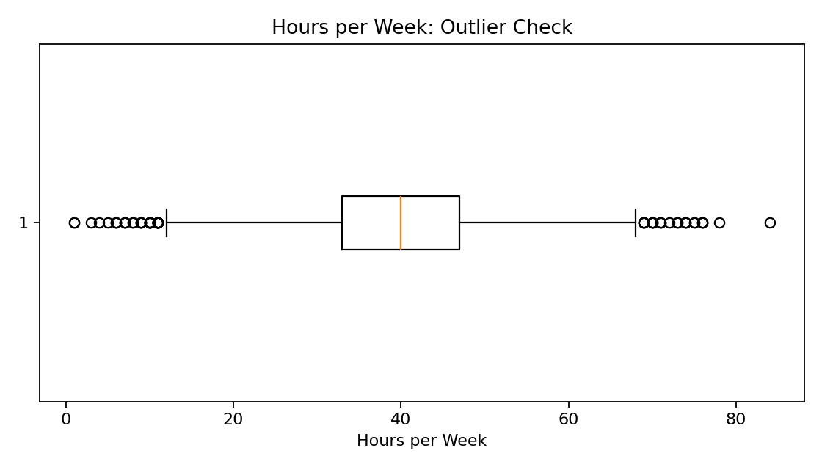
Figure 1. Boxplot used to inspect potential outliers in weekly working hours.

7. Normalization
Min-max normalization transforms a numerical variable to a 0–1 range. It is useful when variables have very different scales and are later used in distance-based or machine-learning methods.
# Min-max normalization
min_max <- function(x) {
(x - min(x, na.rm = TRUE)) /
(max(x, na.rm = TRUE) - min(x, na.rm = TRUE))
}
adult$age_norm <- min_max(adult$age)
adult$hours_norm <- min_max(adult$hours_per_week)
summary(adult[, c("age_norm", "hours_norm")])

8. Categorical Encoding
Categorical variables cannot always be used directly by statistical and machine-learning algorithms. One-hot/dummy encoding converts categories into binary indicator columns. In R, model.matrix() is a convenient way to create dummy variables.
# Convert selected categorical variables to factors
adult$sex <- as.factor(adult$sex)
adult$workclass <- as.factor(adult$workclass)
adult$income <- as.factor(adult$income)
# One-hot/dummy encoding
encoded_data <- model.matrix(~ sex + workclass - 1, data = adult)
head(encoded_data)

9. Exploratory Data Analysis
The exploratory stage summarizes distributions, category frequencies, relationships, and correlations before predictive modelling.

9.1 Descriptive Statistics
summary(adult[, c("age", "education_num",
"capital_gain", "capital_loss",
"hours_per_week")])
mean(adult$age)
median(adult$age)
sd(adult$age)
table(adult$income)
prop.table(table(adult$income))

9.2 Age Distribution
hist(adult$age,
breaks = 30,
main = "Age Distribution",
xlab = "Age",
col = "lightblue")
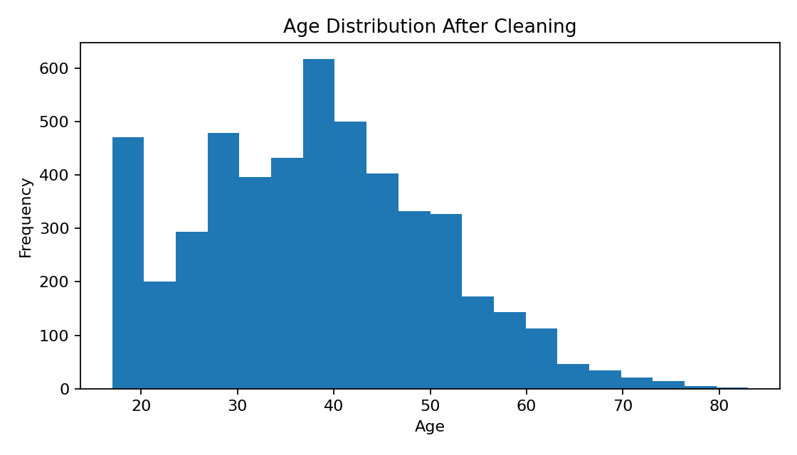
Figure 2. Age distribution after preprocessing.

9.3 Income by Sex
ggplot(adult, aes(x = sex, fill = income)) +
geom_bar(position = "fill") +
labs(title = "Income Category by Sex",
x = "Sex", y = "Proportion") +
theme_minimal()
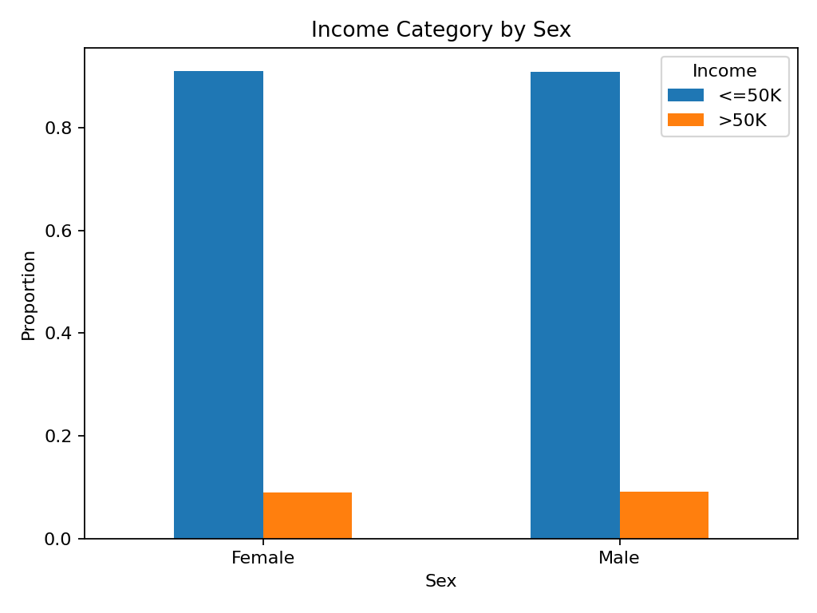
Figure 3. Proportion of income categories across sex groups.

9.4 Correlation Analysis
Pearson correlation was calculated among selected numerical variables. Correlation values close to +1 or −1 indicate stronger linear association, while values near 0 indicate weak linear association.
numeric_data <- adult[, c("age", "education_num",
"capital_gain", "capital_loss",
"hours_per_week")]
correlation_matrix <- cor(numeric_data,
use = "complete.obs")
round(correlation_matrix, 2)
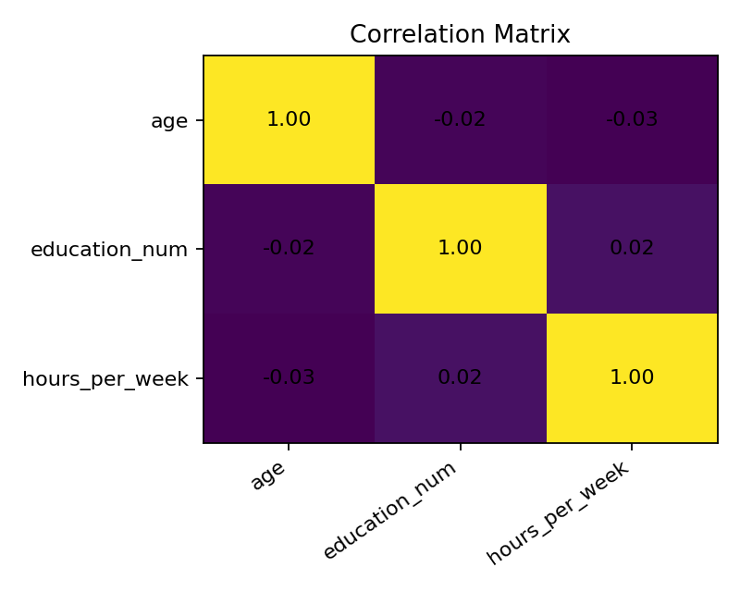
Figure 4. Correlation matrix for selected numerical variables.

10. Preliminary Results and Initial Insights
• The Adult dataset contains a mixture of demographic, educational, employment, and financial variables, making it suitable for mixed-type data analysis.
• Missing values are concentrated in categorical fields such as workclass, occupation, and native country; categorical imputation is therefore appropriate for this preliminary workflow.
• Age and hours worked per week show potentially extreme observations. The IQR method provides an objective way to flag them without automatically removing genuine records.
• Normalization places numerical variables on a common 0–1 scale, which is useful for algorithms sensitive to feature scale.
• Education level, age, working hours, occupation, and employment-related variables can be investigated further for their association with the income category.
• The income target is not evenly distributed; therefore, class proportions should be considered before any future predictive modelling.

11. Reproducible Cleaning Pipeline
# Complete workflow
adult <- read.csv(url, header = FALSE, strip.white = TRUE,
na.strings = "?")
names(adult) <- c("age","workclass","fnlwgt","education",
"education_num","marital_status","occupation",
"relationship","race","sex","capital_gain",
"capital_loss","hours_per_week",
"native_country","income")
# Inspect
str(adult)
summary(adult)
colSums(is.na(adult))
# Impute missing values
for (col in num_cols) {
adult[[col]][is.na(adult[[col]])] <- median(adult[[col]], na.rm = TRUE)
}
for (col in cat_cols) {
adult[[col]][is.na(adult[[col]])] <- get_mode(adult[[col]])
}
# Normalize
adult$age_norm <- min_max(adult$age)
adult$hours_norm <- min_max(adult$hours_per_week)
# Encode categorical variables
encoded_data <- model.matrix(~ sex + workclass - 1, data = adult)
# Final inspection
str(adult)
summary(adult)
colSums(is.na(adult))

12. Conclusion
This Week 1 project completed the main stages of data cleaning and preliminary analysis in R. The UCI Adult dataset was inspected, missing values were identified and handled, numerical outliers were examined using the IQR method, selected numerical variables were normalized, and categorical variables were encoded. Exploratory analysis using summary statistics, distributions, boxplots, bar charts, and correlation analysis provided an initial understanding of the data. The cleaned dataset is now better prepared for later statistical modelling or machine-learning tasks.

13. Dataset Reference
Kohavi, R. & Becker, B. Adult / Census Income Dataset. UCI Machine Learning Repository. Dataset DOI: 10.24432/C5XW20. Source: UCI Machine Learning Repository.
The official UCI repository reports 48,842 instances, 14 features, mixed categorical/integer data types, and missing values.

