WEEK 4 FINAL REPORT
COMPREHENSIVE DATA ANALYSIS, REPORTING AND PRESENTATION
YuvaIntern – Internship Project
Using R for Data Cleaning, Visualization, Statistical Analysis and Predictive Modeling
S.Janani Ishwarya
Internship: YuvaIntern

Executive Summary
This final report consolidates the three earlier R-based internship tasks into one structured account of the data-analysis workflow. Week 1 focused on data cleaning and preliminary analysis using the UCI Adult (Census Income) dataset. Week 2 focused on visualization and communication using the built-in mtcars dataset. Week 3 extended the workflow to statistical analysis and predictive modeling using the Boston housing dataset.
Across the three tasks, the work covered dataset inspection, missing-value treatment, outlier detection, normalization, categorical encoding, descriptive statistics, correlation analysis, visualization, hypothesis testing, train/test partitioning, 10-fold cross-validation, multiple linear regression, model diagnostics, and test-set evaluation. R and relevant packages such as tidyverse, ggplot2, caret, MASS, car, lmtest and corrplot were used in the source work.
An important feature of this integrated report is that the three weeks used different datasets. Therefore, the report integrates the analytical process and skills rather than presenting the three datasets as one combined dataset. This preserves the structure and findings of the original work while showing how the analysis progressed from preparation and visualization to formal statistical testing and predictive modeling.

Table of Contents
1. Introduction
2. Methodology and Overall Workflow
3. Week 1 – Data Preparation and Preliminary Analysis
4. Week 2 – Data Visualization and Insight Communication
5. Week 3 – Statistical Analysis and Predictive Modeling
6. Integrated Results and Discussion
7. Challenges and Lessons Learned
8. Recommendations and Future Directions
9. Conclusion
10. References
Appendix A – Selected R Code

1. Introduction
Data analysis is a structured process of converting raw information into useful evidence for understanding patterns, testing relationships and supporting decisions. The Week 4 task requires the previous three weeks of work to be consolidated into a cohesive report. The resulting workflow moves from data preparation, through visualization and statistical analysis, to predictive modeling and interpretation.

1.1 Objectives
- Prepare and inspect data using R.
- Identify and handle missing values and examine potential outliers.
- Use descriptive statistics and correlation analysis to understand data.
- Create appropriate visualizations and communicate their insights clearly.
- Perform a statistical hypothesis test.
- Build and evaluate a multiple linear regression model.
- Use cross-validation and diagnostic plots to assess model behavior.
- Document the complete workflow with reproducible R code and visual evidence.

1.2 Scope
The report covers the exact datasets and analytical activities documented in Weeks 1–3. It does not merge the Adult, mtcars and Boston datasets because they represent different analytical examples and have different variables and targets.

2. Methodology and Overall Workflow
The overall methodology can be viewed as a progression through five stages: data understanding, data preparation, exploratory analysis and visualization, statistical analysis, and predictive modeling. Each stage produced outputs that supported the next stage.
Stage | Main activities | Primary output
Data understanding | Structure, summary, dimensions, variables | Dataset overview
Data preparation | Missing values, outliers, normalization, encoding | Analysis-ready data
Exploration & visualization | Statistics, charts, correlations | Patterns and relationships
Statistical analysis | Pearson correlation test and hypotheses | Statistical evidence
Predictive modeling | Train/test split, 10-fold CV, linear regression | RMSE, R², diagnostics

2.1 Tools and Technologies
The source reports used R as the main programming environment. Packages and functions varied by task.
Tool/package | Use in the source work
R | Data import, cleaning, statistics and modeling
tidyverse | Data manipulation and analysis
ggplot2 | Visualization in Week 2
caret | Data partitioning, cross-validation and evaluation
MASS | Boston dataset
car | Variance-inflation diagnostics
lmtest | Statistical testing support
corrplot | Correlation matrix visualization

3. Week 1 – Data Preparation and Preliminary Analysis
Week 1 used the UCI Adult (Census Income) dataset. The source report describes 48,842 instances and 14 features, with numerical/integer and categorical variables and documented missing values. The target variable is income, with categories <=50K and >50K.

3.1 Dataset Overview
Variable | Type | Role / example
age | Numerical | Predictor; 17–90
workclass | Categorical | Predictor; Private, Local-gov, Self-emp
education | Categorical | Predictor; Bachelors, HS-grad, Masters
education_num | Numerical | Predictor; 1–16
marital_status | Categorical | Predictor
occupation | Categorical | Predictor
relationship | Categorical | Predictor
race | Categorical | Predictor
sex | Categorical | Predictor
capital_gain / capital_loss | Numerical | Predictors
hours_per_week | Numerical | Predictor; 1–99
native_country | Categorical | Predictor
income | Categorical | Target; <=50K / >50K

3.2 Data Import and Inspection
The dataset was imported with '?' treated as missing values. The workflow then used dim(), head(), str(), summary(), and a column-wise missing-value count to inspect the dataset before transformation.
url <- "https://archive.ics.uci.edu/ml/machine-learning-databases/adult/adult.data"
adult <- read.csv(url, header = FALSE, strip.white = TRUE, na.strings = "?")
names(adult) <- c("age","workclass","fnlwgt","education",
"education_num","marital_status","occupation","relationship",
"race","sex","capital_gain","capital_loss","hours_per_week",
"native_country","income")

dim(adult)
head(adult)
str(adult)
summary(adult)
missing_count <- sapply(adult, function(x) sum(is.na(x)))

3.3 Missing-Value Handling
The source workflow used median imputation for numerical columns and mode imputation for categorical columns. The purpose was to retain observations while limiting the effect of extreme values on numerical summaries.
for (col in num_cols) {
adult[[col]][is.na(adult[[col]])] <- median(adult[[col]], na.rm = TRUE)
}

get_mode <- function(x) {
ux <- unique(x[!is.na(x)])
ux[which.max(tabulate(match(x, ux)))]
}

for (col in cat_cols) {
adult[[col]][is.na(adult[[col]])] <- get_mode(adult[[col]])
}

colSums(is.na(adult))

3.4 Outlier Detection and Normalization
Potential outliers were examined with the IQR rule. The source report explicitly retained flagged observations rather than automatically deleting them because extreme census values can be genuine. Min-max normalization was then applied to age and hours_per_week to place them on a 0–1 scale.
find_outliers <- function(x) {
Q1 <- quantile(x, 0.25, na.rm = TRUE)
Q3 <- quantile(x, 0.75, na.rm = TRUE)
IQR_value <- IQR(x, na.rm = TRUE)
lower <- Q1 - 1.5 * IQR_value
upper <- Q3 + 1.5 * IQR_value
x < lower | x > upper
}

min_max <- function(x) {
(x - min(x, na.rm = TRUE)) /
(max(x, na.rm = TRUE) - min(x, na.rm = TRUE))
}
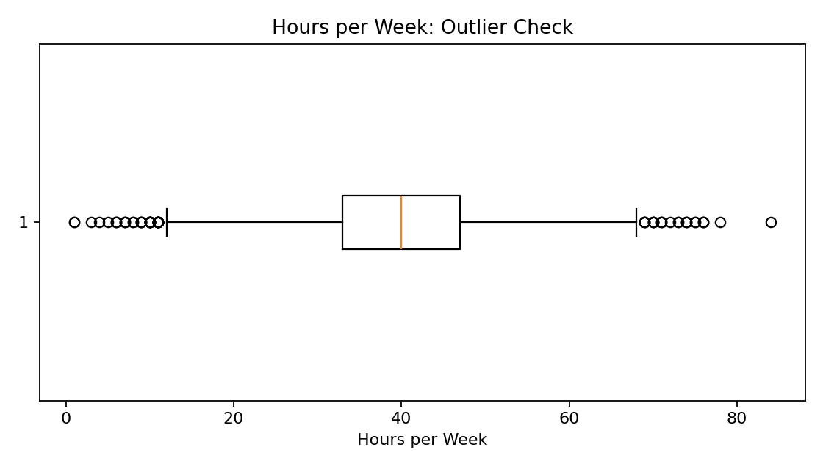
Figure 1. Week 1: Boxplot used to inspect potential outliers in weekly working hours.

3.5 Encoding and Preliminary Findings
Selected categorical variables were converted to factors and model.matrix() was used to create dummy variables. The preliminary analysis also included an age histogram, income proportions by sex and a correlation matrix. The source report notes that missing values were concentrated in categorical fields, age and hours worked had potentially extreme observations, and the income target was not evenly distributed.
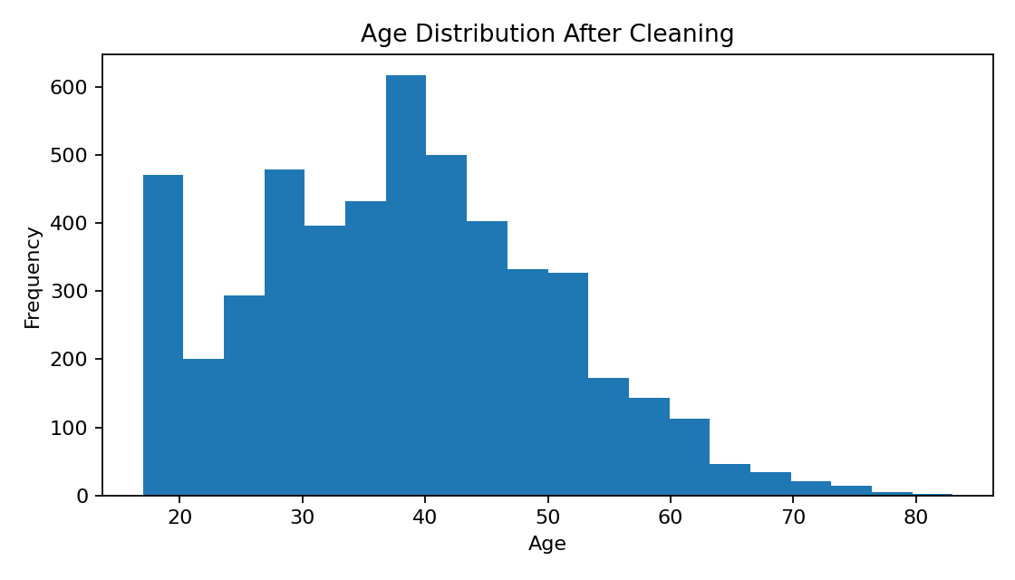
Figure 2. Week 1: Age distribution after preprocessing.
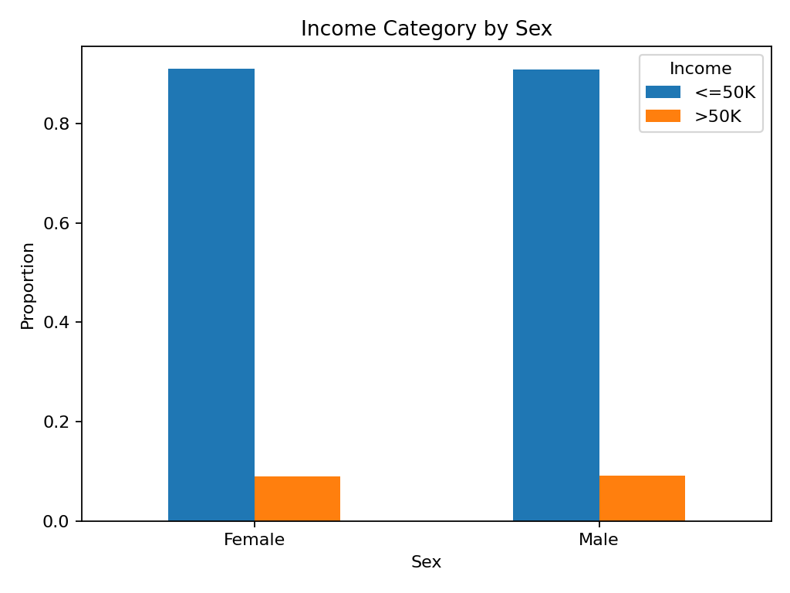
Figure 3. Week 1: Proportion of income categories across sex groups.
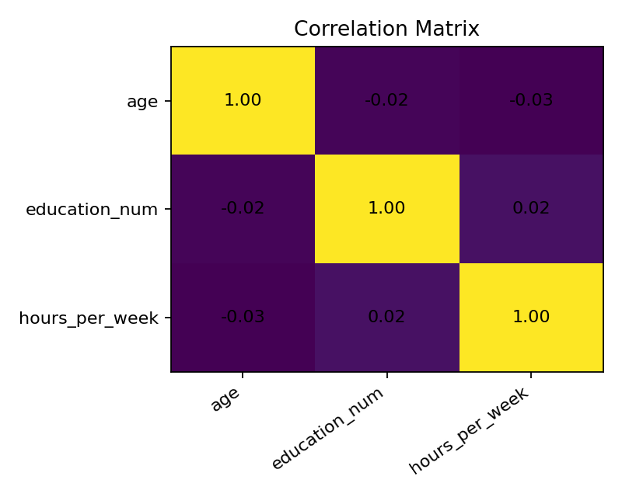
Figure 4. Week 1: Correlation matrix for selected numerical variables.

4. Week 2 – Data Visualization and Insight Communication
Week 2 focused on converting numerical information into clear visual representations using the built-in mtcars dataset. The source report describes 32 automobile observations and 11 variables, with mpg, cyl, hp and wt as key variables. Four chart types were used: bar chart, scatter plot, line chart and histogram.

4.1 Visualization 1 – Average MPG by Cylinder Count
The bar chart compares average fuel efficiency across cylinder groups. The reported averages are approximately 26.7 MPG for 4-cylinder vehicles, 19.7 MPG for 6-cylinder vehicles and 15.1 MPG for 8-cylinder vehicles.
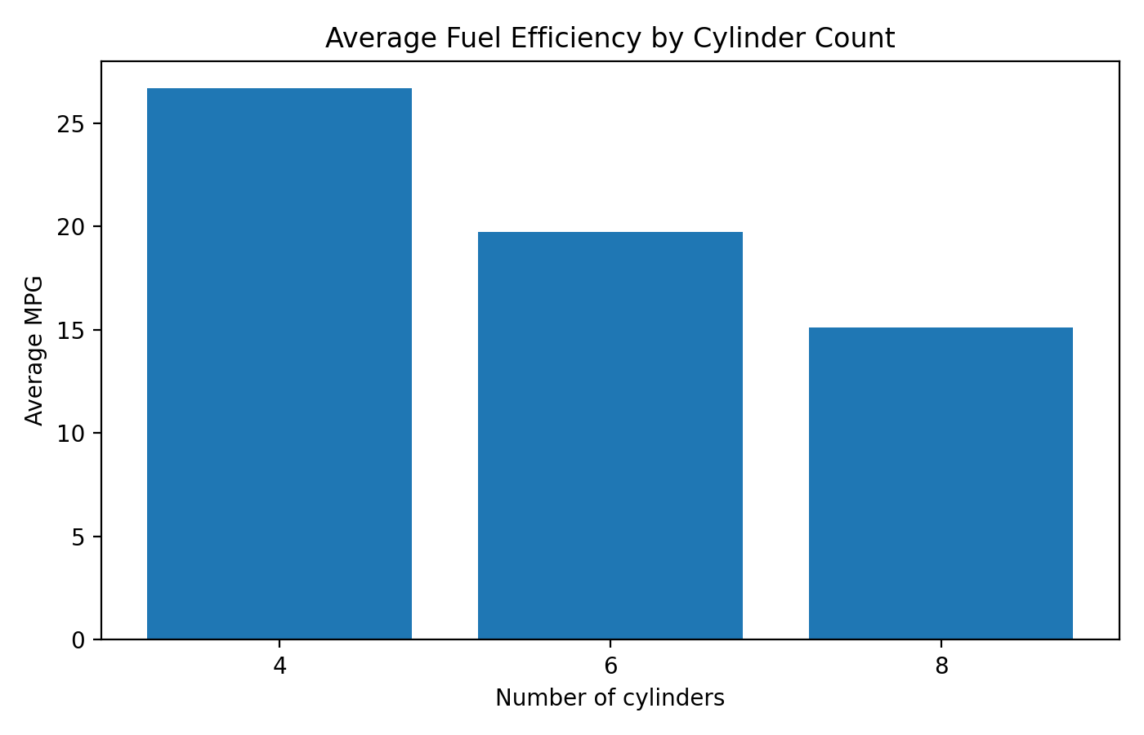
Figure 5. Week 2: Average fuel efficiency by cylinder count.

4.2 Visualization 2 – Vehicle Weight vs MPG
The scatter plot shows a strong negative association between vehicle weight and MPG in the sample. The source report gives a Pearson correlation of approximately -0.87 and correctly notes that correlation alone does not establish causation.
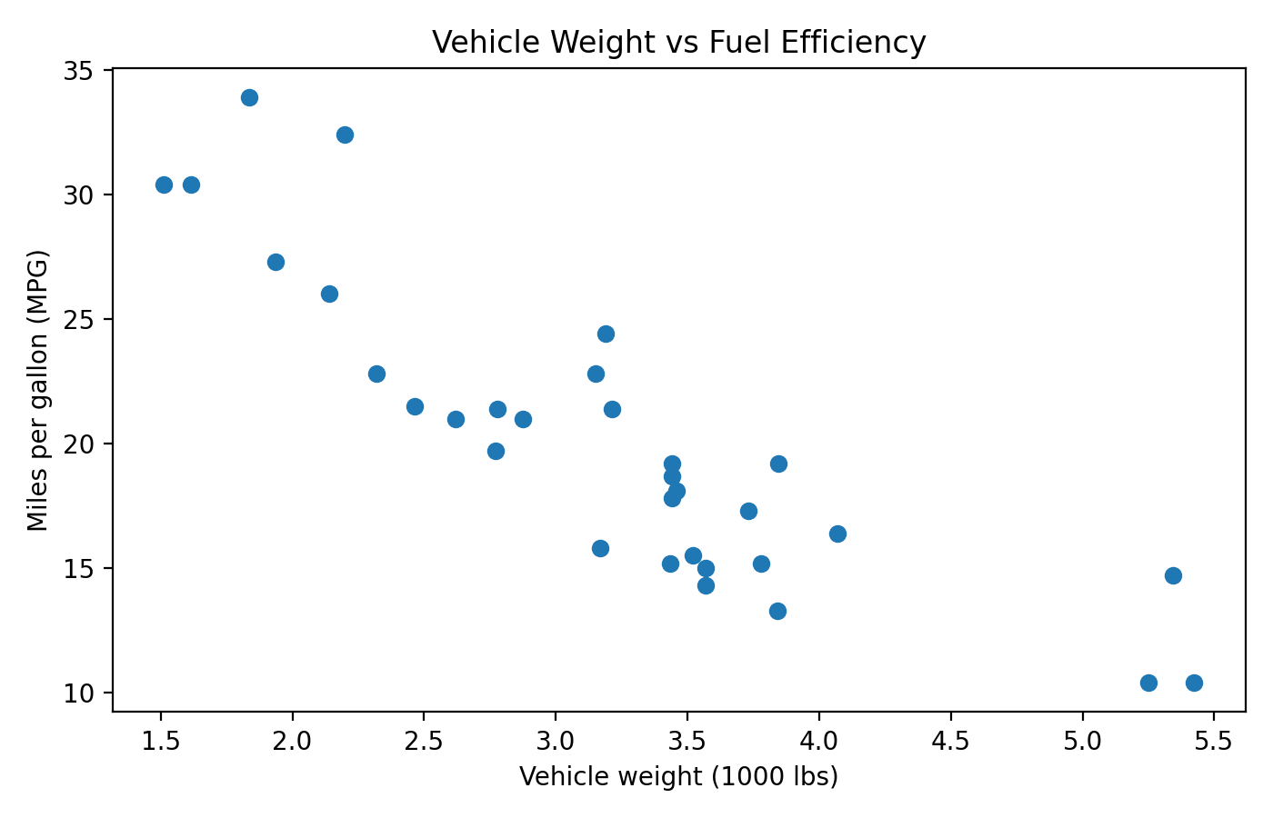
Figure 6. Week 2: Vehicle weight versus fuel efficiency.

4.3 Visualization 3 – MPG Across Vehicles
The line chart shows substantial variation in fuel efficiency across the 32 observations. Some vehicles are above 30 MPG while several are near 10–15 MPG.
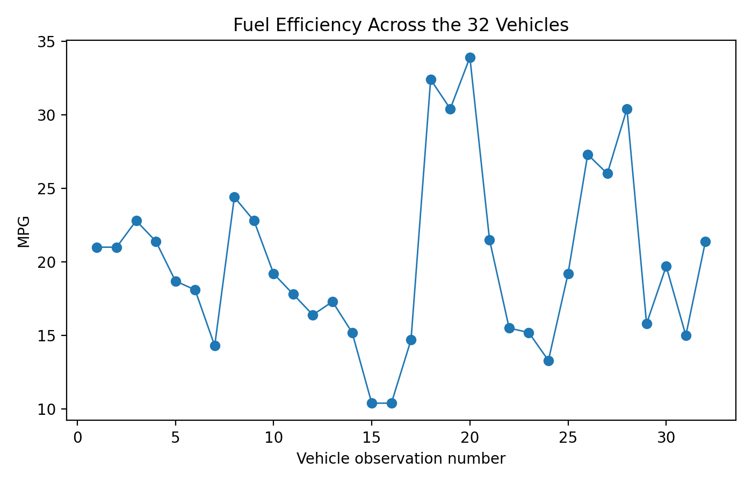
Figure 7. Week 2: Fuel efficiency across the 32 vehicles.

4.4 Visualization 4 – Horsepower Distribution
The histogram examines the distribution of horsepower. The source report states that horsepower ranges from 52 to 335 and that fewer vehicles occur at the highest horsepower levels. The original Week 2 document contains an unresolved placeholder in one sentence referring to the median horsepower; that value is therefore not reproduced here.
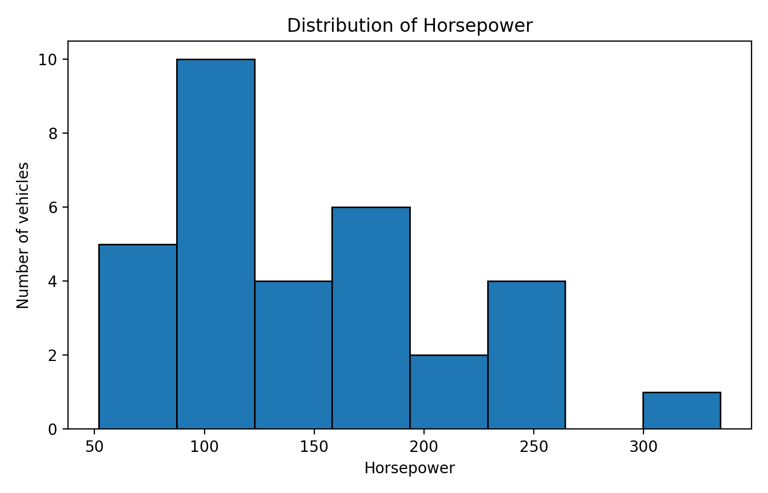
Figure 8. Week 2: Distribution of horsepower.

4.5 Communication Insight
The Week 2 work demonstrates that chart selection should match the analytical question: bars compare groups, scatter plots examine relationships, line charts show sequential variation, and histograms show numerical distributions. Titles and axis labels were used to make the findings understandable to non-technical readers.

5. Week 3 – Statistical Analysis and Predictive Modeling
Week 3 used the Boston housing dataset available through the MASS package. The dataset contains 506 observations and 14 variables. The target variable was medv, the median value of owner-occupied homes in $1,000s.

5.1 Exploratory Statistical Analysis
The source analysis reported zero missing values across the 506 observations. A Pearson correlation matrix was used to inspect relationships. The report identified a strong positive association between rm (average rooms) and medv, and a strong negative relationship between lstat and medv.
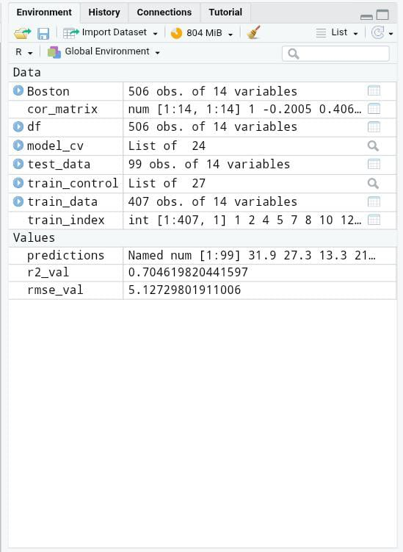
Figure 9. Week 3: R environment output showing the Boston dataset and analysis objects.

5.2 Hypothesis Testing
Component | Source result
H₀ | There is no correlation between rm and medv (ρ = 0).
H₁ | There is a statistically significant correlation between rm and medv (ρ ≠ 0).
Method | Pearson's product-moment correlation test.
Reported result | p < 2.2 × 10⁻¹⁶.
Interpretation in source report | H₀ was rejected and a statistically significant positive relationship was reported.

5.3 Data Splitting and Cross-Validation
The data were split into 80% training data (407 observations) and 20% test data (99 observations). The source report then applied 10-fold cross-validation to the training partition using caret::trainControl.
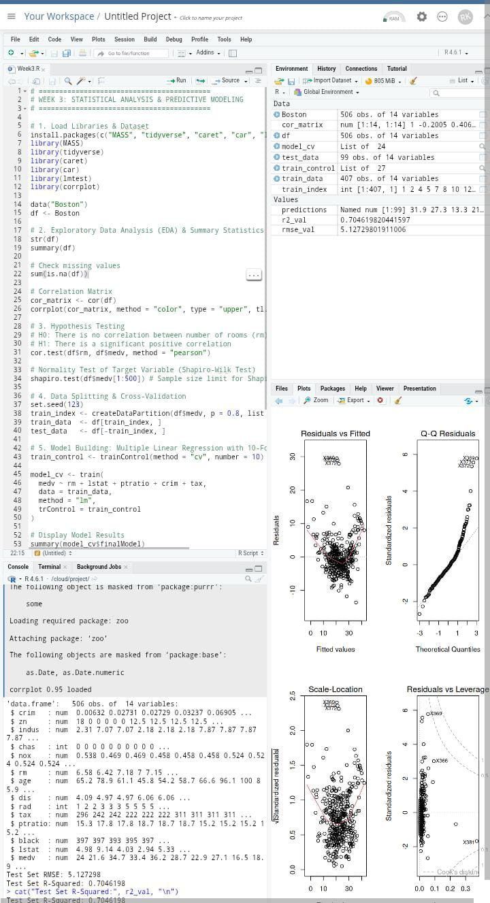
Figure 10. Week 3: RStudio analysis and modeling workflow.

5.4 Multiple Linear Regression Model
The model used rm, lstat, ptratio, crim and tax as predictors of medv. The purpose was to model home value using a set of structural and socio-economic variables.
model_cv <- train(
medv ~ rm + lstat + ptratio + crim + tax,
data = train_data,
method = "lm",
trControl = train_control
)

5.5 Test-Set Performance
Metric | Reported score | Interpretation from source report
RMSE | 5.127298 | Predictions deviate by about $5,127 on average when medv is interpreted in $1,000s.
R² | 0.7046198 | The model explains about 70.46% of the variance in median home prices.
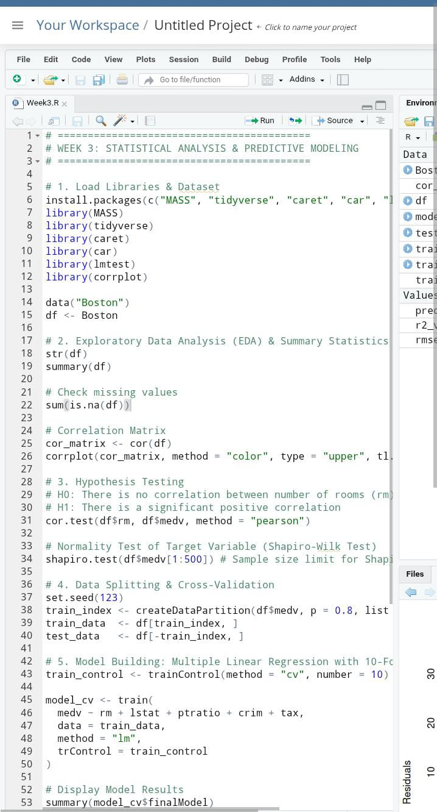
Figure 11. Week 3: RStudio output associated with the statistical/modeling workflow.

5.6 Diagnostic Analysis
Residual diagnostics were used to examine linear regression assumptions. The source report described relatively even residuals around zero, mild possible heteroscedasticity at higher fitted values, close alignment with the normal Q-Q line in the central region, and no extreme leverage points crossing Cook's distance boundaries.
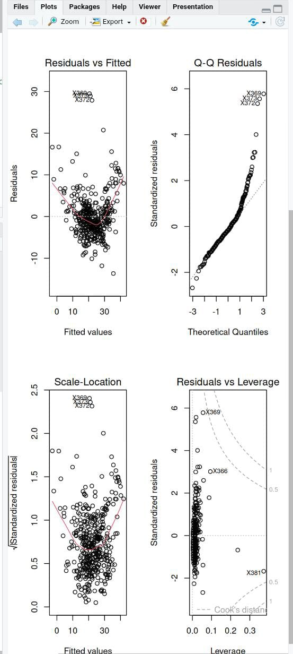
Figure 12. Week 3: Regression diagnostic plots.

5.7 Future Model Improvements
- Apply a logarithmic transformation to medv to potentially stabilize residual variance and reduce right-skewness.
- Test non-linear methods such as Random Forest or Gradient Boosted Decision Trees/XGBoost.
- Explore interaction terms such as rm × lstat within a linear modeling framework.

6. Integrated Results and Discussion
The three weeks demonstrate a progression from preparing data to communicating findings and then testing and predicting relationships. Week 1 established the importance of data quality. Week 2 demonstrated how visualizations can make patterns visible. Week 3 showed how statistical testing and predictive modeling can quantify relationships and evaluate predictive performance.
Week | Dataset | Main focus | Key documented result
1 | UCI Adult | Cleaning and preliminary analysis | Missing values handled; outliers examined; normalization and encoding performed.
2 | mtcars | Visualization | Cylinder groups differ in average MPG; wt and mpg show a strong negative association (r ≈ -0.87).
3 | Boston | Statistics and modeling | rm–medv correlation reported as statistically significant; regression test-set R² = 0.7046198 and RMSE = 5.127298.

6.1 Statistical Significance and Interpretation
The Week 3 Pearson test provides formal statistical evidence for the rm–medv relationship in the Boston dataset, with a reported p-value below 0.05. The Week 2 correlation of approximately -0.87 describes a strong association in the mtcars sample but is not by itself evidence of causation. Week 1 correlation analysis was exploratory and was used to understand relationships before later modeling.

6.2 Practical / Business Implications
The reports illustrate several practical principles. Reliable analysis begins with data quality checks. Visual summaries can help stakeholders understand differences and relationships quickly. Statistical tests can distinguish observed sample relationships from relationships evaluated against a null hypothesis. Predictive models can summarize multiple predictors and provide measurable out-of-sample performance. These implications are methodological rather than claims about a single real-world organization because the three exercises use public or built-in datasets.

7. Challenges and Lessons Learned
- Mixed data types require different preprocessing methods, especially for numerical and categorical missing values.
- Potential outliers need investigation rather than automatic deletion because extreme observations may be valid.
- Choosing the correct chart depends on the analytical question and variable types.
- Correlation describes association and should not be interpreted as proof of causation.
- Predictive modeling requires a separation between training and test data to evaluate performance on unseen observations.
- Cross-validation can provide a more stable training evaluation than relying on a single training fit.
- Residual diagnostics are important because model performance metrics alone do not describe whether model assumptions are reasonable.
- Clear titles, labels, interpretations and reproducible code are necessary for communicating analysis to non-technical audiences.

8. Recommendations and Future Directions
- Continue using reproducible R scripts so that data preparation and analysis can be rerun consistently.
- Document data-quality decisions, especially imputation and outlier treatment, before modeling.
- Compare alternative predictive algorithms and evaluate them on the same held-out test set.
- Explore feature engineering and interaction terms where domain reasoning supports them.
- Use additional diagnostic and validation measures when a predictive model is intended for practical deployment.
- Improve visualizations with consistent labeling and audience-focused explanations.
- Keep the final report synchronized with the actual code and output so that numerical results are traceable.

8.1 Suggested Work Allocation
The Week 2 source document provides a suggested 32-hour allocation: dataset understanding (4 h), learning/revising R and ggplot2 (6 h), data exploration/preparation (4 h), creating/testing visualizations (8 h), interpreting results and writing insights (4 h), report formatting/quality checking (4 h), and GitHub/final submission preparation (2 h). This is a suggested planning allocation from the source, not a claim about actual hours completed.

9. Conclusion
This final report brings together the data-analysis skills developed across the three internship tasks. The Week 1 Adult dataset exercise established a foundation in cleaning, missing-value handling, outlier detection, normalization, encoding and exploratory analysis. Week 2 developed the ability to select and explain visualizations for different analytical questions. Week 3 extended the workflow into hypothesis testing, controlled data splitting, 10-fold cross-validation, multiple linear regression, performance evaluation and diagnostic analysis.
The main lesson is that effective data analysis is not a single statistical technique. It is a connected process in which data quality, exploration, visualization, statistical reasoning, modeling and communication support one another. The completed work provides a reproducible foundation for more advanced modeling and deeper analysis in future projects.

10. References
- UCI Machine Learning Repository. Adult / Census Income Dataset. Dataset DOI: 10.24432/C5XW20.
- R Project documentation and built-in datasets.
- ggplot2 documentation: https://ggplot2.tidyverse.org/
- Source reports prepared during Weeks 1–3 of the YuvaIntern internship.

Appendix A – Selected R Code
The following extracts are selected from the three source reports to show reproducibility.

A.1 Week 1 – Cleaning and Encoding
num_cols <- c("age","fnlwgt","education_num",
"capital_gain","capital_loss","hours_per_week")
cat_cols <- c("workclass","education","marital_status",
"occupation","relationship","race","sex","native_country","income")

adult$sex <- as.factor(adult$sex)
adult$workclass <- as.factor(adult$workclass)
adult$income <- as.factor(adult$income)

encoded_data <- model.matrix(~ sex + workclass - 1, data = adult)

A.2 Week 2 – Visualization
library(ggplot2)
data(mtcars)
df <- mtcars

avg_mpg <- aggregate(mpg ~ cyl, data = df, FUN = mean)
ggplot(avg_mpg, aes(x = factor(cyl), y = mpg)) +
geom_col() +
labs(title = "Average Fuel Efficiency by Cylinder Count",
x = "Number of cylinders", y = "Average MPG") +
theme_minimal()

ggplot(df, aes(x = wt, y = mpg)) +
geom_point(size = 2.5) +
labs(title = "Vehicle Weight vs Fuel Efficiency",
x = "Vehicle weight (1000 lbs)", y = "Miles per gallon (MPG)") +
theme_minimal()

A.3 Week 3 – Testing, Cross-Validation and Evaluation
cor.test(df$rm, df$medv, method = "pearson")

set.seed(123)
train_index <- createDataPartition(df$medv, p = 0.8, list = FALSE)
train_data <- df[train_index, ]
test_data <- df[-train_index, ]

train_control <- trainControl(method = "cv", number = 10)

model_cv <- train(
medv ~ rm + lstat + ptratio + crim + tax,
data = train_data,
method = "lm",
trControl = train_control
)

predictions <- predict(model_cv, newdata = test_data)
rmse_val <- RMSE(predictions, test_data$medv)
r2_val <- R2(predictions, test_data$medv)

Report Quality Note
This report preserves the documented results and terminology of the three submitted weekly reports. Because the weekly tasks use three different datasets, the integration is presented as a progression of analytical methods rather than as one combined dataset. Any value or statement not explicitly supported by the source reports has been avoided.

