DATA VISUALIZATION AND INSIGHT COMMUNICATION USING R
Week 2 Internship Project
Dataset: mtcars
Tools: R, ggplot2
Student Name: __________________________
College: _________________________________
Internship: YuvaIntern

1. Introduction
This project focuses on data visualization and insight communication using the R programming language. The main purpose is to transform numerical data into clear visual representations that can be understood by both technical and non-technical audiences. Visualization helps identify patterns, differences, relationships, and unusual observations that may not be obvious from a table of raw values. The project uses the mtcars dataset, a built-in R dataset containing information about 32 automobile models. The analysis examines fuel efficiency, engine characteristics, vehicle weight, and horsepower. Four different chart types are used: a bar chart, scatter plot, line chart, and histogram. Each visualization has a specific purpose and is followed by an interpretation of the main insight. The R code is included so that the analysis can be reproduced.

2. Objectives
- Understand the structure and important variables of a public dataset.
- Create multiple visualizations using R and ggplot2.
- Select chart types according to the analytical question.
- Interpret patterns and relationships shown by the graphs.
- Communicate analytical findings clearly to a non-technical audience.

3. Dataset Overview
The mtcars dataset contains 32 observations of automobiles and 11 variables. Important variables used in this project are mpg (miles per gallon), cyl (number of cylinders), hp (gross horsepower), and wt (vehicle weight in thousands of pounds). The dataset is included with R, so no separate download is required. This makes it convenient for a reproducible demonstration of R visualization.
Variable | Meaning | Type
mpg | Miles per gallon | Numeric
cyl | Number of cylinders | Numeric/Categorical
hp | Gross horsepower | Numeric
wt | Vehicle weight (1000 lbs) | Numeric

4. Tools and Technologies
R was used for data analysis and visualization. The ggplot2 package was used to build layered visualizations. ggplot2 is designed around the grammar-of-graphics approach, where plots are constructed from data, aesthetic mappings and graphical layers. citeturn0search9

5. Visualization 1 – Bar Chart
A bar chart was selected to compare average fuel efficiency across groups of vehicles based on the number of cylinders. Group comparison is easier to communicate with bars because the height of each bar directly represents the average MPG.
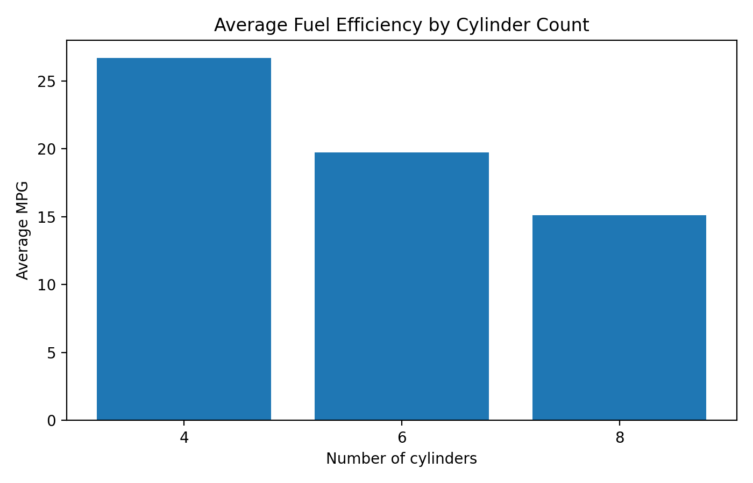
Interpretation: The average MPG differs noticeably by cylinder count. In this dataset, 4-cylinder vehicles average about 26.7 MPG, 6-cylinder vehicles about 19.7 MPG, and 8-cylinder vehicles about 15.1 MPG. This visualization communicates that vehicles with fewer cylinders in this sample generally have higher fuel efficiency.

R Code:
avg_mpg <- aggregate(mpg ~ cyl, data = mtcars, FUN = mean)
ggplot(avg_mpg, aes(x = factor(cyl), y = mpg)) +
geom_col() +
labs(title = "Average Fuel Efficiency by Cylinder Count",
x = "Number of cylinders", y = "Average MPG") +
theme_minimal()

6. Visualization 2 – Scatter Plot
A scatter plot was selected to examine the relationship between vehicle weight and fuel efficiency. Scatter plots are useful when both variables are numeric and the goal is to identify the direction and strength of a relationship.
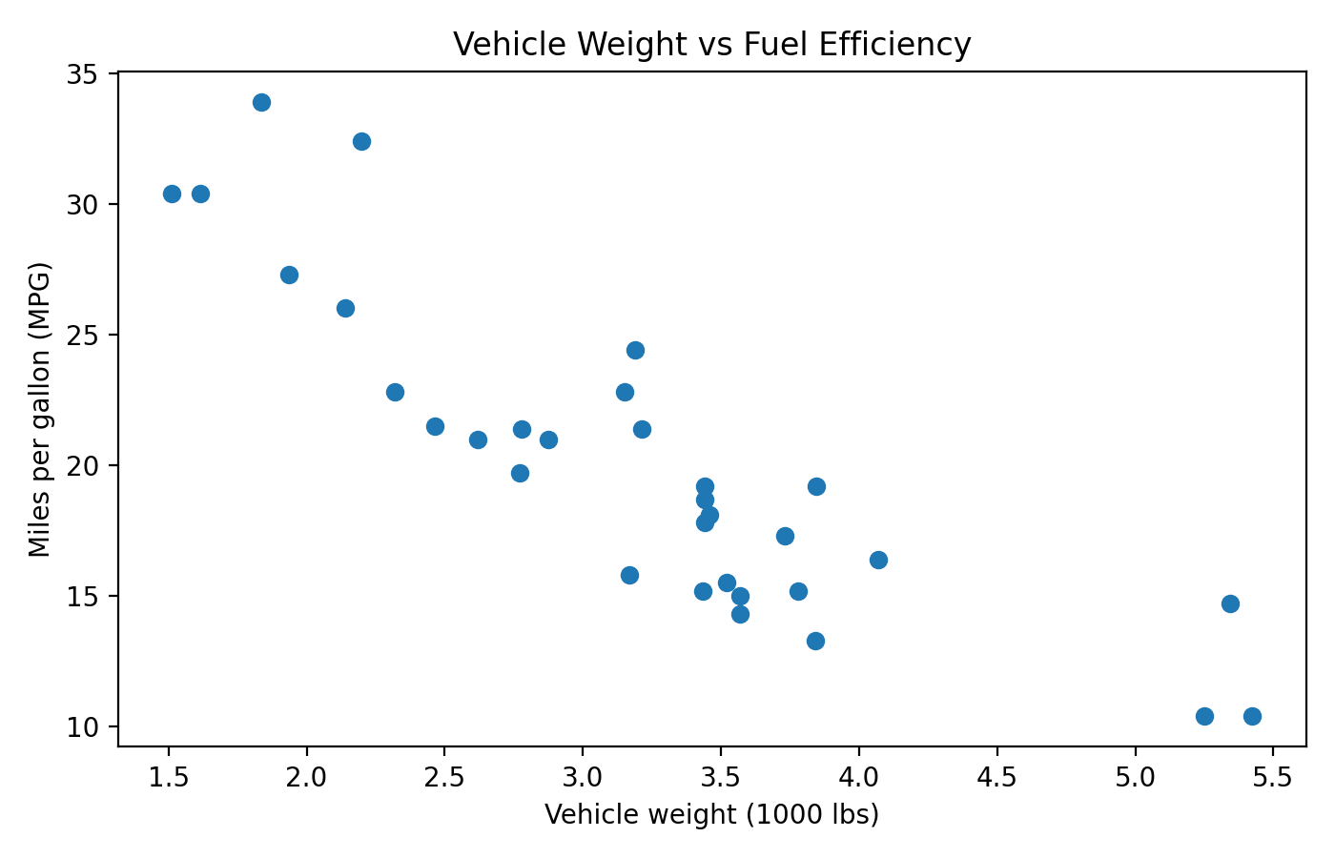
Interpretation: The points show a clear negative association in this dataset: as vehicle weight increases, MPG generally decreases. The Pearson correlation between wt and mpg is approximately -0.87. This indicates a strong inverse relationship in this sample, although correlation alone does not establish causation.

R Code:
ggplot(mtcars, aes(x = wt, y = mpg)) +
geom_point(size = 2.5) +
labs(title = "Vehicle Weight vs Fuel Efficiency",
x = "Vehicle weight (1000 lbs)", y = "Miles per gallon (MPG)") +
theme_minimal()

7. Visualization 3 – Line Chart
A line chart was used to show how MPG changes from one observation to the next in the dataset. The line makes ups and downs easy to see and helps communicate variation across the ordered observations.
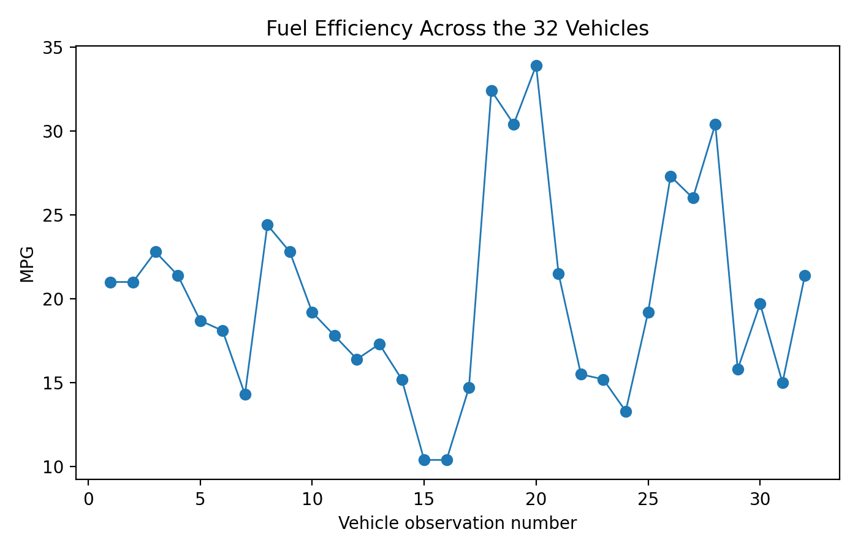
Interpretation: The line chart shows substantial variation in fuel efficiency across the 32 vehicles. Some observations have MPG above 30, while several others are close to 10–15 MPG. The chart therefore highlights the wide range of fuel-efficiency values in the dataset.

R Code:
mtcars$vehicle_no <- seq_len(nrow(mtcars))
ggplot(mtcars, aes(x = vehicle_no, y = mpg)) +
geom_line() + geom_point() +
labs(title = "Fuel Efficiency Across the 32 Vehicles",
x = "Vehicle observation number", y = "MPG") +
theme_minimal()

8. Visualization 4 – Histogram
A histogram was selected to examine the distribution of horsepower. Unlike a bar chart for categories, a histogram groups numerical observations into intervals and shows how frequently values occur.
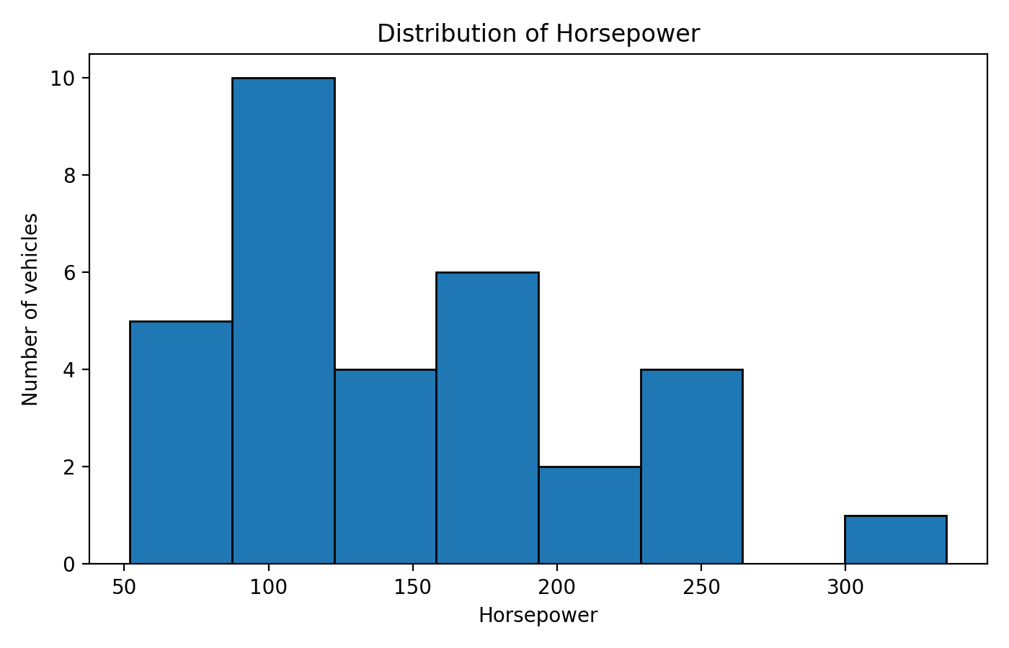
Interpretation: Horsepower values are spread across a broad range, from 52 to 335 horsepower. The distribution contains many observations in the lower-to-middle horsepower range and fewer vehicles at the highest horsepower levels. The median horsepower is {hp_median:.0f}, giving a useful central reference for the sample.

R Code:
ggplot(mtcars, aes(x = hp)) +
geom_histogram(bins = 8, color = "black") +
labs(title = "Distribution of Horsepower",
x = "Horsepower", y = "Number of vehicles") +
theme_minimal()

9. Overall Insights
- Fuel efficiency varies substantially among the vehicles in the dataset.
- Average MPG differs by cylinder count, with the 4-cylinder group having the highest average MPG among the three groups shown.
- Vehicle weight and MPG have a strong negative relationship in this sample.
- Horsepower is distributed across a wide range, with relatively fewer vehicles at the highest horsepower levels.
- Different chart types communicate different questions: bars compare groups, scatter plots show relationships, line charts show sequential variation, and histograms show distributions.

10. Communication for a Non-Technical Audience
The visualizations convert numerical information into patterns that can be understood quickly. Instead of asking a reader to compare 32 rows of numbers, the graphs make the major differences visible. For example, the scatter plot makes the inverse relationship between weight and MPG easier to recognize, while the bar chart makes group-level differences immediately visible. Clear titles and axis labels are important because they tell the audience exactly what is being compared.

11. Conclusion
This Week 2 project provided practical experience in using R for data visualization and insight communication. The mtcars dataset was explored using four visualization techniques: bar chart, scatter plot, line chart, and histogram. Each chart was selected according to the type of question being answered. The analysis demonstrated differences in fuel efficiency between cylinder groups, a strong negative association between weight and MPG, variation in MPG across observations, and the distribution of horsepower. The project also shows that effective data visualization is not only about creating attractive graphs; it is about choosing an appropriate visual form, explaining the result, and communicating the insight clearly.

12. Complete R Code
# Week 2 - Data Visualization and Insight Communication using R
# Dataset: mtcars (built-in R dataset)
# Install once if ggplot2 is not already installed:
# install.packages("ggplot2")
library(ggplot2)
data(mtcars)
df <- mtcars
# 1. Bar chart: average MPG by cylinder count
avg_mpg <- aggregate(mpg ~ cyl, data = df, FUN = mean)
ggplot(avg_mpg, aes(x = factor(cyl), y = mpg)) +
geom_col() +
labs(
title = "Average Fuel Efficiency by Cylinder Count",
x = "Number of cylinders",
y = "Average MPG"
) +
theme_minimal()
# 2. Scatter plot: vehicle weight vs MPG
ggplot(df, aes(x = wt, y = mpg)) +
geom_point(size = 2.5) +
labs(
title = "Vehicle Weight vs Fuel Efficiency",
x = "Vehicle weight (1000 lbs)",
y = "Miles per gallon (MPG)"
) +
theme_minimal()
# 3. Line chart: MPG across the observations
df$vehicle_no <- seq_len(nrow(df))
ggplot(df, aes(x = vehicle_no, y = mpg)) +
geom_line() +
geom_point() +
labs(
title = "Fuel Efficiency Across the 32 Vehicles",
x = "Vehicle observation number",
y = "MPG"
) +
theme_minimal()
# 4. Histogram: horsepower distribution
ggplot(df, aes(x = hp)) +
geom_histogram(bins = 8, color = "black") +
labs(
title = "Distribution of Horsepower",
x = "Horsepower",
y = "Number of vehicles"
) +
theme_minimal()
# Optional numerical insight
cor(df$wt, df$mpg)

13. Suggested Work Allocation
The task asks for work spanning 30–35 hours. The following is a suggested activity allocation to help document the project process. It should be adjusted to reflect the work actually performed.
- Dataset understanding and variable study – 4 hours
- Learning/revising R and ggplot2 – 6 hours
- Data exploration and preparation – 4 hours
- Creating and testing four visualizations – 8 hours
- Interpreting results and writing insights – 4 hours
- Report formatting and quality checking – 4 hours
- GitHub organization and final submission preparation – 2 hours
- Total suggested allocation – 32 hours

14. References
1. R Project documentation and built-in datasets.
2. ggplot2 documentation: https://ggplot2.tidyverse.org/

