ELECTRIC VEHICLE
POPULATION ANALYSIS
DATA CLEANING • EXPLORATORY ANALYSIS • POWER BI DASHBOARD
DATA ANALYTICS MINI PROJECT
Prepared using Excel and Microsoft Power BI

Project at a glance
500 | 16 | 34 | 90
Vehicle records | Source columns | Unique makes | Unique models
Project scope: clean and transform the raw dataset in Excel, then use Power BI to communicate insights about vehicle categories, manufacturers, model years, electric range, eligibility, and geographic distribution.
Prepared: 20 October 2026

1. Executive Summary
This mini project analyses a 500-record sample of electric-vehicle population data. The workbook contains a Raw_Data sheet with 16 source fields, a Cleaned_Data sheet with the same 500 records plus a derived Vehicle Category field, and a Pivot_Data sheet. The analysis focuses on vehicle mix, manufacturer concentration, model-year distribution, electric range, CAFV eligibility, and geographic concentration.
Measure | Result | Interpretation
Total records | 500 | Meets the project guideline minimum of 500 records.
Vehicle category | 406 BEV / 94 PHEV | BEVs represent 81.2%; PHEVs represent 18.8%.
Unique manufacturers | 34 | Tesla has the largest share in this sample.
Unique models | 90 | Shows model-level diversity across the sample.
Average range (non-zero) | 106.29 miles | Calculated after excluding zero-range values.
Key takeaway: the sample is dominated by Battery Electric Vehicles and Tesla records. A substantial number of records contain zero electric-range values, so range results need to be interpreted carefully.

2. Project Objectives
- Prepare a consistent, analysis-ready dataset using Excel.
- Create a derived Vehicle Category field to compare BEV and PHEV records.
- Use summary tables and Power BI visuals to examine manufacturers, models, model years, range, eligibility, and geography.
- Build a clear, interactive dashboard using KPI cards, charts, and slicers.

3. Dataset Description and Source
The dataset is Washington State’s “Electric Vehicle Population Data,” provided by the Washington State Department of Licensing through the State of Washington open-data portal. It covers registered Battery Electric Vehicles (BEVs) and Plug-in Hybrid Electric Vehicles (PHEVs). This project uses a 500-row sample rather than the full live dataset.
Official dataset page: https://data.wa.gov/Transportation/Electric-Vehicle-Population-Data/f6w7-q2d2
The 16 source fields include VIN (1-10), County, City, State, Postal Code, Model Year, Make, Model, Electric Vehicle Type, CAFV Eligibility, Electric Range, Legislative District, DOL Vehicle ID, Vehicle Location, Electric Utility, and 2020 GEOID.
Dataset dimensions: 500 records × 16 original columns. The cleaned sheet contains 17 columns because Vehicle Category was added.

4. Excel Data Pre-processing
The workbook is organised into three worksheets:
Worksheet | Observed contents | Purpose
Raw_Data | 500 records, 16 columns | Original data retained for reference.
Cleaned_Data | 500 records, 17 columns | Analysis-ready version with Vehicle Category.
Pivot_Data | Pivot-style summary output | Aggregated counts supporting analysis.

4.1 Data quality checks
- Row count: 500 records in Raw_Data and 500 in Cleaned_Data.
- Exact duplicate rows detected: 0 in Raw_Data and 0 in Cleaned_Data.
- Blank cells detected: 0 in Raw_Data and 0 in Cleaned_Data.
- The Vehicle Category field maps long vehicle-type labels to short BEV and PHEV labels for easier analysis.
- The Electric Range field contains 334 zero values (66.8%). The non-zero average describes recorded positive values; zero values are not automatically assumed to mean a true 0-mile range.

4.2 Calculated field
A new Vehicle Category column was added using an IF formula that maps Battery Electric Vehicle (BEV) to “BEV” and Plug-in Hybrid Electric Vehicle (PHEV) to “PHEV”, with “Other/Unknown” as a fallback category.
Example Excel formula: =IF(I2="Battery Electric Vehicle (BEV)","BEV",IF(I2="Plug-in Hybrid Electric Vehicle (PHEV)","PHEV","Other/Unknown"))

4.3 Pivot-table use
The Pivot_Data worksheet provides a summary view of records by model year. Pivot tables aggregate row-level records into counts and help verify values represented in the dashboard.
Excel link: Electric Vehicle Analysis.xlsx

5. Analysis and Findings

5.1 Vehicle category distribution
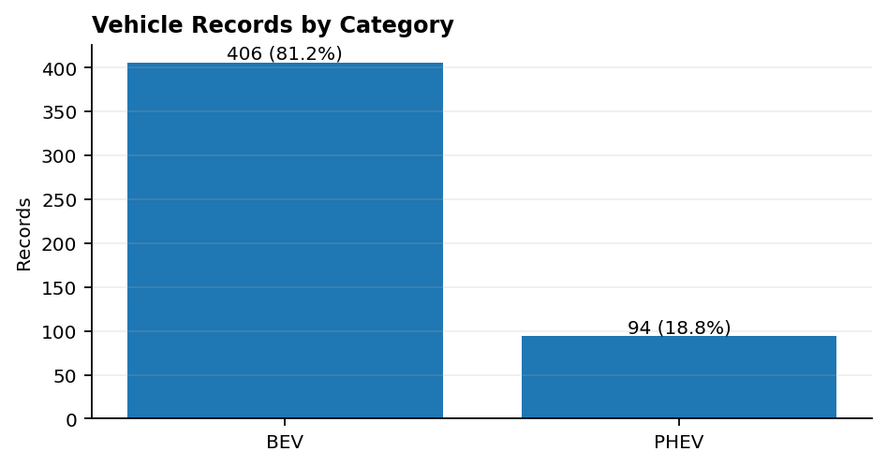
BEVs account for 406 records (81.2%), while PHEVs account for 94 records (18.8%). The sample therefore has a strong BEV majority.

5.2 Manufacturer distribution
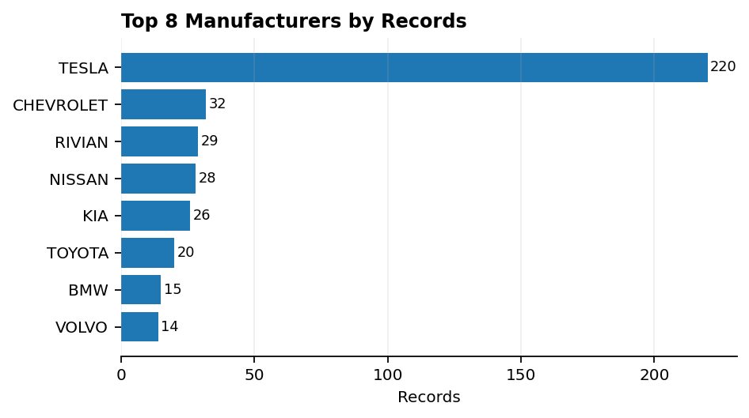
Tesla is the leading manufacturer with 220 records (44.0% of the sample). Other frequently represented makes include Chevrolet, Rivian, Nissan, and Kia. The manufacturer chart highlights concentration in the leading make.

5.3 Model-year distribution
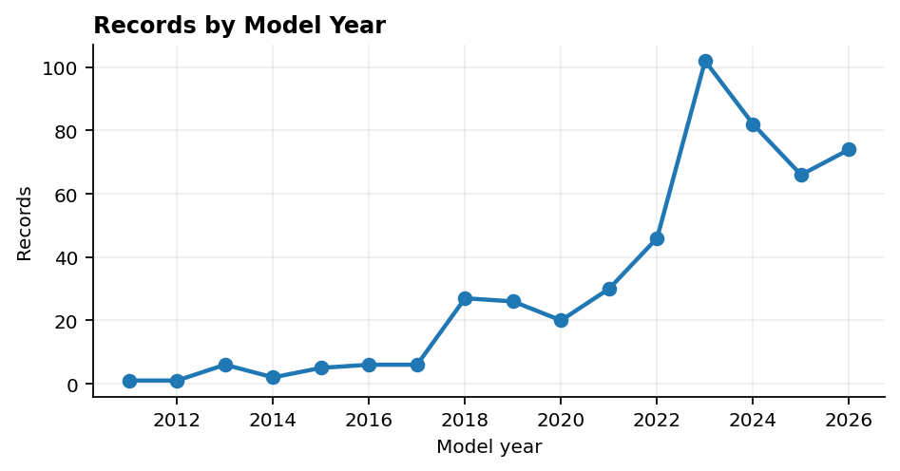
The most frequent model year in the sample is 2023, with 102 records (20.4%). The distribution rises in recent model years. As this dataset represents registered vehicles, it should not be interpreted as total annual EV sales.

5.4 Electric range
The dashboard KPI reports an average electric range of 106.29 miles when zero values are excluded. Including all values produces a mean of 35.29 miles. There are 334 zero values. The source notes that zero may be entered when range has not been researched and that range is no longer maintained for BEVs. Therefore, the non-zero average is more useful for describing recorded positive values, but it does not represent every vehicle in the sample.

5.5 CAFV eligibility
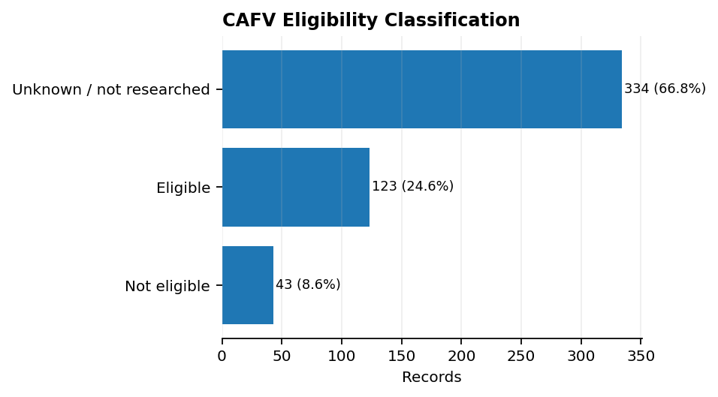
334 records (66.8%) have eligibility unknown because battery range has not been researched; 123 (24.6%) are marked eligible; and 43 (8.6%) are marked not eligible due to low battery range. The large unknown group means eligibility results should be interpreted cautiously.

5.6 Geographic concentration
King County contains 226 records (45.2%), followed by Snohomish County (73) and Pierce County (47). Seattle is the most frequent city in the sample with 69 records. The State field contains 499 WA records and 1 CA record, so the sample is overwhelmingly associated with Washington.

6. Power BI Dashboard Design
The Power BI report is organised into three pages:
- EV Overview: KPI cards for Total Vehicles, Unique Makes, Unique Models, and Average Electric Range; a category donut chart; model-year line chart; top-manufacturer bar chart; BEV/PHEV comparison; and slicers.
- Vehicle Insights: top vehicle models, CAFV eligibility distribution, average electric range by vehicle category and manufacturer, vehicle details table, and make/category/model-year slicers.
- Geographic & Eligibility Analysis: top counties, utilities, cities, geographic detail table, and state/county/category slicers.

Dashboard strengths
- The three-page structure separates overview, vehicle attributes, and geographic/eligibility analysis.
- KPI cards provide a quick summary before users explore detailed charts.
- Bar charts are appropriate for ranking manufacturers, models, counties, cities, and utilities.
- The model-year line chart supports a quick view of the sample’s year distribution.
- Slicers allow users to narrow results by model year, make, category, state, or county.

Recommended refinements
- Keep font sizes, card spacing, chart titles, and colors consistent across all three pages.
- Label the range KPI as “Average range (miles, non-zero values)” or explain the exclusion of zero values in a tooltip.
- For a map visual, assign a valid geographic field such as State or County to Location. Set the Data Category appropriately and test with State alone if the map fails.
- Use high-contrast labels and avoid placing important text over visually busy background artwork.
- Add a note that the report analyses a 500-record sample from a larger public dataset.

7. Power BI Dashboard Screenshots
Paste your own screenshots into the designated spaces below. The screenshots are intentionally not included in this document.
LINK : Power BI Dashboard.docx

Figure 1: EV Overview
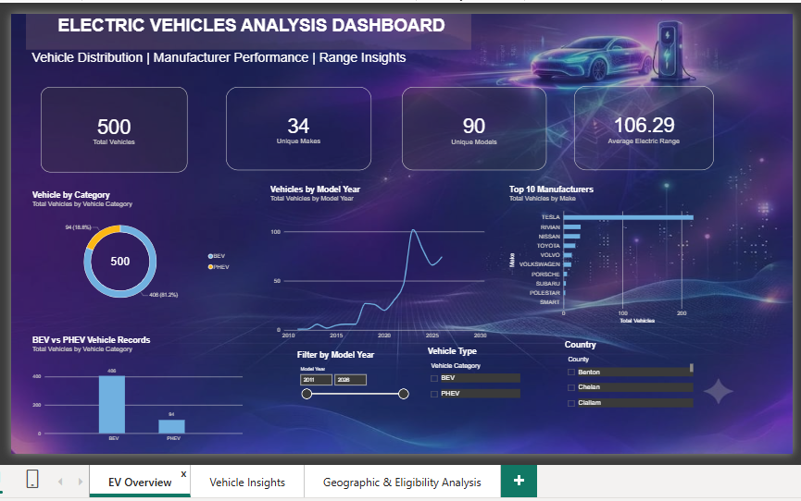

Figure 2: Vehicle Insights
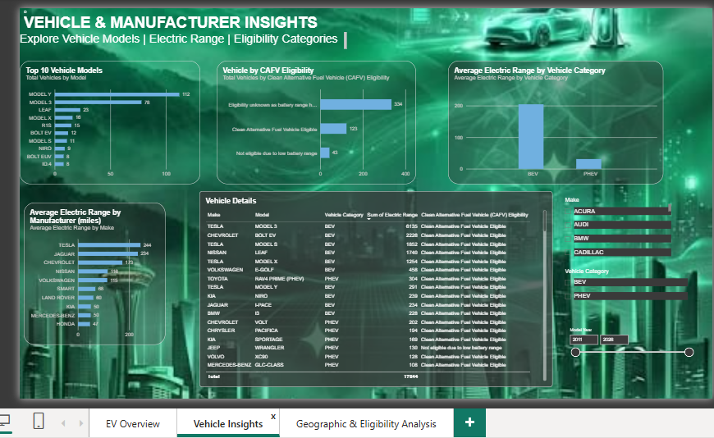

Figure 3: Geographic & Eligibility Analysis
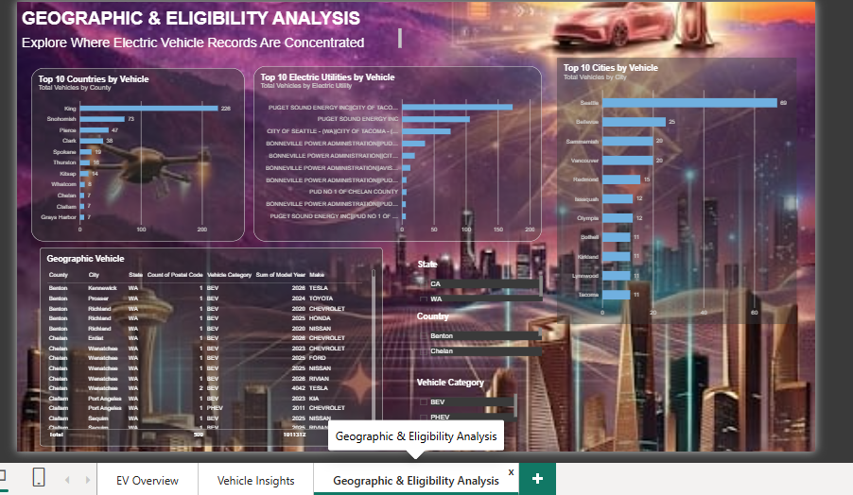

8. Conclusion
The project demonstrates an end-to-end analytics workflow: retaining original data, creating a cleaned worksheet and derived category field, summarising records, and communicating patterns through an interactive Power BI report. The sample contains 500 vehicles, 34 manufacturers, and 90 models. BEVs account for 81.2% of records, Tesla is the most represented make, and King County has the largest geographic count. Range and CAFV findings require caveats because many records contain zero range values or unknown eligibility classifications.
The dashboard is a useful exploratory tool for comparing the sample by category, make, model year, range, eligibility, and location. The average-range measure should be clearly defined, and the map visual should be validated before final export.

