ASG Airlines
End-to-End Data Engineering Pipeline
Project Documentation
JANANI M
M.Sc. Data Science
Vellore institute of Technology -Vellore

1. Project Overview
The ASG Airlines project builds a controlled analytical layer from operational airline data for reporting in Power BI. The implementation ingests source files, validates structure and record quality, separates invalid records, standardizes usable values, derives operational attributes, and publishes curated data for analytics. The reporting solution is delivered through ASG_Airlines_Dashboard.pbix. The implemented report contains two pages: Flight Operations Control and Route Performance.

Objectives
• Build a reproducible pipeline for ingestion, validation, cleaning and transformation.
• Detect missing values, duplicates, malformed identifiers and timestamp-related anomalies.
• Calculate flight duration from departure and arrival timestamps, including cross-day flights.
• Quarantine or flag records that cannot be safely corrected.
• Keep sensitive passenger-level information outside the flight-level analytical serving layer.
• Provide interactive Power BI reporting for operational and route analysis.
• Include logging, reconciliation and automated tests for repeatable execution.

2. Dataset Description
The source data is organised into four logical domains. Flights form the primary analytical grain, while bookings, passengers and payments provide supporting transactional information.
Sheet / Domain | Purpose | Representative fields
flights | Flight schedule and route level | flight_id, airline, source, destination, departure_time, arrival_time
bookings | Booking transactions | booking_id, passenger_id, flight_id, booking_date, status, seat_number
passengers | Passenger reference data | passenger_id, age, gender and personal identifiers
payments | Payment transactions | payment_id, booking_id, amount, payment_method

Analytical grain
The primary reporting grain is one row per flight operation. This avoids accidental multiplication of flight records through booking or payment joins and keeps operational KPIs at a consistent grain.
Sensitive-data boundary
Passenger names, contact details, government identifiers and emergency-contact information are not required for the flight dashboard and are kept outside the flight-level reporting layer.

3. Technology Stack
Technology | Role in the solution
Python 3 | Pipeline implementation and orchestration
Pandas / NumPy | Loading, profiling, validation and transformation
Jupyter Notebook | Reproducible technical walkthrough
SQL | Schema and analytical query definitions
Pytest | Automated pipeline validation
Power BI Desktop | Interactive dashboard and KPI reporting
Python logging | Operational run logging and error visibility
SHA-256 hashing | One-way protection for direct identifiers where required

4. Architecture Diagram
The implemented architecture follows a controlled sequence from source ingestion through quality validation, cleaning, transformation, analytical serving and Power BI reporting. Invalid records are retained in a reason-coded quarantine path for auditability.
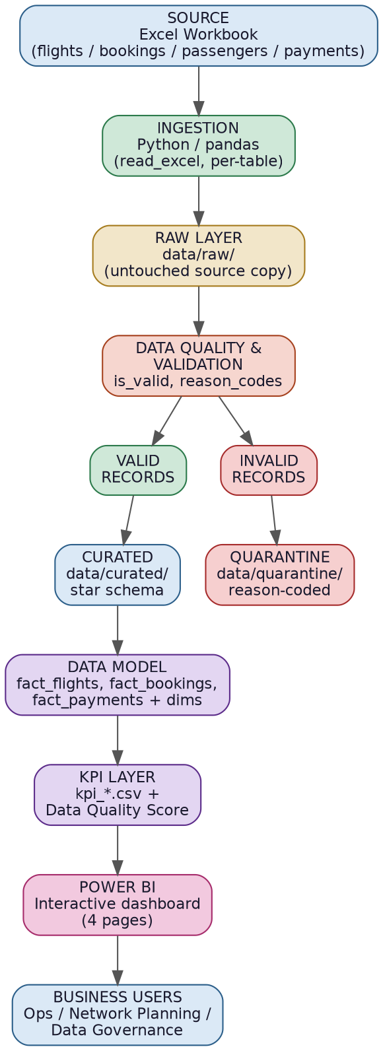
Figure 1 - Solution architecture

5. Data Flow Diagram

The data flow separates the flight analytics path from controlled handling of passenger and booking information. This prevents sensitive fields from entering the flight-level reporting grain.

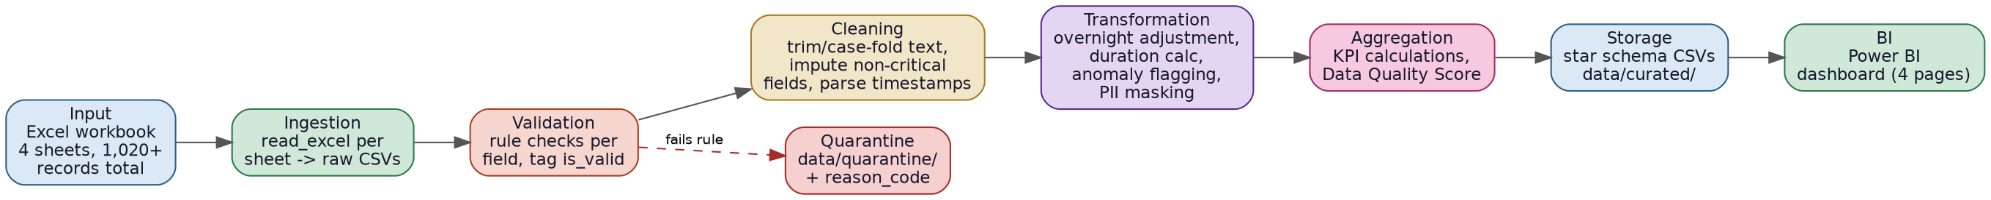
Figure 2 - Data flow from source data to reporting

• Schema validation is performed before downstream transformations.
• Validation produces explicit status and reason information.
• Hard-failure records are retained in quarantine instead of being silently discarded.
• Curated and quarantine outputs are reconciled against the input record population.
• The reporting layer is designed to exclude raw passenger-level PII.

6. Data Model
The project uses a flight-centric analytical model with reusable dimensions and separate booking/payment facts. The uploaded PBIX definition includes fact_flight_operations, cleaned_bookings_masked and cleaned_payments as report entities.
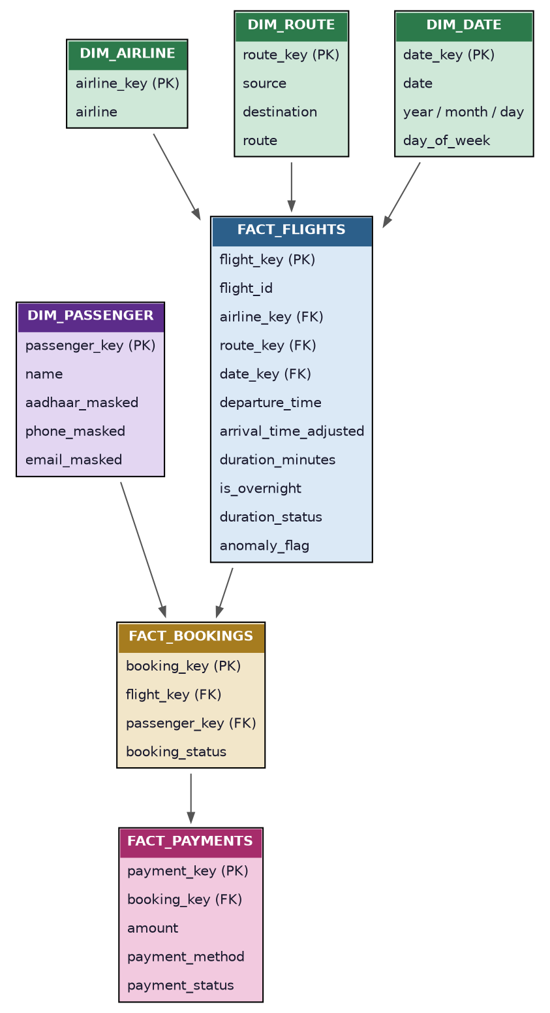
Figure 3 - Analytical data model
The flight fact is the primary reporting grain; airline, route and date dimensions support filtering, while booking and payment facts remain separate to avoid grain-related double counting.

7. Data Quality Issues

Issue | How it is detected | Treatment
Exact duplicates | Full-row duplicate check | Remove exact duplicates where the rule applies
Missing / placeholder values | Null and known-placeholder checks | Standardize when a deterministic replacement is justified
Flight identifiers | Pattern validation | Flag malformed values; do not guess repairs
Timestamp / duration anomalies | Datetime conversion and duration checks | Flag or quarantine invalid records
Duplicate / conflicting relationships | Key and referential checks | Retain separate grains; avoid unsafe joins
PII exposure | Column-level protection assertion | Mask, hash or exclude sensitive fields

Quality philosophy
The pipeline measures an issue before applying a fix. When the source does not provide enough evidence to safely correct a value, the record is flagged or quarantined rather than guessed.

Validation and treatment rules
• Exact duplicate rows are identified using complete-row comparison rather than flight_id alone.
• Known placeholders are standardized to consistent analytical categories.
• Malformed or incomplete identifiers are flagged instead of being silently rewritten.
• Negative or materially inconsistent duration calculations are classified as anomalies.
• Records that fail hard validation rules are preserved in the quarantine layer with reason codes.

8. Data Cleaning & Validation
Cleaning rules are applied only after validation. This keeps the process auditable and separates detection from correction.
Missing values and placeholders
• Non-critical missing categorical values are standardized to an explicit Unknown category when appropriate.
• Values that cannot be recovered from authoritative source data are retained as unknown or flagged.
• Invalid payment values are not replaced with arbitrary estimates.
Duplicate handling
• Exact full-row duplicates are removed from the relevant analytical output.
• Rows sharing a flight number are not automatically treated as duplicates if route or timestamps differ.
• The pipeline preserves evidence in quarantine where a record fails a hard validation rule.
Timestamp and referential validation
• Departure and arrival values are converted to proper datetime types.
• Calendar dates are retained so cross-day flights can be identified directly.
• Child-to-parent identifiers are checked where relationships are meaningful.
• Validation status and reason codes make failed records traceable.
Pipeline validation controls
• Schema checks protect ingestion from unexpected source structure.
• Duplicate checks protect downstream counts from accidental double counting.
• Reconciliation checks confirm that curated plus quarantined records account for the input population.
• PII assertions prevent sensitive column names from entering the flight-level fact.

9. Transformation Logic
Derived attribute | Logic / business meaning
route | Standardized source and destination combined into a route identifier.
departure_date | Calendar date extracted from departure timestamp.
departure_hour | Hour extracted from departure timestamp for departure-pattern analysis.
duration_minutes | Elapsed time between arrival and departure.
is_overnight | True when arrival date differs from departure date.
duration_status | Classifies the duration as usable, anomalous or requiring review.
anomaly_flag | Marks records requiring operational or data-quality review.

10. Flight Duration & Overnight Handling
Flight duration is calculated from timestamp differences rather than relying blindly on a source duration field. Because timestamps retain their calendar dates, an overnight flight can be handled without a manual midnight rollover.
• duration_minutes is derived from arrival_time minus departure_time.
• duration_hours can be derived from duration_minutes for readable charting.
• is_overnight is true when the arrival calendar date differs from the departure date.
• Negative or materially inconsistent durations are flagged as anomalies rather than silently corrected.
• The local prepared sample identified 29 overnight records and 9 anomaly records.

Overnight and anomaly interpretation
• Cross-day flights remain valid operational records when the timestamp sequence is valid.
• Anomaly flags are intended for investigation and data-quality visibility.
• A true scheduled-versus-actual delay cannot be calculated unless scheduled timestamps are present; the dashboard therefore uses available operational/anomaly indicators.

11. PII Protection
Passenger and booking domains may contain direct identifiers and contact information. The project applies data minimisation so the flight-level Power BI reporting layer does not require raw passenger PII.

Sensitive field category | Protection approach
Names | Excluded from the flight-level reporting layer
Aadhaar / passport | Hash with SHA-256 where a protected identifier is required
Email / phone | Mask in controlled inspection outputs
Date of birth | Kept outside the flight-level analytical serving layer
Emergency contacts | Excluded from analytics reporting

Protection controls
• Sensitive fields are separated from the reporting grain.
• Direct identifiers can be one-way hashed when controlled traceability is required.
• Contact information is masked rather than exposed in analytical outputs.
• A final assertion checks that protected PII column names do not enter the flight-level analytical fact.
• Raw PII should not be published in a public GitHub repository.
The protection strategy is based on minimising the amount of personal data carried into reporting. The flight-level fact contains operational fields needed for the dashboard rather than passenger identities or contact details.

12. Assumptions
• A duplicate means an exact full-row duplicate, not simply a repeated flight number.
• Repeated flight identifiers are retained when other operational fields show distinct records.
• An overnight flight is one whose arrival calendar date differs from its departure date.
• Duration anomalies are flagged when timestamp-derived duration is invalid or materially inconsistent.
• Missing values are not filled with guessed business values when no authoritative source exists.
• Flight-level KPIs must not be inflated by unsafe joins to booking-level data.
• Delay interpretation is limited by the timestamps available in the source data.

13. KPI Definitions

KPI | Definition / dashboard usage
Total Flights | Count of flight records used for operational reporting.
Review / Anomaly Flights | Count of records flagged for review or anomaly investigation.
Total Revenue | Aggregated revenue measure exposed by the implemented report where available.
Overnight Flights | Count of flights identified as overnight.
Average Flight Duration | Average usable flight duration.
Total Bookings | Booking volume associated with the reporting layer.
Total Routes | Count of distinct routes used in route analysis.
Average Route Duration | Average duration by route.
The KPI layer is designed to support operational monitoring while keeping each measure aligned to the appropriate reporting grain.

13. Power BI KPI Usage
• Average Flight Duration summarises usable flight durations for operational analysis.
• Route-wise Traffic counts flight operations by source-destination route.
• Anomaly / review counts surface records requiring investigation.
• Airline Distribution compares flight volume across airline groups.
• Overnight Flights provides visibility into cross-day operations.
• Route Duration compares average duration across routes.

14. Power BI Reporting
The submitted report is ASG_Airlines_Dashboard.pbix. Its report definition contains two implemented pages.

Flight Operations Control
• KPI cards: Total Flights, Review / Anomaly Flights, Total Revenue, Overnight Flights, Average Flight Duration and Total Bookings.
• Airline flight-count chart and route flight-count chart.
• Flight departure pattern by departure hour.
• Booking status distribution.
• Slicers for airline, departure date, destination and source.

Route Performance
• KPI cards: Total Routes, Total Bookings and Average Route Duration.
• Top 10 busiest routes.
• Route duration analysis.
• Booking volume by route.
• Source-destination pivot/matrix for route traffic comparison.
• Slicers for destination, source and airline.
The dashboard is designed around flight operations and route performance, while sensitive passenger-level fields remain outside the primary reporting grain.

15. Error Handling & Logging

Situation | How it is handled
Missing source file | Fail immediately with an explicit file-not-found error.
Missing sheet / schema mismatch | Stop ingestion and report the expected structure.
Invalid analytical record | Quarantine or flag with a reason instead of silently deleting it.
Unexpected reconciliation imbalance | Fail the pipeline control.
PII leakage | Fail the protection assertion before publishing analytical output.
Output not written | Verify expected files exist immediately after saving.

Operational logging
Structured Python logging provides visibility into ingestion, validation, transformation and output-writing stages. The run also produces quality and reconciliation information that can be inspected after execution.

16. Validation & Testing
The project includes automated tests for critical pipeline behaviour. The prepared local run completed successfully with reconciliation PASS and 9 automated tests passing.
Test / Control | Purpose
Schema validation | Protects the pipeline from unexpected source structure.
Duplicate checks | Prevents accidental double counting.
Timestamp / duration tests | Protects duration calculations and overnight handling.
Anomaly tests | Ensures invalid duration cases are flagged.
PII assertion | Prevents sensitive columns from entering the analytical fact.
Reconciliation | Ensures input records are accounted for by curated and quarantine outputs.

Prepared sample validation summary
Validation item | Result
Input records | 100
Curated records | 99
Quarantine records | 1
Reconciliation | PASS
Automated tests | 9 passed
DQ score | 99.00%

17. Final Output
Deliverable | Location / name
Python notebook | notebooks/ASG_Airlines_Pipeline.ipynb
Pipeline entry point | run_pipeline.py
Curated analytical data | data/curated/
Quarantine data | data/quarantine/
SQL schema / analytics | sql/
Power BI report | powerbi/ASG_Airlines_Dashboard.pbix
Power BI measures / theme | powerbi/
Documentation | docs/
Automated tests | tests/

The submitted PBIX implements the two documented report pages: Flight Operations Control and Route Performance. The pipeline, curated data, quarantine outputs, SQL definitions, Power BI assets and tests are maintained as separate project components.

Conclusion
The ASG Airlines solution converts operational airline data into a controlled analytical layer and a Power BI reporting experience. The engineering approach prioritises validation before cleaning, explicit anomaly handling, safe duration calculation, data minimisation and reproducibility.
The reporting layer extends the curated model into operational and route analysis through KPI cards, airline and route visuals, departure-pattern analysis, booking analysis, slicers and route-level comparison.
The project is structured so that the pipeline, tests, documentation, analytical outputs and reporting layer can be inspected independently and maintained as the source data evolves.

