ASG AIRLINES
End-to-End Data Engineering Pipeline
Case Study Technical Documentation — Public-Safe Reference Package

1. Executive Summary
This project implements a reproducible local Python/SQL data-engineering pipeline for ASG Airlines operational flight data. The pipeline ingests the workbook, validates required fields, quarantines hard failures with reason codes, standardises text and timestamps, calculates duration across midnight, classifies anomalies, and produces curated Power BI-ready outputs. Supporting passenger and booking/payment data are protected before analytical consumption.
The public package uses a synthetic sample dataset. The measured smoke-test run contains 100 input flight records, 99 curated records, 1 quarantined record, 29 overnight flights, 9 anomaly records, a 99.00% Data Quality Score, and a PASS reconciliation check. These numbers are sample targets only; they must be replaced by measured values when the competition workbook is processed locally.

2. Business Problem
Operational flight feeds can contain malformed identifiers, missing values, inconsistent timestamps, duplicate rows, and cross-day flights. Without explicit validation and transformation rules, duration and route KPIs can be wrong and downstream reporting can lose trust.

3. Objectives
- Ingest flights, bookings, passengers and payments from the source workbook.
- Validate required fields and route hard failures to quarantine.
- Standardise categorical values and timestamps.
- Correctly calculate same-day and overnight flight duration.
- Mask or hash sensitive passenger/booking fields before analytical use.
- Produce a curated analytical model and KPI outputs for Power BI.
- Provide tests, reconciliation, documentation and run instructions.

4. Technology Stack
Primary implementation: Python, pandas, pytest and SQL. The local implementation is reproducible without Azure services. The architecture can be migrated to Azure Data Factory, ADLS Gen2, Databricks/Spark and a warehouse/lakehouse at production scale.

5. Solution Architecture
Source workbook → ingestion → validation/data-quality checks → quarantine for hard failures → cleaning/transformation → curated analytical layer → SQL/KPI layer → Power BI.
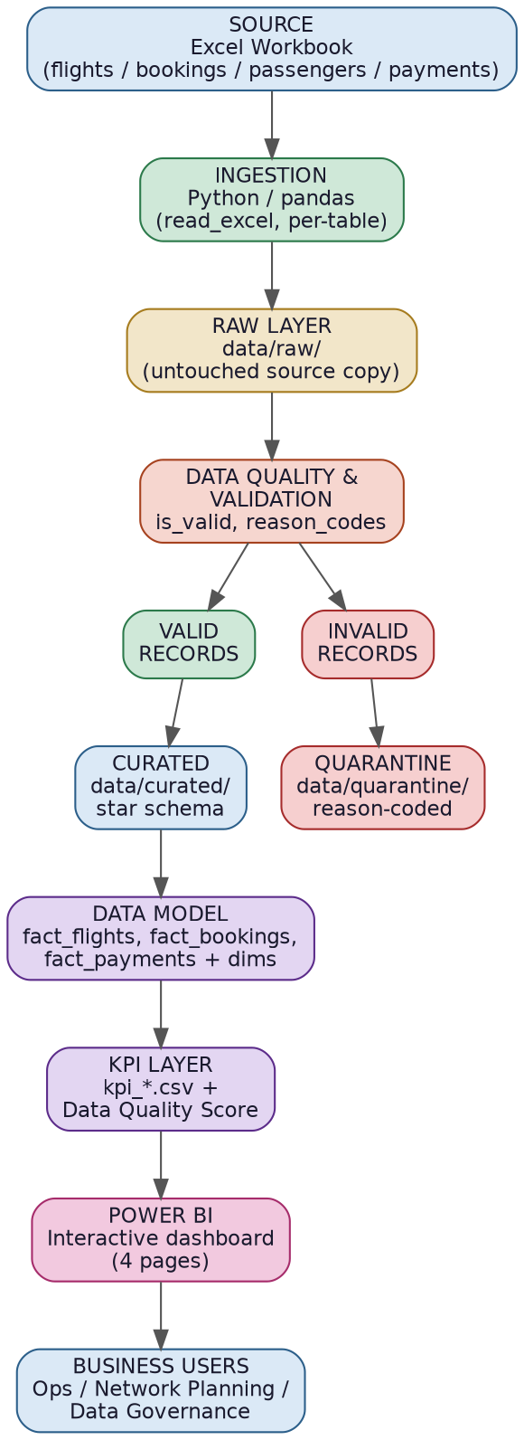
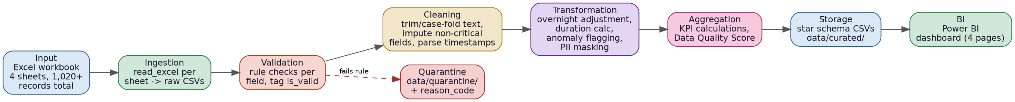
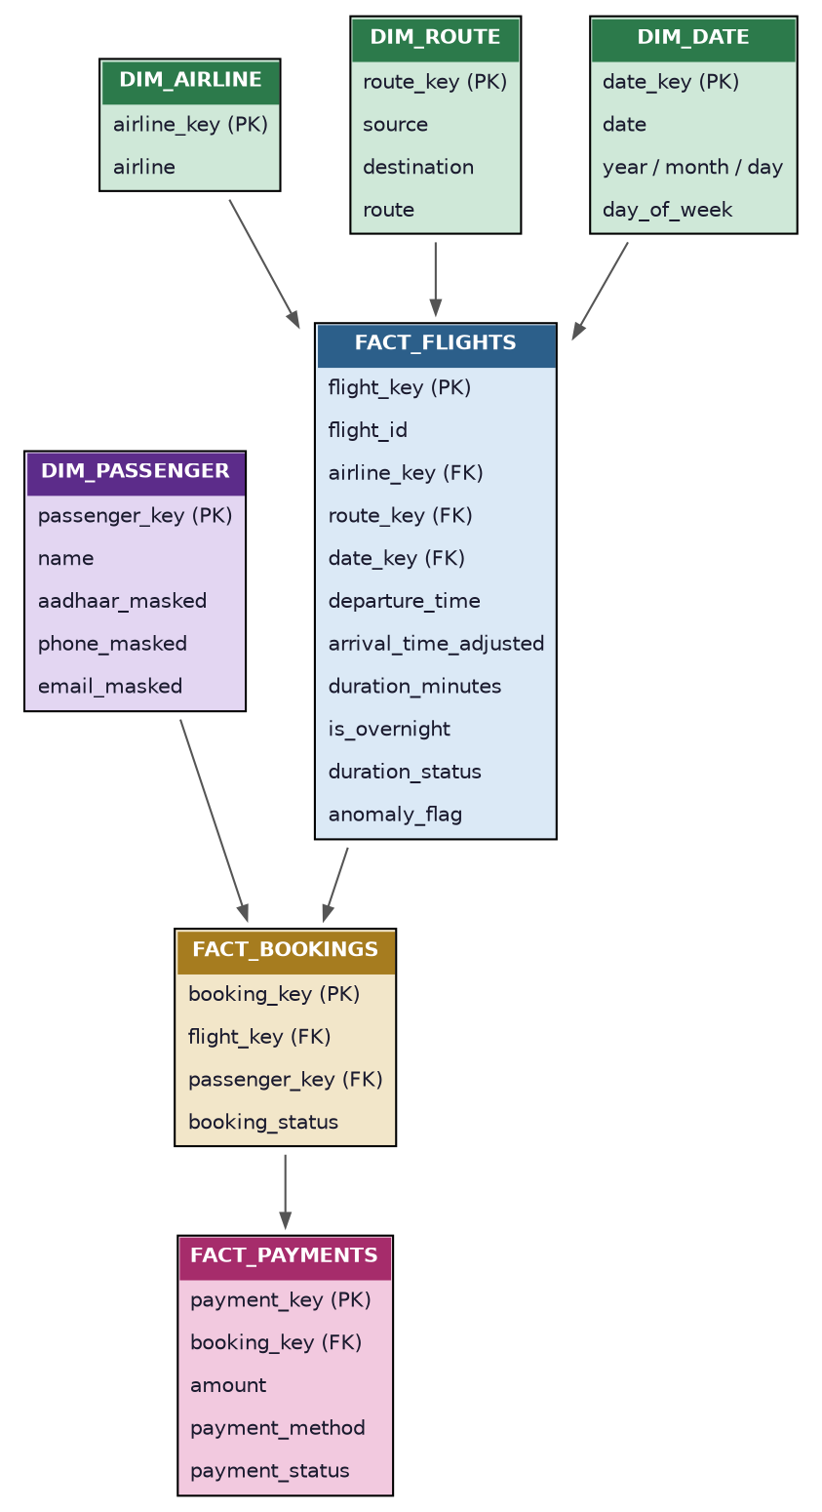

6. Data Quality Strategy
Hard failures include missing/malformed flight IDs, missing source/destination, missing timestamps, corrupted timestamps and duplicate records. Missing/unknown airline is treated as a soft issue: the value is standardised to Unknown and an airline quality flag is retained.
The pipeline Data Quality Score is: 0.30 × Completeness + 0.30 × Validity + 0.20 × Uniqueness + 0.20 × Consistency. The Power BI DQ card reads the measured score from dq_metrics.csv so the dashboard does not implement a competing formula.

7. Transformation Logic
Flight duration is calculated from departure_time to arrival_time_adjusted. If arrival is earlier than departure, one day is added defensively. is_overnight is true when the adjusted arrival date differs from the departure date. Durations above the dataset-informed suspicious threshold are flagged rather than silently discarded. Corrupted timestamps are quarantined during validation.

8. Curated Model
The curated layer contains FactFlights plus DimAirline, DimRoute and DimDate. FactBookings and FactPayments extend the model, while DimPassenger contains masked/synthetic analytical fields. FactFlights exposes airline_key, route_key and date_key so the dimensional relationships used by the SQL schema and Power BI guide are aligned with the actual CSV serving layer.

9. KPI Definitions
- Total Flights — distinct curated flight IDs.
- Average Flight Duration — mean duration_minutes for curated flights.
- Route-wise Traffic — curated flight count by route.
- Airline Distribution — curated flight count/share by airline.
- Overnight Flight Share — overnight curated flights divided by curated flights.
- Anomaly Rate — curated flights classified ANOMALY divided by curated flights.
- Data Quality Score — weighted pipeline quality score described above.
The base source schema does not provide scheduled-vs-actual timestamps, so a numeric delay measure is not fabricated. Anomaly reporting is used for data/operational quality signals instead.

10. Privacy and Governance
The source workbook contains sensitive-looking passenger and booking fields. The public package excludes the raw source folder. Curated passenger/booking outputs use masked or hashed values and the flight-operations dashboard does not require raw identity fields. Do not publish raw Aadhaar, passport, phone, email or emergency-contact information.

11. Testing and Controls
The current test suite contains 9 tests covering same-day duration, overnight duration, missing timestamps, invalid IDs, duplicates, corrupted timestamps, same-airport validation and reconciliation. A smoke-test run should finish with reconciliation PASS and all tests passing.

12. Power BI
The Power BI build guide defines four pages: Executive Operations, Route Performance, Airline Performance and Data Quality Command Center. The package includes DAX measures, a theme and reference designs. The reference PNGs are mockups, not genuine Power BI screenshots; a real report must be built and captured in Power BI Desktop.

13. Run Instructions
pip install -r requirements.txt
python run_pipeline.py
pytest -q

14. Current Sample Smoke-Test Results
Metric | Measured sample value
Input Flights | 100
Curated Flights | 99
Quarantined Flights | 1
Average Flight Duration | 140.93 min
Overnight Flights | 29
Anomaly Rate | 9.09%
DQ Score | 99.00%
Reconciliation | PASS
Tests | 9 passed

15. Limitations and Production Evolution
The public package intentionally uses synthetic sample data. The competition source should be processed locally and its measured results should be used for the final dashboard. For production scale, the same validation contracts and transformations can be implemented with distributed Spark processing and managed orchestration/storage.

