AI Sales & Lead Intelligence Platform - Execution Screenshots
These screenshots demonstrate the successful execution of the project. You can upload this document to your GitHub repository under a folder like `docs/` or use the images directly in your README.md.

Outreach Tab - Application Running
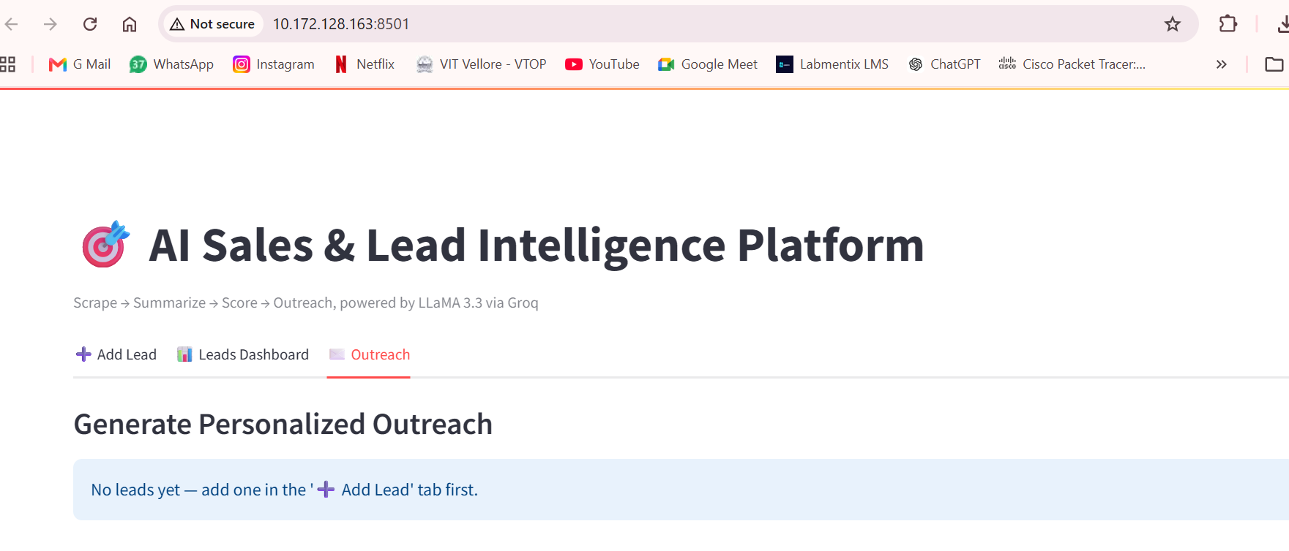
Outreach Tab - Application Running

Leads Dashboard - Application Running
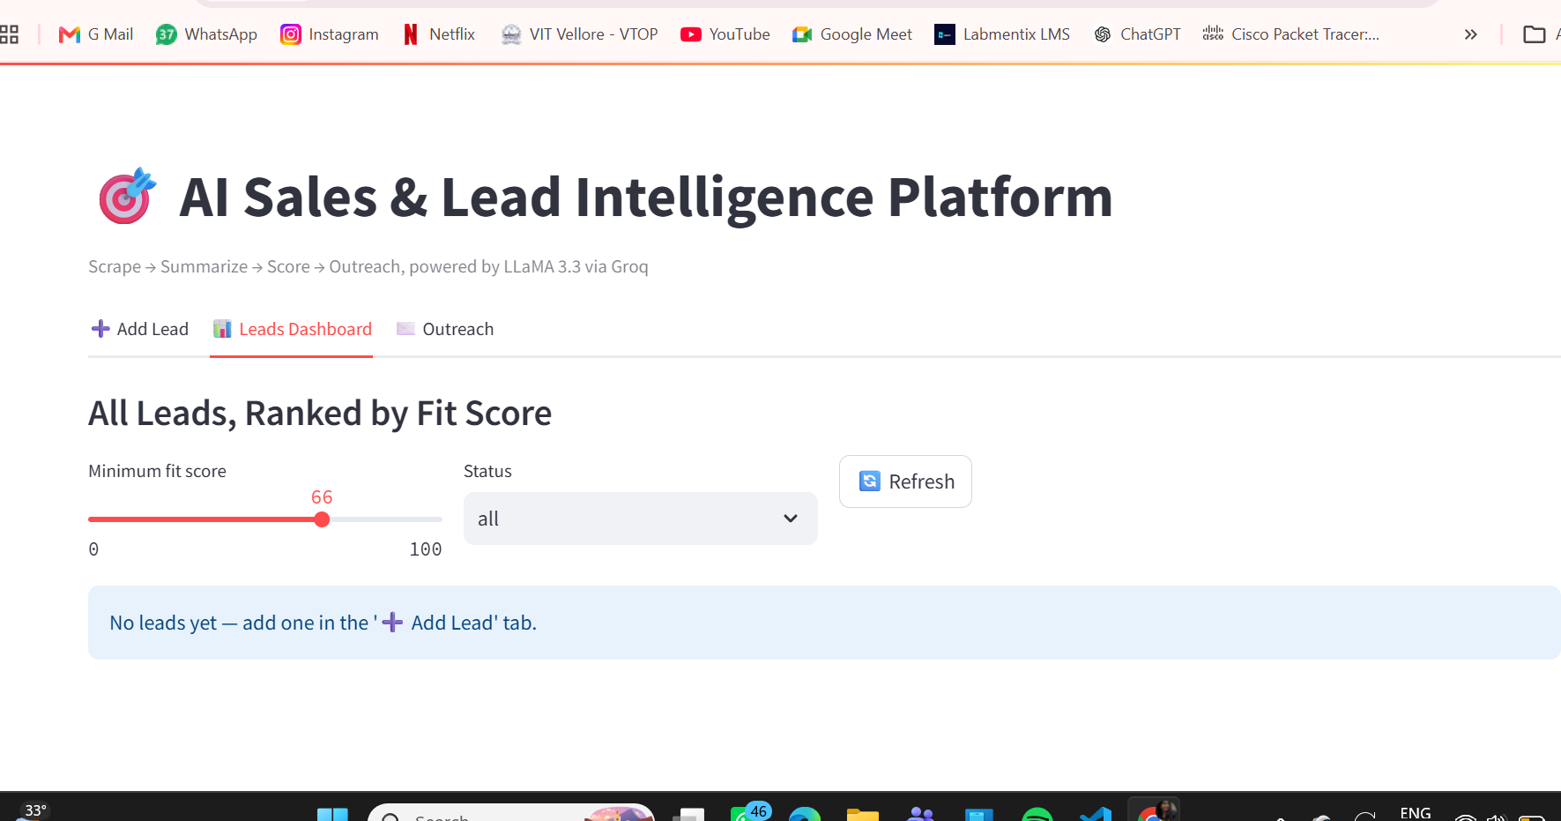
Leads Dashboard - Application Running

