**EXP NO:** **10**

**INTRODUCTION TO PROLOG**

**DATE: 08.05.2024**

**AIM:**

To learn PROLOG terminologies and write basic programs.

**TERMINOLOGIES:**

**1. Atomic Terms: -**

Atomic terms are usually strings made up of lower- and

uppercase letters, digits, and the underscore, starting with a

lowercase letter.

Ex:

dog

ab_c_321

**2. Variables: -**

Variables are strings of letters, digits, and the underscore,

starting with a capital letter or an underscore.

Ex:

Dog

Apple_420

**3. Compound Terms: -**

Compound terms are made up of a PROLOG atom and a

number of arguments (PROLOG terms, i.e., atoms, numbers,

variables, or other compound terms) enclosed in parentheses

and separated by commas.

Ex:

**4. Facts: -**

is_bigger(elephant,X)

f(g(X,_),7)

A fact is a predicate followed by a dot.

Ex:

bigger_animal(whale).

life_is_beautiful.

**5. Rules: -**

A rule consists of a head (a predicate) and a body (a sequence

of predicates separated by commas).

Ex:

is_smaller(X,Y):-is_bigger(Y,X).

aunt(Aunt,Child):-sister(Aunt,Parent),parent(Parent,Child)

**SOURCE CODING:**

**KB1:**

woman(mia).

woman(jody).

woman(yolanda).

playsAirGuitar(jody).

party.

# OUTPUT:

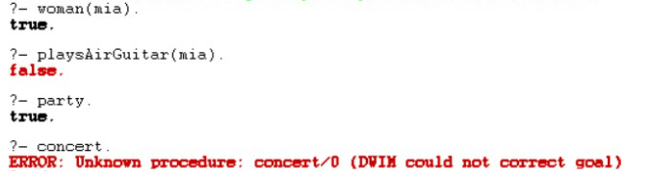

**KB2:**

happy(yolanda).

listens2music(mia).

Listens2music(yolanda):-happy(yolanda).

playsAirGuitar(mia):-listens2music(mia).

playsAirGuitar(Yolanda):-listens2music(yolanda).

# 

# OUTPUT:

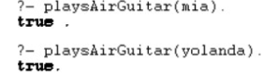

**KB3:**

likes(dan,sally).

likes(sally,dan).

likes(john,brittney).

married(X,Y) :- likes(X,Y) , likes(Y,X).

friends(X,Y) :- likes(X,Y) ; likes(Y,X).

# OUTPUT:

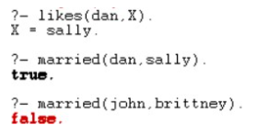

**KB4:**

food(burger).

food(sandwich).

food(pizza).

lunch(sandwich).

dinner(pizza).

meal(X):-food(X).

# 

# OUTPUT:

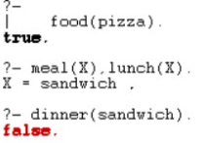

**KB5:**

owns(jack,car(bmw)).

owns(john,car(chevy)).

owns(olivia,car(civic)).

owns(jane,car(chevy)).

sedan(car(bmw)).

sedan(car(civic)).

truck(car(chevy)).

# OUTPUT:

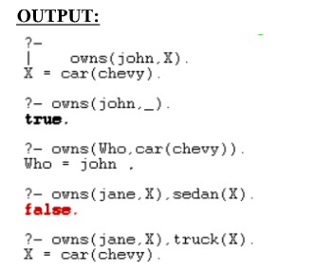

**KB6:**

% Rules to find the minimum of two numbers

min(X, Y, Min) :-

    X =< Y,

    Min is X.

min(X, Y, Min) :-

    X > Y,

    Min is Y.

% Rules to find the maximum of two numbers

max(X, Y, Max) :-

    X >= Y,

    Max is X.

max(X, Y, Max) :-

    X < Y,

    Max is Y.

# OUTPUT:

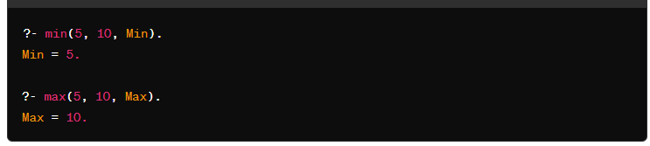

**KB7:**

% Existing facts

likes(mary, food).

likes(mary, wine).

likes(john, wine).

likes(john, mary).

% New facts

likes(john, X) :- likes(mary, X).         % John likes anything that Mary likes

likes(john, Y) :- likes(Y, wine).          % John likes anyone who likes wine

likes(john, Z) :- likes(Z, Z).             % John likes anyone who likes themselves

**OUTPUT:**

query:

?- likes(mary,food).

 yes.

?- likes(john,wine).

 yes.

?- likes(john,food).

 no.

?- likes(john,X).

X = wine .

?- likes(john,Y).

Y = wine .

?- likes(john,Z).

Z = wine

**RESULT:**

Thus to learn PROLOG terminologies has been executed successfully.