INTERNSHIP[JAVA DEVELOPMENT]
NAME : JANANI K

REGISTER NUMBER : 732424104040

DEGREE : BACHELOR OF EDUCATION

DEPARTMENT : COMPUTER SCIENCE AND ENGINEERING

DATE : 15-12-2025

-----------------------------------------------------
BASIC LEVEL PROJECT
----------------------------------------------------
Project Title: Daily Habit Tracker (Console Application)

CODE:
package healthhabits;
import java.util.Scanner;
public class HabitTrackers {
static Scanner sc = new Scanner(System.in);
static String[] habits = new String[10];
static boolean[] completed = new boolean[10];
static int count = 0;
static int weeklyScore = 0;
public static void main(String[] args) {
int choice;
do {
System.out.println("\n=== Daily Habit Tracker ===");
System.out.println("1. Add Habit");
System.out.println("2. Mark Habit Completed");
System.out.println("3. View Habits");
System.out.println("4. Weekly Score");
System.out.println("5. Exit");
System.out.print("Enter choice: ");
choice = sc.nextInt();
sc.nextLine();
if (choice == 1) addHabit();
else if (choice == 2) markHabit();
else if (choice == 3) viewHabits();
else if (choice == 4) showScore();
} while (choice != 5);
System.out.println("Goodbye! Keep building good habits 💪");
}
static void addHabit() {
System.out.print("Enter habit name: ");
habits[count] = sc.nextLine();
completed[count] = false;
count++;
System.out.println("Habit added!");
}
static void markHabit() {
viewHabits();
System.out.print("Enter habit number to mark completed: ");
int index = sc.nextInt();
if (index > 0 && index <= count) {
completed[index - 1] = true;
weeklyScore++;
System.out.println("Habit marked completed!");
} else {
System.out.println("Invalid number.");
}
}
static void viewHabits() {
if (count == 0) {
System.out.println("No habits yet.");
} else {
for (int i = 0; i < count; i++) {
System.out.println((i + 1) + ". " + habits[i] + " - " +
(completed[i] ? "Completed ✅" : "Pending ⏳"));
}
}
}
static void showScore() {
System.out.println("Weekly Habit Score: " + weeklyScore);
}
}

Output:
------ Daily Habit Tracker ------
1. Add Habit
2. Mark Habit Completed
3. View Habits
4. Weekly Score
5. Exit
Enter choice: 1
Enter habit name: Singing
Habit added!

------- Daily Habit Tracker -------
1. Add Habit
2. Mark Habit Completed
3. View Habits
4. Weekly Score
5. Exit
Enter choice: 1
Enter habit name: Playing
Habit added!

-------Daily Habit Tracker-------
1. Add Habit
2. Mark Habit Completed
3. View Habits
4. Weekly Score
5. Exit
Enter choice: 1
Enter habit name: Eating
Habit added!

------- Daily Habit Tracker -------
1. Add Habit
2. Mark Habit Completed
3. View Habits
4. Weekly Score
5. Exit
Enter choice: 2
1. Singing - Pending ⏳
2. Playing - Pending ⏳
3. Eating - Pending ⏳
Enter habit number to mark completed: 1
Habit marked completed!

-------Daily Habit Tracker -------
1. Add Habit
2. Mark Habit Completed
3. View Habits
4. Weekly Score
5. Exit
Enter choice: 2
1. Singing - Completed ✅
2. Playing - Pending ⏳
3. Eating - Pending ⏳
Enter habit number to mark completed: 2 3
Habit marked completed!

------- Habit Tracker -------
1. Add Habit
2. Mark Habit Completed
3. View Habits
4. Weekly Score
5. Exit
Enter choice: 1. Singing - Completed ✅
2. Playing - Completed ✅
3. Eating - Pending ⏳

------- Daily Habit Tracker -------
1. Add Habit
2. Mark Habit Completed
3. View Habits
4. Weekly Score
5. Exit
Enter choice: 2
1. Singing - Completed ✅
2. Playing - Completed ✅
3. Eating - Pending ⏳
Enter habit number to mark completed: 3
Habit marked completed!

------- Daily Habit Tracker -------
1. Add Habit
2. Mark Habit Completed
3. View Habits
4. Weekly Score
5. Exit
Enter choice: 3
1. Singing - Completed ✅
2. Playing - Completed ✅
3. Eating - Completed ✅

------- Daily Habit Tracker -------
1. Add Habit
2. Mark Habit Completed
3. View Habits
4. Weekly Score
5. Exit
Enter choice: 4
Weekly Habit Score: 3

------- Daily Habit Tracker -------
1. Add Habit
2. Mark Habit Completed
3. View Habits
4. Weekly Score
5. Exit
Enter choice: 5
Goodbye! Keep building good habits 💪

-------------------------------------------------------------------
MEDIUM LEVEL PROJECT
------------------------------------------------------------
Project Title: Expense Splitter (Mini Splitwise Console App)

CODE:
package expense;
import java.util.*;
public class amount {
static class User {
int id;
String name;
User(int id, String name) { this.id = id; this.name = name; }
public String toString() { return id + " - " + name; }
}
static class Expense {
int payerId;
double amount;
String description;
List<Integer> participants;
Expense(int payerId, double amount, String description, List<Integer> participants) {
this.payerId = payerId;
this.amount = amount;
this.description = description;
this.participants = participants;
}
public String toString() {
return "Expense: " + description + " | Amount: " + amount +
" | Payer: " + payerId + " | Participants: " + participants;
}
}
static class ExpenseManager {
int nextUserId = 1;
Map<Integer, User> users = new HashMap<>();
List<Expense> expenses = new ArrayList<>();
Map<Integer, Double> balances = new HashMap<>();
User addUser(String name) {
User u = new User(nextUserId, name);
users.put(nextUserId, u);
balances.put(nextUserId, 0.0);
nextUserId++;
System.out.println("Added: " + u);
return u;
}
void addExpense(int payerId, double amount, String desc, List<Integer> participants) {
if (participants == null || participants.isEmpty()) {
System.out.println("Error: participants cannot be empty.");
return;
}
if (!users.containsKey(payerId)) {
System.out.println("Error: payer id " + payerId + " does not exist.");
return;
}
for (int pid : participants) {
if (!users.containsKey(pid)) {
System.out.println("Error: participant id " + pid + " does not exist.");
return;
}
}
Expense e = new Expense(payerId, amount, desc, participants);
expenses.add(e);
double share = amount / participants.size();
for (int pid : participants) {
balances.put(payerId, balances.getOrDefault(payerId, 0.0) + share);
balances.put(pid, balances.getOrDefault(pid, 0.0) - share);
}
System.out.println("Expense added: " + e);
}
void showUsers() {
if (users.isEmpty()) { System.out.println("No users."); return; }
System.out.println("Users:");
for (User u : users.values()) System.out.println(" - " + u);
}
void showExpenses() {
if (expenses.isEmpty()) { System.out.println("No expenses."); return; }
System.out.println("Expenses:");
for (Expense e : expenses) System.out.println(" - " + e);
}
void showSummary() {
if (balances.isEmpty()) { System.out.println("No balances yet."); return; }
System.out.println("\nSettlement Summary:");
for (int id : balances.keySet()) {
double bal = Math.round(balances.get(id) * 100.0) / 100.0;
if (bal > 0) System.out.println(users.get(id).name + " should RECEIVE ₹" + bal);
else if (bal < 0) System.out.println(users.get(id).name + " should PAY ₹" + (-bal));
else System.out.println(users.get(id).name + " is SETTLED.");
}
}
}
public static void main(String[] args) {
Scanner sc = new Scanner(System.in);
ExpenseManager manager = new ExpenseManager();
while (true) {
System.out.println("\nMenu:");
System.out.println("1. Add User");
System.out.println("2. Add Expense");
System.out.println("3. Show Users");
System.out.println("4. Show Expenses");
System.out.println("5. Show Summary");
System.out.println("6. Exit");
System.out.print("Choose: ");
if (!sc.hasNextInt()) { sc.nextLine(); System.out.println("Invalid choice."); continue; }
int choice = sc.nextInt();
sc.nextLine();
switch (choice) {
case 1 -> {
System.out.print("Enter user name: ");
String name = sc.nextLine().trim();
if (name.isEmpty()) { System.out.println("Name cannot be empty."); break; }
manager.addUser(name);
}
case 2 -> {
System.out.print("Enter payer id: ");
if (!sc.hasNextInt()) { sc.nextLine(); System.out.println("Invalid payer id."); break; }
int payer = sc.nextInt();
System.out.print("Enter amount: ");
if (!sc.hasNextDouble()) { sc.nextLine(); System.out.println("Invalid amount."); break; }
double amt = sc.nextDouble();
sc.nextLine();
System.out.print("Enter description: ");
String desc = sc.nextLine().trim();
System.out.print("Enter participant ids (comma separated): ");
String[] parts = sc.nextLine().split(",");
List<Integer> pids = new ArrayList<>();
for (String s : parts) {
s = s.trim();
if (s.isEmpty()) continue;
try { pids.add(Integer.parseInt(s)); }
catch (NumberFormatException ex) { System.out.println("Invalid id: " + s); }
}
manager.addExpense(payer, amt, desc, pids);
}
case 3 -> manager.showUsers();
case 4 -> manager.showExpenses();
case 5 -> manager.showSummary();
case 6 -> {
System.out.println("Exiting...");
sc.close();
return;
}
default -> System.out.println("Invalid choice!");
}
}
}
}

Output:
Menu:
1. Add User
2. Add Expense
3. Show Users
4. Show Expenses
5. Show Summary
6. Exit
Choose: 1
Enter user name: john
Added: 1 - joh
Menu:
1. Add User
2. Add Expense
3. Show Users
4. Show Expenses
5. Show Summary
6. Exit
Choose: 1
Enter user name: daniel
Added: 2 - daniel
Menu:
1. Add User
2. Add Expense
3. Show Users
4. Show Expenses
5. Show Summary
6. Exit
Choose: 2
Enter payer id: 1
Enter amount: 2000
Enter description: lunch
Enter participant ids (comma separated): 1,2
Expense added: Expense: lunch | Amount: 2000.0 | Payer: 1 | Participants: [1, 2]
Menu:
1. Add User
2. Add Expense
3. Show Users
4. Show Expenses
5. Show Summary
6. Exit
Choose: 3
Users:
- 1 - john
- 2 - daniel
Menu:
1. Add User
2. Add Expense
3. Show Users
4. Show Expenses
5. Show Summary
6. Exit
Choose: 4
Expenses:
- Expense: lunch | Amount: 2000.0 | Payer: 1 | Participants: [1, 2]
Menu:
1. Add User
2. Add Expense
3. Show Users
4. Show Expenses
5. Show Summary
6. Exit
Choose: 5
Settlement Summary:
john should RECEIVE ₹1000.0
daniel should PAY ₹1000.0
Menu:
1. Add User
2. Add Expense
3. Show Users
4. Show Expenses
5. Show Summary
6. Exit
Choose: 6
Exiting...

--------------------------------------------------------
ADVANCED LEVEL PROJECT
-------------------------------------------------------
Project Title: Smart Parking Lot System

CODE:
package Vehicle;
import java.io.*;
import java.time.*;
import java.util.*;
public class SmartParkingSystem {
static class NoSlotAvailableException extends Exception {
public NoSlotAvailableException(String msg) { super(msg); }
}
static class VehicleNotFoundException extends Exception {
public VehicleNotFoundException(String msg) { super(msg); }
}
static class Vehicle {
String plate;
String type;
LocalDateTime entryTime;

Vehicle(String plate, String type) {
this.plate = plate;
this.type = type;
this.entryTime = LocalDateTime.now();
}
}
static class Ticket {
Vehicle vehicle;
int slotId;
LocalDateTime exitTime;
double charges;
Ticket(Vehicle v, int slotId) {
this.vehicle = v;
this.slotId = slotId;
}
void checkout() {
this.exitTime = LocalDateTime.now();
Duration d = Duration.between(vehicle.entryTime, exitTime);
long hours = Math.max(1, d.toMinutes()/60); // minimum 1 hr
charges = calculateCharges(vehicle.type, hours);
}
private double calculateCharges(String type, long hours) {
switch(type) {
case "CAR": return hours * 40;
case "BIKE": return hours * 20;
case "TRUCK": return hours * 75;
default: return hours * 30;
}
}
public String toString() {
return "Ticket: Plate=" + vehicle.plate +
", Type=" + vehicle.type +
", Slot=" + slotId +
", Entry=" + vehicle.entryTime +
", Exit=" + exitTime +
", Charges=₹" + charges;
}
}
static class ParkingLot {
int totalSlots;
Map<String, Ticket> activeTickets = new HashMap<>();
Set<Integer> occupiedSlots = new HashSet<>();
ParkingLot(int slots) { this.totalSlots = slots; }
void addVehicle(String plate, String type) throws NoSlotAvailableException {
int slotId = findFreeSlot();
if(slotId == -1) throw new NoSlotAvailableException("No free slots available!");
Vehicle v = new Vehicle(plate, type);
Ticket t = new Ticket(v, slotId);
activeTickets.put(plate, t);
occupiedSlots.add(slotId);
System.out.println("Vehicle parked: " + plate + " at Slot " + slotId);
saveToFile("tickets.txt", "PARKED: " + t);
}
void removeVehicle(String plate) throws VehicleNotFoundException {
if(!activeTickets.containsKey(plate)) throw new VehicleNotFoundException("Vehicle not found!");
Ticket t = activeTickets.get(plate);
t.checkout();
occupiedSlots.remove(t.slotId);
activeTickets.remove(plate);
System.out.println("Vehicle removed: " + plate);
System.out.println(t);
saveToFile("tickets.txt", "REMOVED: " + t);
}
int findFreeSlot() {
for(int i=1;i<=totalSlots;i++) {
if(!occupiedSlots.contains(i)) return i;
}
return -1;
}
void showStatus() {
System.out.println("Total Slots: " + totalSlots);
System.out.println("Occupied: " + occupiedSlots.size());
System.out.println("Free: " + (totalSlots - occupiedSlots.size()));
}
void saveToFile(String filename, String data) {
try(FileWriter fw = new FileWriter(filename, true)) {
fw.write(data + "\n");
} catch(IOException e) {
System.out.println("File error: " + e.getMessage());
}
}
}
public static void main(String[] args) {
ParkingLot lot = new ParkingLot(5); // 5 slots
Scanner sc = new Scanner(System.in);
while(true) {
System.out.println("\n1.Add Vehicle 2.Remove Vehicle 3.Status 0.Exit");
if (!sc.hasNextInt()) {
System.out.println("Enter a valid choice number.");
sc.next();
continue;
}
int choice = sc.nextInt();
try {
if(choice==1) {
System.out.print("Enter plate: ");
String plate = sc.next();
System.out.print("Enter type (CAR/BIKE/TRUCK): ");
String type = sc.next().toUpperCase();
lot.addVehicle(plate, type);
} else if(choice==2) {
System.out.print("Enter plate: ");
String plate = sc.next();
lot.removeVehicle(plate);
} else if(choice==3) {
lot.showStatus();
} else if(choice==0) {
break;
} else {
System.out.println("Invalid choice.");
}
} catch(Exception e) {
System.out.println("Error: " + e.getMessage());
}
}
sc.close();
}
}

Output:
1.Add Vehicle 2.Remove Vehicle 3.Status 0.Exit
1
Enter plate: TN38BT5650
Enter type (CAR/BIKE/TRUCK): Bike
Vehicle parked: TN38BT5650 at Slot 1
------------------------------------------------------------------------------
1.Add Vehicle 2.Remove Vehicle 3.Status 0.Exit
1
Enter plate: TN40DJ1201
Enter type (CAR/BIKE/TRUCK): Car
Vehicle parked: TN40DJ1201 at Slot 2
-------------------------------------------------------------------------------
1.Add Vehicle 2.Remove Vehicle 3.Status 0.Exit
1
Enter plate: TN39JD1201
Enter type (CAR/BIKE/TRUCK): Bike
Vehicle parked: TN39JD1201 at Slot 3
--------------------------------------------------------------------------------
1.Add Vehicle 2.Remove Vehicle 3.Status 0.Exit
3
Total Slots: 5
Occupied: 3
Free: 2
-----------------------------------------------------------------------------
1.Add Vehicle 2.Remove Vehicle 3.Status 0.Exit
1
Enter plate: TN78YI7896
Enter type (CAR/BIKE/TRUCK): Car
Vehicle parked: TN78YI7896 at Slot 4
----------------------------------------------------------------------------
1.Add Vehicle 2.Remove Vehicle 3.Status 0.Exit
1
Enter plate: TN42KG2520
Enter type (CAR/BIKE/TRUCK): Bike
Vehicle parked: TN42KG2520 at Slot 5
-----------------------------------------------------------------------------
1.Add Vehicle 2.Remove Vehicle 3.Status 0.Exit
3
Total Slots: 5
Occupied: 5
Free: 0
-----------------------------------------------------------------------------
1.Add Vehicle 2.Remove Vehicle 3.Status 0.Exit
2
Enter plate: TN42KG2520
Vehicle removed: TN42KG2520
Ticket: Plate=TN42KG2520, Type=BIKE, Slot=5, Entry=2025-12-15T22:56:40.445411, Exit=2025-12-15T22:57:05.154631400, Charges=₹20.0
--------------------------------------------------------------------------------
1.Add Vehicle 2.Remove Vehicle 3.Status 0.Exit
3
Total Slots: 5
Occupied: 4
Free: 1
1.Add Vehicle 2.Remove Vehicle 3.Status 0.Exit
0
Screenshot: Basic Level
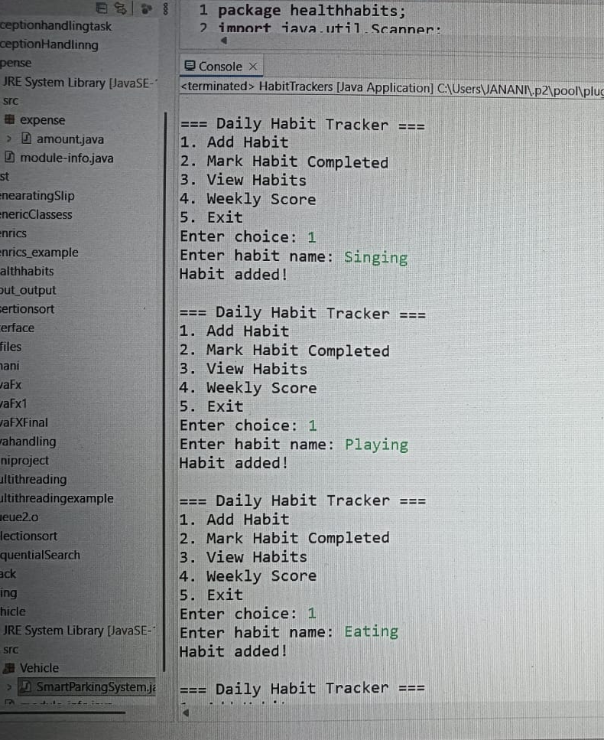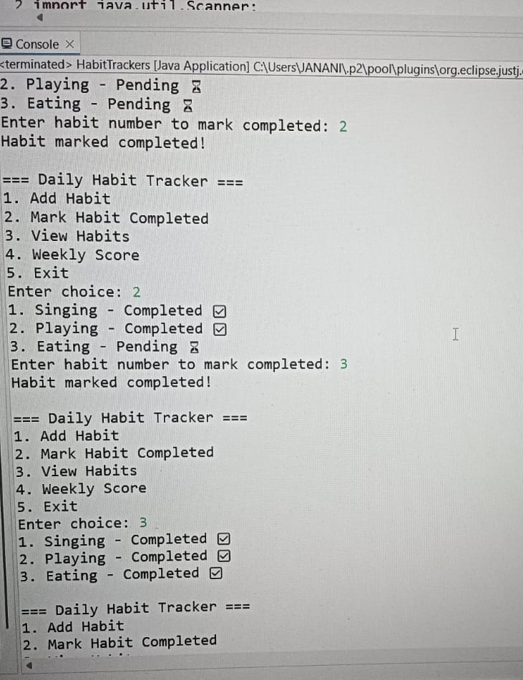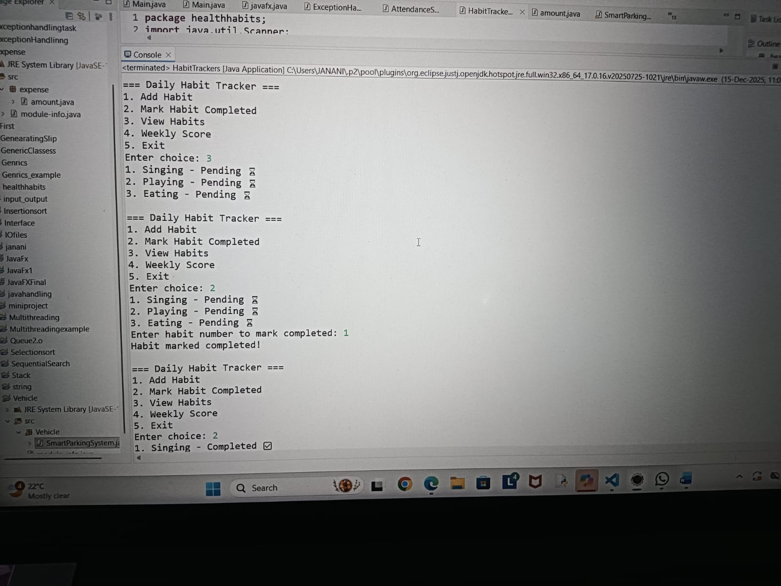

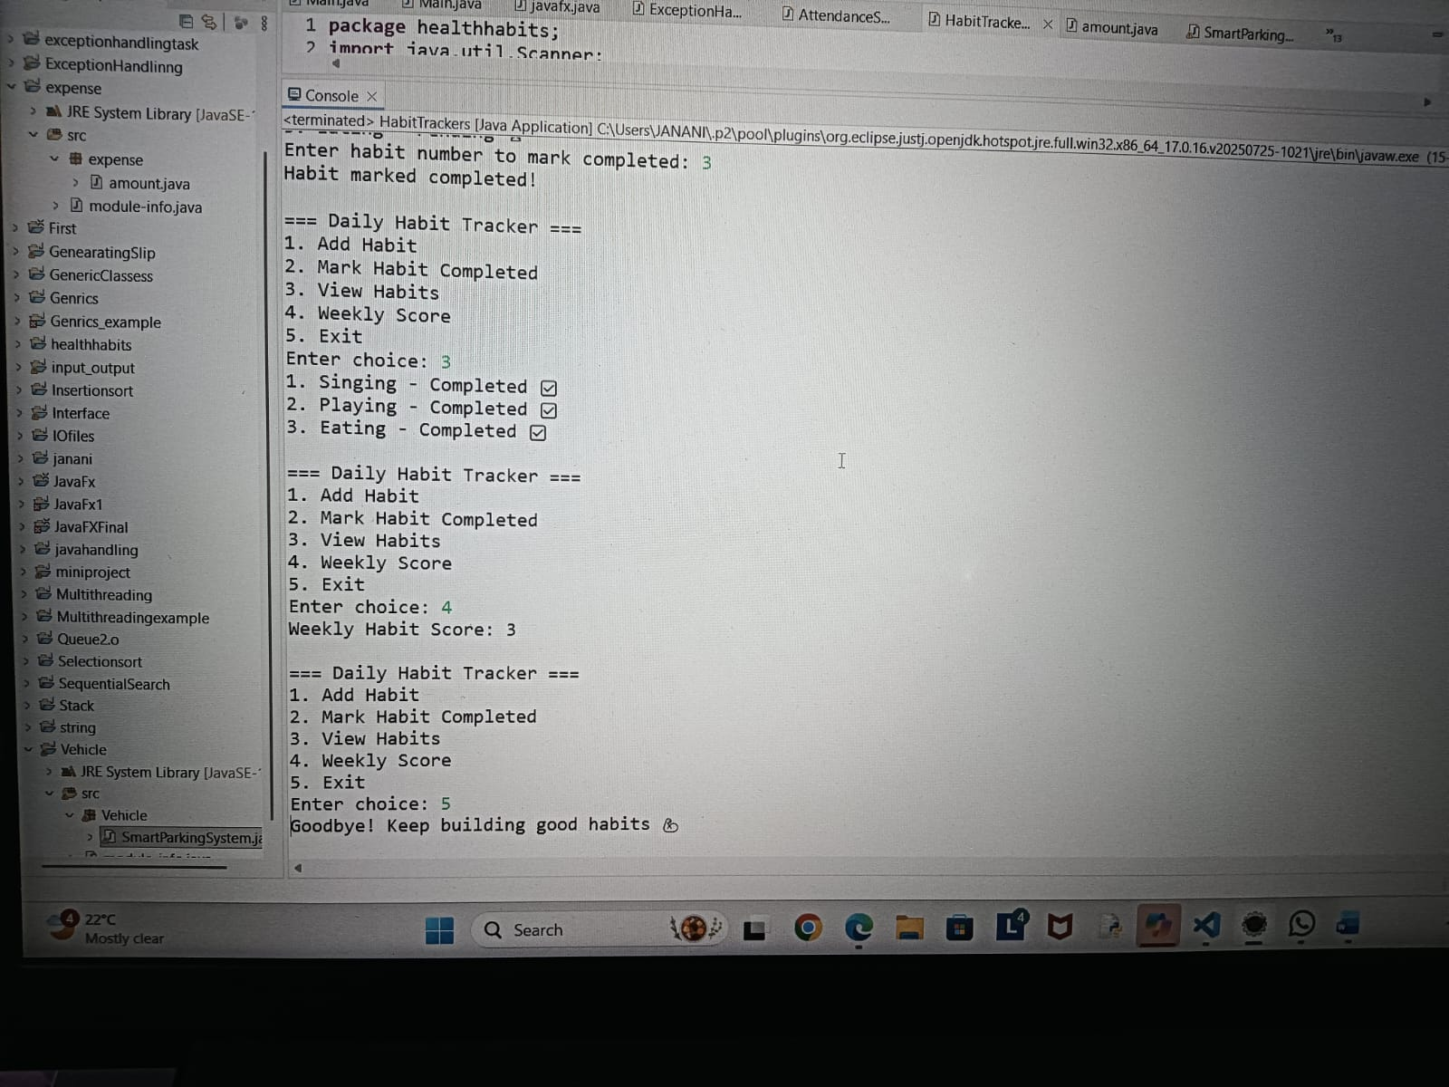
Screenshot:Medium Level
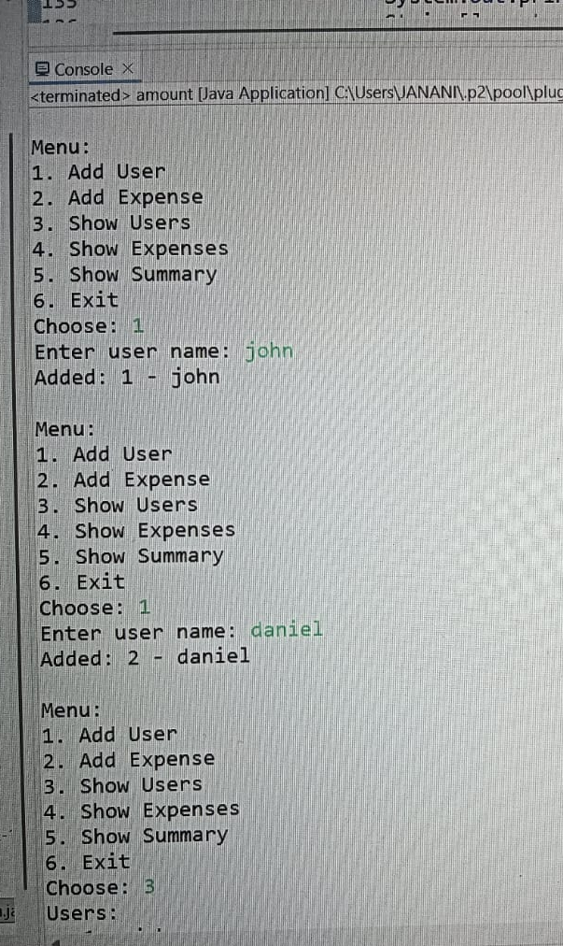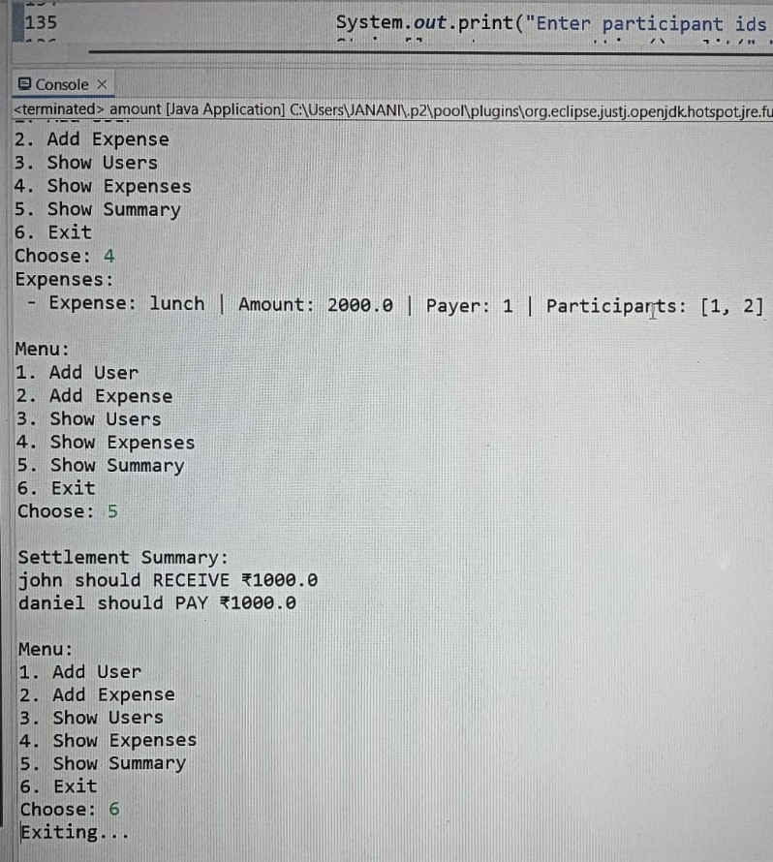
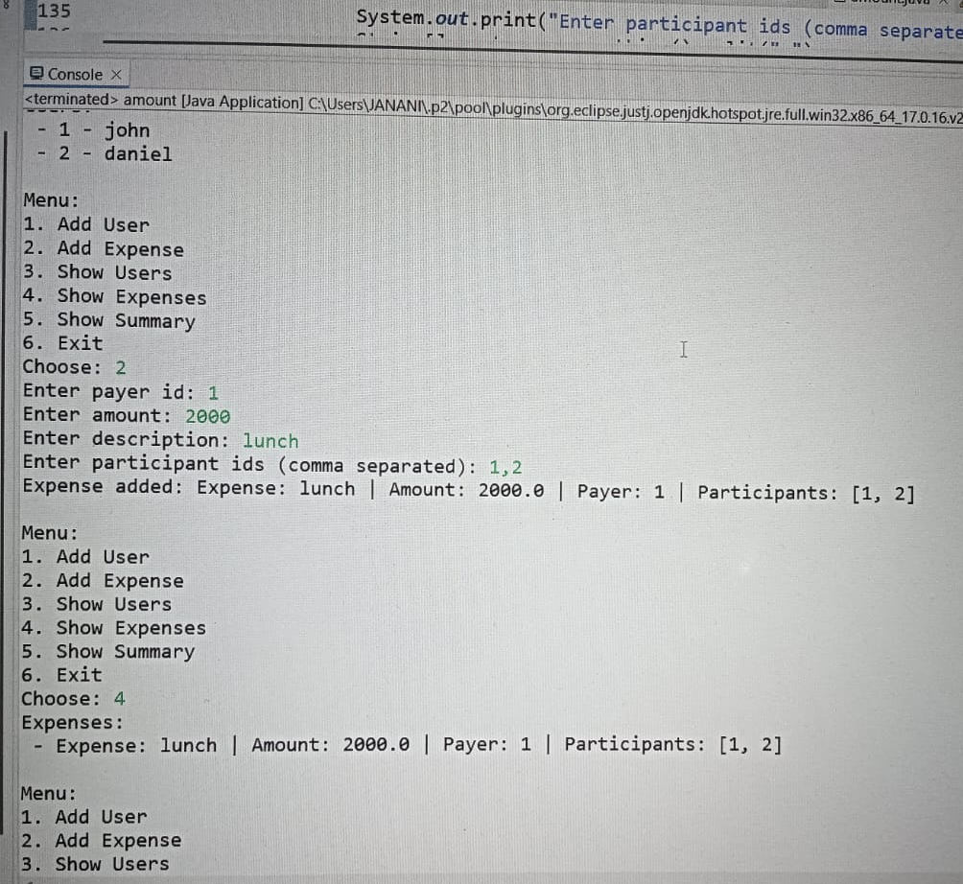

Screenshot: Advanced Level

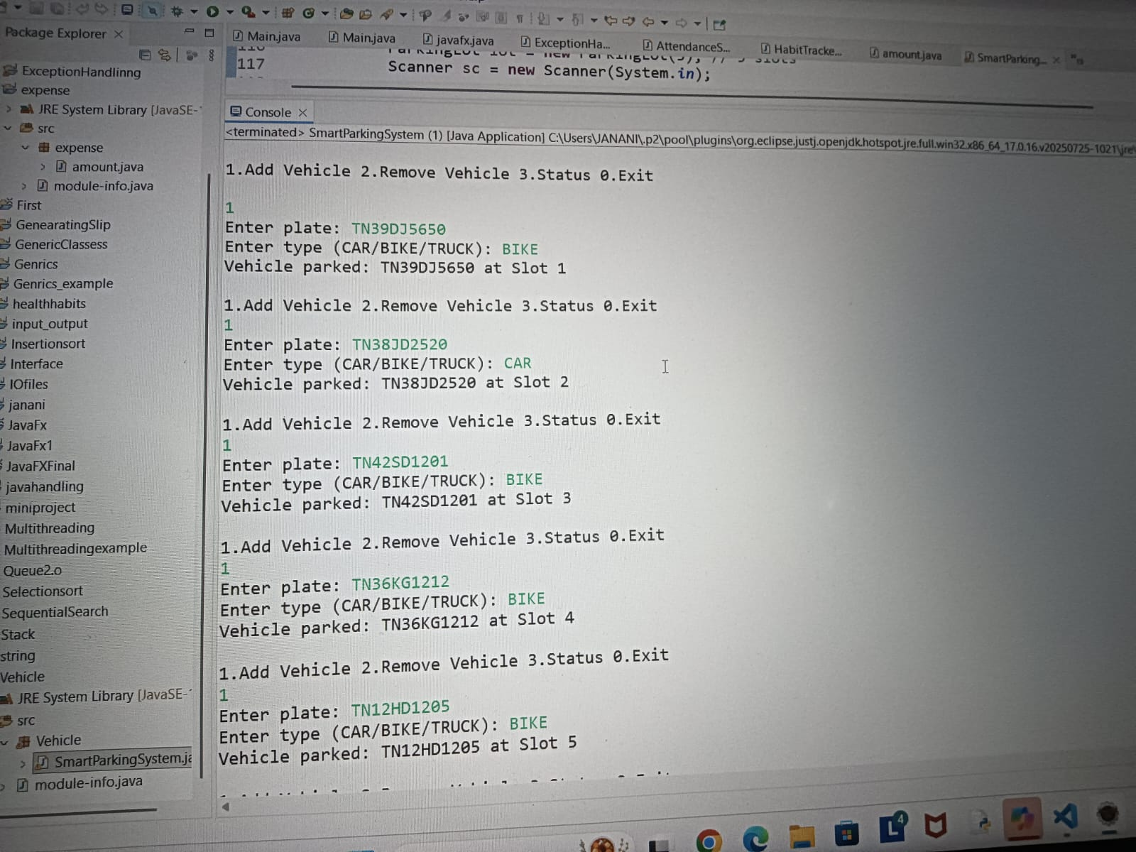
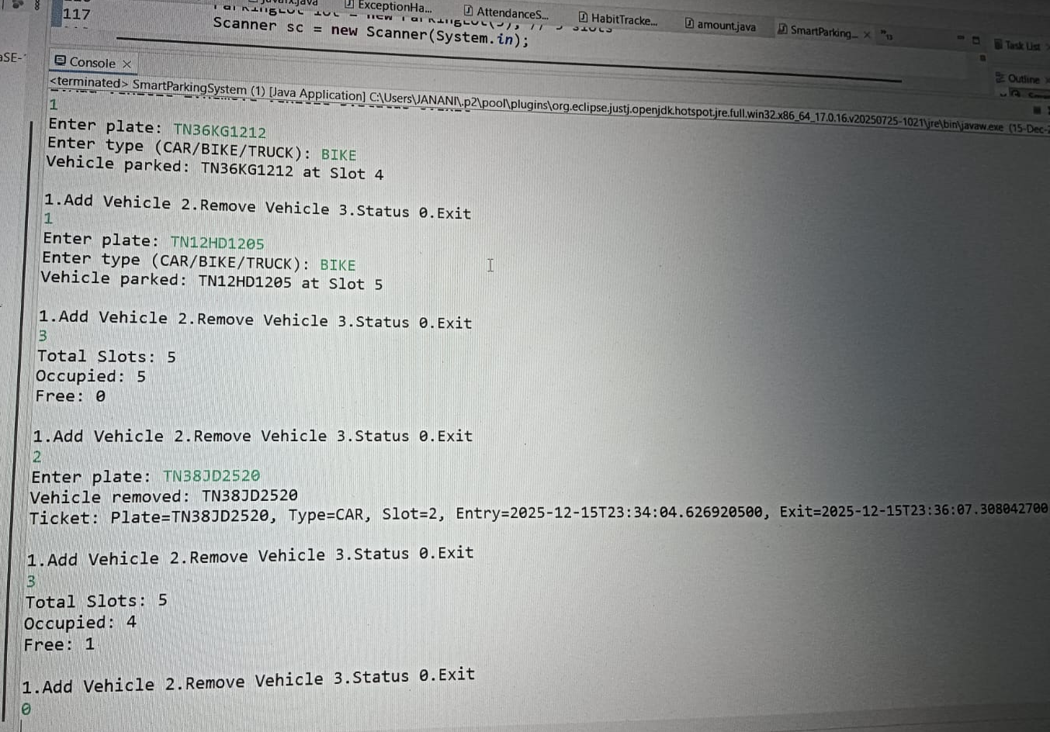

THANK YOU!!!!!!!!!!!!!

